Town, flat_type and rent_approval_date are factors are positively correlated to rent prices for HDB flats in Singapore. The more rooms or more premium the flats, the more expensive the median rent. Same relationship for town vs median rent and rent_approval_date vs monthly_rent. Number of units doesn’t seems to have linear pattern against monthly_rent when compared through flat_type and town. Distribution of different flat-types and towns are similar in their respective box charts.

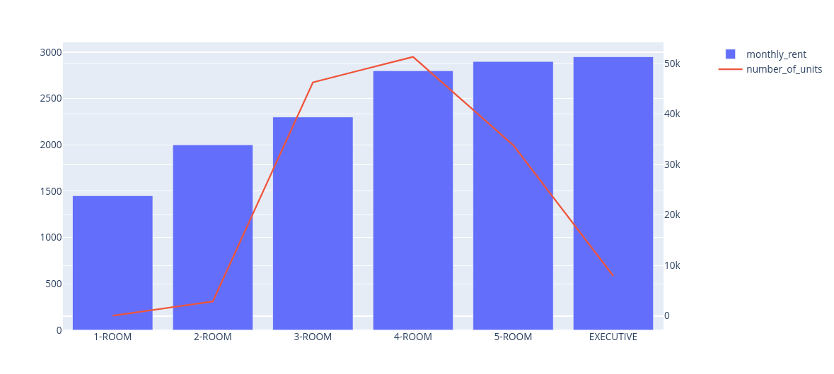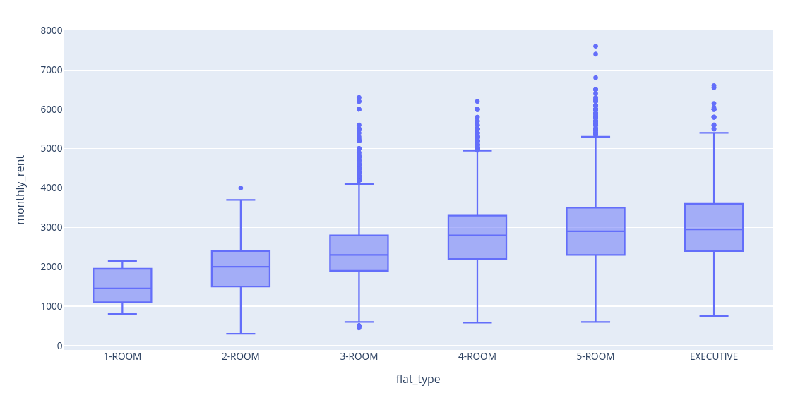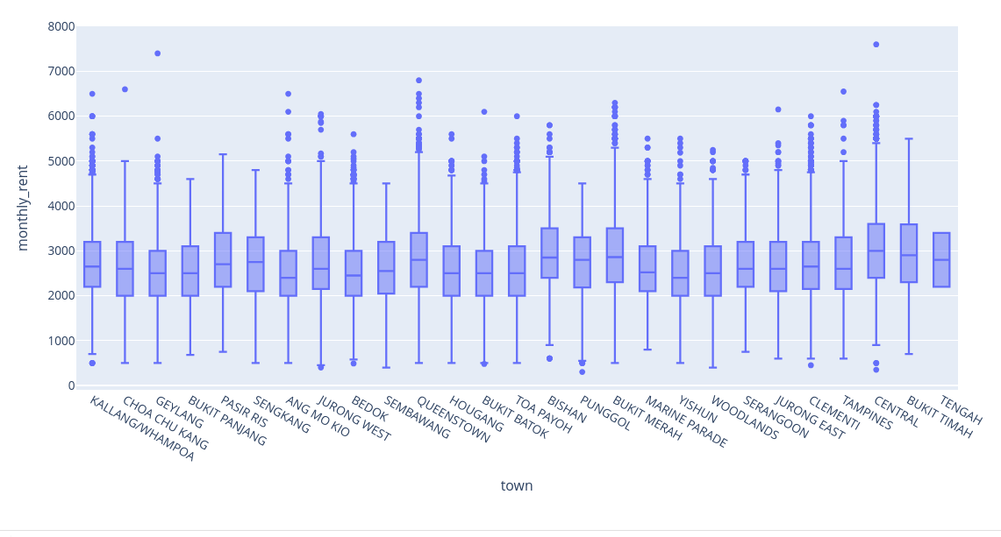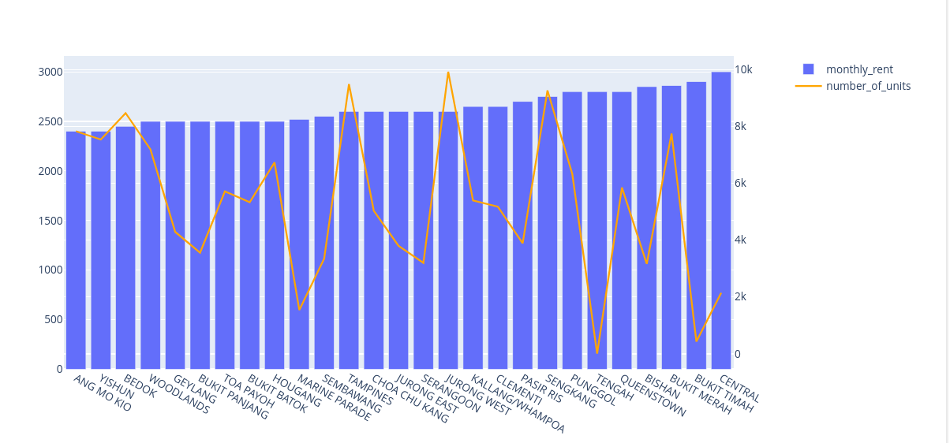

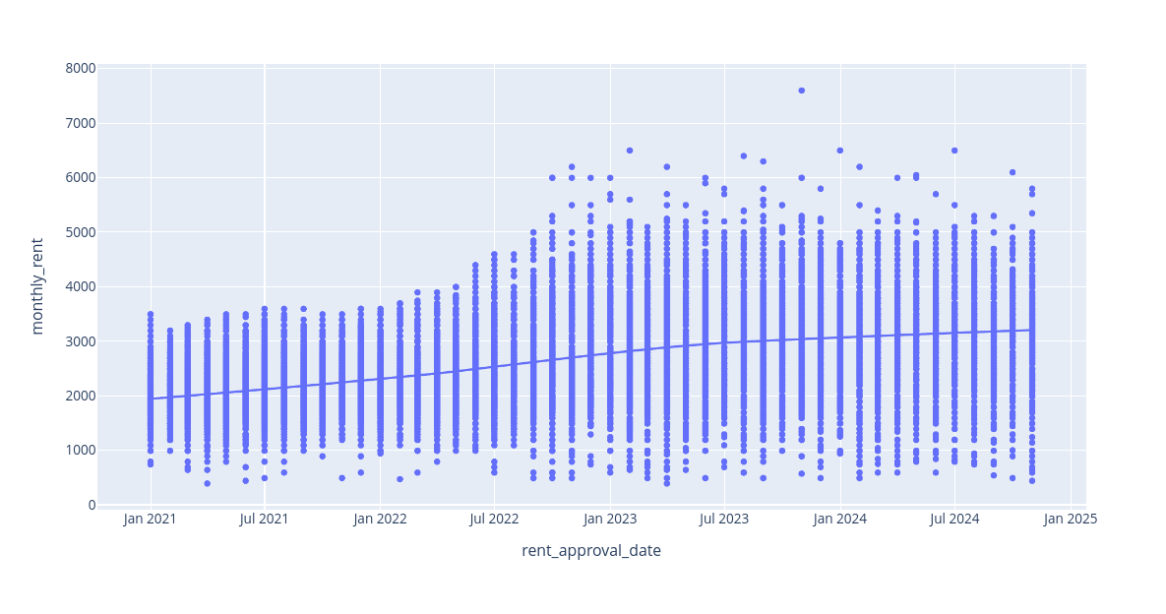

Hypothesis testing using StatsModel’s OLS also helps support these inferences where these factors are all statistically significant at 0.00 (alpha=0.05). Also feature importances using sklearn’s RandomForestRegressor as shown in the table below seems to at least partially back the importances of these three factors. OneHotEncoding from sklearn has been used for hypothesis testing and feature importances.

| feature | importance |
| --- | --- |
| "rent_approval_date" | 0.591887 |
| "flat_type_3-ROOM" | 0.166797 |
| "flat_type_2-ROOM" | 0.064238 |
| "town_BUKIT MERAH" | 0.025475 |
| "town_QUEENSTOWN" | 0.023931 |
| "town_CENTRAL" | 0.021147 |
| "flat_type_4-ROOM" | 0.018706 |
| "town_CLEMENTI" | 0.010809 |
| "town_KALLANG/WHAMPOA" | 0.009249 |
| "town_TOA PAYOH" | 0.00623 |