Robert Horrocks

IT2650

Assignment 1- Project 9

Identification Note

Detail of experience with completing the assignment:

I read Chapter 1 and the parts of Chapter 2 I needed for my coding project.

I installed the BlueJ IDE, watched the videos. I encountered some problems running my code and using the debugger in the BlueJ, so I switched to NetBeans, where I had a little more experience, for the balance of this project. This was the biggest obstacle for me this week.

I chose to work problem # 9 for my assignment.

I developed my algorithm and wrote up some pseudocode.

Then, I developed some test code and ran some debugging tests. I learned about the keyboard scanner utility and added that code to get user input to meet the requirement for the assignment.

Algorithm/Pseudocode

Goal: calculate ideal body weight using a formula, feet and inches

Feet/Inches Ideal Body Weight

5’ 110

5’1” 115

5’2” 120

5’11” 165

6’ 170

6’1” 175

6’3” 185

START PROGRAM

Ask USER INPUT for HEIGHT IN FEET and INCHES, assign to variables for FEETHEIGHT and INCHHEIGHT

DECLARE a variable for IDEALBODYWEIGHT

Compute IDEALBODYWEIGHT with formula ((110) + ((FEETHEIGHT-5) \* (12 \* 5)) + (INCHHEIGHT \* 5))

PRINT CONSOLE OUTPUT for IDEALBODYWEIGHT

END PROGRAM

Run Screen Shots

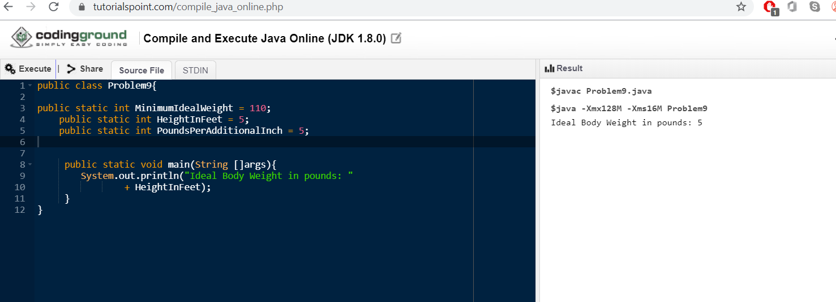

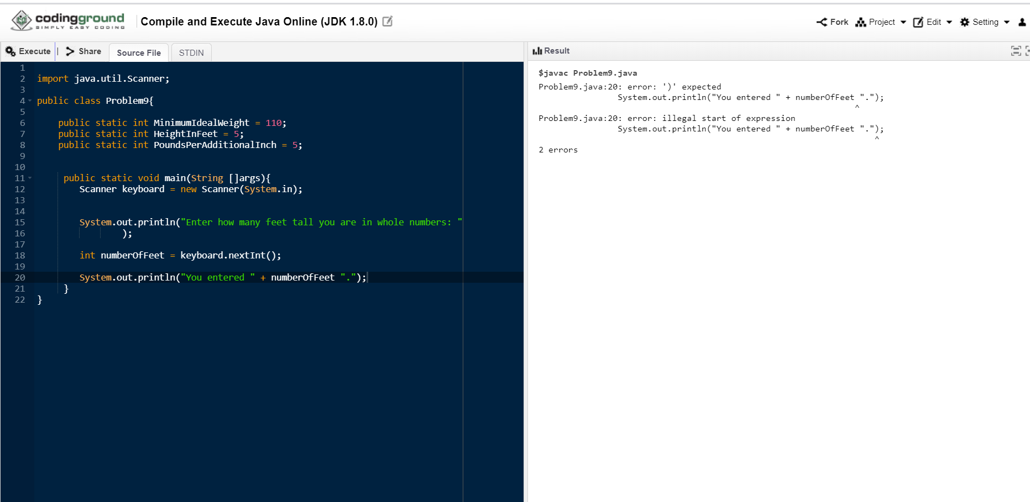

I moved to NetBeans because I was having problems using the debugger in BlueJ.

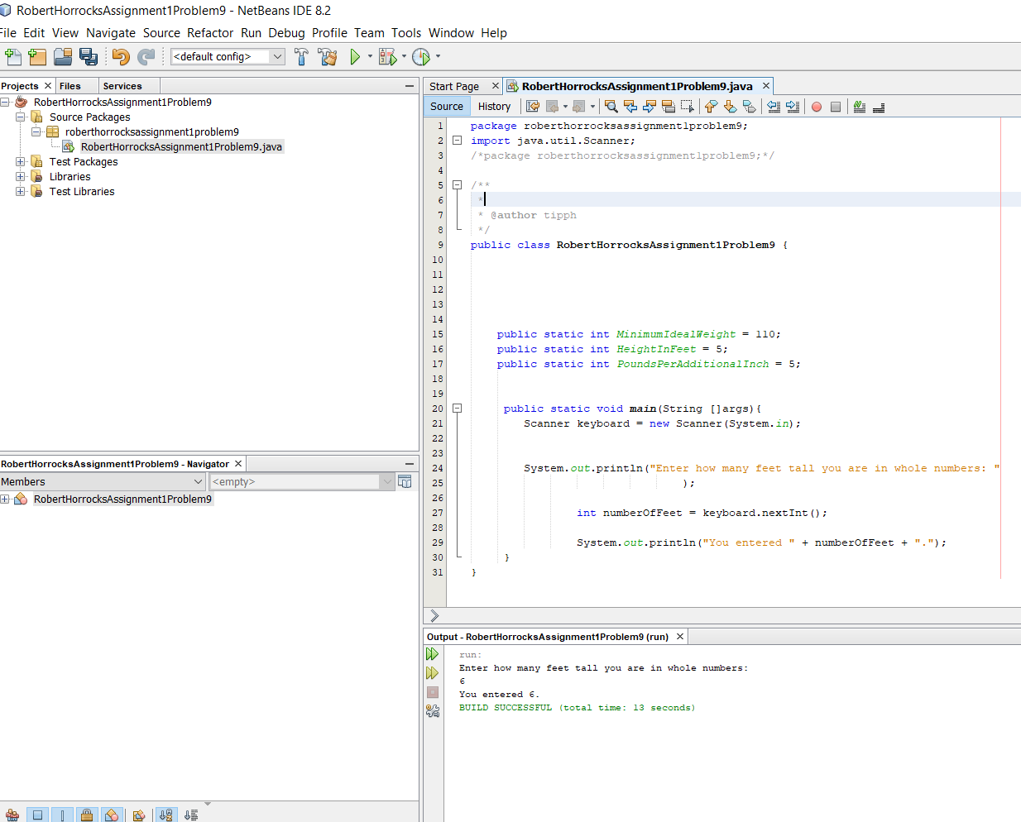

Added code to ask user input for inches:

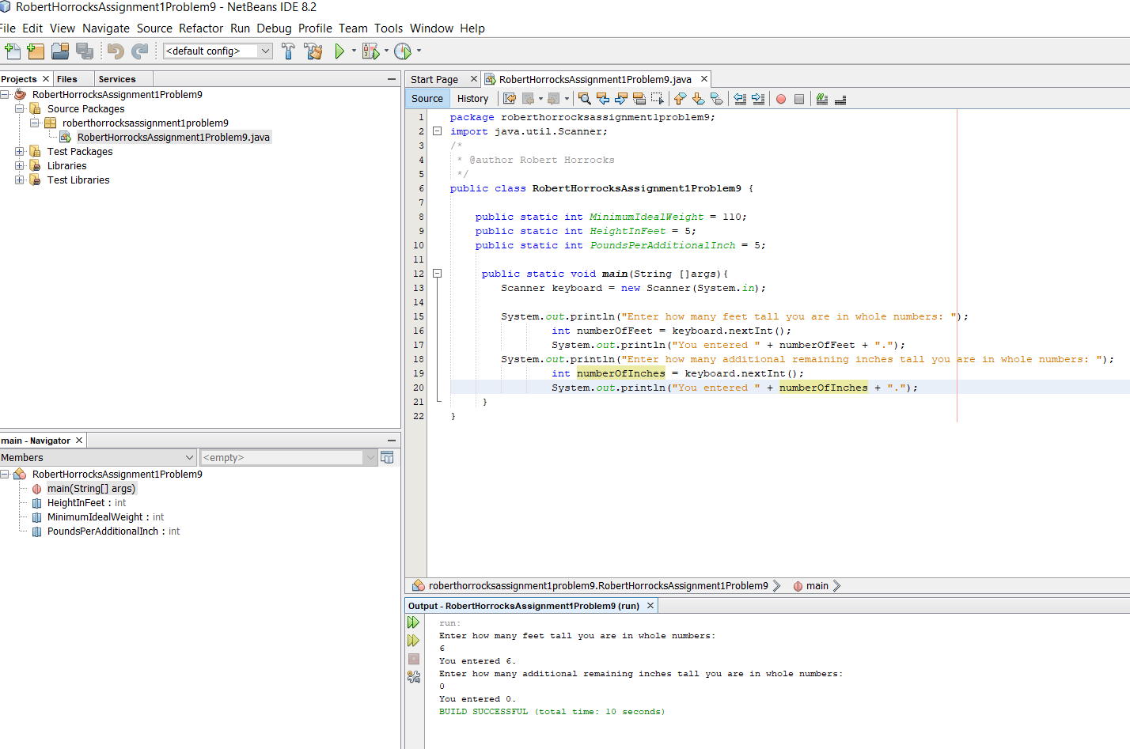

I added code to compute the ideal weight and modified some variables to meet naming conventions:

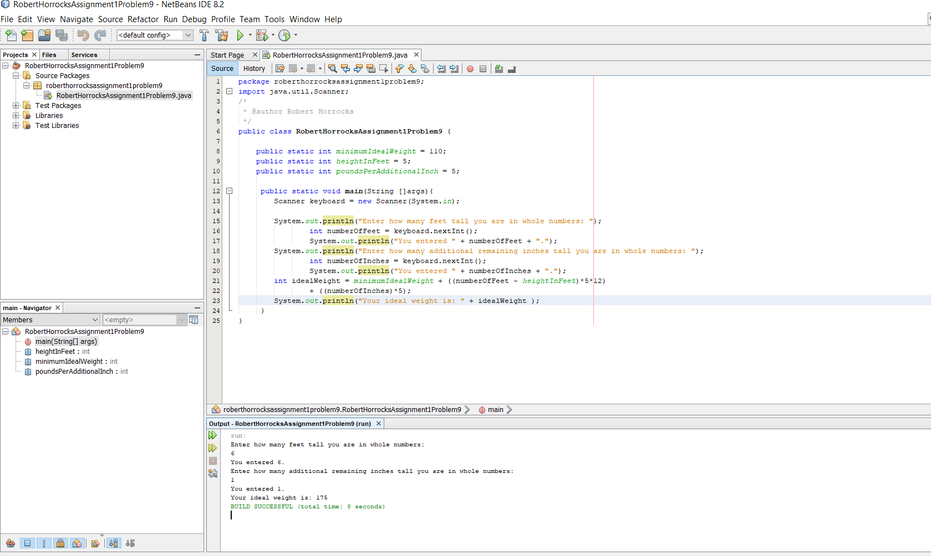

At this point it is a functioning code, so I uploaded my folder.