Robert Horrocks

IT2650

Assignment 2- Project

Identification Note

Detail of experience with completing the assignment:

I read Chapter 2.

I learned about formatting screen output, specifically the variances and differences with the different type of outputs including print, println, and printf. With the printf method, I learned about formatting with the character, string, float, and double settings. I also learned about money formats using printf.

I learned about currency formatting and formatting user input to variables.

I chose to work problem # 4 for my assignment.

I developed my algorithm and wrote up some pseudocode.

Then, I developed some test code and ran some debugging tests. I learned more about the keyboard scanner utility and added that code to get user input to meet the requirement for the assignment.

I got into the project and ran into some challenges with formatting input to money and showing output in currency. I updated my code with changes until the bugs were clear and had a good program.

Algorithm/Pseudocode

Goal: Develop a program to compute the cost of a commute based on user input of distance, a vehicle’s average gas consumption, and the price of a gallon of gas.

Cost of Commute = (number of miles / miles per gallon) \* Price per gallon of gas

Example 1: (10 miles / 10 mpg) \* 3.00 per gallon = 3.00 commute

Example 2: (30 miles / 15 mpg) \* 2.00 per gallon = 4.00 commute

Example 3: (50 miles / 20 mpg) \* 2.50 per gallon = 6.25 commute

START PROGRAM

Ask USER INPUT for NUMBER OF COMMUTE MILES, MILES PER GALLON OF VEHICLE, and PRICE OF GAS, assign to variables for COMMUTEMILES, MPG, PRICE

DECLARE a variable for COMMUTECOST

Compute COMPUTECOST with formula ((COMMUTEMILES) \* (MPG)) / (PRICE))

PRINT CONSOLE OUTPUT for COMMUTECOST

END PROGRAM

Run Screen Shots

I started off by working a few of the book examples to familiarize coding using printf.

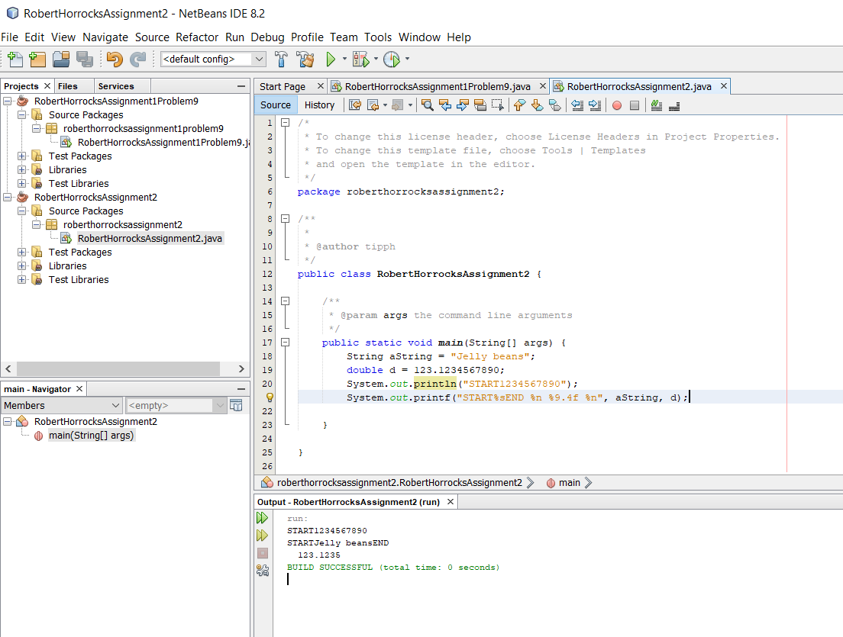

I added some code to review currency method concepts.

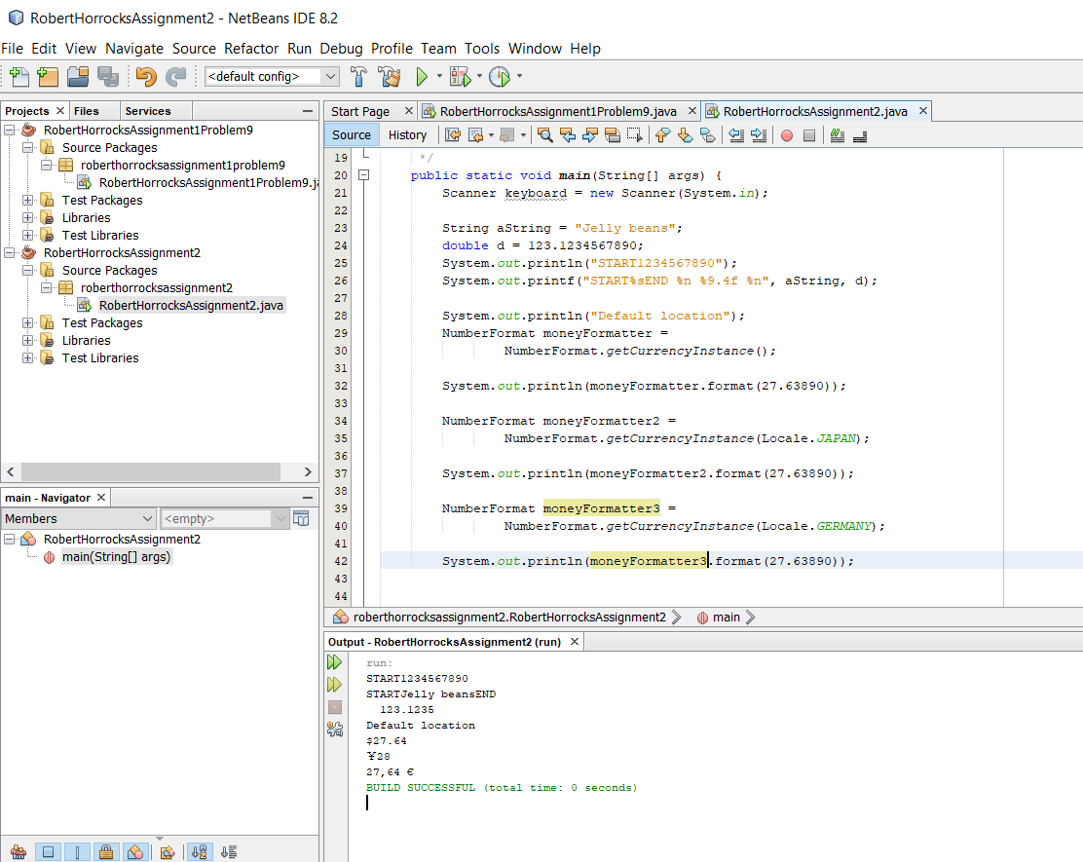

I decided to do problem #4, cost of commute.

I added some code to put in the user input request for the three variables for miles commuted, miles per gallon, and cost of gas. I put the wrong formula into the cost of commute and got an undesired result in the form of a logic error.

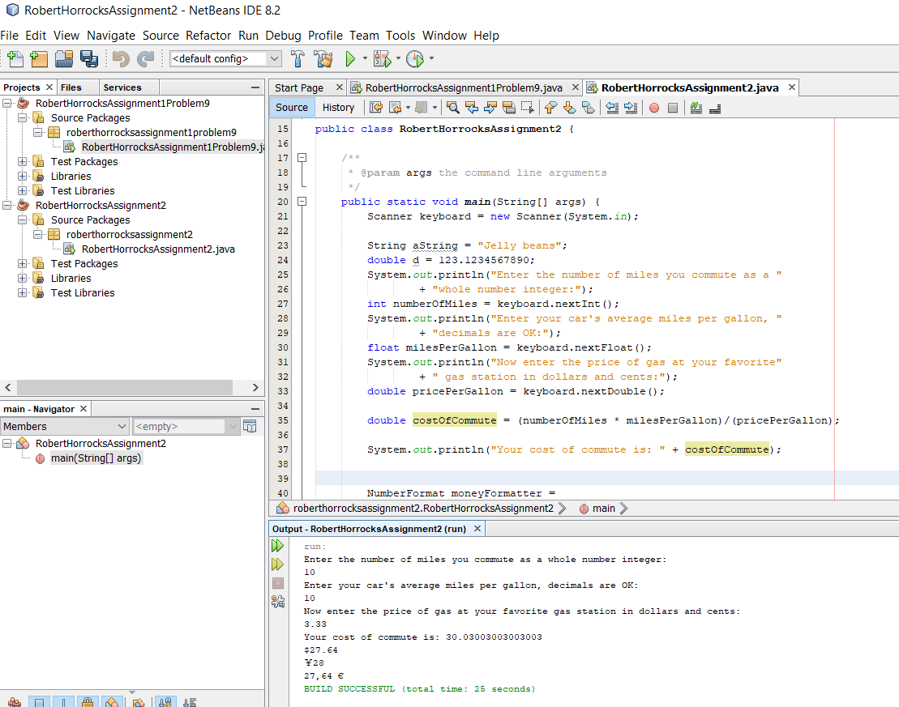

I cleaned out the book example code and fixed my algorithm in the code.

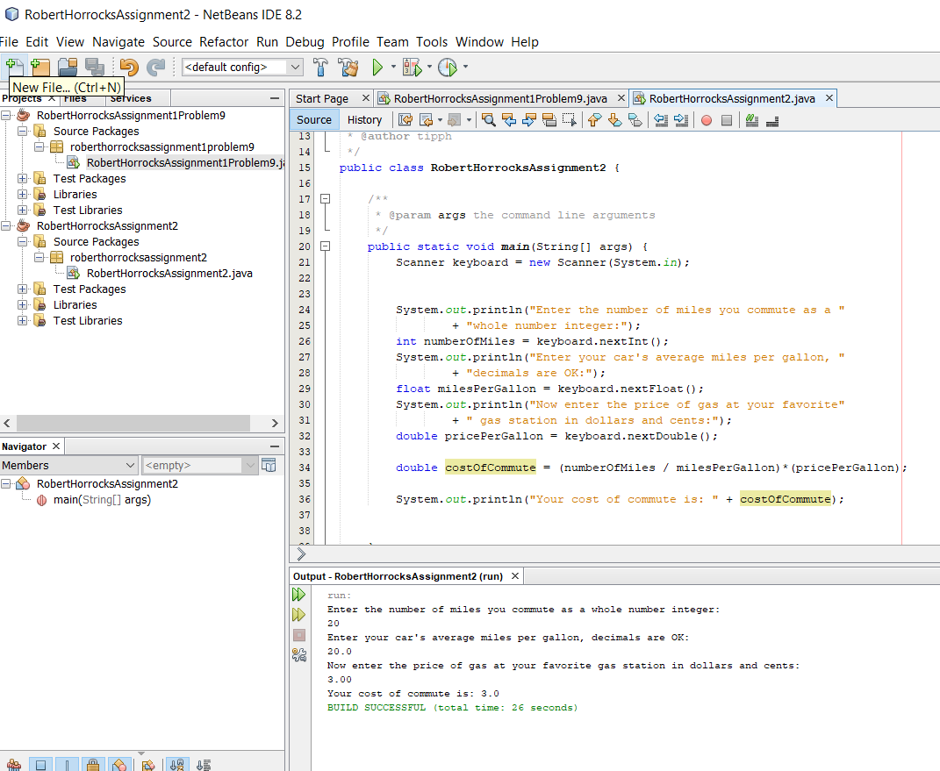

I wanted to show the output in dollars and cents, but my first run at formatting the output was not correct:

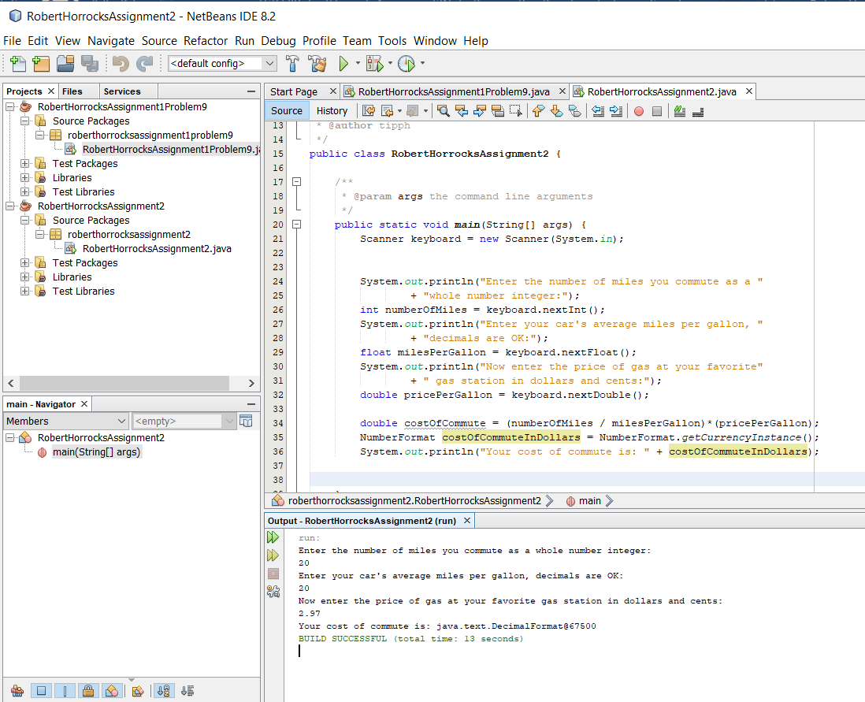

Joys of debugging, part 1:

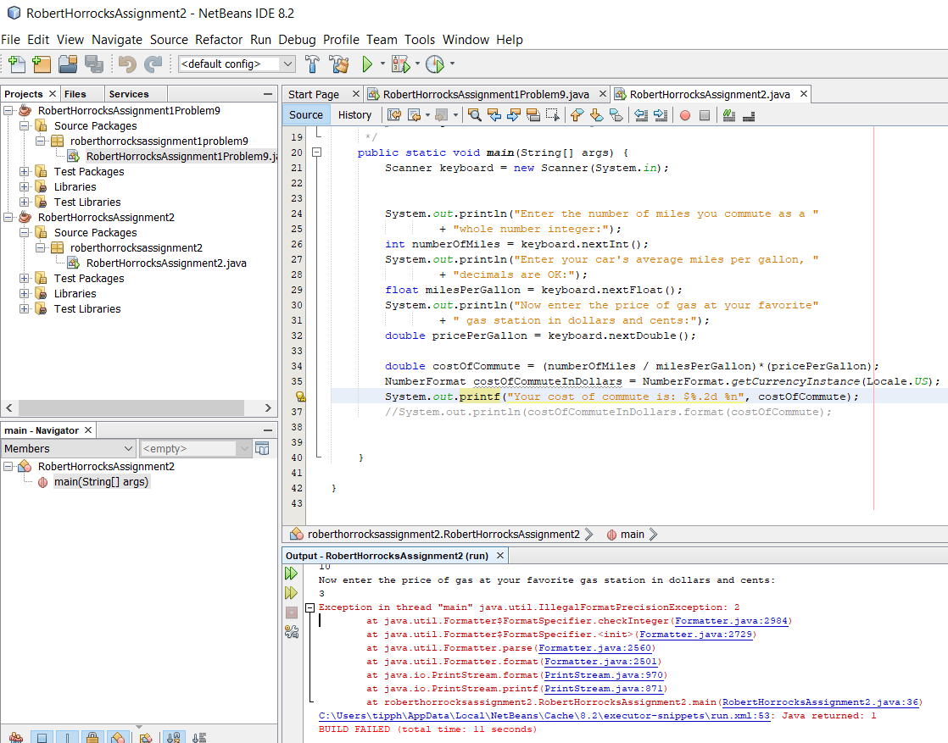

Joys of debugging part 2- learning I needed a second closing parenthesis:

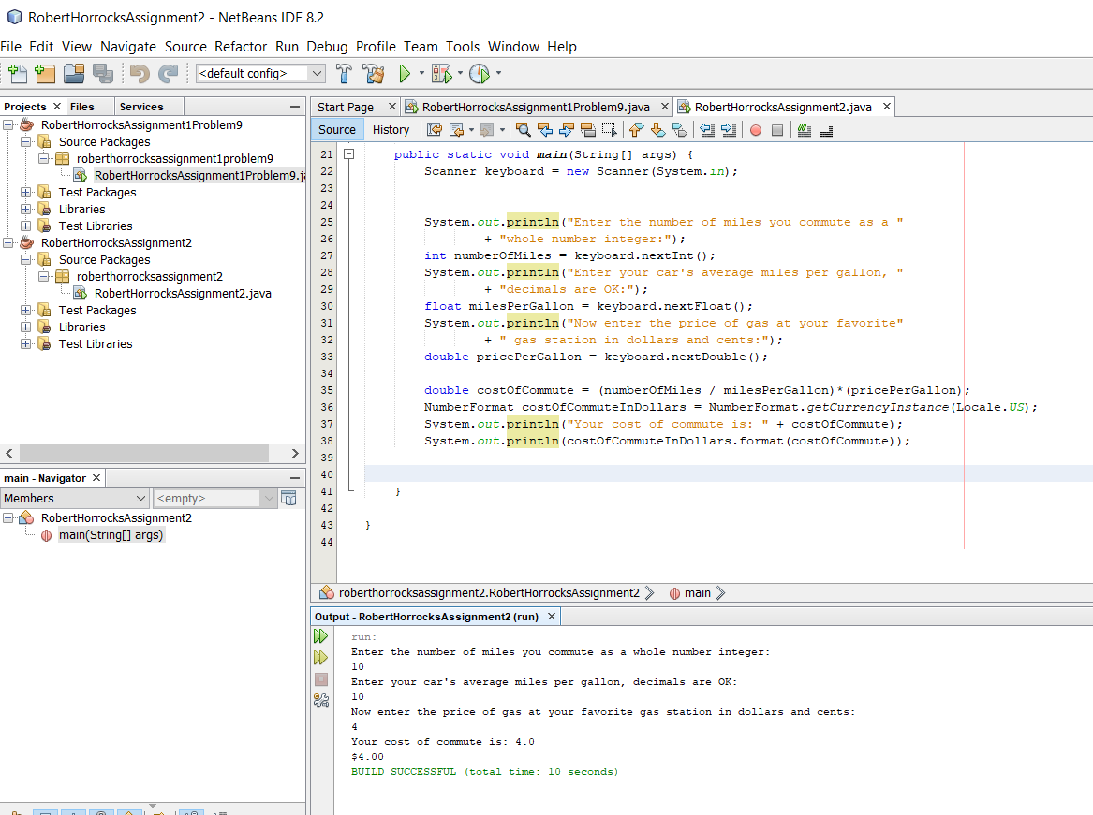

Updated code for formatting price of gas in dollars and cleaning up output:

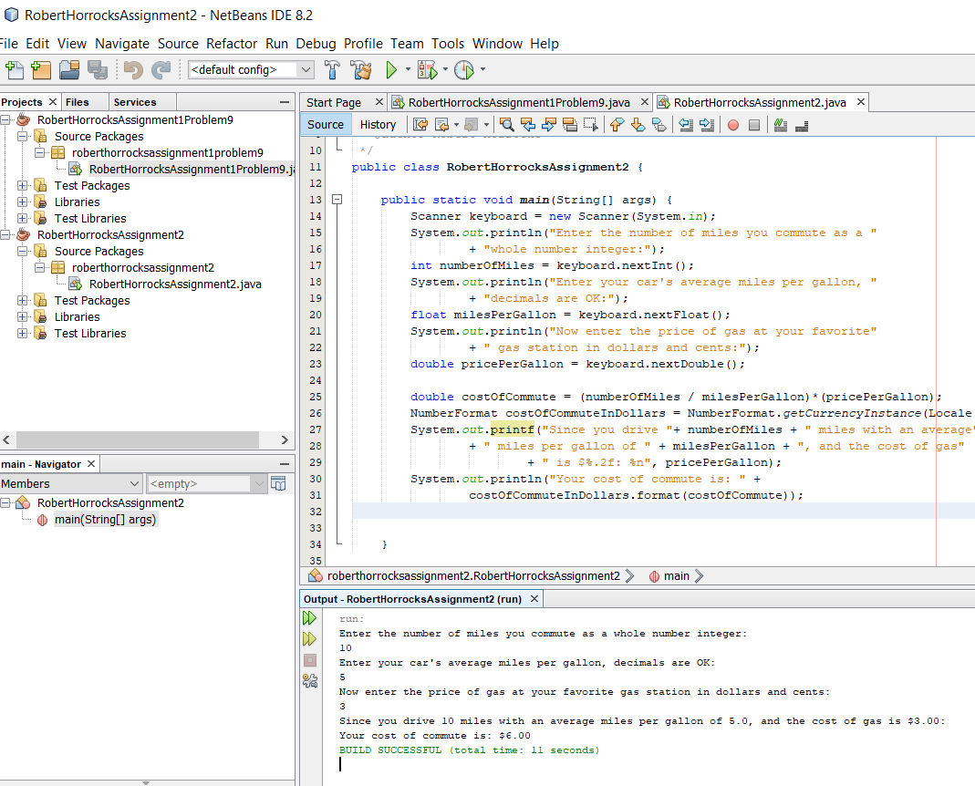

At this point it is a functioning code, so I uploaded my folder.