Robert Horrocks

IT2650

Assignment 3- Project

Identification Note

Detail of experience with completing the assignment:

I read Chapter 4. I also watched a number of the videos to see various examples and further discussion of the material.

I learned about flow of control and branching mechanisms. Learning if-else statements, compound statements, multiway if-else statements, I also learned about the switch statement and cases. I also read about Boolean expressions, comparison operators and order of precedence.

I then read about loops and the while, do-while and for loops. I learned about nesting and breaks, continue, and exit statements.

I also read the section about debugging. I learned about utilizing incremental development, pair programming, and code review to assist with coding and debugging a program.

Finally, I learned about random number generation and its applications.

I chose to work problem # 11 for my assignment.

I developed my algorithm and wrote up some pseudocode.

Then, I developed some test code and ran some debugging tests. I learned more about the keyboard scanner utility and added that code to get user input to meet the requirement for the assignment.

I got into the project and ran into some challenges with formatting input to money and showing output in currency. I updated my code with changes until the bugs were clear and had a good program.

Algorithm/Pseudocode

Goal: Develop a program to randomly generate 3 winners from a pool of 30 finalists, by selecting three unique numbers between 1 and 30.

START PROGRAM

Set a RANDOM GENERATOR for the program with limits from 0 to 29. Add 1 so that 0 is not a valid number.

DECLARE a variable for WINNER1, WINNER2, and WINNER3

Have RANDOM GENERATOR pick and assign WINNER1

Have RANDOM GENERATOR pick and assign WINNER2 IF NOT EQUAL TO WINNER1, ELSE pick again.

Have RANDOM GENERATOR pick and assign WINNER3 IF NOT EQUAL to WINNER1 or WINNER2, ELSE pick again.

PRINT CONSOLE OUTPUT for WINNER1, WINNER2 and WINNER3

END PROGRAM

Run Screen Shots

I started off by copying in the book example on the coin flip random generator to see a baseline for the random generator and the while loop.

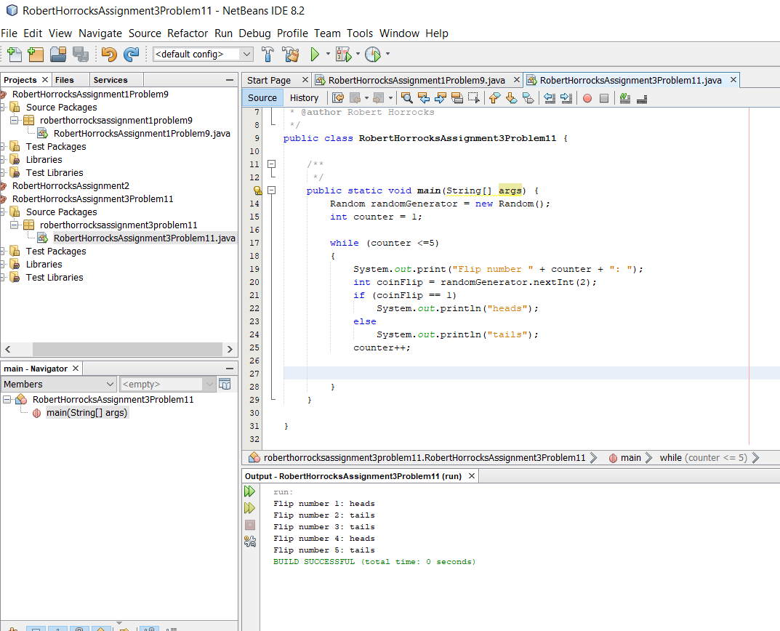

I changed some code to output 3 results and changed the string to Winner.

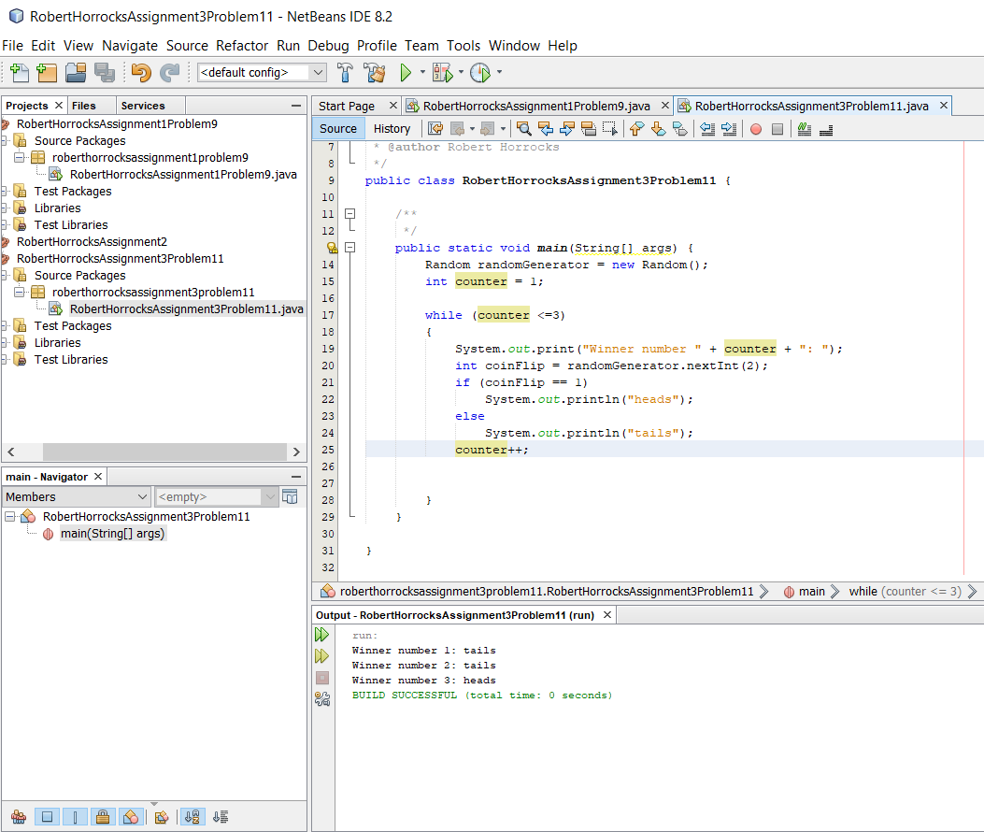

I changed the code to generate the three random numbers. At this point, I do not have a solution coded to make sure they are unique, and the system could generate a 0.

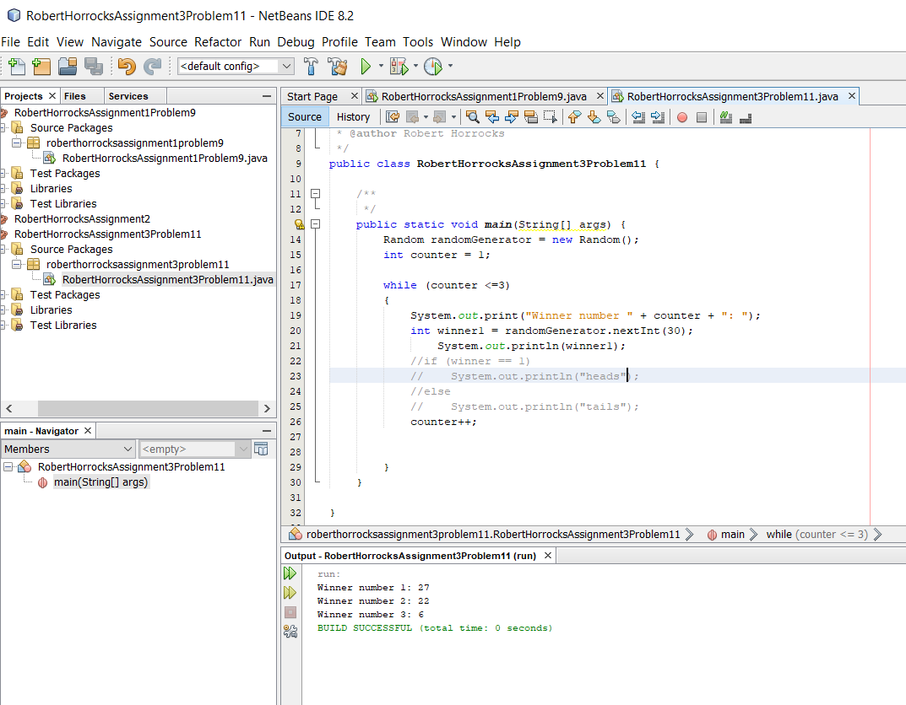

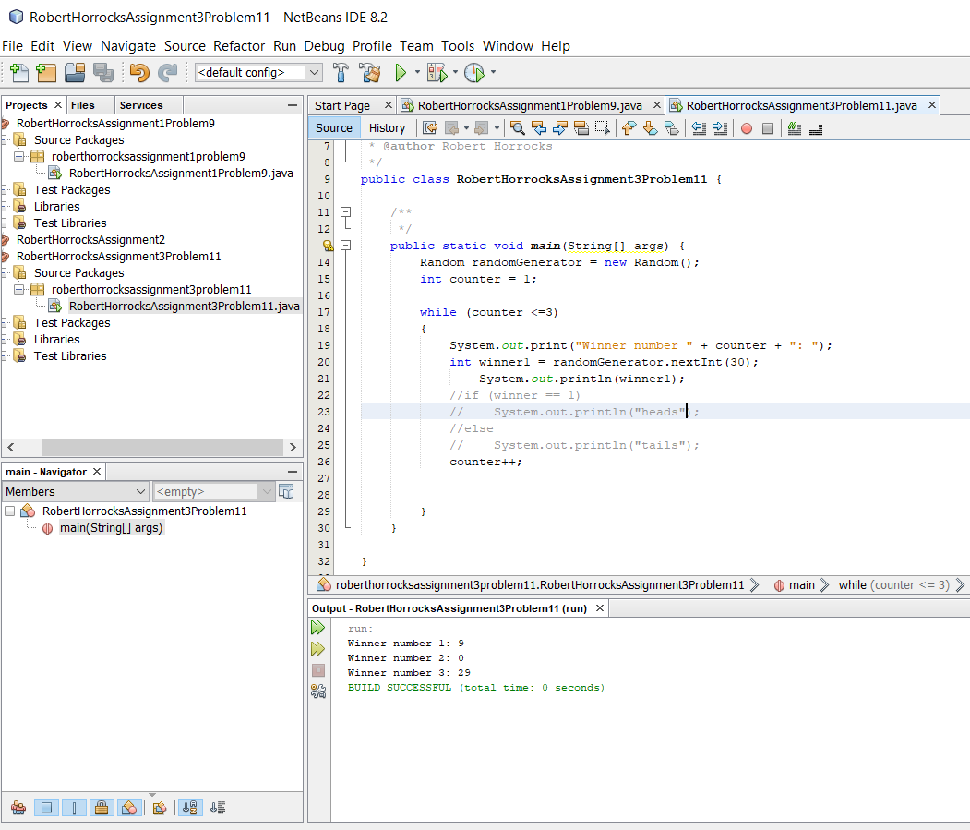

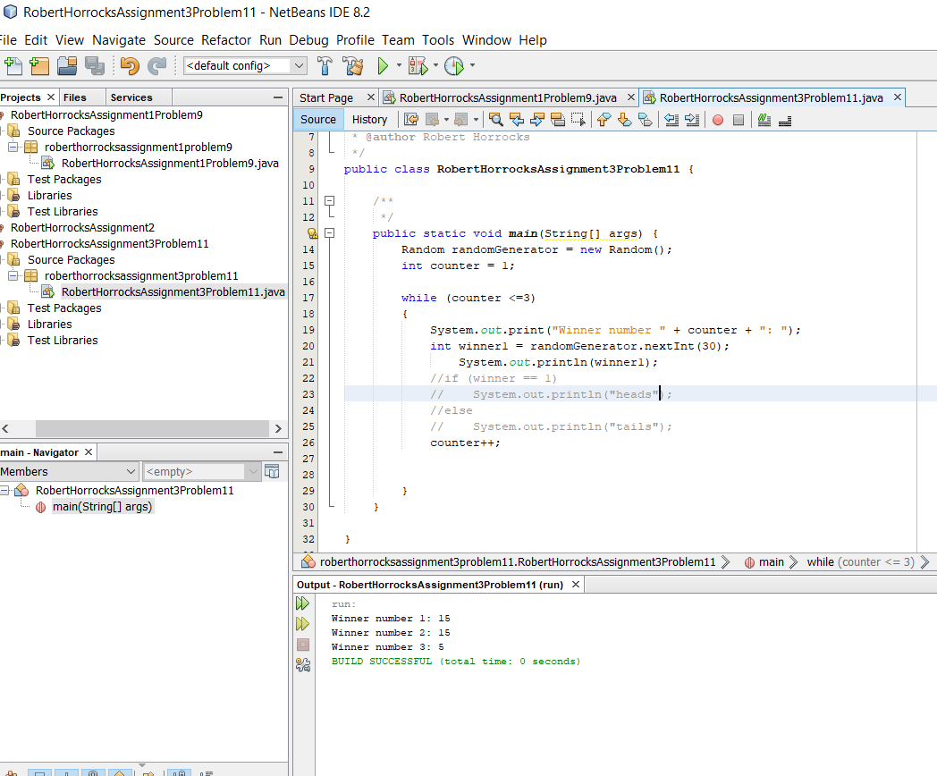

I cleaned out the book example code and generated three different winners, still not unique yet.

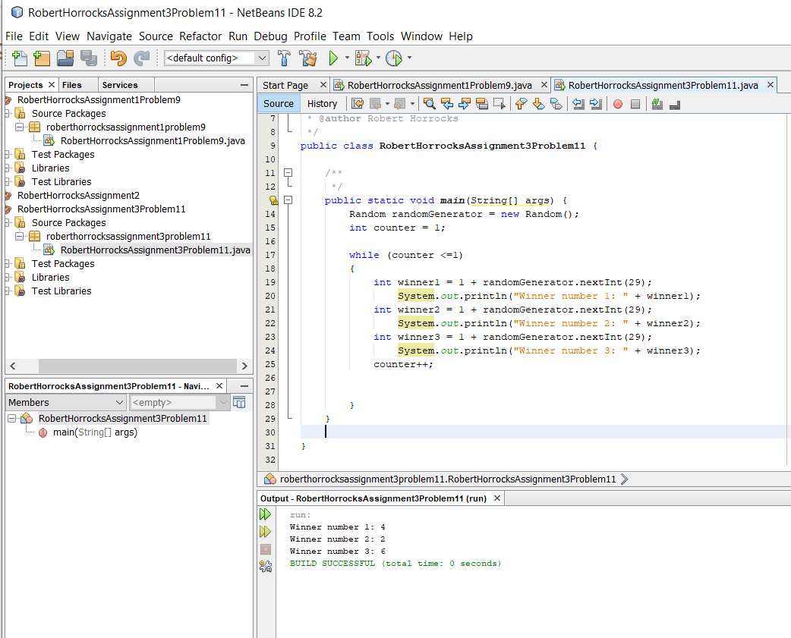

I wanted to show the output of the three winners, but if the random picked the same number, it did not print.

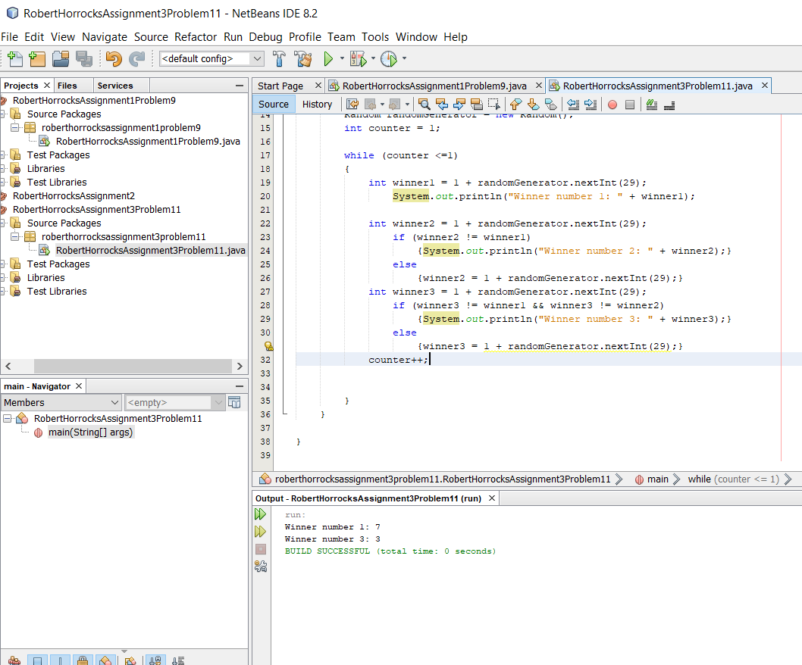

I corrected the reassign without printing issue.

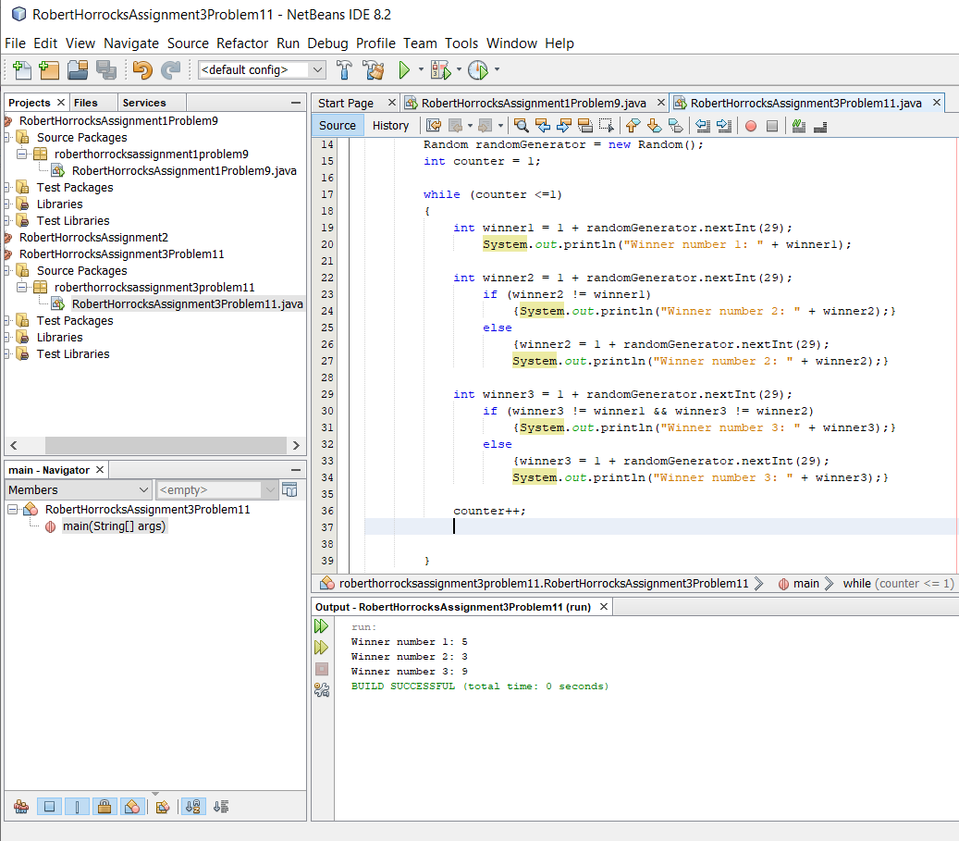

At this point it is a functioning code, so I uploaded my folder.