Robert Horrocks

IT2650

Assignment 3- Project

Identification Note

Detail of experience with completing the assignment:

I read Chapter 4. I also watched a number of the videos to see various examples and further discussion of the material.

I learned about classes in Java. learned about class definitions, instance variables and the new constructor. Learned about instance methods.

I then read about invocating methods and the return statement.

I ran through some of the class examples to get an idea of how to code class solutions.

I learned about primitive types, casting, and parameters.

I learned about methods equal and toString.

I read about abstraction and encapsulation, and learned use cases for private and public identifiers.

I learned about the process of overloading and the rules. I also learned more about constructors. I read about StringTokenizer, because I think it will come up in my assignment.

I chose to work problem # 4 for my assignment, BlogEntry.

I developed my algorithm and wrote up some pseudocode.

Then, I developed some test code and ran some debugging tests.

Algorithm/Pseudocode

Goal: Define a class that can store an entry for a Web log. Main method is used to test the class. BlogEntry to have instance variables to store username, text of entry, and date. A method called DisplayEntry will output all the instance variables. A class called getSummary will return the first ten words from the text of the post.

START PROGRAM

Start BLOGENTRY CLASS

Ask User for name, set in a variable USERNAME

Ask user for text of the entry. Store in a string variable ENTRYTEXT

Open DATE class.

Apply DATE to BLOGENTRY

Use method DISPLAYENTRY to output all the instance variables-

Output USERNAME

Output ENTRYTEXT

Output DATE

Use method GETSUMMARY to return first 10 words

Use StringTokenizer to parse first 10 words into variables

Display 10 words or full post to screen

END PROGRAM

Run Screen Shots

I started off by copying in the book example to see a baseline for classes and the structure of the class code.

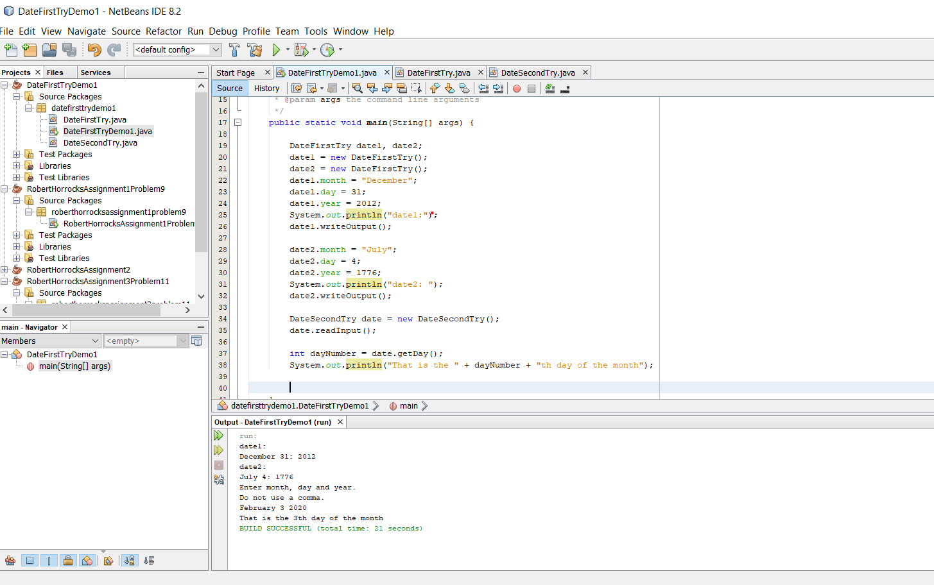

I did some public void examples.

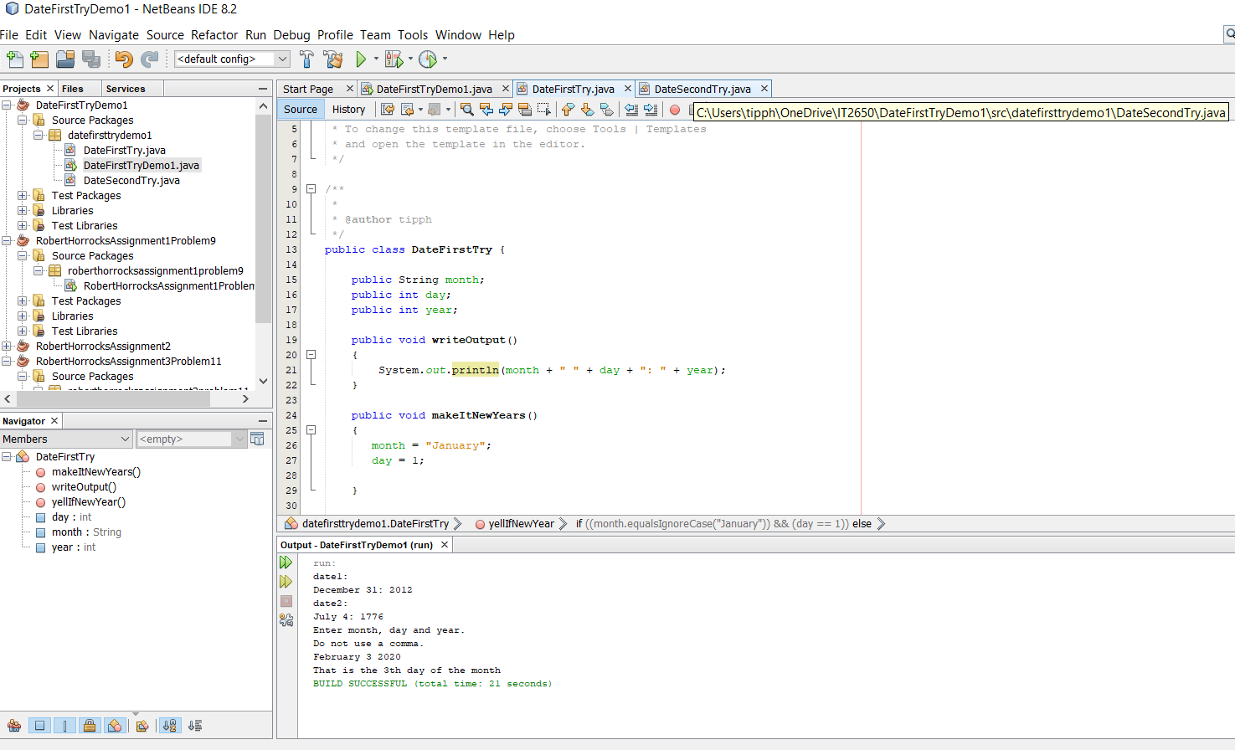

I learned a little more about public vs private variables. Most of mine in the problem will be public since the problem called out for the user to be able to change them.

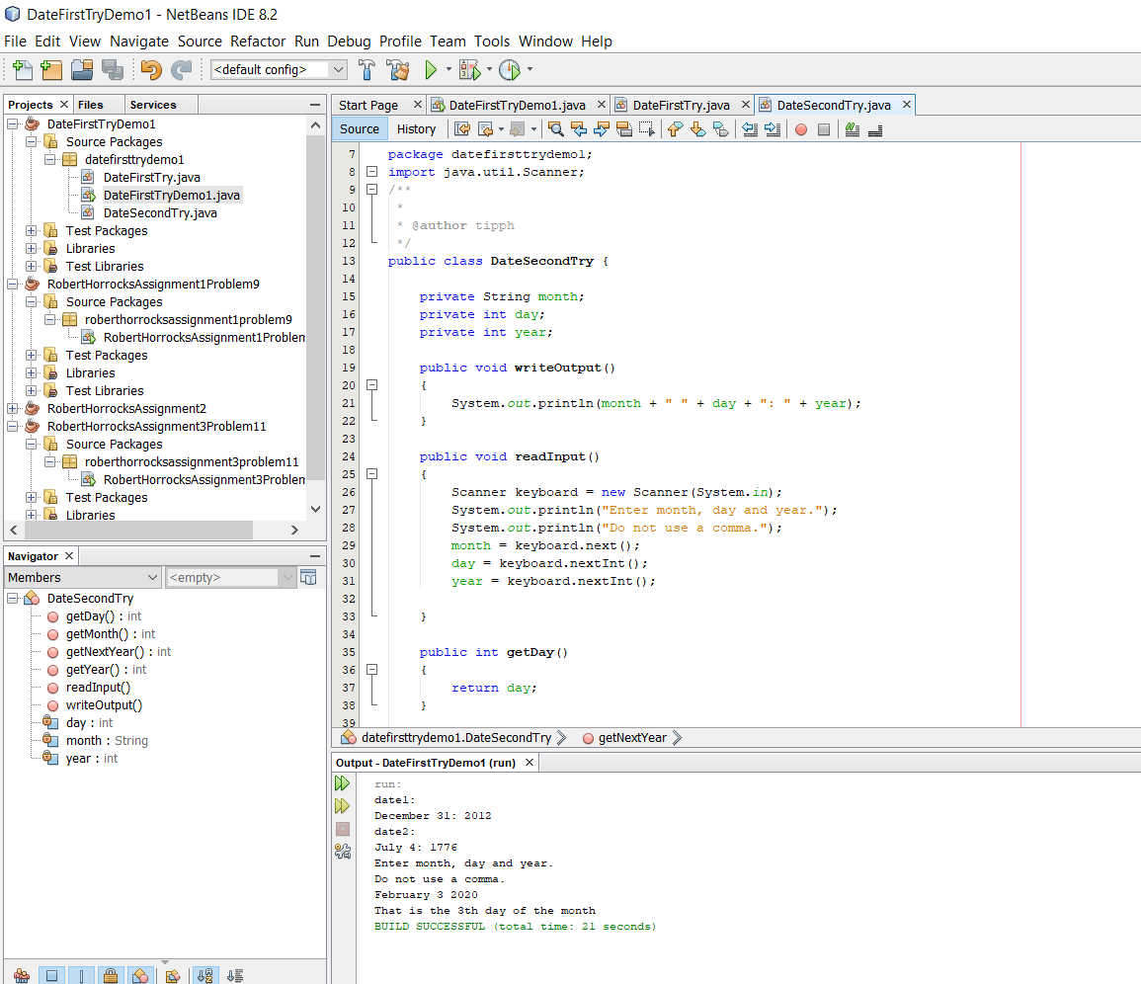

I started the project with a new class. I brought in the Scanner class and I coded a few lines to get started. I realized I will need something other then keyboard.next() to get the whole user input.

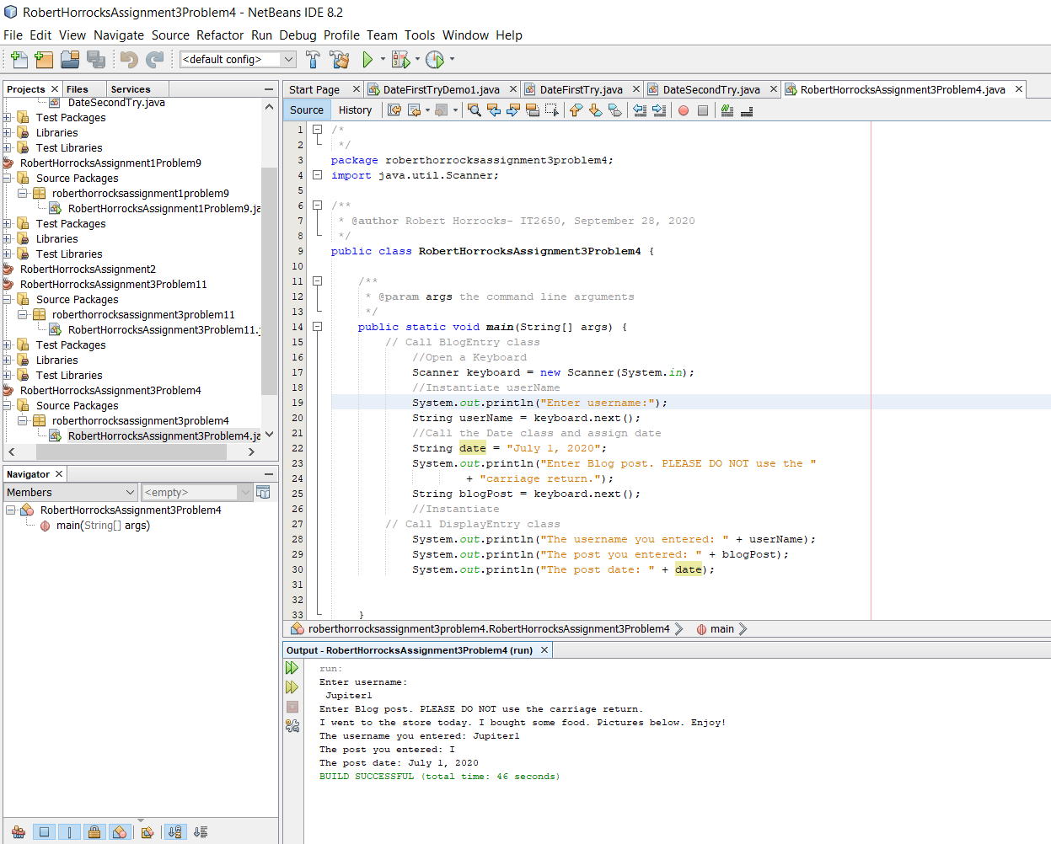

I tried to put the code in its class and then call the class in my program, but I got an error. Will re-read the text.

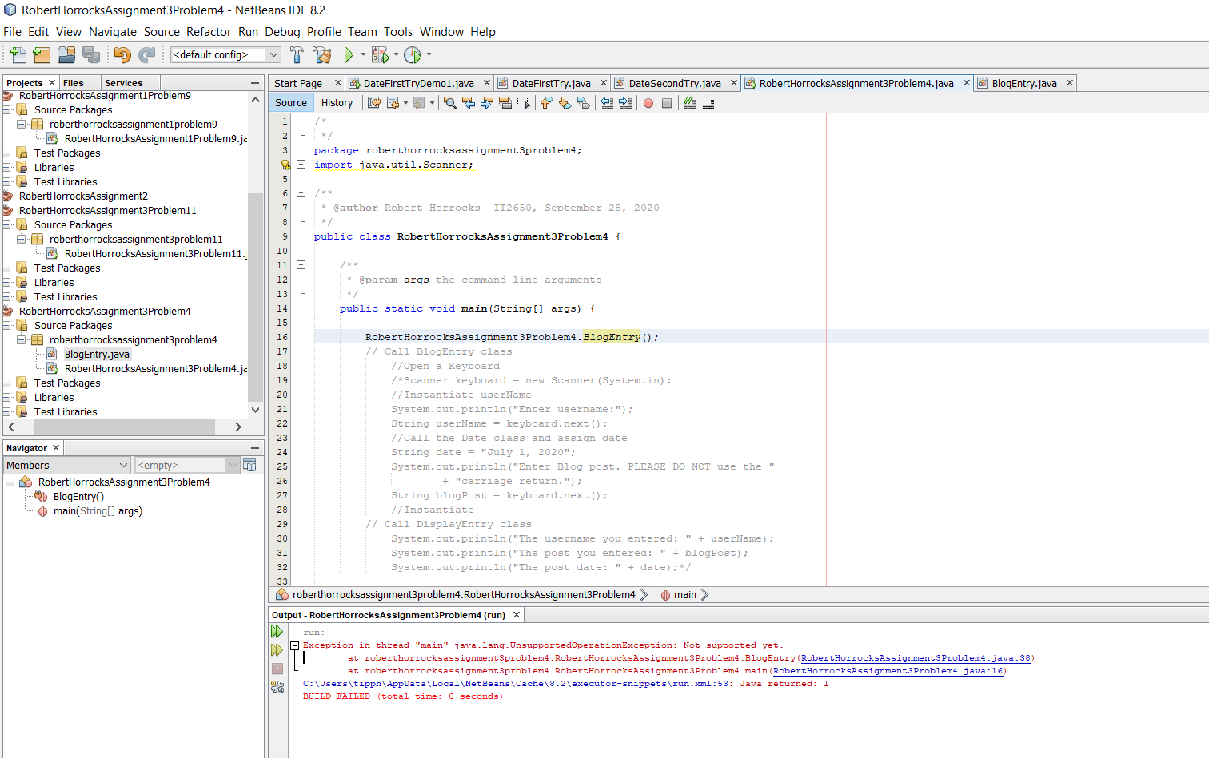

I went into the Pet project to learn more about the types of classes and further my understanding of the material.

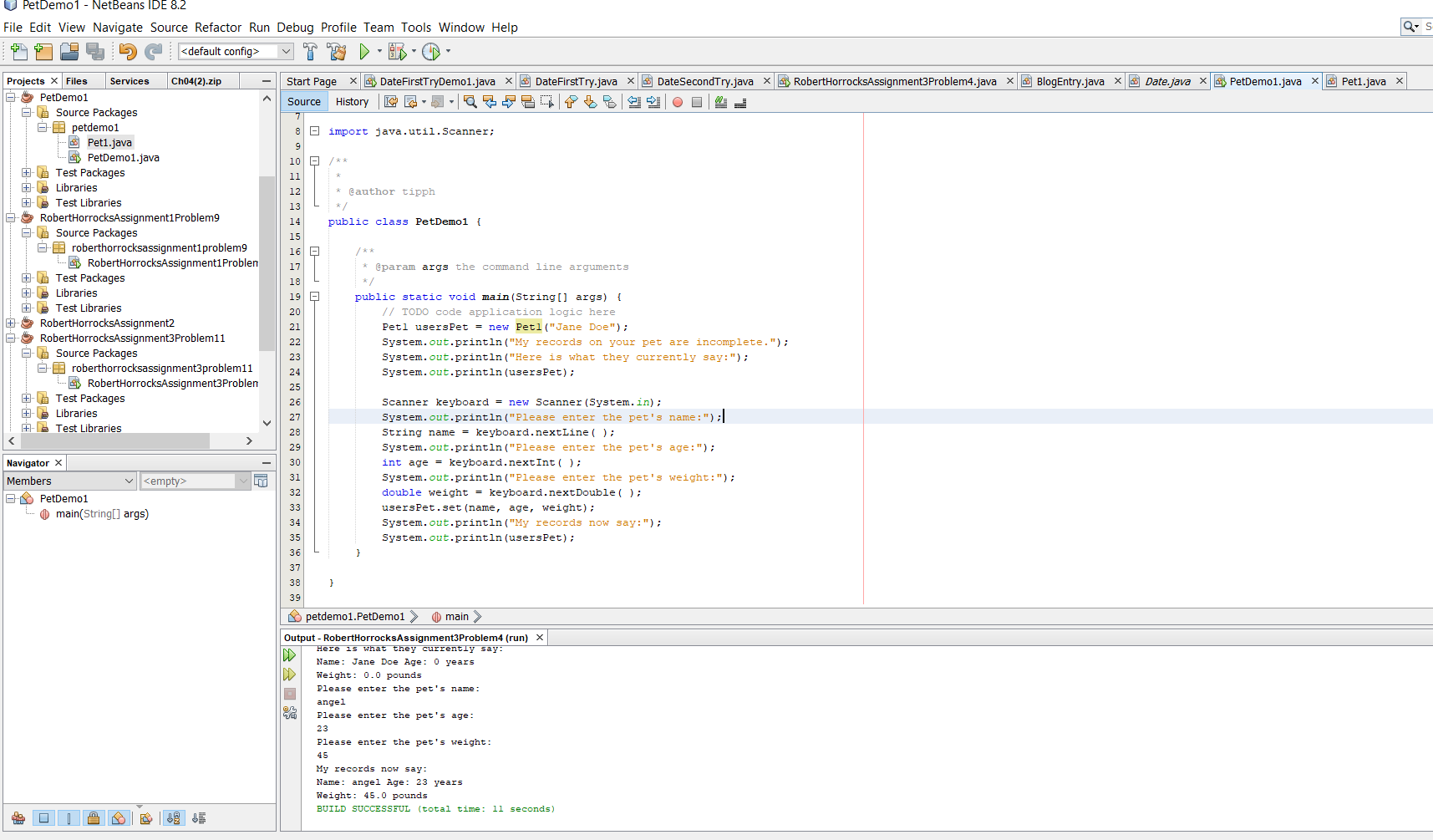

I went back and refactored my code to correct the classes. It is functioning now:

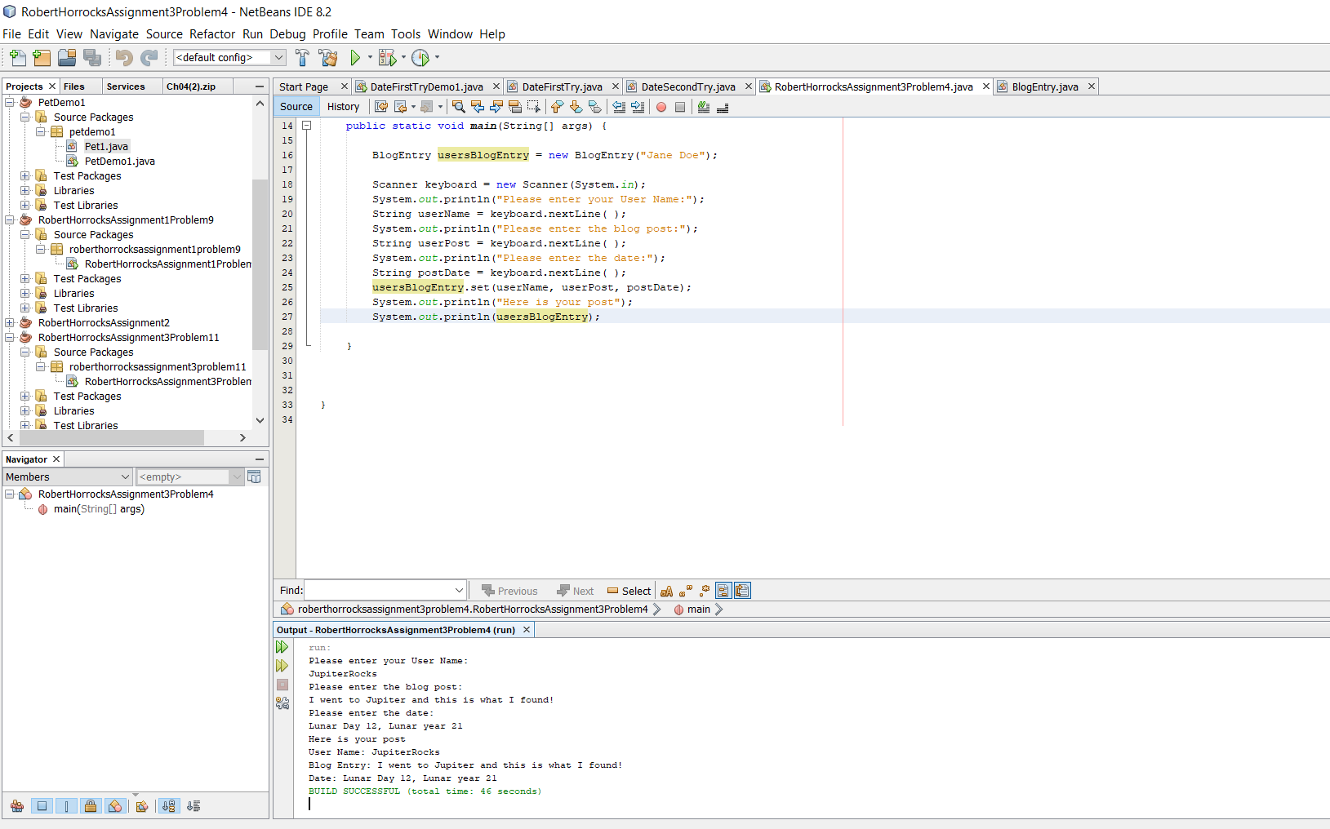

At this point I am moving to the DisplayEntry method. I started by coding in main.

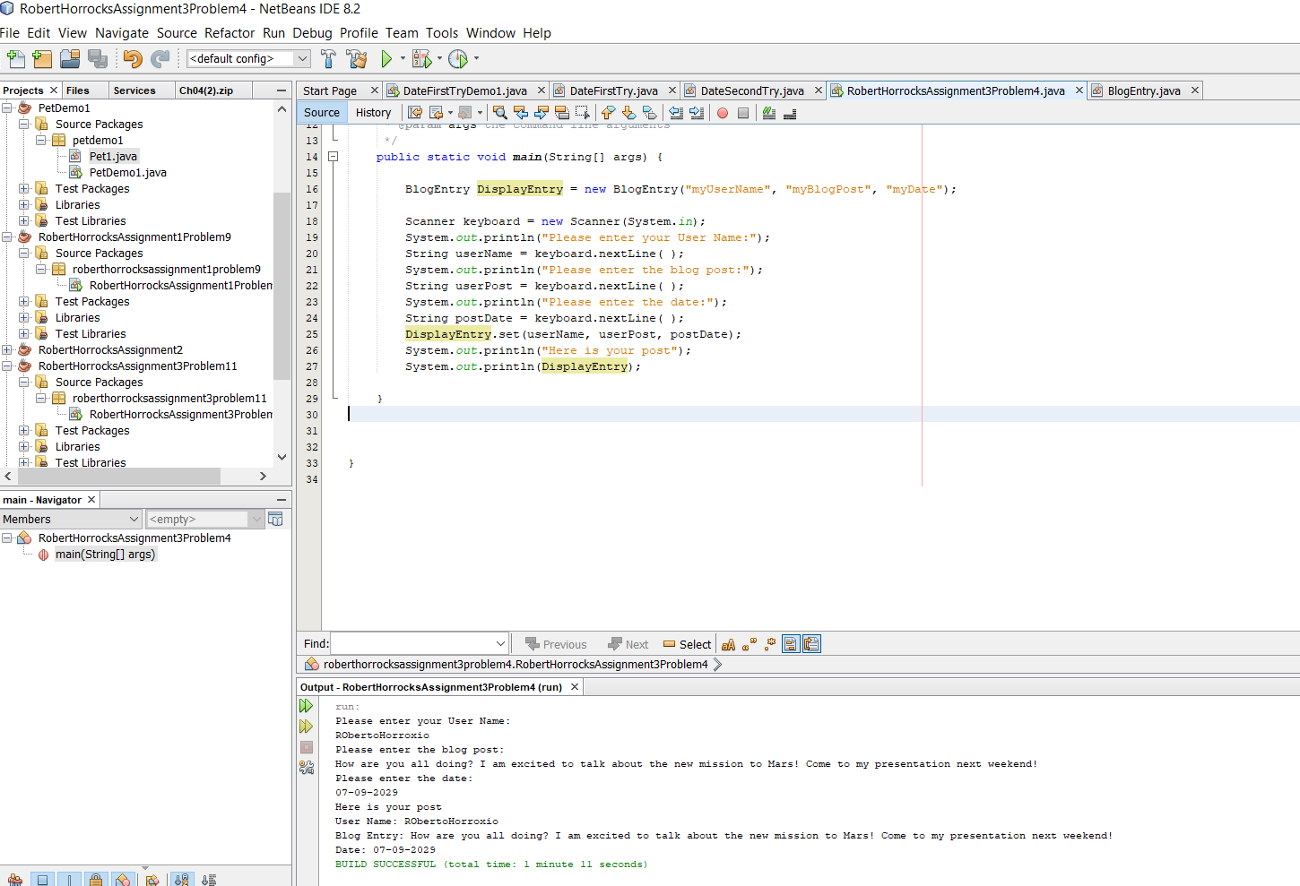

I added the functionality for the 10 words summary. At this point it is getting close to the due time, and I am not sure your attitude toward late submissions, so I am going to wrap this up and then follow up with putting the StringTokenizer in its own function.

