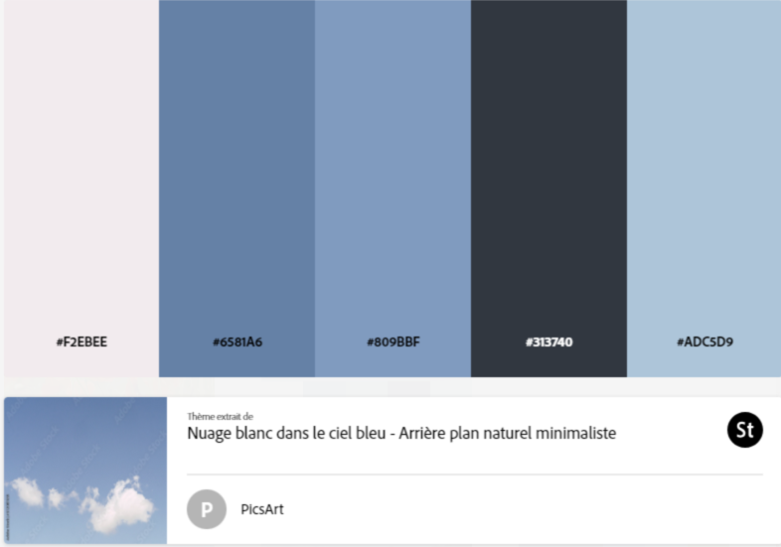

<https://thenounproject.com/browse/collection-icon/management-185809/?p=1>

font ou icône noun project, mots clé : [business](https://thenounproject.com/browse/icons/term/business/)-[mangement](https://thenounproject.com/browse/icons/term/mangement/)-[planning](https://thenounproject.com/browse/icons/term/planning/)-[improvement](https://thenounproject.com/browse/icons/term/improvement/" \o "See other tag results for \"improvement\" tag)-[strategy](https://thenounproject.com/browse/icons/term/strategy/" \o "See other tag results for \"strategy\" tag)



Font awesome : https://fontawesome.com/search?o=r&m=free