
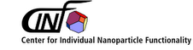

µ-reactors for Heterogeneous Catalysis

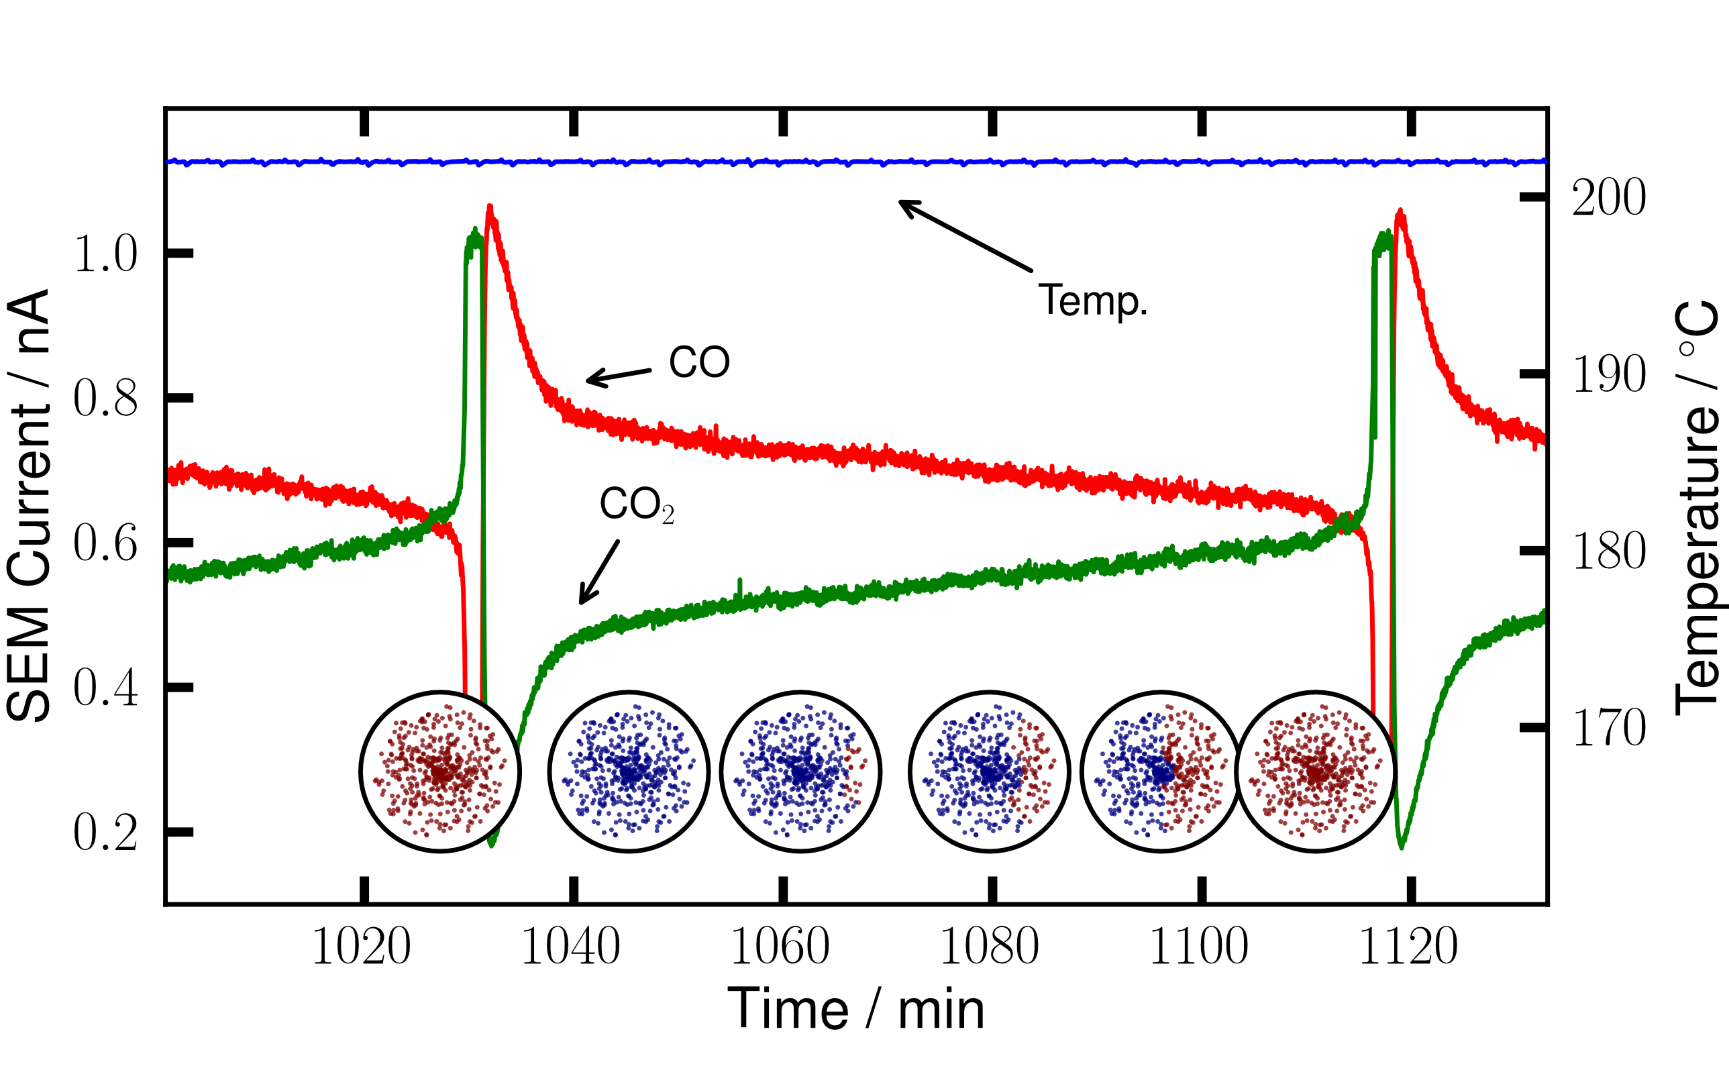

Center For Individual Nanoparticle Functionality
Department of Physics
Technical University of Denmark
Robert Jensen
May 2012

