Better Finance
Systematic Combined Funds, News Sentiment and Investor App

FINS5545 Project B
Student ID: z5465752
Part B Report

1. Funds and Backtest Design
Better Finance is open for people who are lacking professional invest knowledge and time. At the same time, they still want to make enough money in the market. In the project A, we cleaned the data of stocks, cryptocurrencies and news. Now, we transform these into a systematic website which can help people read news and create their own portfolios.
Based on the result of part A, stock returns are measured by stock trading days. Return of cryptocurrencies are calculated by its own trading days. Then, convert into stock trading days. This kind of calculation is benefited to the backtest. In this case, the backtest can use the calculated return directly, avoiding to extract the raw data.
In Better Finance, the backtest use the 252 as the trading days per year. Therefore, we begin from the fourth January, 2021 and end at twenty ninth December, 2023. In addition, in the python code, we use every past_only_check to show that every news we try to use is after the exact day. Then, we can conclude that we are not trying to use the news which we can not know at that time.
To make sure that our funds can benefit consumers, we set a constrain that the weighting of any single asset is capped at 20% and the total proportion of cryptocurrencies can not exceed 25%. This is because cryptocurrencies always have the largest risk. Since there are 50 stocks and 10 cryptocurrencies, we can have different portfolios. Take an example, in the relevant rebalancing, the proportion of cryptocurrencies in Minimum Variance is only 2.09%, but in the Risk Parity fund, this number is 9.06%.
Then, we set risk free rate as 0 because I am conservative. I am trying to assume the extreme condition. For the annualized return, we use the compounded method. The maximum drawdown is the peak minus the lowest point. In addition, in our models, transaction costs are set to zero.
Since different people have different risk tolerance, we create four different funds. Three of them are combined stocks and cryptocurrencies, and the left one is connected with the news’ sentiment. First of all, Equal Weight fund is the primary one. This fund is the most simple one. Every equities and cryptocurrencies have the same weight. People do not need to consider how to balance the fund. Second, Minimum Variance is the fund which chasing fixed income. In this fund, our portfolio’s profit is close to the risk free rate. Although this profit is low, the condition of losing a large number of money is seldom. Third, Risk Parity is another kind of fund. In this case, we do not separate same money into different equities. We are trying to make any equities have the same risk, then decrease the dominance of the most volatile assets in the overall portfolio. At last, Minimum Variance fund plus the news’ sentiment is based on the second fund, rebalancing the portfolio based on the news’ sentiment. If the news show positive attitude, our portfolio will increase this equity’s proportion. In other words, we will decrease the proportion if news show a negative attitude. Take an example, the proportion of cryptocurrencies in Equal Weight fund is high, the proportion of cryptocurrencies in Minimum Variance fund is low and in the Risk Parity fund, it is medium. In general, our funds are covering most people in the market, whether you are looking for high returns or low risk.
Based on the Markowitz’s research, investment portfolio should balance risk and expected return. In addition, we can not just consider the single variance, correlation should also be considered(Markowitz, 1952). The Minimum Variance fund is same as this thought. Also, based on Maillard’s article, if we want to diversify risks of portfolio, it is not enough to just divide capital equally, a more reasonable approach is to distribute risk contributions equally(Maillard, et al., 2010). This is the theoretical basis of the Risk Parity fund.

2. Out-of-Sample Results and Fund Fact Sheets
The table one below show that there is not exist one fund that dominate all metrics. We need to pick appropriate one based on people’s risk tolerance and expected return. For example, the Risk Parity has the best performance after adjust the risk. Its annualized return is 14.01%, annualized volatility is 16.01% and the Sharpe Ratio is 0.899. The Equal Weight fund has the highest annualized return which is 14.98%. However, this fund also has the highest volatility, reaching 21.25%. Also, it has a maximum drawdown of -28.75%. The Minimum Variance fund reduces the annualized volatility to 12.69% and controls the maximum drawdown to -14.87%, but the annualized return is only 5.78%. Finally, the performance of the Minimum Variance fund plus the news’ sentiment is close to the Minimum Variance fund, with an annualized return of 5.72%, volatility of 12.69% and a Sharpe Ratio of 0.502.
Table 1. Out-of-sample performance across Better Finance funds
Fund | Ann. return | Ann. vol. | Sharpe | Max drawdown
Equal Weight | 14.98% | 21.25% | 0.763 | -28.75%
Minimum Variance | 5.78% | 12.69% | 0.506 | -14.87%
Combined Risk Parity | 14.01% | 16.01% | 0.899 | -19.71%
Minimum Variance + Sentiment | 5.72% | 12.69% | 0.502 | -14.92%
Source: results/tables/performance_metrics.csv. Risk-free rate = 0; transaction costs = 0 bps.
The graph of the growth of one dollar show this trends directly. Based on the calculation, one dollar invested in the Equal Weight fund can get 1.52 dollar, one dollar invested in the Risk Parity fund can get 1.48 dollar and one dollar invested in the two Minimum Variance fund can get 1.18 dollar. In addition, we can see that the Equal Weight fund grows 44.02% in 2021, decreases 15.58% and grows up 24.82% in 2023. The Risk Parity fund actually show the same trend. It grows 37.71% in 2021, decreases 6.93% and grows up 15.43% in 2023. However, the two Minimum Variance funds are different, both of them are grow up in three years, despite the number is small. In 2021, they grow up 12.56%, in 2022, the number is 3.7% and the last year is 1.34%.
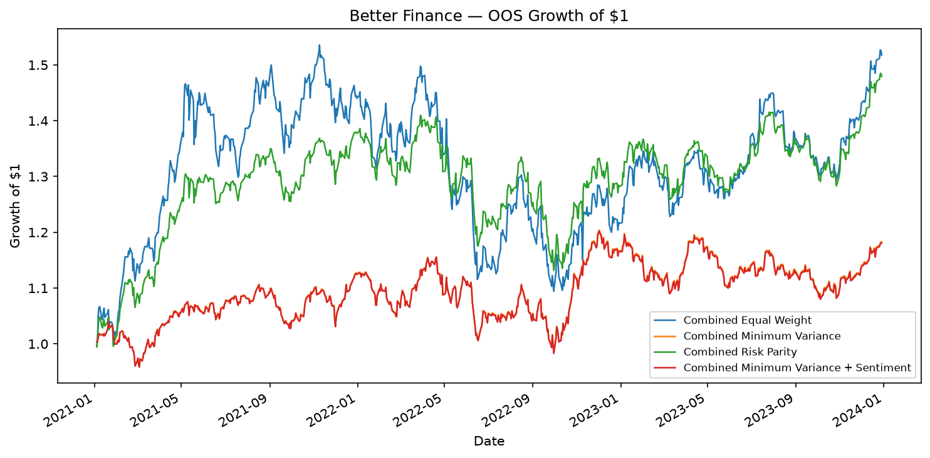
Figure 1. Out-of-sample growth of $1 across the four Better Finance funds, 4 January 2021–29 December 2023.
Source: Project B generated results.
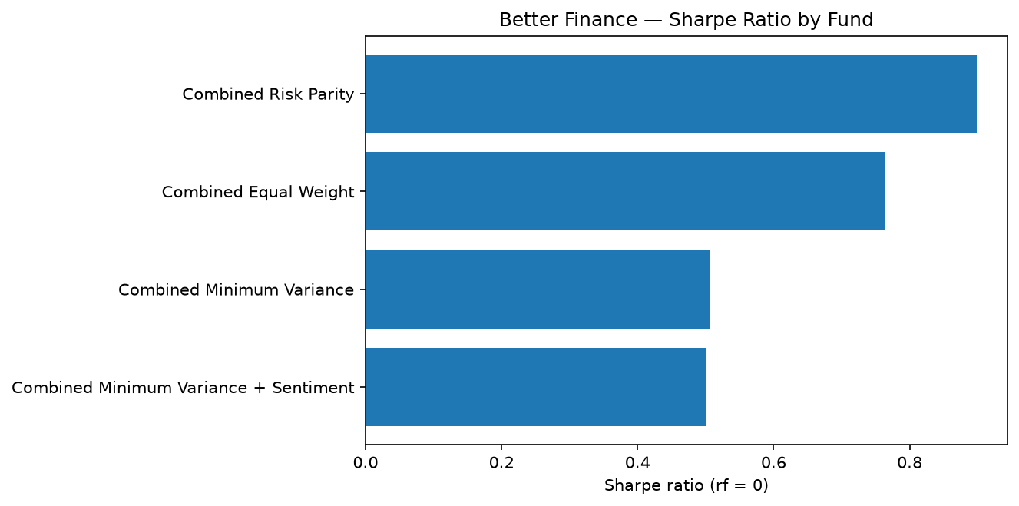
Figure 2. Out-of-sample Sharpe ratio comparison across Better Finance funds, risk-free rate = 0, 2021–2023.
Source: Project B generated results.
We can get a conclude right now that the Equal Weight fund is the most simple fund. This fund’s advantage is every asset has the same weight. It is easy for customers to understand how their portfolio worked. In the latest investment portfolio, the average single asset proportion is 1.67%, 16.67% of them is cryptocurrencies. But I have to point out that although this fund is easy to understand and get the highest historical return, this fund also grows up the effect of some asset which has higher volatility. In other words, consumers should have a high risk tolerance.
The Minimum Variance fund is different. This fund is focus on low volatility fund such as ABBV, MRK and so on. The proportion of cryptocurrencies is only 2.09%. In the latest portfolio, we have 15.97% KO, 15.23% WMT, 10.04% ABBV, 9.88% MRk and 9.24% V. First of all, I have to point out that this fund is not focused on the highest return. It is under the cap of 20% of the most single asset proportion. Therefor, despite the Minimum Variance fund also decrease a lot in 2022, the performance of this fund is better than others. This fund is suitable to people who are willing to have a stable income.
The Risk Parity fund provides a moderate outcome. Compared with the Minimum Variance fund, the Risk Parity fund is more diversified. The largest single asset weight is around 3% to 4%. The proportion of cryptocurrencies is about 9.06%. Based on the Figure 2, the Risk Parity has the highest Sharpe ratio. Meanwhile, this fund has 14.01% annualized return with the lower volatility. Therefore, the Risk Parity fund is the best fund.
The Combined Minimum Variance fund plus sentiment is not to create a totally different fund. It’s an experimental version. In this fund, we will use the lagged news’ sentiment to rebalance the fund. Therefore, this fund is similar to the original one. In this case, we can research the impact of adding a new source of information without changing their original investment goals.
Based on the result, we can see that any single matric can not judge the performance of the fund. The Equal Weight fund and the Risk Parity fund both grow up in 2021, 2023 and decrease in 2022. Although the Minimum Variance fund still make profit, the total return is lower than other funds. In addition, the Risk Parity fund’s Sharpe ratio show that it increases more in the grow up period and decrease less during the descent phase. Therefore, Better Finance will not rank the fund based on the annualized return and volatility. If we only consider annualized returns, the Equal Weight fund will rank first, despite it experiences the deepest drawdown. If we only consider volatility, the Minimum Variance fund will rank first, despite its significantly lower cumulative growth. If we display returns, volatility, Sharpe ratio and maximum drawdown at the same time. Under the assumption of risk free rate is 0, we can see that the Risk Parity fund’s 0.899 is higher than the Equal Weight fund's 0.763 and the Minimum Variance fund's 0.506.
Now, fund compositions can explain these data difference. Take an example, to keep the lowest variance, the Minimum Variance fund is focusing on the health industry. Therefore, it is important to display holdings and the performance at the same time. Different methods can create different outcomes despite we have the same 60 assets.

3. Equity Sector Sentiment Index
In the news’ sentiment part, we use VADER. We reserve the cleaned data from the project A and every news title will get a score. Then, we take an average on the score within the industry and create a panel. This panel covers ten industries and, 3 January 2020 to 29 December 2023.
For news without ticker and date, our company assume it is neutral and will not delete them directly. Because we think that this condition just show there is no new sentiment. If we delete these news, we will remove some stocks and then change the composition of the industry. In our model, the index covers both sentiment and coverage. In these days, the average coverage is 75.47% and the median is 80.00%. This means the index can reflect most industries’ information. In addition, the coverage series in the app will show that whether the index is based on a few stocks.
.In the panel, the average sentiment score of the industry is 0.085 and the standard deviation is 0.090. From the Figure 3, we can see that most news are positive and positive or negative peaks are seldom.
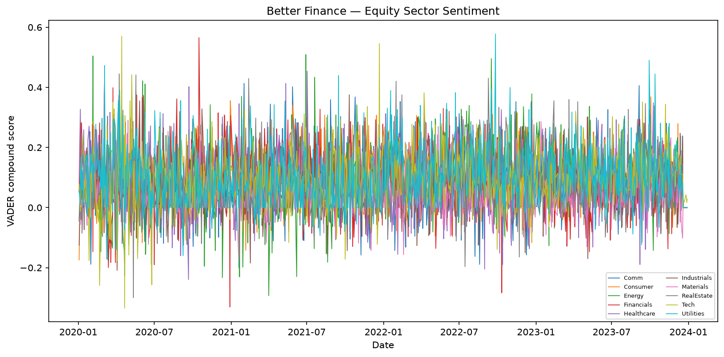
Figure 3. Daily VADER compound sentiment across the ten equity sectors, 3 January 2020–29 December 2023.
Source: Project B generated results.
Better Finance will not treat the sentiment index as a single factor to evaluate the expected return. Although VADER does not need extra training on labeled indexes to deal with a large number of news title, it still only a language affect indicators, not focused on the financial markets. Therefore, our app’s function News Mood allow users to compare industries’ sentiment, lagged trading signals and news coverage. This will help us explain the reason during the test since signals used by the investment portfolio are public.
In addition, news coverage are important when we are explaining the time series. A higher coverage rate means that we get stock information for every day. Obviously, a industry with higher coverage number, the prediction is more accurate. Take an example, on the last trading day, most industries do not have any sentiment and show neutral, only the technology industry show some positive sentiment, then VADER shows that we have a positive attitude. In this case, the news coverage is only 20%. We can not directly use this data since it is not significant.
Also, different industries have different news coverage rate. For example, the average news coverage for consumer industry is 93,9%, financial industry is 87.5% and technology industry is 86.5%. On the contrary, material industry is 53.1% and real estate is 55.6%. Therefore, if we show the news coverage at the same time, we can help consumers distinguish positive sentiment based on most stock news or just come from a small amount of news. It can increase the information content of sentiment analysis.
At last, our app do not assign different weights to different news publishers. This is because in the provided news data, most publisher information is missing. Therefore, if we add different weights, our model will become more complex and hard to explain.

4. Extensions and Innovations
To make better outcome, in this project, we also make some extensions.
First of all, we add the Risk Parity fund. We add another asset allocation logic here. It is totally different with the Equal Weight fund and the Minimum Variance fund. In the test, the Risk Parity fund has the highest Sharpe ratio which is 0.899 and the largest drawdown which is -19.71%. Also, it gets a 14.01% annualized return. Therefore, we can set the Risk Parity fund as the middle choice between high profit, high risk Equal Weight fund and low volatility, low return Minimum Variance fund.
Second, we combine the Minimum Variance fund with the sentiment score. For every stock, our model will search the newest industry lagged sentiment. Then, the new stock weight is the old one multiple by 1.15 industry sentiment score. In other words, industries with positive news will get more weight and industries with negative news will lose some weight. Also, the new weight can not less than 0. in addition, the weight of cryptocurrencies is not changed since cryptocurrencies do not have news sentiment. To avoid adjust the investment portfolio frequently and significantly, we only set the multiplier as 0.15.
However, based on the result of Table 2 and Figure 4, our new model does not improve the performance of the investment portfolio. The annualized return decreases from 5.782% to 5.719%, the Sharpe ratio decreases from 0.5064 to 0.5016 and the maximum drawdown decreases from -14.868% to -14.917%. Based on this result, we can know that we will not get additional return if we only add the sentiment analysis.
Table 2. Minimum Variance sentiment fusion: before versus after
Metric | Base MinVar | With sentiment | Change
Annualised return | 5.782% | 5.719% | -0.063 pp
Sharpe ratio | 0.5064 | 0.5016 | -0.0048
Maximum drawdown | -14.868% | -14.917% | -0.050 pp
Source: results/tables/fusion_comparison.csv.
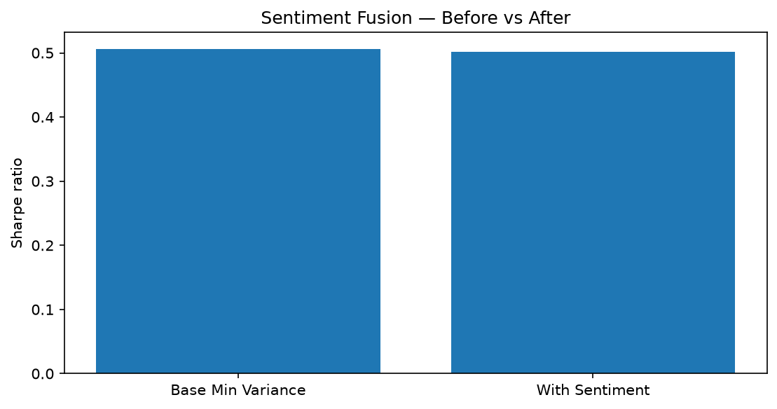
Figure 4. Minimum Variance Sharpe ratio before and after the fixed 0.15 lagged sector-sentiment tilt, OOS 2021–2023.
Source: Project B generated results.
Third, Better Finance improve Streamlit’s interface design. Better Finance uses the blue design system, not the original one. In addition, we add a simple risk guide, a fund suggestion based on consumers’ risk tolerance, a user allocation builder and a News Mood page.

5. App and Investor Journey
The Better Finance Streamlit is designed based on consumer experience.
On the first page, we introduce our app shortly. We are a platform which can help users compare investment portfolios about stocks and cryptocurrencies, view risks and track financial news sentiment.
Then, Compare Funds can help investors make decisions. In this part, we will show the investment portfolio which has highest Sharpe ratio, lowest volatility, complete return table and a simple preference selector. Users can choose their favourite portfolios.
After that, Fund Details can provide every fund’s performance. When consumer choose one investment portfolio, it will show its annualized return, annualised volatility, Sharpe ratio, maximum drawdown, growth of 1 dollar, drawdown history and the current target holdings from the most recent rebalance. Our four investment portfolios have the same layout, then consumers can compare their performances easier. Also, our app adds a relative risk label about annualised volatility across the offered funds.
My Allocation will help consumers assume their profits. Users only need to enter a dollar amount for each investment portfolio. The app will converts the amounts to allocation shares, combines them with a computed in advance return series, reports historical volatility and Sharpe ratio for the selected portfolios.
Subsequently, News Mood will show products’ unstructured data part. Users can get the newest industry sentiment score, choose one of the ten sectors, view raw and lagged sentiment over time and check news coverage. On the same page, our Streamlit will show the result of comparisons between the performance of the Minimum Variance investment portfolio before and after including the sentiment analysis.
At last, About and Data will explains the test rule and provides a stock data inspection function.
During the period of deployment, Our app will directly read the CSV files containing the results, which have been prepared in advance. In this case, when users are using streamlit, our app does not need to run VADER and backtest again. Therefore, users can switch investment portfolios and asset allocations quickly. At the same time, every number displayed in the interface can be traced back to the submitted research output. In this way, the interface for investors remains lightweight.
In addition, the order of functions is a product design choice. Better Finance first allows users to compare funds, then view detailed information about a specific fund and build a hypothetical asset allocation. Then followed by a news sentiment layer. This order aligns with the target users’ consideration. A customer usually ask themselves some questions: "Which fund seems right for me?" "What assets does it hold? What is its historical risk?" "How much should I invest in each fund?" After users complete these questions, they will further examine sentiment scores and specific technical backtesting settings.

6. Critical Reflection and Recommendations
Based on our research on samples, we find that method selections are more important than the complexity of the model. Three different investment portfolios show different risk and return characteristics. The Equal Weight fund gets the highest return but also has the highest volatility and largest drawdown. The Minimum Variance fund reduces risk but sacrifices some returns. The Risk Parity fund achieves a better balance between returns and risk and gets the highest Sharpe ratio. This illustrates that there is no single best fund for all users. Different funds can satisfy different investment needs. Therefore, we can position the Equal Weight fund as a growth oriented fund, the Minimum Variance fund as a defensive option and the Risk Parity fund as a more balanced choice.
In contrast, the performance of sentiment experiments was relatively limited. VADER successfully generated an industry sentiment index with high news coverage. Also, we ensure that the feasibility of the signal by lagging it by one trading day. However, after adding a 15% industry sentiment bias to the Minimum Variance fund, the annualized return and Sharpe ratio decrease a little, and the maximum drawdown also worse than the original one. This indicates that the current simple daily average industry sentiment signal does not provide significant additional value to the portfolio. But I do not think the news sentiment is useless. Our experiment only use one simple sentiment method and a fixed multiplier 0.15. We can conclude that the current rules have not improved performance, rather than proving that sentiment can not be a prediction factor. Therefore, News Mood is also a good supplementary information that can help users understand recent industry news.
In my opinion, Better Finance can take three main directions. First of all, the Risk Parity fund can be used as the default fund for comparison by users. It has the highest Sharpe ratio in the current sample, reaching 0.899, and also have a higher annualized return. For users willing to accept higher volatility and chase higher returns, the Equal Weight fund is the better option. For users who pay attention on risk and drawdown control can choose the Minimum Variance fund. Our app is not just simply tell all users which fund is the best.
Second, sentiment features should continue to serve as a decision making helper. Our app can continue to display industry sentiment and news coverage. The failure of sentiment may be due to the news sentiment has already been priced in. Then, we rebalance holdings by lagged news sentiments will undoubtedly decrease some returns. We can adjust funds’ holdings on that day's news sentiment.
Third, we need to make the backtest more realistic and practical. Currently, the trading cost is assumed to be zero, which means we can buy and sell without any costs. However, this is not realistic in real world markets. For our next version app, we should include a clear transaction cost assumption.
In general, our app is sufficient for its current purpose. So, the next stage’s development should not focus on adding more complex optimization models, but rather on transaction costs, independent validation and user choice. Adding specific risk preference questionnaires, calculating turnover rates, testing more reliable sentiment signals, and adding some independent equity and cryptocurrency funds. These behaviours can better improve the experience than just add more models.
Finally, the value of Better Finance is not to find the best model forever, is to help users with different risk tolerance can understand the difference between different investment methods and make the most suitable decisions.

Appendix A: Remaining Required Exhibits
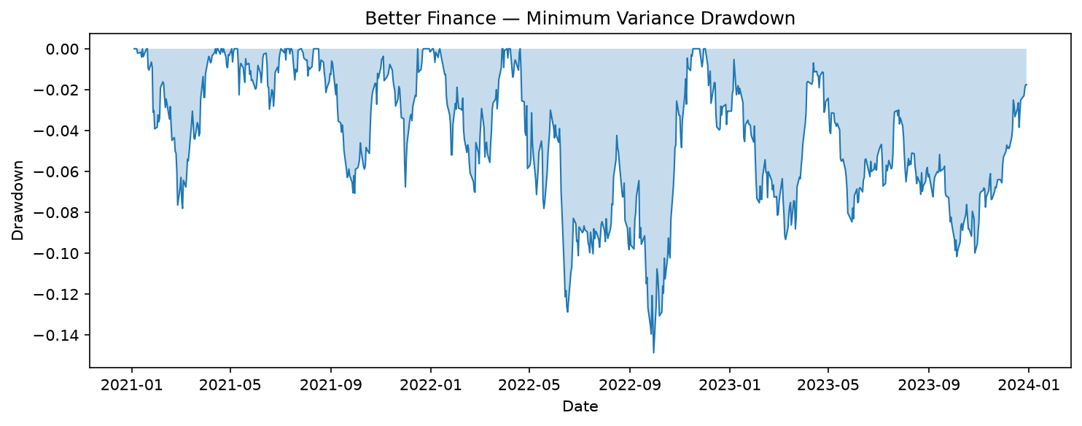
Figure 1. Drawdown path for Combined Minimum Variance, OOS 4 January 2021–29 December 2023.
Source: Project B generated results.
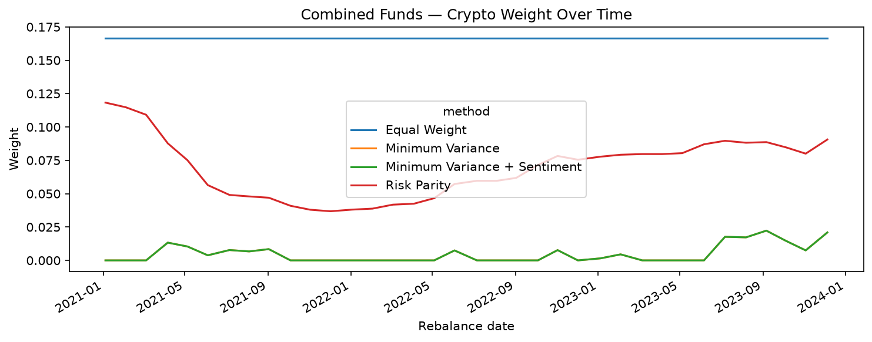
Figure 2. Crypto-sleeve target weight over time across the four Combined fund methods, rebalance dates 2021–2023.
Source: Project B generated results.

Table 3. Funds design and look-ahead audit summary
Fund | Window | Step | First live | Rebalances | Past-only
Equal Weight | 252 obs. | 21 days | 2021-01-04 | 36 | True
Minimum Variance | 252 obs. | 21 days | 2021-01-04 | 36 | True
Risk Parity | 252 obs. | 21 days | 2021-01-04 | 36 | True
Table 4. Latest target holdings summary (5 December 2023)
Fund | Top five positions | Crypto sleeve | Interpretation
Equal Weight | ABBV 1.7%; ABT 1.7%; ADBE 1.7%; AEP 1.7%; AMD 1.7% | 16.67% | Uniform capital allocation
Minimum Variance | KO 16.0%; WMT 15.2%; ABBV 10.0%; MRK 9.9%; V 9.2% | 2.09% | Defensive / concentrated in lower-volatility equities
Risk Parity | ABBV 3.8%; MRK 3.8%; KO 3.3%; WMT 3.3%; TMUS 3.2% | 9.06% | More balanced risk allocation
Minimum Variance + Sentiment | KO 16.0%; WMT 15.2%; ABBV 10.0%; MRK 9.9%; V 9.2% | 2.09% | MinVar base with sector-sentiment equity tilt
Table 5. Sector sentiment index summary
Period | Sectors | Mean sentiment | Mean coverage | Median coverage
2020-01-03 to 2023-12-29 | 10 | 0.085 | 75.47% | 80.00%
Table 6.Calendar-year OOS returns
Year | Combined Equal Weight | Combined Minimum Variance | Combined Risk Parity | Combined Minimum Variance + Sentiment
2021 | 44.02% | 12.56% | 37.71% | 12.43%
2022 | -15.58% | 3.70% | -6.93% | 3.64%
2023 | 24.82% | 1.34% | 15.43% | 1.33%

Appendix B: Project Links

Live url: https://z5465752projectb-wn5zhk3wzbhgaykwsewmau.streamlit.app/
Repo link: https://github.com/robertjiao020119/z5465752_projectB

References
- Markowitz, H., 1952. Portfolio selection. The Journal of Finance, 7(1), p.77.
- Maillard, S.,, Roncalli, T., and Teïletche, J., 2010b. The properties of equally weighted risk contribution portfolios. The Journal of Portfolio Management, 36(4), pp.60–70.

