The NFL Player Picker program allows you to view a list of players and add them to your roster. You may filter the list of players by team or position.

When you first start the program, you are greeted with the main menu. Here, you will hit the button “Click here, let’s begin.” To access the player selection screen.

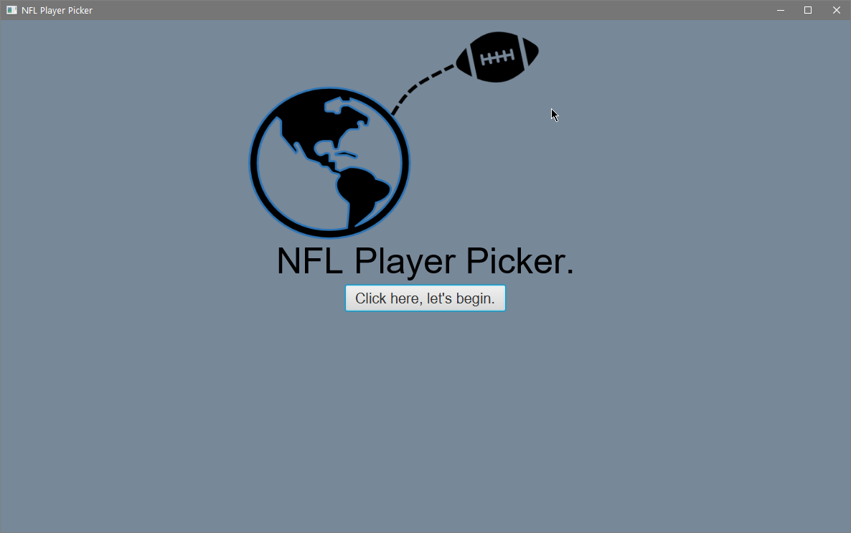

To begin

The player selection screen allows you to filter down the list of players you would like to see. You can choose a team and it will display each player that is in that team. You may also choose a position and it will display each player that is of that position.

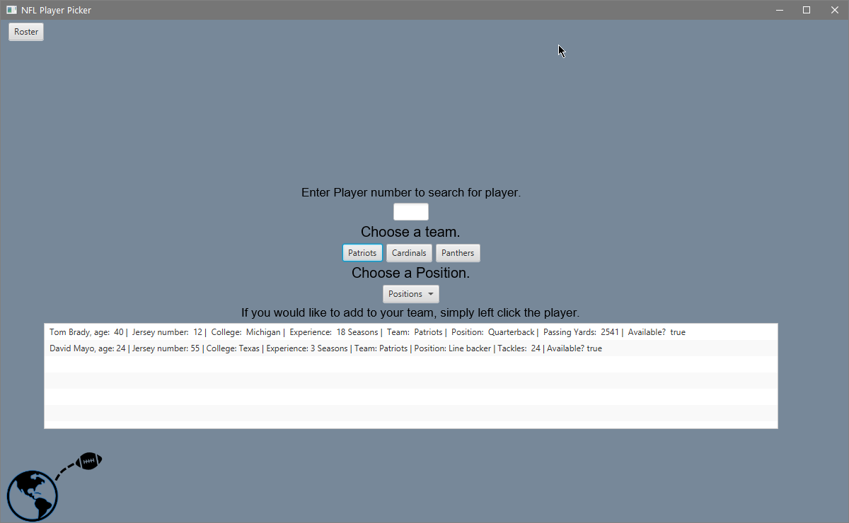

To sort.

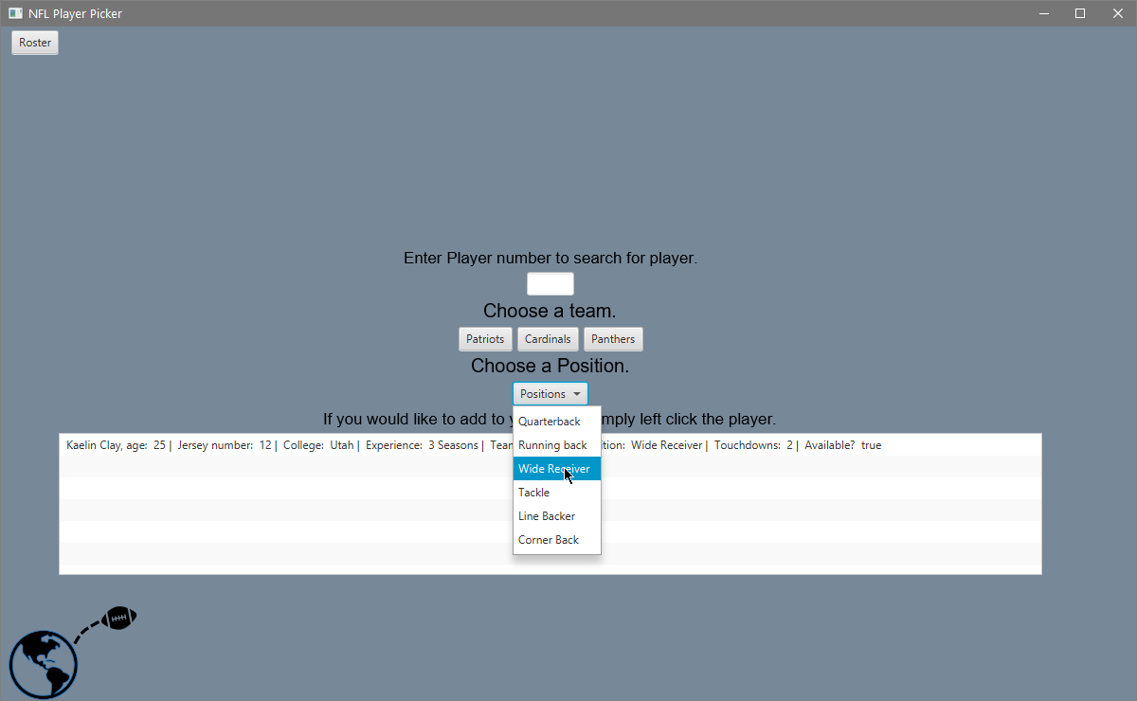

To go to Roster.

To Filter by position

Once you have a list of players generated, you may left click them to add to your roster. There is added functionality that prevents you from adding the same player twice. When you are done adding players to your roster, you may hit the “Roster” button on the top left.

The Roster screen allows you to view the players you currently have. If you decide that you would like to delete a player from your roster, simply left click the player and that player will be deleted. To return to the player selection screen, simply click the “Player” button on the top left to return to your player selection screen.

To return to play selection

