1. a) BFS:

**Expand order:** S->A->B->C->D->G

Path= S->A->G

b) UCS:

**Expand order:** S->C->B->D->F->G

Path = S->C->F ->G

c) Depth-first search

**Expand order:** S->A->D->F->G

Path= S->A->D->F->G

d) Greedy search

**Expand order:** S->C->F->G

Path= S->C->F->G

e) A* search

**Expand order:** S->C->F->G

Path= S->C->F->G

1. a) Follow path of circled tables for correct path. H=dead means the only move is a previous state

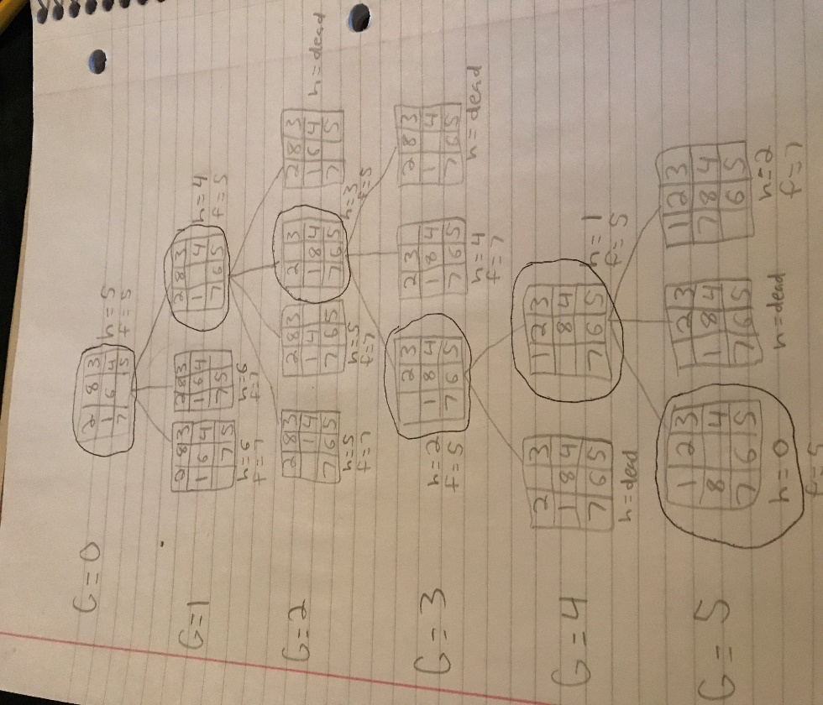

b) A heuristic function is said to be admissible if it never overestimates the cost of reaching the goal, i.e., the cost it estimates to reach the goal is not higher than the lowest possible cost from the current point in the path.

Admissible heuristics must not overestimate the number of moves to solve this problem. Here you can only move a block one at a time in one of four directions if it has no other block obstructing its path. Thus, the M.D, Manhattan Distance, is the distance in which you reach the goal destination in the least number of moves possible from its current position. Thus, the M.D heuristic never overestimates and is admissible.

c) Refer to part A

1. a) DFS: S->F->P->Q->R->T->G

b) Greedy Search: S->H->K->C->A->B->D->M->G

c) A* Search: S->H->K->C->F->P->Q->R->T->G