Student Name: **Robert Johnson**

Student Id: **010796992**

Question 1:

P(B) = (0.5 * 0.4) + (0.2 * 0.8) + (0.3 * 0.6) = **0.54**

Question 2:

X = A.I job accepted after exam

P(X) = (0.25 * 0.6) + (0.35 * 0.9) + (0.4 * 0.8) = **0.785**

Question 3:

Two results for each coin toss (heads or tails). There will be 4 coin tosses, so 2^4 = 16 different results possible. Probability is 0.5 for both heads and tails.

Assume X = success of getting heads

We are looking for P(X = 2)

Which using factorials (4! / 2!2!) = (24/4) = 6

So, 6/16 = **0.375**

Question 4-1:

a) True

b) True

c) True

d) True

e) True

Question 5:

a) False

b) False

c) True

d) True

e) True

f) False

g) True

Question 6-1:

P(A, B, C, D, E, F) = P(A) P(B) P(C | A, B) P(D | B) P(E | C, D) P(F | E)

Question 7:

a) 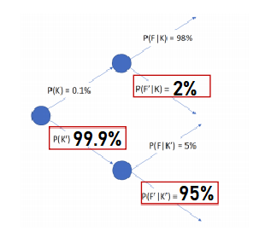

b) P(F) = P(F | K) + P (F | K’) = (.98* 0.001) + (.05*.999) = 0.05093

P(K|F) = **(**P(F | K) P(K)**)** / P(F) = (0.98 * 0.001) / 0.05093 = **0.019242097**

Question 8:

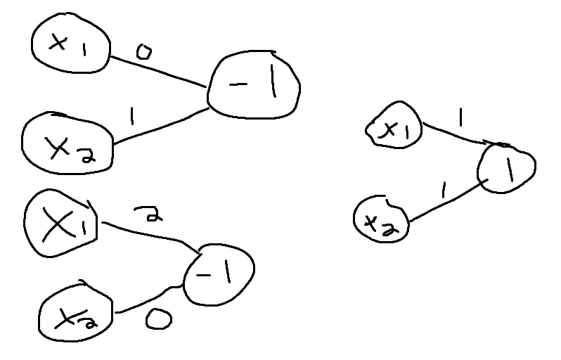

Question 9-1:

Accuracy = 100%

Question 10: