Student Name: **Robert Johnson**

Student Id: **010796992**

Question 1: True or False

1. False

2. True

3. False

4. False

5. True

6. False

7. False

8. True

9. False

10. True

11. True

12. True

13. True

14. False

15. False

Question 2: State-Space Search

1. DFS:

Expand Order: S A B C G

Path: S A B C G

1. BFS:

Expand Order: S A B C D G

Path: S B C G

1. UCS:

Expand Order: S A B D C G

Path: S A B D C G

1. Greedy Search:

Expand Order: S B C G

Path: S B C G

1. A*:

Expand Order: S A B C G

Path: S A B C G

Question 3: Game Tree

1. 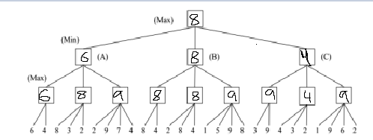

B) 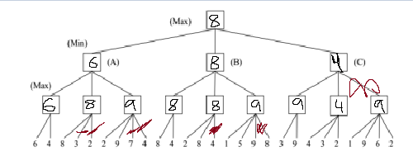

C) 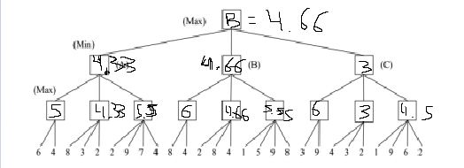

Question 4:

Variables and Domains:

C1 {3}

C2 {2,3}

C3 {1,2,3}

C4 {1,2,3}

C5 {2,3}

Constraints:

C1 cannot equal C2

C2 cannot equal C3

C3 cannot equal C4

C4 cannot equal C5

C2 cannot equal C4

C3 cannot equal C5

1. 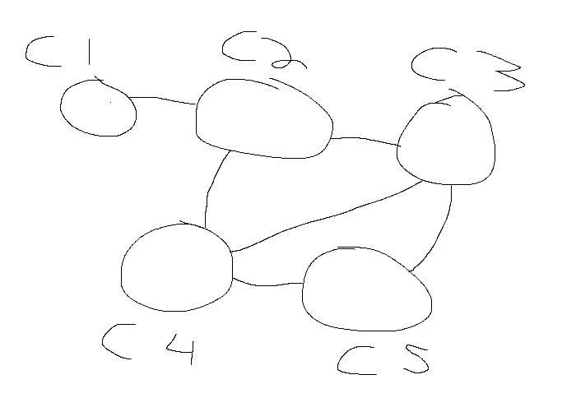
2. C1 = 3

C2 = 2

C3 = 1

C4 = 3

C5 = 2