**Programming Project 2 Report**

Student Name: Robert Johnson

Student UAID: 010796992

**Problem Statement:**

This was part 2 of what looks like may be a semester long project or close to a semester long. The goal of this program is to create a game of Tetris. More specifically, the goal of part 2 was to implement keyboard callback functionality. If you input certain keys it will spawn/create certain Tetris blocks and there are keys to translate and rotate the blocks. These goals also were introduced to help progress with our coordinate system and how to get that working efficiently.

**Design:**

For this part of the project there were a lot of design options to be considered compared to the first part which was straight forward as to what to do. For my coordinate system I decided to make the x axis go from 0-10 and y axis from 0-20. I wanted to keep all positive numbers and not get any weird confusion with negative numbers.

I did not use any fancy data structures or algorithms for this part, at least for right now I do not see a use for anything to out of the box. Very keep it simple stupid style. This helped me follow my code better and for others to read it as well, but I have a feeling going forward with this project I will have to import some trickier stuff to get things going.

**Implementation:**

For the implementation process this time around, I decided to build on the part 1 solution that was given by the professor. I noticed my implementation for part 1 was not efficient and was much more code than his solution due to him using his brain smarter and me using mine harder. As well as building on the solution I imported a lot of stuff from his keyboard callback sample programs that showed how to implement the keyboard callback and the special callback for OpenGL.

I struggled with a few different things while implementing. Mainly, I struggled with the OpenGL functions, trying to figure out what was needed, what was not, sometimes it was even just the ordering of things I added was not right.

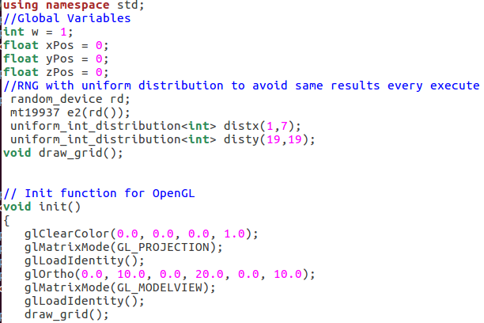

In the screenshot above I struggled figuring out what things to put in the init() function and what to put in the display() function. I must have spent at least a hour or two figuring out what order to put things for these functions, eventually I had to put draw_grid() in the init() function which I have a feeling isn’t right.

I spent at least 10-20 hours working and thinking about this part, which is a lot more than I spent on part 1. My brain was pretty burnt out from doing other class’s homework, so this took longer than expected.

**Testing:**

Once again, I used a Virtual Machine running Ubuntu to compile and test my code. I first tested and finished making all of the blocks appear based on what keys you press. One of the things that stumped me for a bit with this was that I had to comment out the glClear() function in display() to get them to appear, not sure why still. Then, I added the 10x20 grid in this picture:

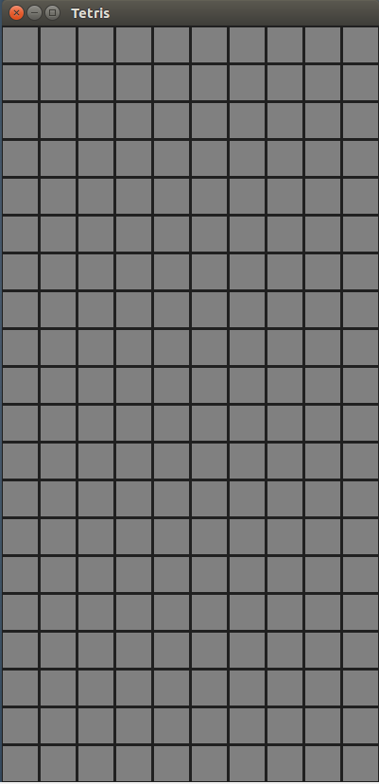

Once I got this working however, I then couldn’t get the tetris blocks to appear over the grid, eventually this led me to putting the grid function in the init() function instead of the display(). What I could not get working for this part unfortunately, was the directional key inputs which are supposed to move and rotate the current block.

For this I tried many things, including pre-multiplying matrices and just adding and subtraction from x and y Positions. Both options were used in the sample office3 and office4 code from Professor’s website but for whatever reason, I could not get either to work for the life of me. I will put screenshots showing code of both ways I tried it below:

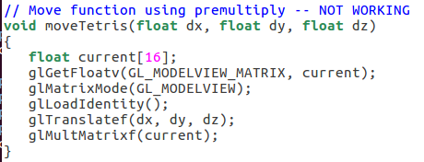

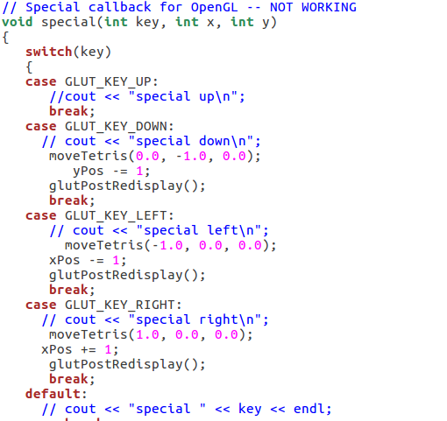

**Conclusions:**

This part, part 2 of the Tetris project, would not be considered a success in my eyes. Although I got a lot of the functionality working, being able to move the blocks is a very important piece missing I would say. I think I am just doing a few things with OpenGL wrong that will be easy fixes. Although I spent 10-20 hours working on this part over the past few days, it was not quality time/work. Next time, I need to ask the professor or a TA for help rather than trying to use the internet to figure it out, probably a little pride got in my way. Also, no excuses but I had a lot of other homework for other classes due this week and had a stressful week with doctor appointments, babysitting, etc. This led to me not having quality time with this project that I had last time. Now I know to prioritize this over some other classes because it will not be as easy as I thought. Below is a screenshot of what I got working. A grid with blocks able to spawn near the top of the screen using keyboard input.

