**Programming Project 4 Report**

Student Name: Robert Johnson

Student UAID: 010796992

**Problem Statement:**

The goal of this project was to implement a “toolbox” of graphics functions that are often used so will be easily accessible for future graphics programs. The goal is too also getting us familiar with some of the formulas involved with these functions, understanding what we are doing with them. There are three types of functions: geometric, interpolation, and shading. The inputs will be read from a text file and user will input some as well. We are to write to an output text file. No error handling was required for reading these inputs.

**Design:**

For design choices I used float arrays to keep track [x,y,z] for the normals, points, and colors. I had separate functions for all the different operations involved, all in one main program. I used the algorithms that were given to us through our lectures and slides that we have used and talked about before. I also used a struct to keep track of Point coordinates.

I do not think there are any real pros or cons for the choices I used. This project was designed to get us to use specific formulas so almost everyone should have used the same formulas/algorithms for these operations. The only big differences might be with how they inputted or outputted to their files.

**Implementation:**

For implementation, this time around, there was no good base sample code to start with. Also, this project was designed to have us start from scratch and create our own functions. No OpenGL was required, we were given a program that will display our outputs for us. I did take a little bit of code from the show_poly.cpp program that was given to us just to see how Professor Gauch was reading from a file and what data structures he was using.

I did struggle with implementing the required functions to read and write to a file. Mainly the reading portion, how to parse the information correctly specifically. I would say this timeline was over a couple of days of working on it and reaching out for help.

Below is something I drew on paint to help me visualize the 16 points involved for what we were implementing.

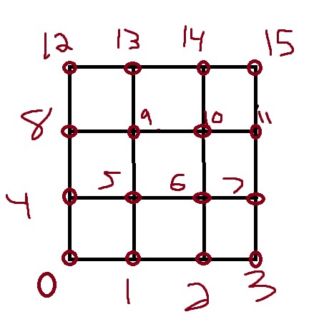

**Testing:**

Once again, I used a Virtual Machine running Ubuntu to compile and test my code. I did not have a hard time the geometric operations, as those formulas seemed a little easier and we had used them before, maybe talked about them a little more than the other sections. I had to remind myself a little about how to use file stream and read from file, parse, and store the data correctly. I had a few bumps in the road with that, had to do a little bit of debugging for a while. Getting inputs from the user was easy, I have a lot of experience with C++ and reading inputs from users.

The hardest part for me was understanding the interpolation and shading functions. This was mainly because I am still trying to wrap my head around all the formulas and algorithms for this. Due to this and being busy with a lot of midterm studying and other assignments I do not have the shading implemented correctly. Below is when I tested to make sure I was reading and writing to files correctly, had to do a little debugging through the terminal at one point because I was not reading from file correctly.

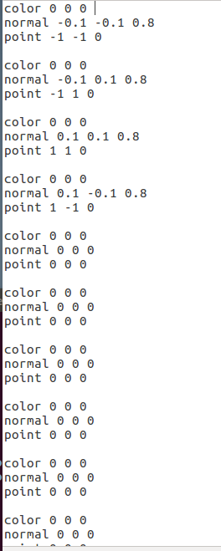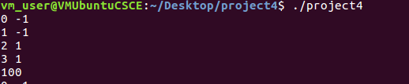

I eventually got the interpolation working correctly so that it evenly cuts one rectangle into 9 different rectangles. However, I was not able to get the shading or normal implemented correctly. I used my linear Interpolation function and some hard coding to get the correct 16-point values in. I know this probably is not what was intended with this project, but it at least got the interpolation showing correctly as shown below:

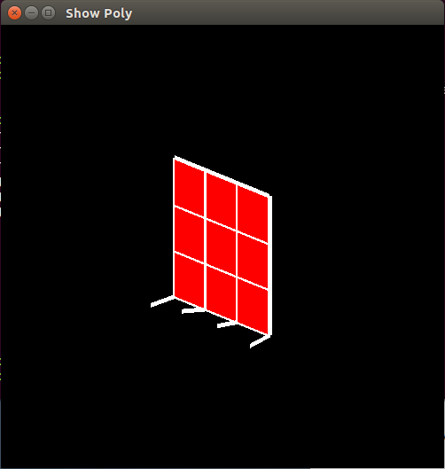

**Conclusions:**

Overall, this project was not the hardest in terms of writing the functions seeing as though we have all the formulas in our slides/lectures and are searchable online. But it was the most time consuming and trying to figure out how actually use everything and get it pieced together. I feel like almost all my function operations are written/work correctly except for some of the shading operations. I did not correctly implement interpolating the normal or get the shading working. I would say I would just have to get started earlier next time so I could reach out to office hours more and just think over the problems longer. Very unfortunate this was the most time-consuming project right during midterm time which usually seems like the busiest part of a semester, but it is what it is. I do think it helped me understand the formulas we have been reading about better, using them and piecing them out. I did not “complete” it, but it took me a few days of very long working hours to figure out what I could. I think if I started just a few days earlier it would have gone a lot smoother and less stressful.