COMP 2210 – Exam 3 Study Guide Robert Sanek

**RECURSION**

**Recursive Definitions consist of:**

if (base case) return solution;

else return recursive\_call;

1. Base Case – simple statement/definition not involving recursion
2. Recursive Case – set of rules that reduce all other cases toward base case

* When a method is called, an *activation record* (stack frame) for that method is **pushed** onto the *runtime stack* (call stack). When a method returns, its activation is **popped** from the call stack.
* One of the benefits of recursion is that it **focuses our thinking very clearly on specific cases of the problem**. Our thinking, and the resulting code structure, is based directly on the recursive structure of the object we’re dealing with.
* **Recursive code is generally less efficient than an equivalent iterative version.**
* Generally: If code is “naturally recursive,” code recursively. If this becomes a bottleneck, implement iterative version.

**Tail Recursion** – a special case of recursion where the last operation of the method is the recursive call.

public int factTR(int n, int fact) {

if (n==0) return fact;

else return factTR(n-1, n\*fact); }

public int factorial (int n) { factTR(n, 1); }

public int factorial (int n) {

if (n==0) return 1;

else return n\* factorial(n-1); }

* To write a method in tail recursive form, add parameters as necessary so that the computation is performed on the “up” calls via the parameters instead of performing it on the returns.
* Compilers can eliminate tail recursion automatically, and this is a common optimization (ex. GCC in C programs).
* **Writing a method in tail recursive form can speed things up independently of what the compiler does/doesn’t do** (ex. Fibonacci, improvement from O(2N) to O(N))

public int fib(int n) {

if (n==0) return 0;

else return fibTR(n, 1, 1, 0); }

public int fibTR(int n, int k, int fibk, int fibk1) {

if (n==k) return fibk;

else return fibTR(n, k+1, (fibk + fibk1), fibk); }

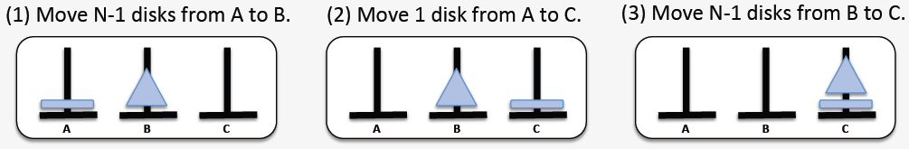**Tower of Hanoi**

public void moveTower(int numDisks, String startPeg, String endPeg, String tempPeg) {

if (numDisks == 1)

moveOneDisk(startPeg, endPeg);

else {

moveTower(numDisks-1, startPeg, tempPeg, endPeg);

moveOneDisk(startPeg, endPeg);

moveTower(numDisks-1, tempPeg, endPeg, startPeg);

}

}

**TREES**

**Tree** – a collection in which elements are arranged in a hierarchy.

* **Lists vs. Trees**:
  + A list is a **one-dimensional** structure: it defines *linear* relationships between elements (predecessor, successor)
  + A tree is a **two-dimensional** structure: it defines *hierarchical* relationships between elements (parent, child).
* Composed of nodes and branches (edges).
* Can be implemented with arrays or nodes and pointers
* **Node Types**: **parent** (1+ children) **leaf** (no children), **child** (1 parent), **root** (no parent).
* **Order** – an integer ≥ 2 that represents the upper limit on the number of children that any node can have.
  + Ex. **binary** (≤2 children), **ternary** (≤3 children), **general** (no specified order/number of children)
* **Path** – sequence of nodes from one node to another, parent to child. **Path length** = number of nodes (or edges) on the path.
  + Node X is an **ancestor/descendant** of node Y iff there is a path from X/Y to Y/X, respectively.
* **Subtrees** – trees within larger trees. There are as many subtrees as there are nodes in the tree (tree itself is a subtree).
* **Height** – measures distance of given node from the “bottom” of the tree. It is the length of the longest path from a given node to a descendent leaf.
  + O(log n) for full/complete/balanced trees
* **Depth** – measures distance of given node from the “top” of the tree. It is the length of the path from the root of the tree to a given node (same concept as “level”).
  + 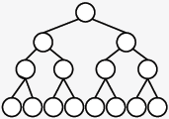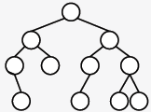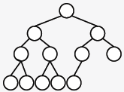Depth of lowest leaf = height of tree
* Tree terminology
  + **Full** – all leaves have same depth, every parent node has maximum number of children.
    - Height: floor(log2(n)) + 1
  + **Complete** – tree is full to the next-to-last level; all leaves on lowest level are “left-justified.”
    - Shortest possible tree (minimum height) that can store N nodes.
  + **Balanced** – each node’s subtrees have similar heights.
    - Near-optimal height for storing N nodes. Height: O(log N)

**BINARY TREES**

**Binary tree** – a tree of order 2

* Implementation Strategies
  + **Node-and-link based** (matches conceptual picture of a tree)
    - store the element and pointers to right and left trees
  + **Array-based** (can use too much space)
    - store root at index 0; nodes stored at index i:
      * **left** child: 2i + 1 | **right** child: 2i + 2 | **parent**: (i-1)/2
* Common algorithms can be implemented recursively – calculating height, calculating number of nodes, searching for a value, traversing. Generally, these are implemented by doing something at the current node, then handling the left/right subtrees recursively.
* Transversal Types
  + 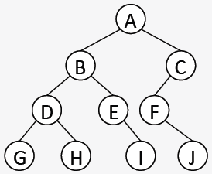Depth-first:
    - **Preorder**: NLR (A B D G H E I C F J)
    - **Postorder**: LRN (G H D I E B J F C A)
    - **Inorder**: LNR (G D H B E I A F J C)
  + Breadth-first:
    - **Level order:** (A B C D E F G H I J)
      * Visits nodes level by level: can be implemented with a FIFO queue

**BINARY SEARCH TREES**

**Binary search tree** – a tree in which the search property holds on *every* node

* **Search property** – every left child of a node must be less than the parent; every right child must be greater than the parent.
* A binary search tree imposes a **total order** on all its elements. Inorder transversals will necessarily list elements smallest to largest.
* **Searching for values** – the number of comparisons to find a given value is equal to the depth of the node that contains it.
  + Worst-case: searching for a lowest-leaf value. Entire height of tree is traversed.
    - tall and narrow trees: O(N); short and wide trees: O(log N)
* **Inserting values**
  + A new node will always be a new leaf. Use search algorithm to locate insertion point.
  + Worst-case is O(height) (@ lowest leaf) | Tree stays relatively flat when values are added in random order.
* **Deleting values**
  + Use search algorithm to locate value to be deleted. Worst-case is O(height) (@ lowest leaf)
  + Three cases for deletion. If node to be deleted is a:
    - **Case 0** Leaf node: set the parent’s pointer to this node to null.
    - **Case 1** Node with one non-empty subtree: set the parent’s pointer to this node to this node’s child.
    - **Case 2** Node with two non-empty subtrees: find a replacement node, delete the node containing selected replacement.
      * Replacement value can be inorder predecessor or successor
  + Values deleted in random order cause the tree to be less well-structured.

**AVL TREES**

**AVL Tree** – a binary search tree in which the heights of the left and right subtrees of *every* node differ by at most 1

* **Balance Factors**
  + Every node in an AVL tree has a balance factor.
  + ***bfN = hR - hL***
  + Balance factor will be positive if right subtree is greater in height; negative if left subtree is greater in height.
  + A bf of ±2 means that the subtree rooted at that node is out of balance.
    - Balance can be restored with rotations. All rotations occur in the context of a **3-node neighborhood**.
* 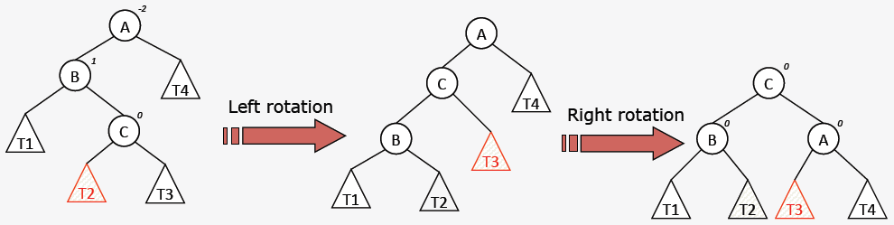Rebalancing Operations
* 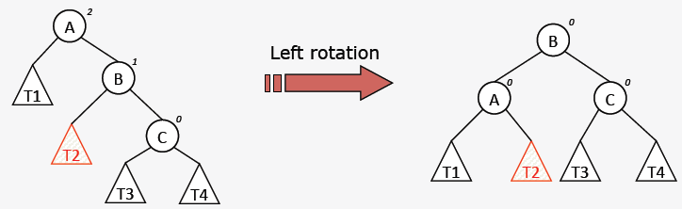Coding Rotations

B = rotateLeft(A);

public BTN rotateLeft(BTN n) {

BTN m = n.right;

n.right = m.left;

m.left = n;

return m; }

* **Inserting** new elements – use the standard BST insertion algorithm to insert new nodes. Starting with this node, walk the reverse path back towards the root, recalculating balance factors.
  + Stop at the first (lowest) node that has a bf of ±2. This node roots the 3-node neighborhood that will be rotated.
  + **At most one rebalancing operation is required per insertion**.
* **Deleting** elements – use standard BST deletion algorithm to delete the element. Starting at the *point of deletion*, walk the reverse path back towards the root, recalculating balance factors.
  + Stop at the first (lowest) node that has a bf of ±2. This node roots the 3-node neighborhood that will be rotated.
  + **Multiple rebalancing operations may be required per deletion**, so the reverse walk must go to the root each time.
* 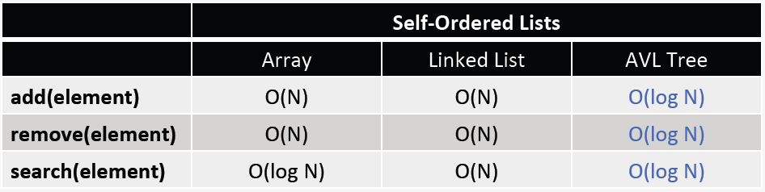AVL Trees offer guaranteed **O(log N)** performance on all 3 major collection operations: **add, remove, & search**.

**RED-BLACK TREES**

|  |  |  |  |  |
| --- | --- | --- | --- | --- |
|  | **Max Height** | **Insertion** | **If unbalanced** | **Repair** |
| **AVL** | ~1.44log2N | Insert according to value, then check balance with reverse walk   * bf = ±2? | Identify a 3-node neighborhood | Rotations   * ≤1 repair per insertion * Many repairs possible for deletion |
| **R-B** | 2log2(N+1) | Insert according to value, then check balance with a reverse walk.   * red-red? | Identify a 4-node neighborhood | Rotations + Re-colorings   * Many repairs possible for both insertion and deletion. |

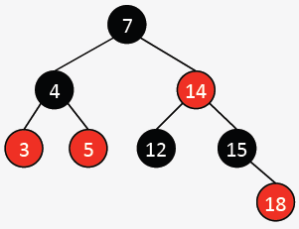**Red-black tree** – a binary search tree with the following node color rules:

1. **Each node is either red or black.**
   1. Defines legal nodes: black and red.
2. **The root and all empty trees are black.**
   1. Defines “boundaries” of red-black trees
3. **All paths from the root to an empty tree contain the same number of black nodes.**
   1. 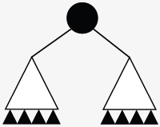First half of balance requirement. It makes a statement about the height of the tree in terms of black nodes. Often called the **black height**.
   2. Constrains black node usage. Without red nodes, red-black trees could only be **full**.
4. **A red node can’t have a red child.** 
   1. A red node is used like “filler.” It allows the red-black tree to obey rules 1-3 without being full.
   2. Constrains red node usage.

* Tensions between Rules 3 and 4 force rotations and re-colorings, keeping the tree balanced.
* **Inserting** elements
  + Use standard BST insertion algorithm to insert new node. **Color it red.**
  + Beginning with the red node just inserted, walk the reverse path back toward the root, looking for violations of Rule 4 (red-red).
  + Stop at the first (lowest) red node that has a red parent. This node’s grandparent roots the 4-node neighborhood that will be repaired.
* **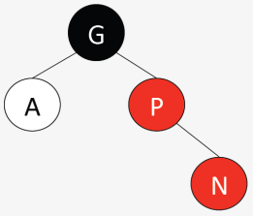The 4-node neighborhood**
  + Bottom node (**N**) is first node with a red parent (**P**). Grandparent (**G**) of N is the root of the neighborhood, and it is black. The ancle (**A**) of N is the fourth node.
  + The repair needed is determined first by A’s color and second by the structural configuration of these four nodes.
* **5 cases for repair**:

1. 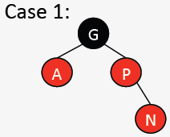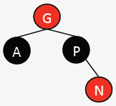A is red. Re-coloring.
   1. Color flip P, color flip A, color flip G
2. A is black.
   1. Rotate left around P, GOTO Case 3
3. 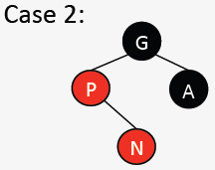A is black.
   1. 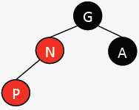Color flip P, color flip G, rotate right around G
4. 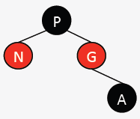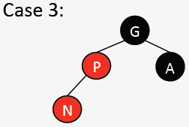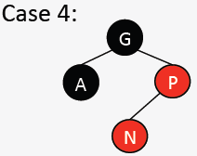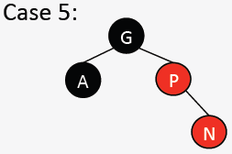A is black.
   1. Rotate right around P, GOTO Case 5
5. 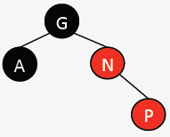A is black.
   1. 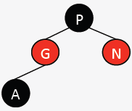Color flip P, color flip G, rotate left around G

* Red-Black trees offer guaranteed **O(log N)** performance on all three major collection operations: **add, remove, & search**.

**LEFT-LEANING RED-BLACK/WAR EAGLE TREES**

**War Eagle trees** are left-leaning red-black trees. They have the same rules as red-black trees, plus:

1. **Blue** corresponds to **black**, **orange** corresponds to **red**
2. An orange node can only be a left child.

* 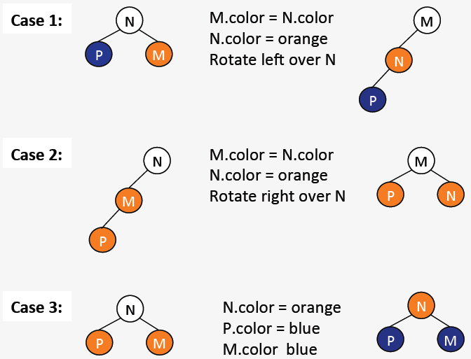This fifth rule greatly simplifies the add and remove algorithms by reducing the number of cases to three, with **3-node neighborhoods**. Cases must be checked in this order:

Change N to orange, change P & M to blue.

Swap colors of M & N, rotate right over N.

Swap colors of M & N, rotate left over N.

**MULTI-WAY SEARCH & 2-4 TREES**

**Multi-way search tree** (an **M-way tree**) – a tree of order M ≥ 2 in which the search property (total order) holds on every node and in which all leaves are at the same depth.

* 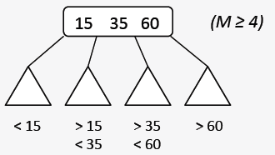M-way tree properties:
  + Each node holds between 1 and M-1 values in sorted order.
  + A non-leaf node with K values has K+1 non-empty subtrees that are M-way search trees.
  + The ith subtree of a node that holds values [v0…vk] (0 ≤ i ≤ K) can only store values v such that vi-1 < v < vi

**2-4 tree** – a 4-way search tree where each non-leaf node must have at least two non-empty subtrees.

* **Inserting** values
  + To add a new value, use the total order to find the leaf that should hold this value. **New values are always added in the context of an existing leaf node** (never a new leaf!)
  + 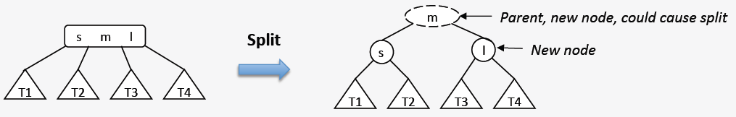Nodes in 2-4 trees can store at most 3 values. 2-4 trees grow “up” by adding a new root rather than down by adding a new (lower) leaf. When a 2-4 node is full but needs to store another value, perform a **split**:
  + Worst-case add in 2-4 trees causes the root to change.

**BINARY HEAPS**

|  |  |  |  |  |
| --- | --- | --- | --- | --- |
| PQ Method | Unsorted List | Sorted List | Balanced BST | Binary Heap |
| Add | O(1) | O(N) | O(log N) | O(log N) |
| Remove | O(N) | O(1) | O(log N) | O(log N) |
| Peek | O(N) | O(1) | O(log N) | O(1) |
|  | Nodes/Arrays | Nodes/Arrays | AVL, R-B, etc. | Nodes/**Arrays** |

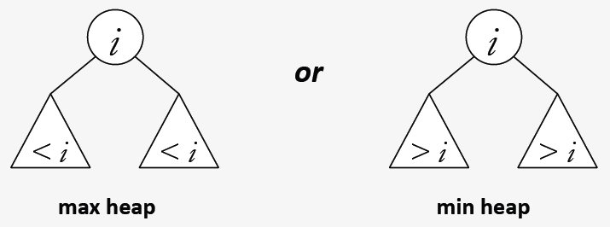**Binary heap** – a complete binary tree in which each node obeys a partial order property

* Binary heaps are almost always **implemented as arrays** because:
  + Acceptable space efficiency (complete shape)
  + Easy transversal (parent to child via multiplication, child to parent via division). Store values as in BST:
    - store root at index 0; nodes stored at index i:
      * **left** child: 2i + 1 | **right** child: 2i + 2 | **parent**: (i-1)/2
* Binary Heap **Insertion**
  1. Insert new element in the only location that will maintain the complete shape.
  2. Swap values as necessary on leaf-to-root path to maintain partial order.
* Binary Heap **Deletion**
  1. Maintain the complete shape by replacing the root value with the value in the lowest, right-most leaf. Then delete that leaf.
  2. Swap values as necessary on root-to-leaf path to maintain partial order.
* Heapsort – an in-place comparison sort with O(N log N) time complexity
  + Important because N log N is lower bound (optimal) on number of comparisons necessary for comparison sorts.
  + 2 Phases of heapsort:
    - Rearrange the array elements into max heap order: beginning with the lowest, right-most parent and continuing to the root, heapify each subtree.
    - Repeatedly move the maximum element to its final stored place toward the end of the array, and heapify the remaining elements.
* Heapsort is an in-place sort with guaranteed N log N worst-case performance, but it is not stable and typically has larger constant factors than quicksort.

**Huffman’s algorithm** – generates a variable-length encoding for a given alphabet for the purposes of data compression.

* ASCII – binary character encoding scheme (a sequence of 0s and 1s (bits) used to encode characters) that includes English alphabet, punctuation, digits, and “control” characters.
* ASCII is a **fixed length code**. Each character is represented by the same number of bits. 8 bits = 1 parity bit + 7 bits to encode character (27 = 128 different characters)
* **Variable length codes** – number of bits per character determined by the char’s relative frequency of occurrence. Most frequently occurring chars should use the fewest bits.
  + 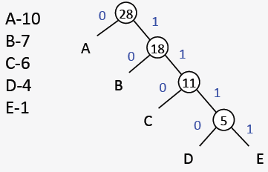Generating a vlc: The code for one char can’t be a prefix of another char’s code.
* Code trees – binary trees in which the leaves contain the characters to be coded. Interior nodes are just place-holders; the root of every subtree is annotated with the cumulative frequency of all its descendent leaves.
* 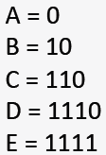Character codes are generated by root to leaf traversals.
* L\left(C\right) = \sum_{i=1}^{n}{w_{i}\times\mathrm{length}\left(c_{i}\right)}There are many possible code trees and many possible char codes. Since char codes are defined by the root to leaf paths, the tree’s shape determines “average” code length.

wi = weight(ai)

L(C) = “average” code length.

(left branch = 0, right branch = 1)

* Huffman’s algorithm generates a code tree with an average code length that is at least as small as any other code tree that could be generated.
  + Create a single node code tree for each character
  + Insert each of these trees into a priority queue (min heap).

while (pq has more than one element) {

c1 = pq.deletemin();

c2 = pq.deletemin();

c3 = new codetree(c1, c2);

pq.add(c3); }