ELEC 5220 Information Networks and Technology  
Lab 1 Report

Robert Skelton

# Abstract

This lab consisted of installing XAMPP, then learning basic tasks that can be accomplished using MySQL and PHP. phpMyAdmin was used for the majority of this lab. phpMyAdmin includes many helpful tools that run in your web browser so that you don’t have to type in MySQL commands manually. The other half of the lab involved using and modifying HTML and php files, then running them in a web browser. In this lab, I created a few databases, where each database had multiple tables with different fields. Each table had a part or customer number, which started at 1 and automatically incremented.

# Introduction

Before I started the lab, XAMPP was installed. XAMPP is a distribution of the popular Apache web server that comes packaged with MySQL, PHP, and Perl. Once installed XAMPP provides a simple control window for starting and stopping the services built into XAMPP. The Apache and MySQL services must be started before preceding any of the steps throughout this lab. I used Sublime Text 2 as my text editor and Google Chrome as my web browser. All html and php files were stored in C:\xampp\htdocs\html.

# Design

### phpMyAdmin Exercise 1

The first step’s “On your own” exercise was the easiest by far. I set a root password that is easy to type in, since I’m not too worried about security on localhost. I verified that the XAMPP version is 4.1.12 and php version is 5.5.11, as seen below in Figure 1.

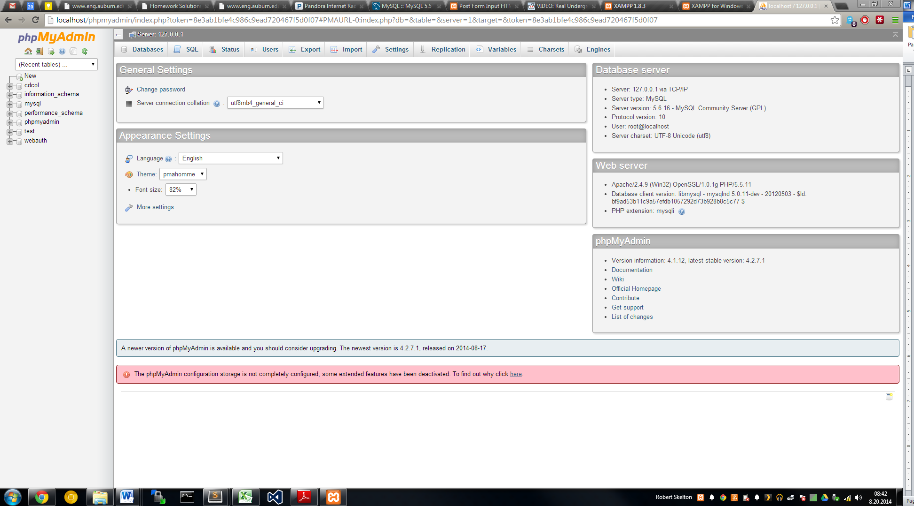

Figure 1. Screen verifying the XAMPP and php versions.

### phpMyAdmin Exercise 2

In step 2, I created a pet_store database with a single table called animals. I made sure to check A_I for auto increment on the id_num box. I then used phpMyAdmin to insert another column for weight. I manually changed the weight for the Black Lab, then inserted 9 other animals in the animals table, for a total of 10 animals. You can see the final table in Figure 2 below.

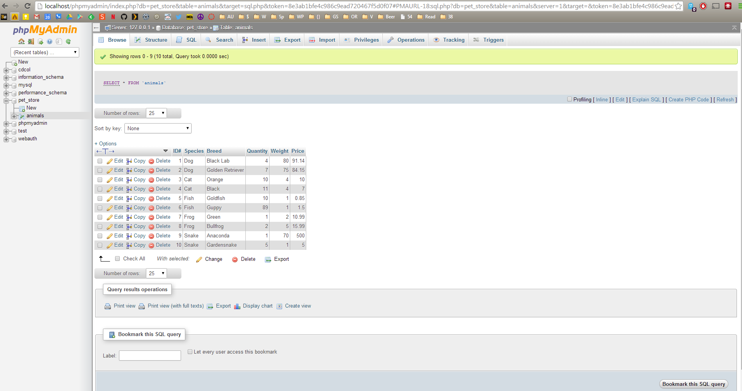

Figure 2. Table for animals in the pet_store database with 6 columns.

### phpMyAdmin Exercise 3

First, I created a user joe/joe to have all privileges within the pet_store database. Then, I created a user robert/robert to have SELECT, INSERT, UPDATE, but not DELETE privileges within the pet_store database. You can see this below in Figure 3.

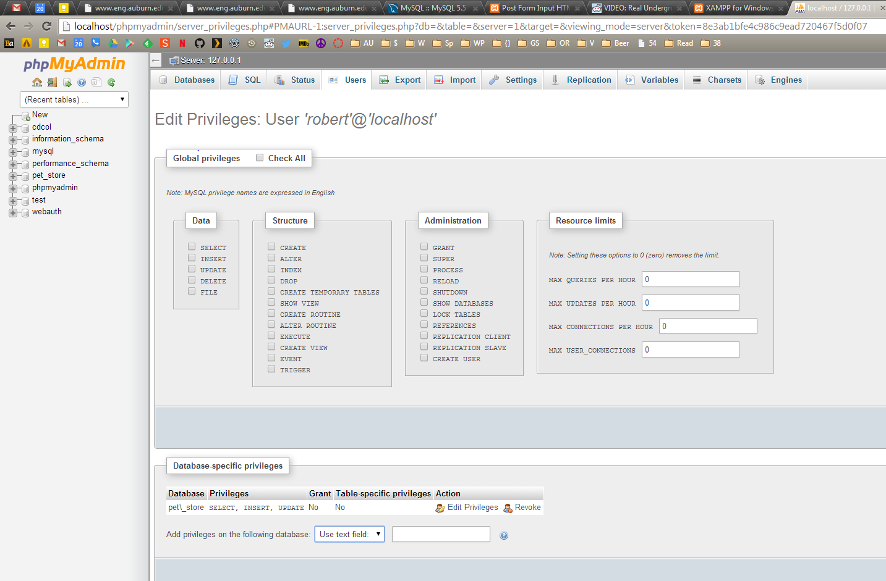

Figure 3. The user robert has SELECT, INSERT, and UPDATE privileges in the pet_store database.

### phpMyAdmin Exercise 4

This step involved created a cd_store database and multiple tables for that database. This step took a while, but was not overly difficult. There are tables called cd_store, customers, and orders. Each table has an auto incrementing number as part of it. I then exported the database to a SQL file contained in this zip file, called cd_store.sql.

### php Exercise 1

For all the php and HTML exercises to follow, the files are stored in C:\xampp\htdocs\html. This step was a good intro to php syntax in HTML. I edited the included HTML file to display my information, including my name, age, favorite color, and favorite animal. White tigers are awesome. You can see the screenshot of my php file and the web browser in Figure 4 below.

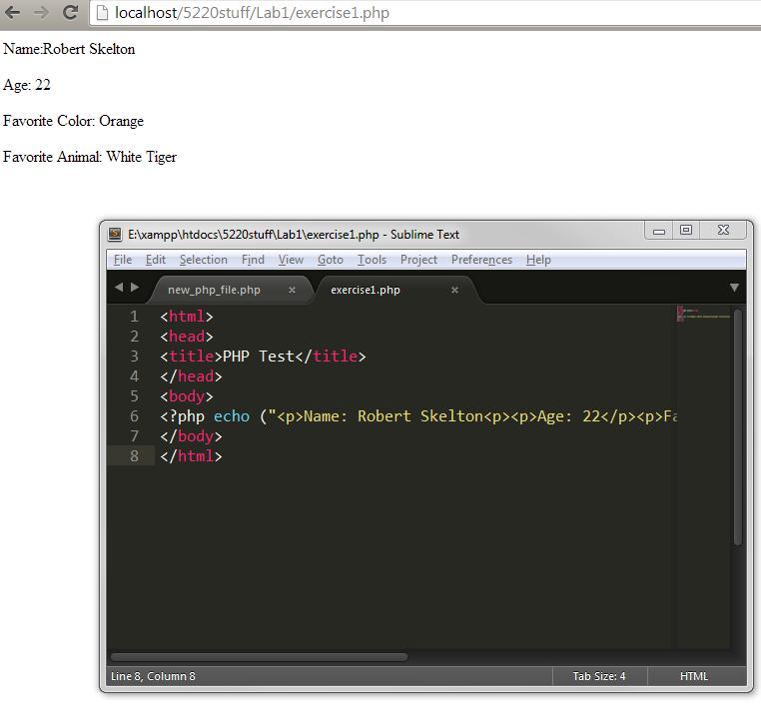

Figure 4. My personal information displayed using embedded php in HTML.

### php Exercise 2

This step is a browser test to make sure you aren’t using the atrocity that is Internet Explorer 9. We were asked to take the given php code and modify it to reverse the order it prints them off. This was just a matter of cut and pasting the two lines around, and the output is shown below in Figure 5, along with the final version of the php code.

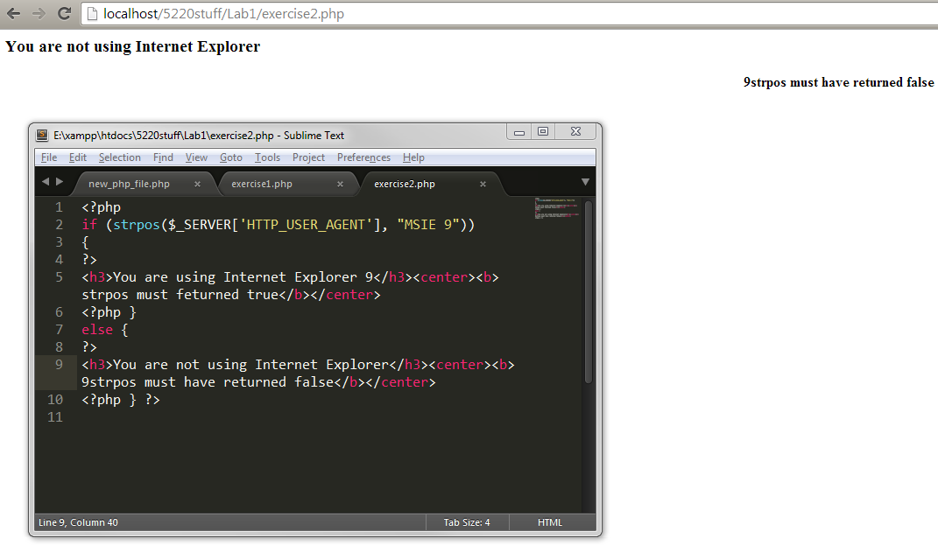

Figure 5. Output of the modified webpage and the php code.

### php Exercise 3

This step taught us about using Get and Post in php. Using Get, your information will be passed through a URL, where using Post seems to be more secure. At least I liked Post better. The “on your own” of this step was time consuming. I haven’t done much HTML, so I had to use some of the included HTML code and add lots of my own. Eventually, I had a basic site that had a text box, a password field, two checkboxes and two pull down menus, and a comment box. The site is shown below in Figure 6, and the result, using the Get method, is in Figure 7. The code is included, and very commented.

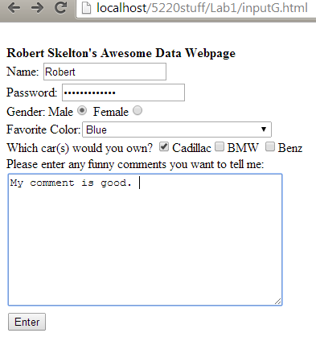

Figure 6. Website with the criteria for this step.

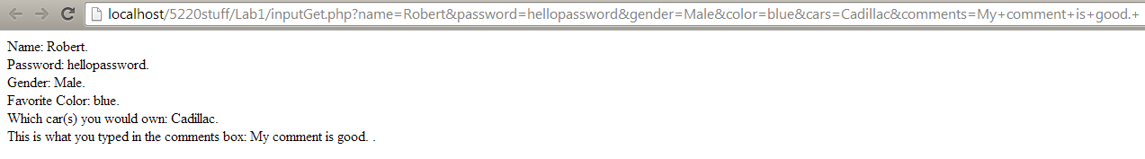

Figure 7. Output of the website using the Get method.

### php Exercise 4

I connected my pet_store database using php in this step. I used the included breed_lookup.html and breed_lookup.php to search my database for a “Black Lab”. I only had to modify it for my chosen username and password, which was joe/joe. I was having an issue with this step because I initially was dragging the HTML file from my text editor to the browser. This did not give the correct link, as I had to go to localhost then navigate to the correct file. This fixed my issue. In this step, you can enter a search query. It will then search the animal table and see if there are any matches, and if so, print them out, as you can see below in Figure 8.

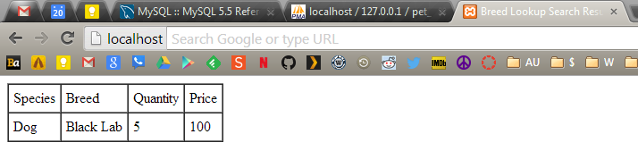

Figure 8. A query for Black Lab was issued to the animals table.

To do the required “On you own” exercise, much more modification of the original code was required. The code was commented appropriately, and can be viewed in the attached breed_lookup2.php file and breed_lookup.html. The php method was changed from GET to POST. There were three different $query/$result methods used.

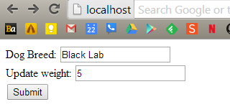

Figure 9. Updating the weight of a black lab.

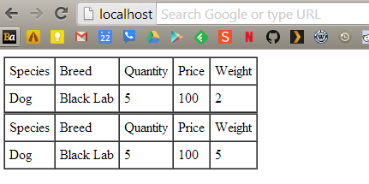

Figure 10. The old weight is displayed above, and the updated weight is displayed below.

# Result

These eight exercises were a good introduction to using XAMPP, php, HTML, and MySQL. I believe this will be a good foundation for future coursework in ELEC 5220. The “On your own” exercises were difficult, but not impossible.

# Conclusion

This lab had just a few problems, mostly to do with me being lazy and dragging the HTML file to the browser. The included guide for Lab 1 is very outdated, and many of the links in phpMyAdmin have changed significantly since it was written. This was not much of an issue, since Google can solve most of my problems. All html and php code are included in the code directory.

# References

* XAMPP download, https://www.apachefriends.org/download.html
* Dr. Wu’s included slides and lab materials
* Add a column in phpMyAdmin, http://support.hostgator.com/articles/specialized-help/technical/phpmyadmin/adding-a-column-to-a-database-table-in-phpmyadmin