ELEC 5220 Information Networks and Technology  
Lab 2 Report

Robert Skelton

# Abstract

This lab was meant to give us a more detailed background into php and databases using phpMyAdmin. The basic tasks from last week, such as creating a table in SQL and inserting data, are now considered second nature, and are not expounded upon in this week’s lab.

# Introduction

I found out that we need to re-download all data from the SCP site every week since the lab is constantly changing. I had originally downloaded every lab on the first day of class, and there were lots of errors in the lab write-ups which were giving me issues. Re-downloading the entire lab helped alleviate some of my issues. This lab mostly deals with settings cookies using php, and how to read data from your database. I used a Windows 7 Ultimate desktop with Sublime Text 3 as my text editor. Google Chrome was the browser I used. XAMPP was used to start and run the localhost Apache server.

# Design

**PHP Exercise 5**

I used the existing database “cd_store”, and created a new table in it called “lab2”. It has fields for username and password, which are both varchar’s of length 25. I then created two test users, joe/joe and robert/robert. I made a few edits in the code that was provided, which you can see in the attached code directory. This step let you input a user and password, then check if the user/password combo was stored in the database I pointed to.

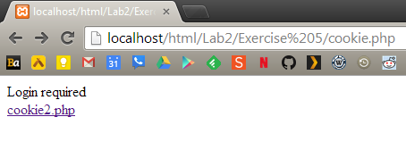

Figure 1. The main page of cookie.php with no cookie set.

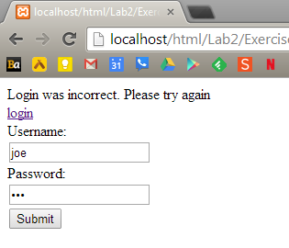

Figure 2. Using an incorrect login on cookie.php.

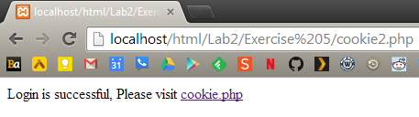

Figure 3. Setting the cookie using cookie2.php

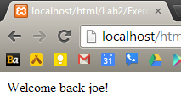

Figure 4. The main page of cookie.php with a cookie set.

I then modified the code to direct to multi_exercise.php, which stores three cookies, one for each user. This is shown below in the Advanced Chrome Settings to show all cookies. As you can see, there are three unique cookies set for localhost.

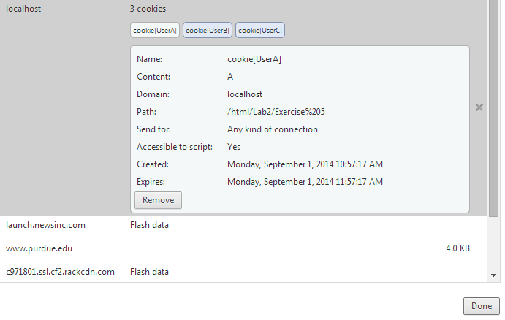

Figure 5. Setting multiple cookies for localhost using multi_exercise.php.

**PHP Exercise 6**

For this “On your own” step, I created an array of length 3, that contains names inputted from a user via a text box and displayed them on the screen using the same php file.

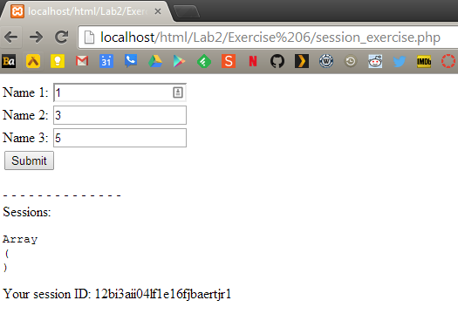

Figure 6. Before pressing submit.

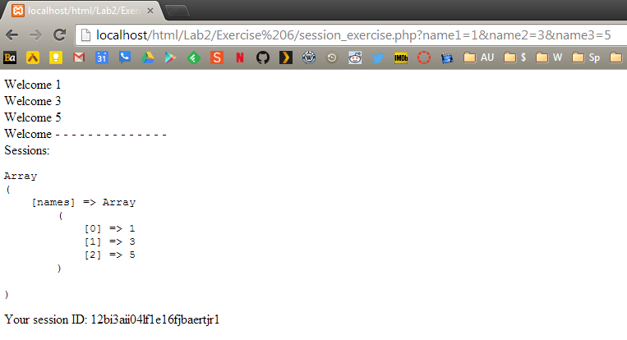

Figure 7. Once submitted, the saved array is printed out and each user is welcomed.

**PHP Exercise 7**

This was the easiest step, in my opinion. I reused code that was included with Lab 2 and made some modifications. First I had to rename the files to what Step 7 asked for. I created a php function that would convert an integer from 1-12 into a month name, and then print that out. I did this using if and else statements, but could have been done with nicer looking code using a switch statement. I also implemented my own function, called my_own_function, which takes a number as input and prints out your expected favorite musician. If the input is not 0 or 1, it will print Led Zeppelin, which should be everyone’s favorite band anyways. The result is shown below, along with my code for both files for Step 7. The file called ‘php_exercise_7.inc’ must be included in the main file, ‘php_exercise_7.php’ for both function calls to be able to be seen, and must be in the same directory as the php file.

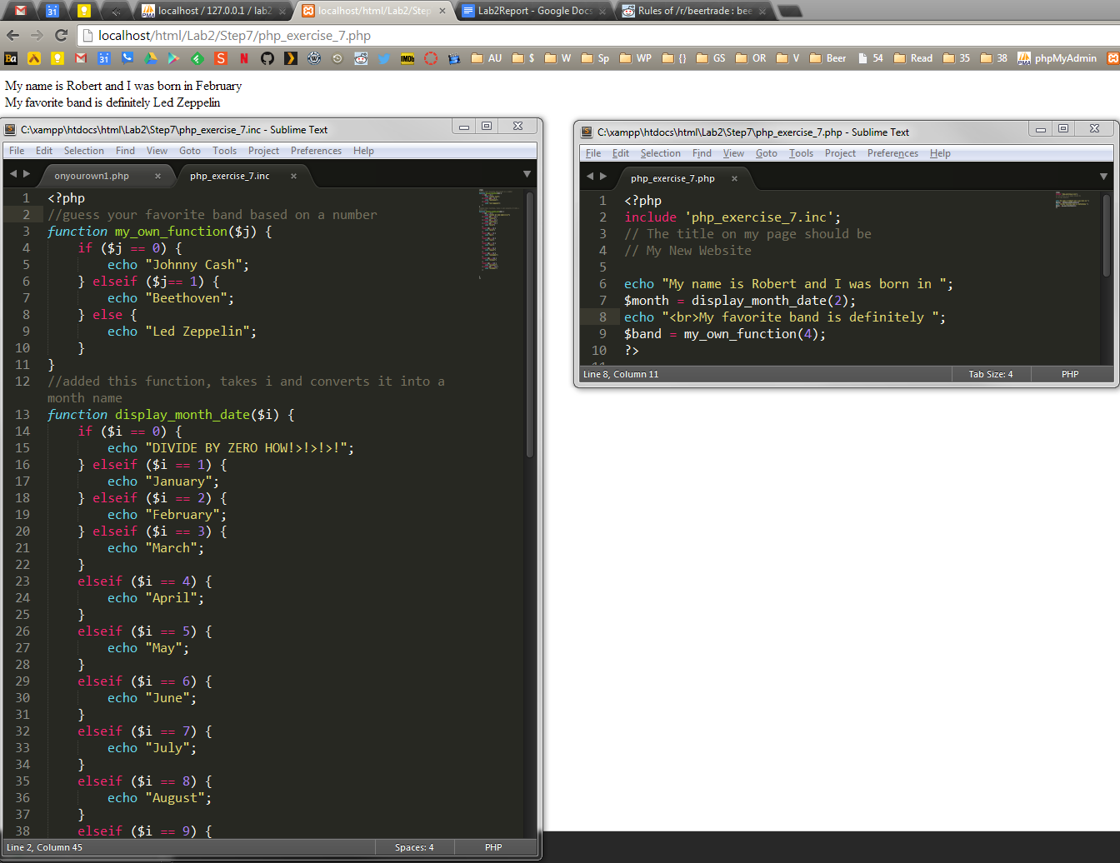

Figure 8. The result of writing and including a few simple functions using php.

# Result

In this lab, I learned more about databases and php. I got to implement a couple functions using php. I feel very confident using phpMyAdmin and XAMPP to start the Apache services.

# Conclusion

This lab caused more trouble for me than the first lab due to less hand holding throughout the tutorial. Using cookies will be useful for remembering users when they return to your site, and creating functions in php will save time when writing redundant code.

# References

* Dr. Wu’s included slides and lab materials
* <http://stackoverflow.com/questions/2306159/array-as-session-variable>
* <http://php.net/manual/en/control-structures.switch.php>