ELEC 5220 Information Networks and Technology  
Lab 4 Report

Robert Skelton

# Abstract

The purpose of this lab was to get a basic introduction into the XML markup language, as well as work hands on with AJAX, or Asynchronous Javascript and XML. There were five parts to this lab, which are all detailed below. I had barely seen XML before this lab, and had never even heard of AJAX, so this was a great lab to work through.

# Introduction

For this lab, I used the same setup as in previous labs. I am running the Apache server using XAMPP 3.2.1 on my Windows 7 Ultimate 64-bit Operating System, using Google Chrome as my internet browser and Sublime Text 3 to view and modify all code.

# Design

**XML Example 1**

The goal of this step was to learn to parse through XML files using php. I reused code from the given Step 1 and Step 2 for the On Your Own Part. For On Your Own, I had to add a few more books, and add a price, genre and year tags, and add multiple authors on two of the books. The authors took a while to understand, but then I read that the requirements wanted their own tags, so I made the second and third authors have the tags author2 and author3, respectively. The output is shown below in Figure 1, with the Books3.xml file shown on the right.

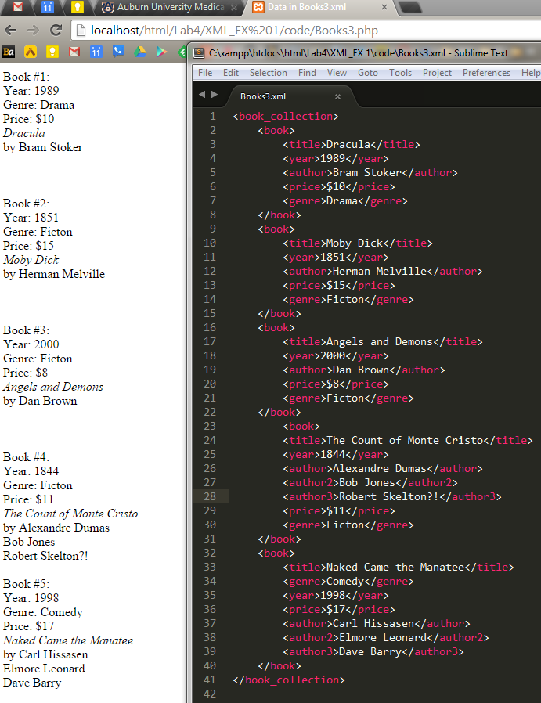

Figure 1. The parsed output of Books3.xml using php on the left, and Books3.xml on the right.

**XML Example 2**

This step introduced us to XML data, schemas and transforms. The On Your Own section this time wanted us to modify the XML scheme and data files to see the publisher, release date, and an aspect of my choice to each book. Then I was to validate the input. So I edited book1.xsd and book1.xml to have a publisher and release date category, then inside the character I also added a country element. To verify this, we had to submit the .xml and .xsd (schema) files to http://www.corefiling.com/opensource/schemaValidate.html to verify them. You can check below in Figure 2 that I verified the two files using the website noted above.

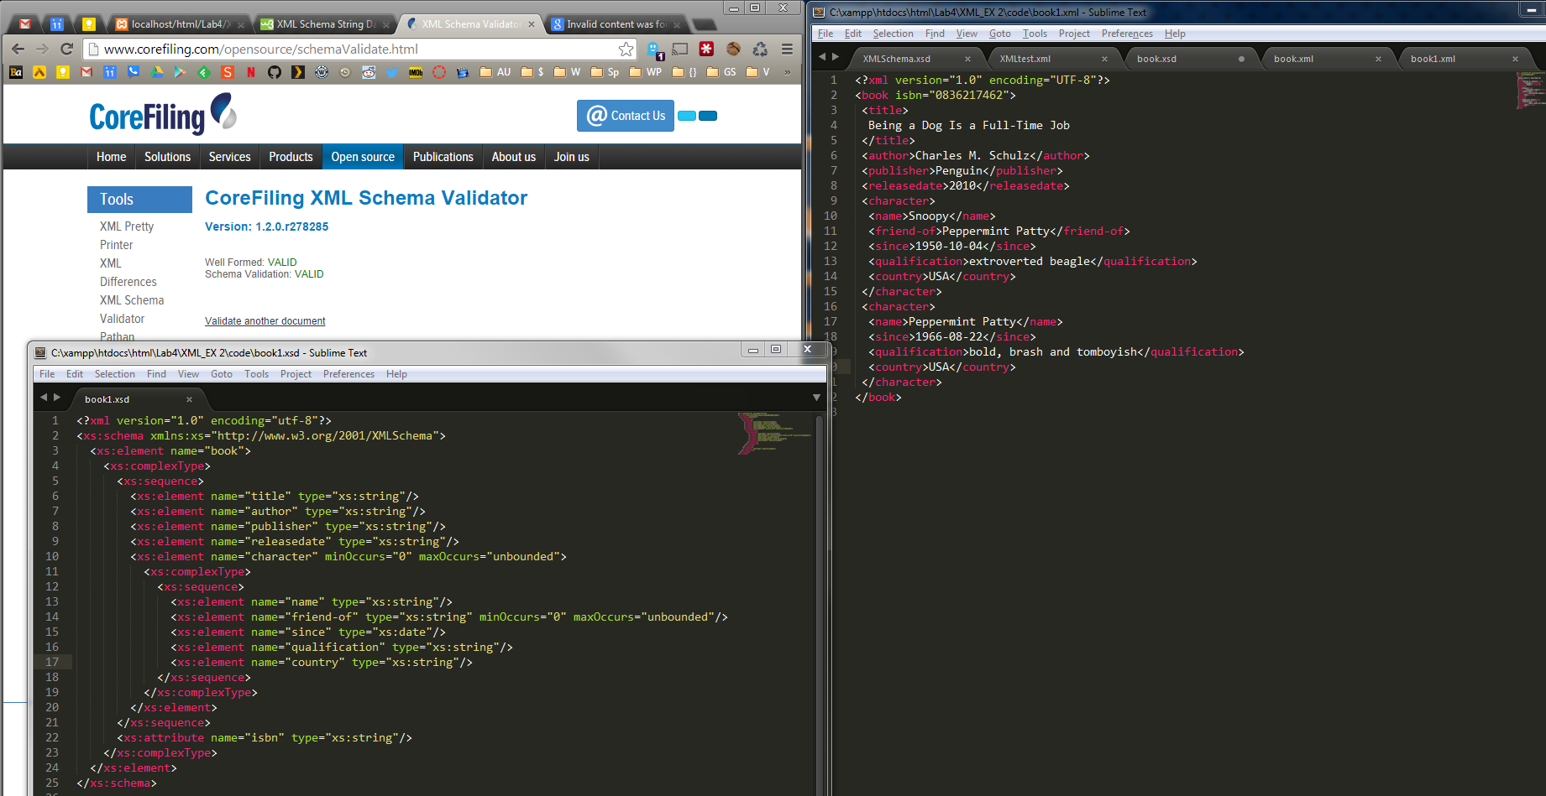

Figure 2. Verifying book1.xsd and book1.xml for use on <http://www.corefiling.com/opensource/schemaValidate.html>.

**XML Example 3**

For this step, we were instructed to use a given php script to format and update information from a database table about books, and modify it to have Errata, or errors that have been corrected in books. This step was quite difficult since the included code did not work, so I had to debug that before actually starting this step. Then I had to create an entire new database to have information on anything I wanted. The example given was phone models. This was doable, and I decided to make a table for Guitars, since I play guitar. I then had to modify a php to show the output of this table in a webpage, which is shown below in Figure 3.

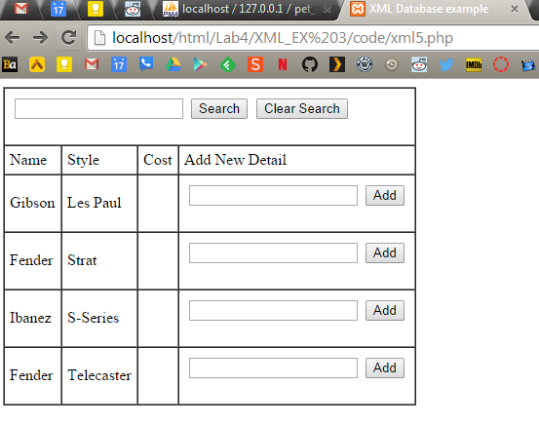

Figure 3. Output of table from XML Example 3.

**AJAX Example 1**

The purpose of this step was to get used to usnig AJAX, or Asynchronous Javascript + XML. We were provided completely working codes in this step, but just had to change the price of CD7 to be $12.95 instead of $12.75. You can see the before and after screenshots below.

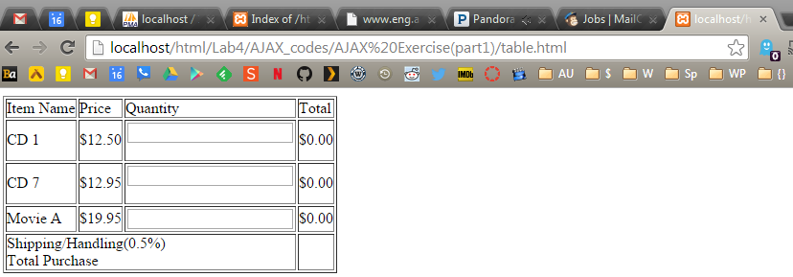

Figure 4. Before entering any items into the quantity field.

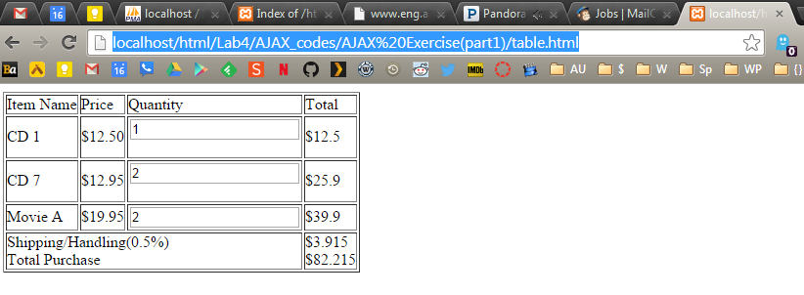

Figure 5. After specifying a quantity for each item, the total price is immediately updated.

**AJAX Example 2**

This step required us to modify the AJAX example files from Example 2 not include a page that reports when a user is not found when searching through the XML file. I showed in Figure 6 that you can still search for a user contained in the XML file, but a short message is returned when you edit the search field to search for a user that does not exist. Using AJAX, this is all accomplished without refreshing the page.

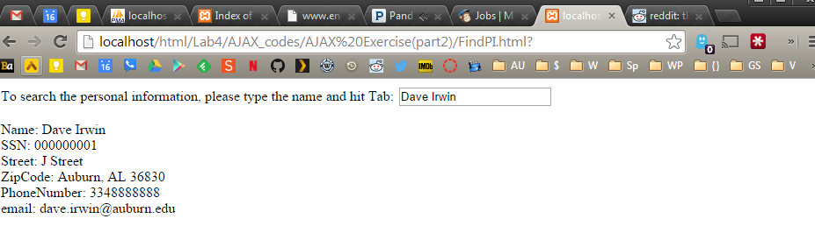

Figure 6. Output of searching for an existing user.

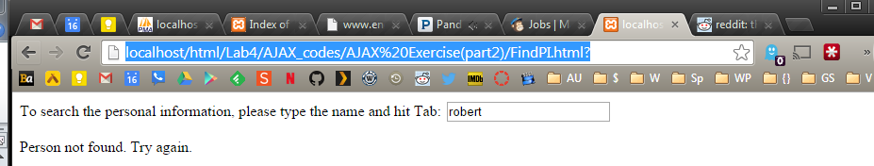

Figure 7. Output of searching for a user that does not exist.

# Result

I completed every step of the On Your Own of Lab 4 using the supplied codes from Dr. Wu and modifying them to fit to the requirements. Each step probably took between 30 minutes and 1 hour, with XML Step 3 taking the longest.

# Conclusion

At the completion of this Lab, I feel more comfortable editing php files, and working with web development. Databases aren’t near as difficult as I thought they would be. The most challenging part for me is managing so many windows open on my computer, and even with three monitors space gets cramped.

# References

* Dr. Wu’s included slides and lab materials
* <http://www.corefiling.com/opensource/schemaValidate.html>
* <http://stackoverflow.com/questions/17173383/invalid-content-was-found-starting-with-element-country-one-of-country-is>
* http://www.w3schools.com/default.asp