ELEC 5220 Information Networks and Technology  
Lab 8 Report

Robert Skelton, TJ Lowry, Cristina Grajales, Adam Cubel, Saurabh Gupta

# Abstract

The purpose of this lab was to learn how to use Bind 9, the most popular DNS program in use today. A DNS, or Domain Name System, is a distributed naming system that basically turns domain names into IP address, so that computers can read human readable websites, such as google.com. BIND was created by the University of California at Berkley, and is an acronym for the Berkeley Internet Name Domain. When you use BIND, you don’t have to update the /etc/hosts file every time a new computer is added to the network. BIND 9 handles this automatically, so it is partly responsible for the forward progress of the Internet.

# Introduction

First of all, our group members consist of Robert Skelton, TJ Lowry, Cristina Grajales, Adam Cubel, and Saurabh Gupta. We used an Adtran 3120 router provided by Dr. Wu to implement this week’s lab, as well as a web server, a Domain Name Server, and a few laptops that were running Windows 8 and Mac OS X. This lab was separated throughout two weeks. This week we were to complete Steps 1 and 2, and next week our group will implement Steps 3 and 4. Design

**Step 1**

For step one, we had to set up two servers: a web server, which was located at 192.168.127.2, and a DNS server, at 131.204.128.2. We ran Wireshark on both of these servers, and submitted the attached configuration files for BIND in the code directory of this project.

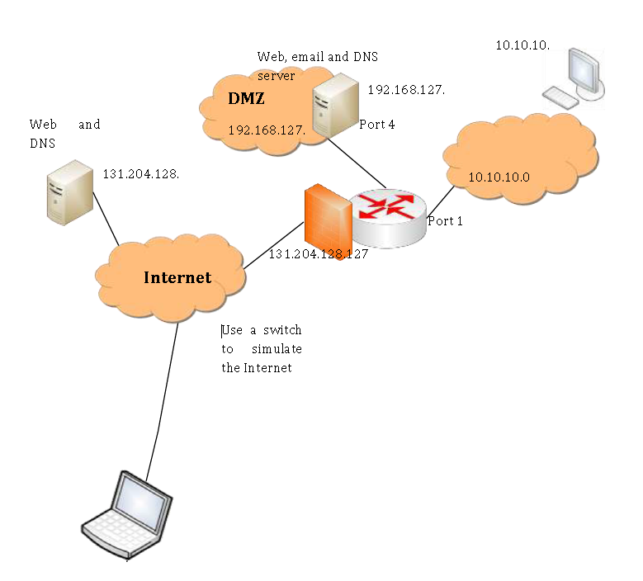

Figure 1. Network Overview.

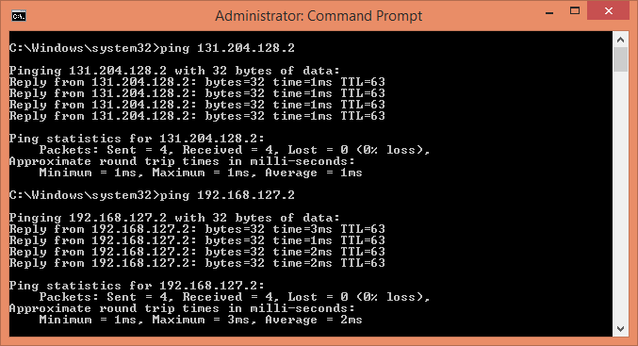

Figure 2. Pinging the web and DNS server to verify they are running and accessible.

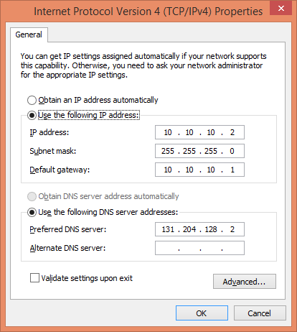

Figure 3. Setup on the Windows PC.

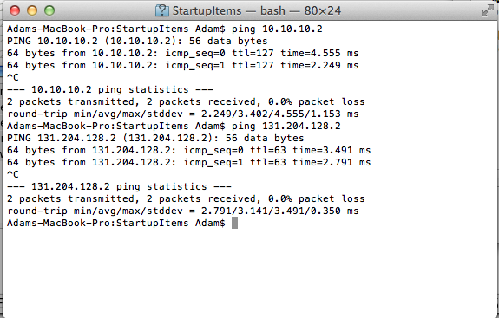

Figure 4. Ping the web and DNS server on the Mac for verification.

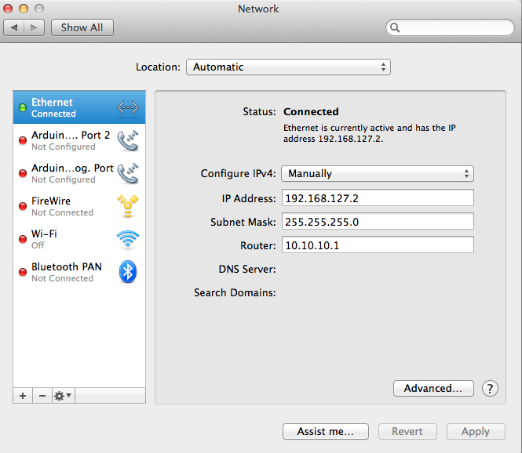

Figure 5. Network setup on the Macintosh.

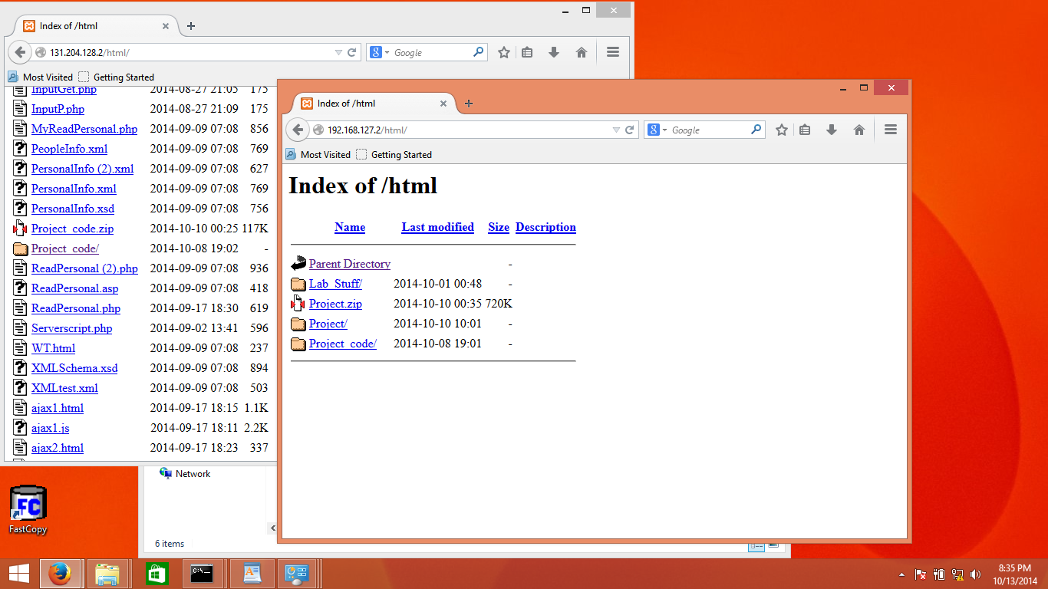

Figure 6. Verification of the web server.

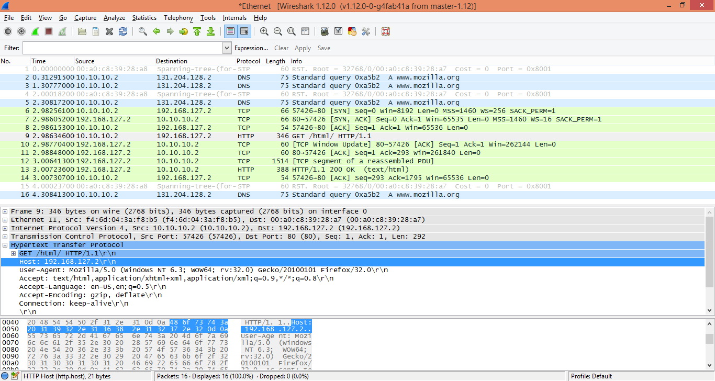

Figure 7. Wireshark run on the web server.

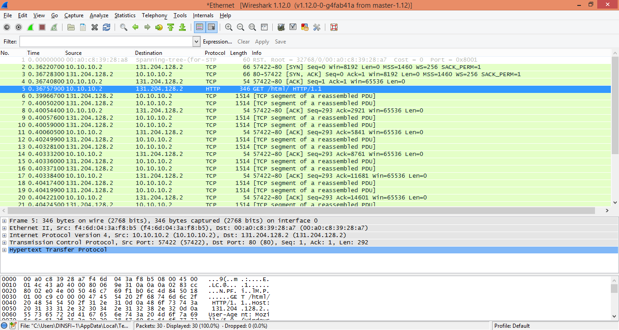

Figure 8. Wireshark run on the DNS Server.

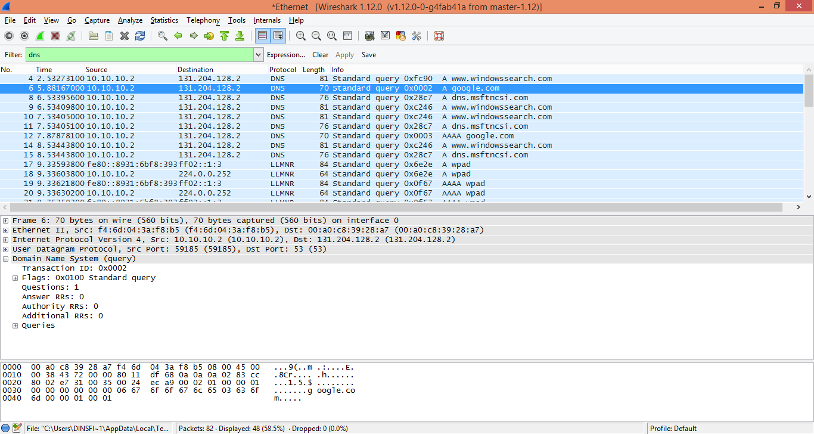

Figure 9. DNS to Wireshark.

**Step 2**

We then established a routing between 3 different subnets, which were 131.204.128.0/24, 192.168.127.0/24, and 10.10.10.0/24. Every subnet can ping all of the other subnets. The DNS and web servers both work in this configuration as well. We verified that the network was setup correctly by using ping.

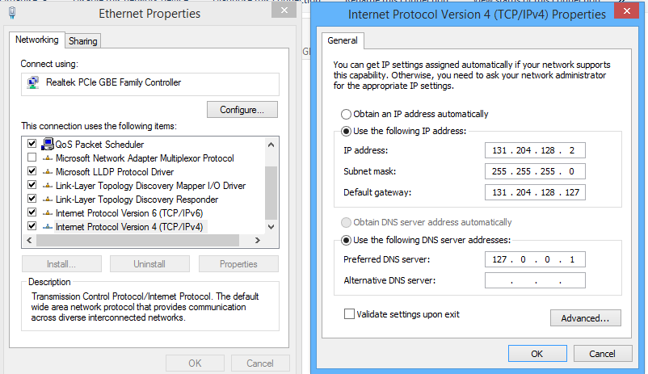

Figure 10. DNS configuration on Windows 8.

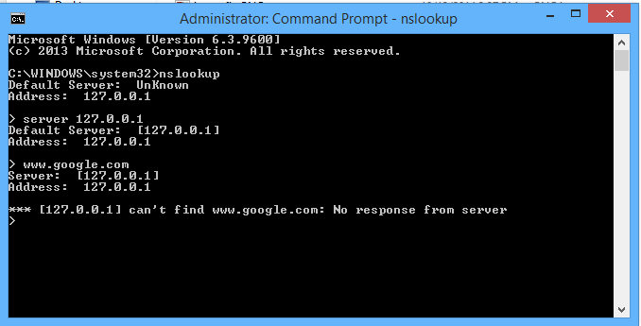

Figure 11. Running nslookup on Windows 8 before and after changing the DNS.

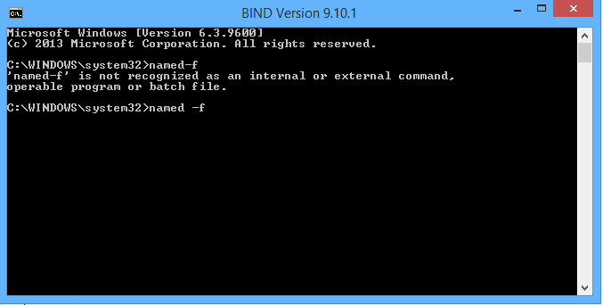

Figure 12. Running named –f on the Windows 8 PC.

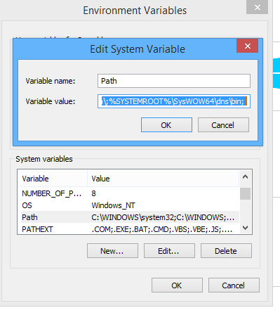

Figure 13. Modifying the PATH on Windows 8.

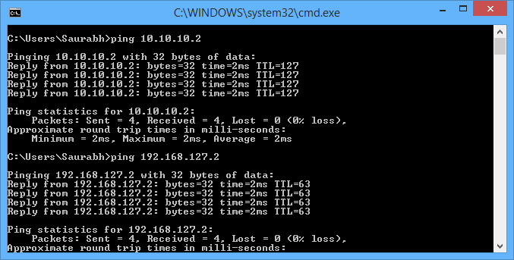

Figure 13. Verifying the network setup was correct by pinging all others in the network.

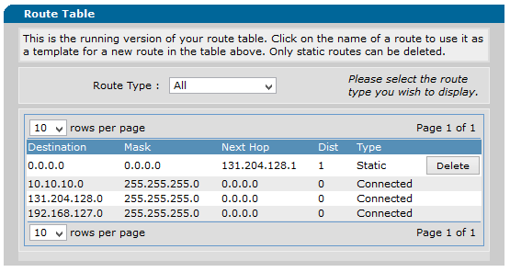

Figure 14. This is the setup for the routing table we used on the Adtran router.

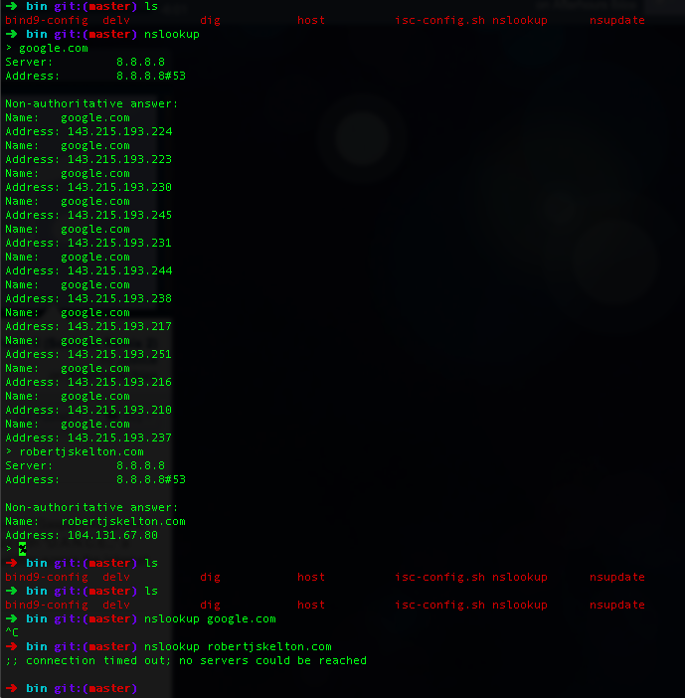

Figure 15. Running nslookup before and after changing the DNS server on another Macbook.

# Result

Our group was able to properly implement all steps. Some issues we had were installing BIND on a Mac, since brew is sometimes a little weird to install things. FEEL FREE TO ADD WHATEVER

# Conclusion

Our group did not struggle much throughout this lab, and we look forward to implementing Steps 3 and 4 next week.

# References

* Dr. Wu’s included slides and lab materials
* <http://stackoverflow.com/questions/19538118/osx-mavericks-bind-no-longer-installed-how-to-get-local-dns-server-working>
* ALSO ADD SOURCES IF YOU GOT ANY