# INSTALL PCLAKE

## STEP 1: Download the model and instal

To install PCLake for the SIL-course go to GitHub <https://github.com/robertladwig/SIL21_SC07/blob/main/PCLake_files/PreparationDocuments_PCLake/PCModel-master_LakeVeluw_precompiled.zip>

1. Click on download to download the zip file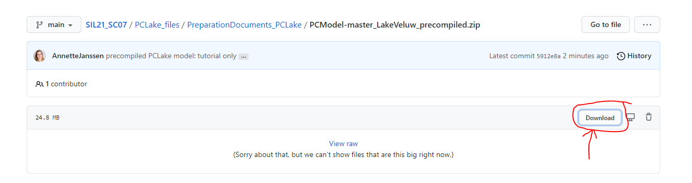
2. Store the zip file at any location on your computer
3. Unzip the zip file at any location on your computer (preferred is a local hard-drive, other storage locations will make the software slow or even not working).
4. The package is stand-alone, and the directory tree should remain intact. So you can store it at any location, but do not change the folder structure of the file you just downloaded.

## STEP 2: Computer settings

The settings of your computer must be in the right notation. The settings of your computer are so that the dot (.) is the decimal symbol, while the comma (,) is the digit grouping symbol (i.e. a million is 1,000,000.00). For most computers this is already the default, otherwise, follow the steps below. You might skip this step but if you get really strange results later, please try this step first to solve this issue.

Depending on your Windows version the following steps might look different at your computer. The figures below are for Windows 10. To check if the settings are correct:

1. Go to the settings of your computer

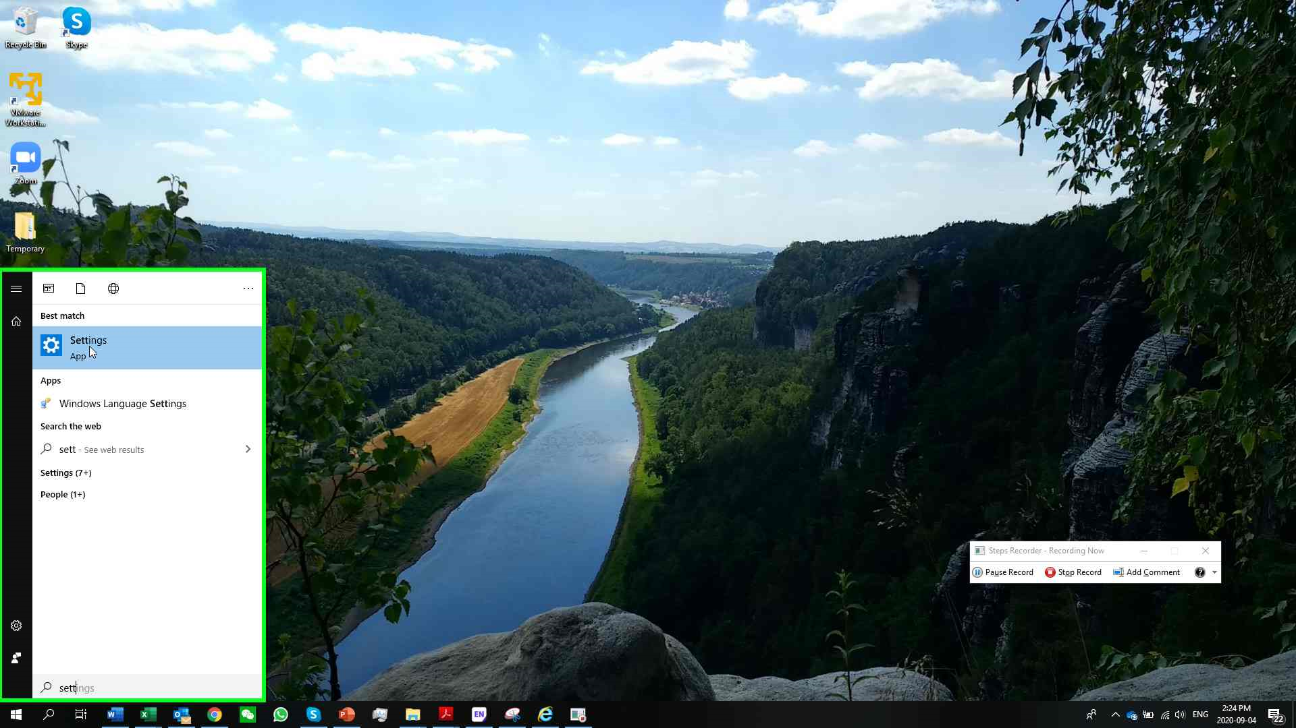

1. Go to Region and language --> additional date, time & regional settings

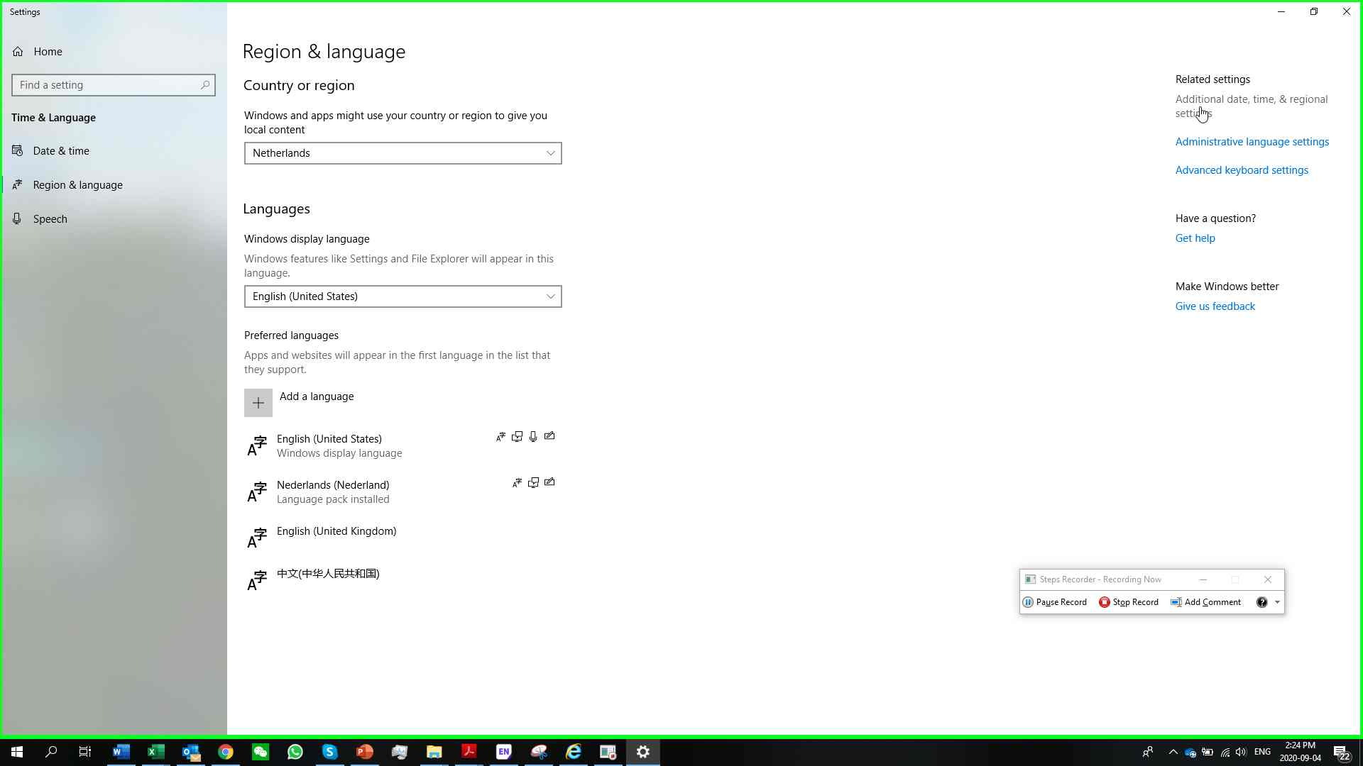

1. Click on “Change date, time, or number formats”

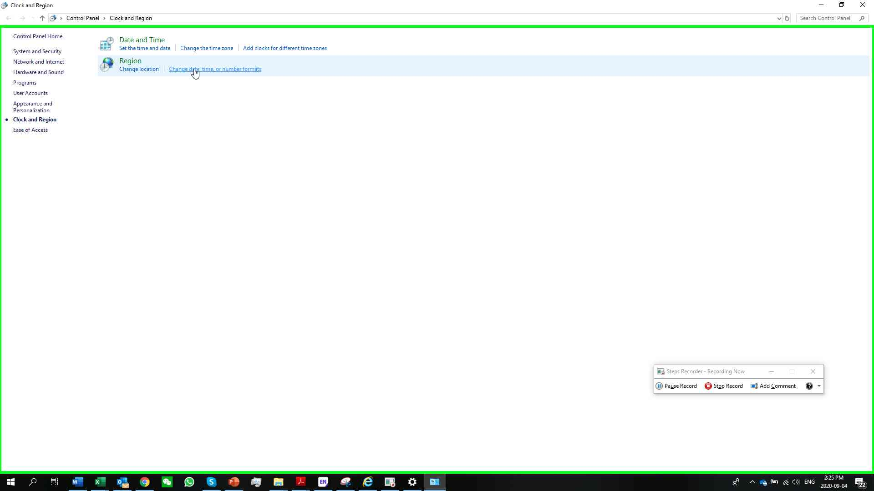

1. Click on “additional settings”

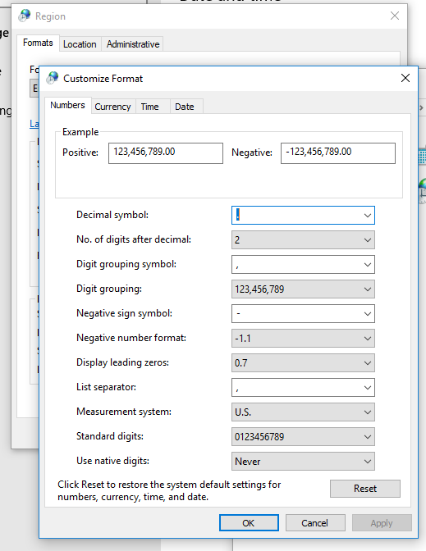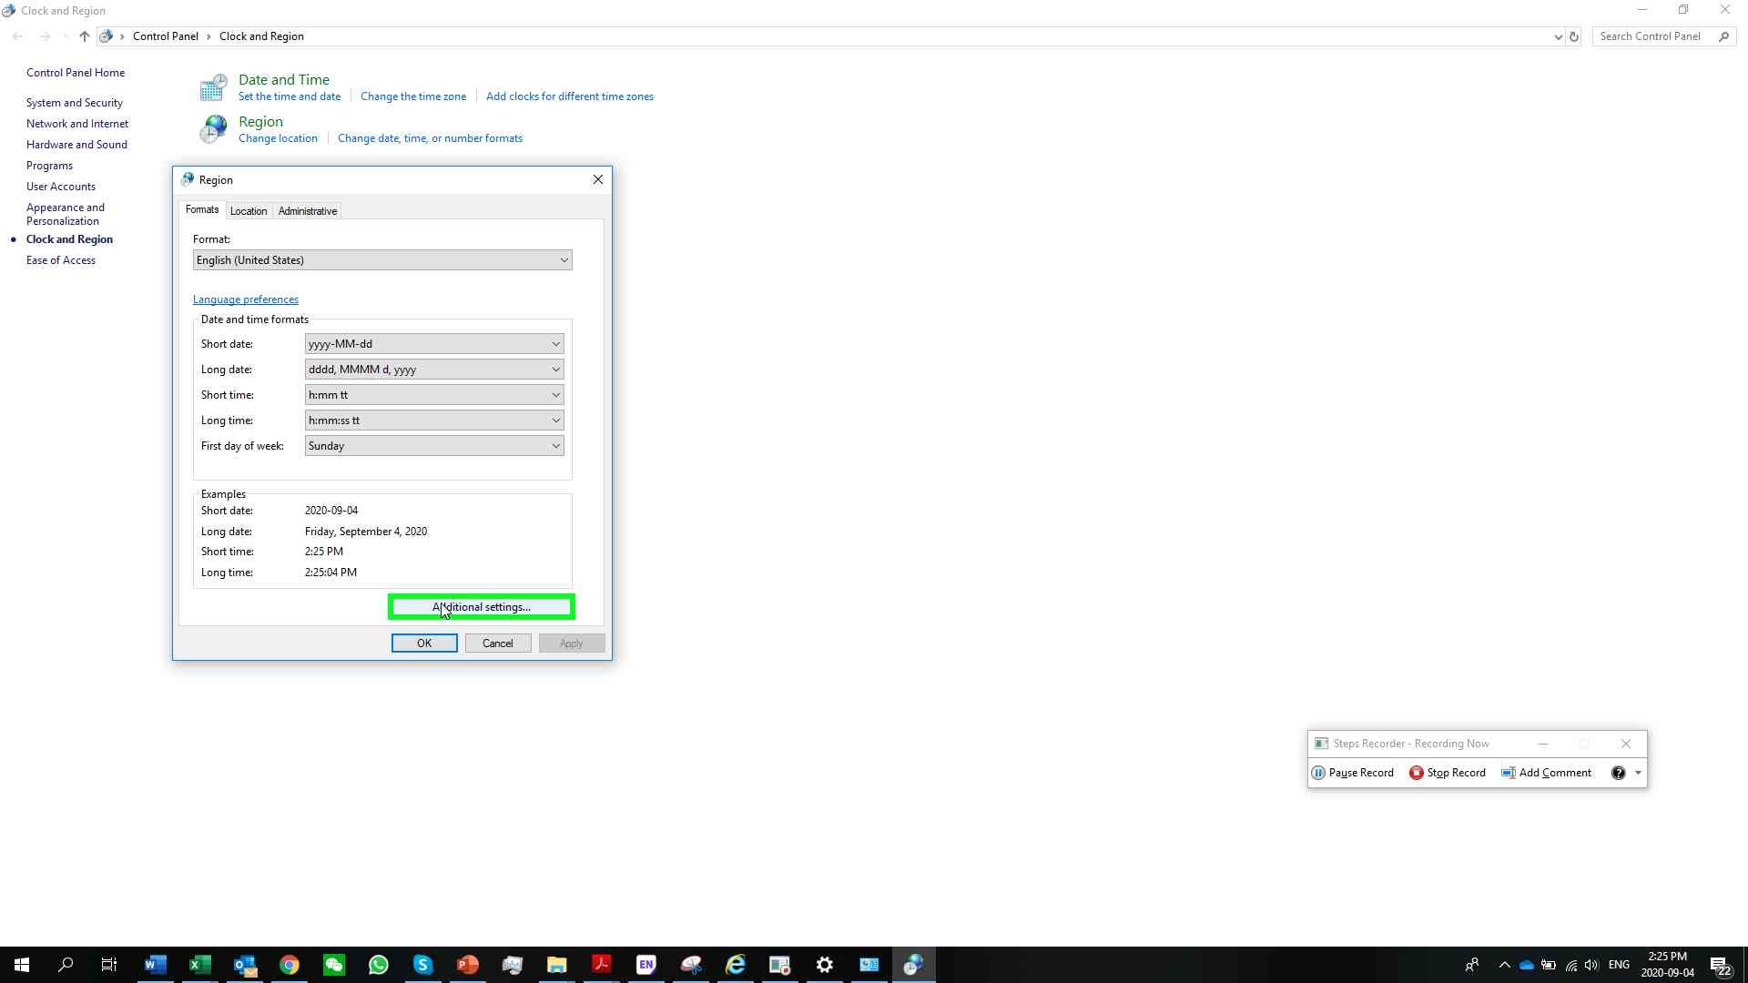

1. Check if your settings are according to the figure below. If not, adjust.

decimal symbol = .

digit grouping simbol = ,

negative sign symbol = -

List separator = ,

Measurement system = U.S.

## STEP 3: Download Rtools for compilation (optional, only for people that want to change code)

Download RTools for compilation from <https://cran.r-project.org/bin/windows/Rtools/history.html>

Make sure you take the right version (see below)

