Introduction into Artificial Intelligence

Mid-term 2. – Group A

1. Solve these problems on paper:

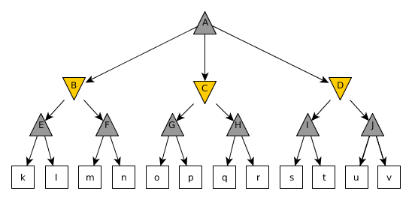

1. The evaluation function assigns the following numbers to the leaves of the tree: [[[6, 0], [-2, 1]], [[-3, -5], [3, 5]], [[-7, -4], [4, -6]]]. Give a good strategy for the ‘Maximum’ player using the Mini-max algorithm.
2. The evaluation function assigns the following numbers to the leaves of the tree: [[[-7, -3], [1, -2]], [[4, -1], [-6, 5]], [[-5, -4], [6, 2]]]. Which nodes will not have a value determined because of pruning? (The nodes in the figure are examined from left to right.)
3. We have constraints A, B, C, D, E, F ∈ {1,2,3,4,5,6}, 3 * A – 1 < C, A < B, B = 3 * E, 3 * E > D, F < D, C < F. Give the possible domain for each variable after checking arc consistency.
4. There are 26 slots in a row on the table. 2 players take turns on placing down 1 rock in one of the slots. A player can only place a rock in a blank slot where its left neighbor is also blank. The player who would be next and can’t put a rock in a slot loses the game. Implement this game using the provided name_neptuncode.py file. Follow the instructions in the code. (5 points)
5. **Description:**

H= {0, 1}

0 – blank slot, 1 – there is a rock in the slot

1. **Set of game states: $$B ⊆ H^{26}$$**

$$[b_{1}, b_{2}, …, b_{26} ]∈ H^{26}$$

$b_{i}∈H$ $i=[1, 2, …, 26]$

$$B=\left\{[b_{1}, b_{2}, …, b_{26} ] | \begin{aligned}\left[b_{1}, b_{2}, …, b_{26} \right]∈H^{26}∧ \\ \bigwedge_{i=2}^{26}{b_{i}=1⊃} b_{i-1}=0 \end{aligned}\right\}$$

*(if there is a rock in a slot, the left neighbor should be blank)*

1. **Initial game state:**

$b_{0}∈B$ $b_{0}= \left[0, 0,…,0\right] (all 26 slots are blank)$

1. **End game state:**

$$V= \left\{[b_{1}, b_{2}, …, b_{26} ] | \left[b_{1}, b_{2}, …, b_{26} \right]∈B∧\bigwedge_{i=2}^{26}{b_{i}=0 ⊃ b_{i-1}=1}\right\}$$

*(for each blank slot there is a rock in the left neighbor, meaning the player can’t place the next rock)*

1. **Set of steps:**

$$L= \left\{l_{i} | i∈\left\{1, 2, …,26\right\}\right\}$$

$$dom\left(l_{i}\right)=\left\{[b_{1}, b_{2}, …, b_{26} ] | \left[b_{1}, b_{2}, …, b_{26} \right]∈B∧ b_{i}=0 ∧ b_{max(i-1, 0)}=0\right\}$$

*(the slot where we want to put the rock is empty and left neighbor slot is also empty)*

1. **Effect definition:**

$$l_{i}\left([b_{1}, b_{2}, …, b_{26} ]\right)=\left([e_{1}, e_{2}, …, e_{26} ]\right)$$

$e_{p}=\left\{\begin{matrix}1 & if p=i \\ b_{p} & otherwise\end{matrix}\right.$ $p=1, …, 26$