CRIMES AGAINST WOMEN IN INDIA

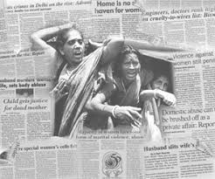

Journey with the apache team through the dreadful acts of violence against women in India.

**INTRODUCTION**

Violence against women refers to physical or sexual violence committed against a woman, typically by a man. Common forms of violence against women in [India](https://en.wikipedia.org/wiki/India) include acts such as [domestic abuse](https://en.wikipedia.org/wiki/Domestic_abuse), [sexual assault](https://en.wikipedia.org/wiki/Sexual_assault), and [murder](https://en.wikipedia.org/wiki/Murder). In order to be considered violence against women, the act must be committed solely because the victim is female. Most typically, these acts are committed by men as a result of the long-standing gender inequalities present in the country.

Violence against women in India is actually more present than it may appear at first glance, as many expressions of violence are not considered crimes, or may otherwise go unreported or undocumented due to certain Indian cultural values and beliefs.

The term violence against women encompasses a multitude of abuses directed at women and girls over the life span. The UN Declaration on the Elimination of Violence against Women (defines violence against women as: “any act of gender-based violence that results in, or is likely to result in physical, sexual or psychological harm or suffering to women, including threats of such acts, coercion or arbitrary deprivation of liberty, whether occurring in public or in private life”. This statement defines violence as acts that cause, or have the potential to cause harm, and by introducing the term “gender based” emphasises that it is rooted in inequality between women and men.

The term gender-based violence has been defined as “acts or threats of acts intended to hurt or make women suffer physically, sexually or psychologically, and which affect women because they are women or affect women dis-proportionally”. Thus, gender based violence is often used interchangeably with violence against women. Both these definitions point at violence against women as a result of gender inequality. This inequality can be described as discrimination in opportunities and responsibilities and in access to and control of resources that is rooted in the sociocultural ascribed notion of masculinity as superior to femininity.

Violence is divided into three broad categories according to who commits the violent act: self-directed violence, interpersonal violence, and collective violence. It further captures the nature of the violent acts that can be physical, sexual, or psychological, including deprivation and neglect.

Women experience all forms of violence, however, interpersonal violence, that is, violence inflicted by another person or by a small group of people on the woman is the most universal form of violence against women, as it takes place in all societies. It is in turn divided into two subcategories: family/intimate partner violence and community violence. Family/partner violence describes violence between family members (often taking place in the home), while community violence describes violence between people who are unrelated and who may or may not know each other, and it generally takes place outside the home.

This article will concentrate on various forms of violence that strike women, showing also how the types of violence increased overtime in India.

**DIFFERENT FORMS OF VIOLENCE AGAINST WOMEN IN INDIA**

Violent acts, irrespective of whether they are self-directed, interpersonal, or collective are commonly categorized as physical, sexual, or psychological. Deprivation and neglect can be considered as forms of psychological abuse. However, these different forms often interact with each other, and form a complex pattern of behavior where psychological violence is combined with physical and/or sexual abuse for some settings.

### Comparing different forms of violence against women in India with Apache dataset from kaggle(2001-2014)

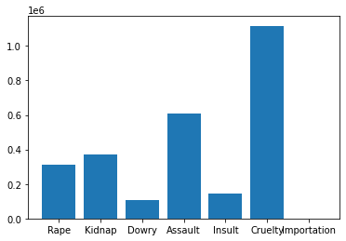

## Plot above shows over a million cases of cruelty and half million cases of assault have been reported in just 14 years.

**TYPES OF VIOLENCE;**

From our dataset we have data for 7 crimes. Rape, Kidnapping and abduction, dowry deaths, assault on women, insult to modesty, cruelty by husband or relatives, importation of girls. Below we explain the three categories of violence and place each of the crimes above and more into a category. We also talk about some crimes that are not in our data set.

1. **Physical violence** is exercised through physically aggressive acts such as kicking, biting, slapping, beating, or even strangling. Intentionally inflicted injuries are often disguised as accidents. At times, women are seriously injured and, in some cases, die as a result of their injuries.
2. **Psychological, mental, or emotional violence** describe acts such as preventing a woman from seeing family and friends, ongoing belittlement or humiliation, economic restrictions, violence or threats against cherished objects and other forms of controlling behaviors. This form of violence is more difficult to define across cultures and countries as it can take different forms.
3. **Sexual violence** includes forced sex through the use of physical force, threats, and intimidation, forced participation in degrading sexual acts as well as acts such as the denial of the right to use contraceptives or to adopt measures to protect against sexually transmitted diseases.

Although much sexual violence occurs in the context of intimate partner violence it can also take place in many other settings. Sexual violence can be exercised by another family member, a dating partner, acquaintance or stranger, striking young girls and adolescents as well as grown up women. A woman can be sexually violated by one or several people as in gang rapes.

The terms rape, sexual assault, sexual abuse, and sexual violence are often used interchangeably. However, these terms may have very different meanings and implications in varying situations and locations. The first two tend to be defined legally, with rape often being more narrowly defined than sexual assault. Legal definitions may vary from medical and social definitions and can also vary between countries.

1. **PHYSICAL VIOLENCE**

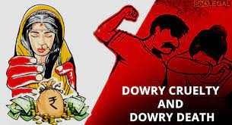

**Dowry death** - A [dowry death](https://en.wikipedia.org/wiki/Dowry_death) is the murder or suicide of a married woman caused by a dispute over her [dowry](https://en.wikipedia.org/wiki/Dowry). In some cases, husbands and in-laws will attempt to extort a greater [dowry](https://en.wikipedia.org/wiki/Dowry) through continuous harassment and torture which sometimes results in the wife committing suicide, or the exchange of gifts, money, or property upon marriage of a family's daughter.

The majority of these suicides are done through hanging, poisoning or [self-immolation](https://en.wikipedia.org/wiki/Self-immolation). When a dowry death is done by setting the woman on fire, it is called [bride burning](https://en.wikipedia.org/wiki/Bride_burning). Bride burning murder is often set up to appear to be a suicide or accident, sometimes by setting the woman on fire in such a way that it appears she ignited while cooking with a kerosene stove. Dowry is illegal in India, but it is still common practice to give expensive gifts to the groom and his relatives at weddings which are hosted by the family of the bride.

### 

### 

### 

### 

### Comparing number of reported dowry deaths cases by year with Apache dataset from kaggle

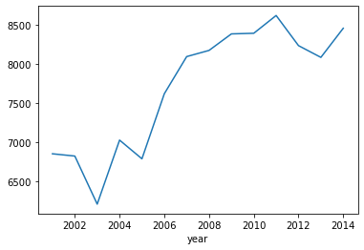

## The plot shows that there is no decline in the number of dowry deaths as it keeps rising per year.

In [Uttar Pradesh](https://en.wikipedia.org/wiki/Uttar_Pradesh), 2,244 cases were reported, accounting for 27.3% of the dowry deaths nationwide. In Bihar, 1,275 cases were reported, accounting for 15.5% of cases nationwide.

Incidents of dowry deaths have decreased 4.5% from 2011 to 2012.

In 2018, still as many as 5,000 dowry deaths are recorded each year.



**Honour killings**- An [honor killing](https://en.wikipedia.org/wiki/Honor_killing) is a murder of a family member who has been considered to have brought dishonor and shame upon the family. Examples of reasons for honor killings include the refusal to enter an arranged marriage, committing adultery, choosing a partner that the family disapproves of, and becoming a victim of rape. Village caste councils or [khap panchayats](https://en.wikipedia.org/wiki/Caste_panchayat) in certain regions of India regularly pass death sentences for persons who do not follow their diktats on [caste](https://en.wikipedia.org/wiki/Caste) or [gotra](https://en.wikipedia.org/wiki/Gotra). The volunteer group known as [Love Commandos](https://en.wikipedia.org/wiki/Love_Commandos) from Delhi, runs a helpline dedicated to rescuing couples who are afraid of violence for marrying outside of caste lines.

The most prominent areas where honor killings occur in India are northern regions. Honour killings are especially seen in [Haryana](https://en.wikipedia.org/wiki/Haryana), [Bihar](https://en.wikipedia.org/wiki/Bihar), [Uttar Pradesh](https://en.wikipedia.org/wiki/Uttar_Pradesh), [Rajasthan](https://en.wikipedia.org/wiki/Rajasthan), [Jharkhand](https://en.wikipedia.org/wiki/Jharkhand), [Himachal Pradesh](https://en.wikipedia.org/wiki/Himachal_Pradesh), and [Madhya Pradesh](https://en.wikipedia.org/wiki/Madhya_Pradesh). Honour killings have notably increased in some Indian states which has led to the [Supreme Court of India](https://en.wikipedia.org/wiki/Supreme_Court_of_India), in June 2010, issuing notices to both the Indian central government and six states to take preventative measures against honor killings.

Honour killings can be very violent. For example, in June 2012, a father decapitated his 20-year-old daughter with a sword upon hearing that she was dating a man who he did not approve of.

Honour killings can also be openly supported by both local villagers and neighbouring villagers. This was the case in September 2013, when a young couple who married after having a love affair were brutally murdered.

**DOMESTIC VIOLENCE (CRUELTY BY HUSBAND AND RELATIVES)**

[Domestic violence](https://en.wikipedia.org/wiki/Domestic_violence) is abuse by one partner against another in an intimate relationship such as dating, marriage, cohabitation or a familial relationship.

Domestic violence is also known as domestic abuse, spousal abuse, battering, family violence, [dating abuse](https://en.wikipedia.org/wiki/Dating_abuse) and [intimate partner violence](https://en.wikipedia.org/wiki/Intimate_partner_violence) (IPV). **Sometimes the relatives of husbands in the case of marriage could also commit some of the acts that harm the woman**. Domestic violence can be physical, emotional, verbal, economic and [sexual abuse](https://en.wikipedia.org/wiki/Sexual_abuse). Domestic violence can be subtle, coercive or violent. In India, 70% of women are victims of domestic violence.

38% of Indian men admit they have physically abused their partners.The Indian government has taken measures to try to reduce domestic violence through legislation.

## 

The map shows the comparative rate of violence against women in Indian states and union territories in 2012. Crime rate data per 100,000 women in this map is the broadest definition of crime against women under Indian law. It includes rape, sexual assault, insult to modesty, kidnapping, abduction, cruelty by intimate partner or relatives, trafficking, persecution for dowry, dowry deaths, indecency, and all other crimes listed in Indian Penal Code.

## Forms of domestic violence

1)**Physical violence -** Physical injury is the most visible form of domestic violence. The scope of physical domestic/intimate partner violence includes slapping, pushing, kicking, biting, hitting, throwing objects, strangling, beating, threatening with any form of weapon, or using a weapon.Worldwide, the percentage of women who suffer serious injuries as a result of physical domestic violence tends to range from 19% – 55%.Physical injuries as a result of domestic violence against women are more obvious than psychological ones, and can be more easily discerned by health professionals as well as courts of law in the context of legal prosecution.

**2) Emotional abuse -** [Emotional abuse](https://en.wikipedia.org/wiki/Emotional_abuse) has been gaining more and more recognition in recent years as an incredibly common form of domestic violence (and therefore a [human rights abuse](https://en.wikipedia.org/wiki/Human_rights_abuse)) within the private home throughout developing nations such as India. Psychological abuse can erode a woman's sense of self-worth and can be incredibly harmful to overall mental and physical wellbeing. Emotional/psychological abuse can include harassment; threats; verbal abuse such as name-calling, degradation and blaming; stalking; and isolation

Women who experience domestic violence overwhelmingly tend to have greater overall emotional distress, as well as disturbingly high occurrences of suicidal thoughts and attempts. According to a study by the National Centre for Biotechnology Information, suicide attempts in India are correlated with physical and psychological intimate partner violence. Of the Indian women who participated in the study, 7.5% reported attempting suicide. This correlation is supported by the high rates of domestic violence in India, although the rates differ greatly by region, individual [socioeconomic status](https://en.wikipedia.org/wiki/Socioeconomic_status) and other factors.

3) **Sexual assault** - Domestic [sexual assault](https://en.wikipedia.org/wiki/Sexual_assault) is a form of domestic violence involving sexual/[reproductive coercion](https://en.wikipedia.org/wiki/Reproductive_coercion) and [marital rape](https://en.wikipedia.org/wiki/Marital_rape). Under Indian law, marital rape is not a crime, except during the period of [marital separation](https://en.wikipedia.org/wiki/Marital_separation) of the partners.

**KIDNAPPING AND ABDUCTION**



Kidnapping means unlawfully detaining a person or persons against their will (including through the use of force, threat, fraud or enticement) for the purpose of demanding for their liberation an illicit gain or any other economic gain or other material benefit; or in order to oblige someone to do or not to do something.

People are kidnapped and abducted by criminals for various reasons and intentions, which can include adoption, begging, illicit intercourse, marriage, prostitution, ransom, revenge, sale, selling body parts, slavery, murder and for many other purposes.

A total of 77,237 cases of kidnapping and abduction were reported during the year 2014, showing an increase of 67.9% over the 2004 level (46,003 cases), an increase of 67.9% over the average of 2009-2013 and an increase of 18.0% over the previous year (65,461 cases).

The highest incidence of kidnappings and abductions were reported from Uttar Pradesh (12,361 cases) accounting for 16.0% of total such crimes followed by 10.1% in Madhya Pradesh (7,833 cases), 9.2% in Delhi UT (7,143 cases) and 8.5% in Bihar (6,570 cases).

A total of 78,446 persons were kidnapped and abducted during 2014 compared to 66,441 persons in the previous year (2013), showing an increase of 16.2% during 2014 over the year 2013.

Majority of victims of kidnapping and abduction were females (58,492), accounting for 74.6% of total kidnapped and abducted persons during 2014.

Marriage was the main cause of kidnapping and abduction of females accounting for 52.9% (30,957 out of 58,492) of the total females kidnapped and abducted.

**3. SEXUAL VIOLENCE**

**ASSAULT ON WOMEN WITH INTENT TO OUTRAGE HER MODESTY.**

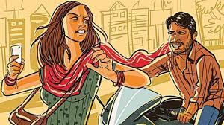

This refers to **assaults or uses of criminal force to any woman**, intending to outrage or knowing it to be likely that he will thereby outrage her modesty. For example, the act of pulling a woman, removing her saree, coupled with a request for sexual intercourse...would be an outrage to the modesty of a woman.

Outraging the modesty In ordinary language "modest" means freedom from conceit or vanity or propriety in dress, speech and conduct. The word "outrage" has affinity with extremely rude, violent, injurious or insulting act on one hand and it is connected with guilt, culpability, criminality and deviation from rectitude on the part of the person committing assault or using criminal force on a woman.

**INSULT TO MODESTY OF WOMEN**.

To insult the modesty of any woman means to utter any words, make any sound or gesture, or exhibit any object, intending that such word or sound shall be heard, or that such gesture or object shall be seen, by such woman, or intrudes upon the privacy of such woman.

Acts such as inappropriate staring and taking up-skirt photographs that have been mistaken to be an outrage of modesty. This can be reconciled with the understanding that these acts **do not involve an assault or use of criminal force,** and hence do not satisfy the first element of an outrage of modesty.

**RAPE**

There are many myths about rape—to have sex against one’s will—which are based on stereotypes about what is appropriate sexual behaviour for men and women. For example, most people associate rape with a violent attack by a stranger, but rape is most often perpetrated by someone known to the victim. There is also an assumption that rape leaves obvious signs of injury, which is often not the case. Only around one third of rape victims sustain visible physical injuries. Physical violence or pressure in the form of blackmail or threats might occur simultaneously with the rape, or is the violence carried out while the woman is asleep or under the influence of alcohol or other drugs, unable to defend herself. Rape is often not reported to the police and existing statistics greatly underestimate the magnitude of the problem.

India is considered to be one of the world’s most dangerous country for sexual violence against women. Rape is one of the most common crimes in India. [Criminal Law (Amendment) Act, 2013](https://en.wikipedia.org/wiki/Criminal_Law_(Amendment)_Act,_2013) defines rape as penile and non-penile penetration in bodily orifices of a woman by a man, without the consent of the woman.According to the National Crime Records Bureau, one woman is raped every 20 minutes in India. Incidents of reported rape increased 3% from 2011 to 2012. Incidents of reported incest rape increased 46.8% from 268 cases in 2011 to 392 cases in 2012.Despite its prevalence, rape accounted for 10.9% of reported cases of violence against women in 2016.Victims of rape are increasingly reporting their rapes and confronting the perpetrators. Women are becoming more independent and educated, which is increasing their likelihood to report their rape.

Although rapes are becoming more frequently reported, many go unreported or have the complaint files withdrawn due to the perception of family honour being compromised. Women frequently do not receive justice for their rapes, because police often do not give a fair hearing, and/or medical evidence is often unrecorded which makes it easy for offenders to get away with their crimes under the current laws.

Increased attention in the media and awareness among both Indians and the outside world is both bringing attention to the issue of rape in India and helping empower women to report the crime. After international news reported the gang rape of a 23-year-old student on a moving bus that occurred in Delhi, in December 2012, Delhi experienced a significant increase in reported rapes. The number of reported rapes nearly doubled from 143 reported in January–March 2012 to 359 during the three months after the rape. After [the Delhi rape case](https://en.wikipedia.org/wiki/2012_Delhi_gang_rape), Indian media has committed to report each and every rape case.

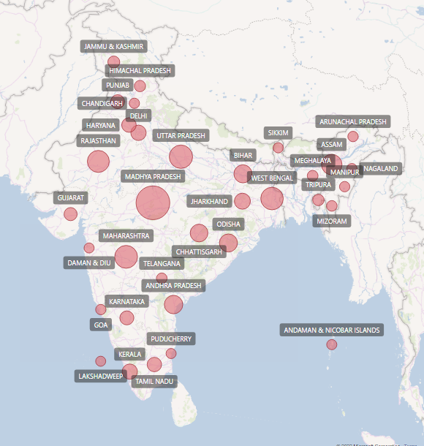

Plot comparing rape cases in India in different states (2001-2014)

## Top 10 states with most number of rapes in 2014 with Apache dataset from kaggle

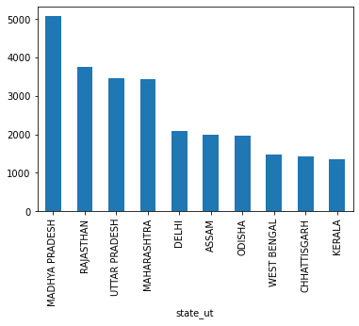

Plot comparing rape cases in different states in India(2014) shows Madhya Pradesh as the state with the highest number of rape

**Marital Rape -** In India, [marital rape](https://en.wikipedia.org/wiki/Marital_rape) is not a criminal offense. India is one of fifty countries that have not yet outlawed marital rape. 20% of Indian men admit to forcing their wives or partners to have sex. Marital rape of an adult wife, who is unofficially or officially separated, is a criminal offence punishable by 2 to 7 year in prison; it is not dealt by normal rape laws which stipulate the possibility of a death sentence.

Marital rape can be classified into one of three types:

* Battering rape: This includes both physical and sexual violence. The majority of marital rape victims experience battering rape.
* Force-only rape: Husbands use the minimum amount of force necessary to coerce his wife.
* Compulsive or obsessive rape: Torture and/or "perverse" sexual acts occur and are often physically violent.

### Comparing number of reported rape cases by year with Apache dataset from kaggle

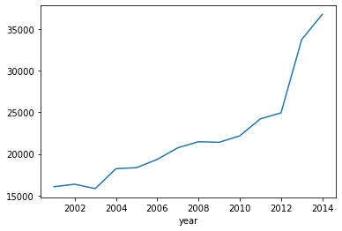

## Plot above shows that the number of rape cases have an increasing trend over the years.

**HUMAN TRAFFICKING AND FORCED PROSTITTION(Importation of Girls)**

Human trafficking in India, although illegal under Indian law, remains a significant problem. People are frequently illegally trafficked through India for the purposes of commercial sexual exploitation and forced/bonded labour. Women and children are trafficked in India for diverse reasons. Women and girls are trafficked within the country for the purposes of commercial sexual exploitation and forced marriage, especially in those areas where the sex ratio is highly skewed in favour of men.

Human trafficking in India results in women suffering from both mental and physical issues. Mental issues include disorders such as PTSD, depression and anxiety. The lack of control women have in trafficking increases their risk of suffering from mental disorders. Women who are forced into trafficking are at a higher risk for HIV, TB, and other STDs. Condoms are rarely used and therefore there is a higher risk for victims to suffer from an STD.

### Comparing number of reported human trafficking by year with Apache dataset from kaggle

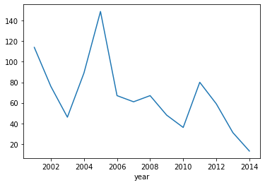

## Plot above shows that the number of human trafficking cases have a decreasing trend over the years.

We notice from above that we have the most cases in the early part of the century, but most of them in 2005.

**The plots below shows the trend of human trafficking cases across the different states and districts in india.**

## 

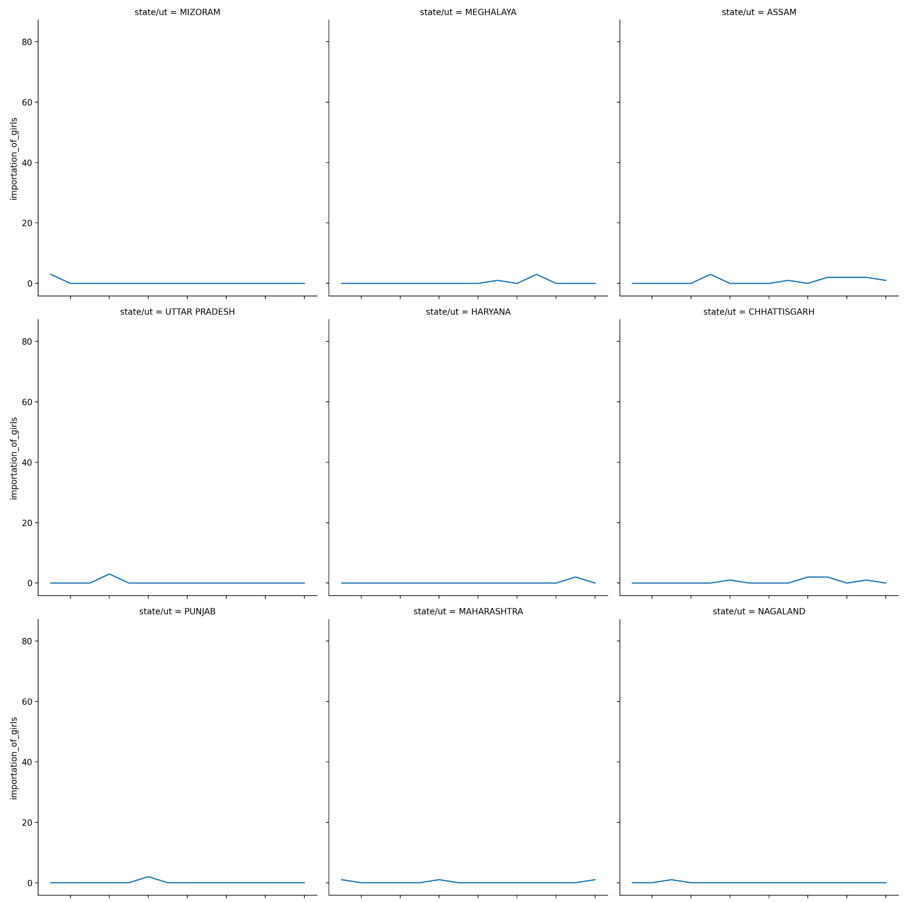

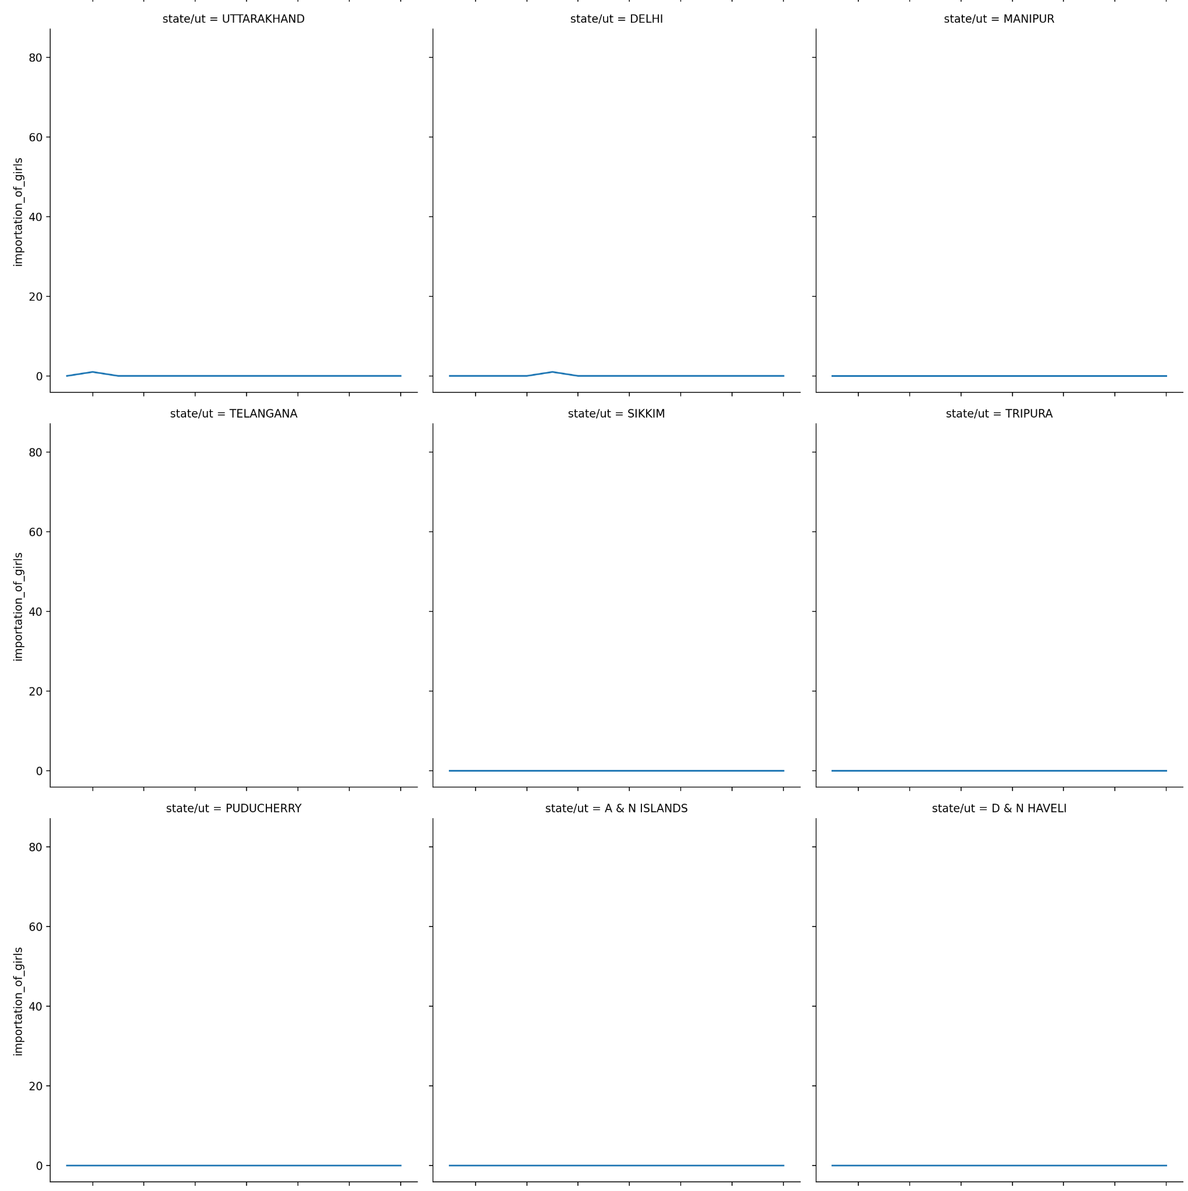

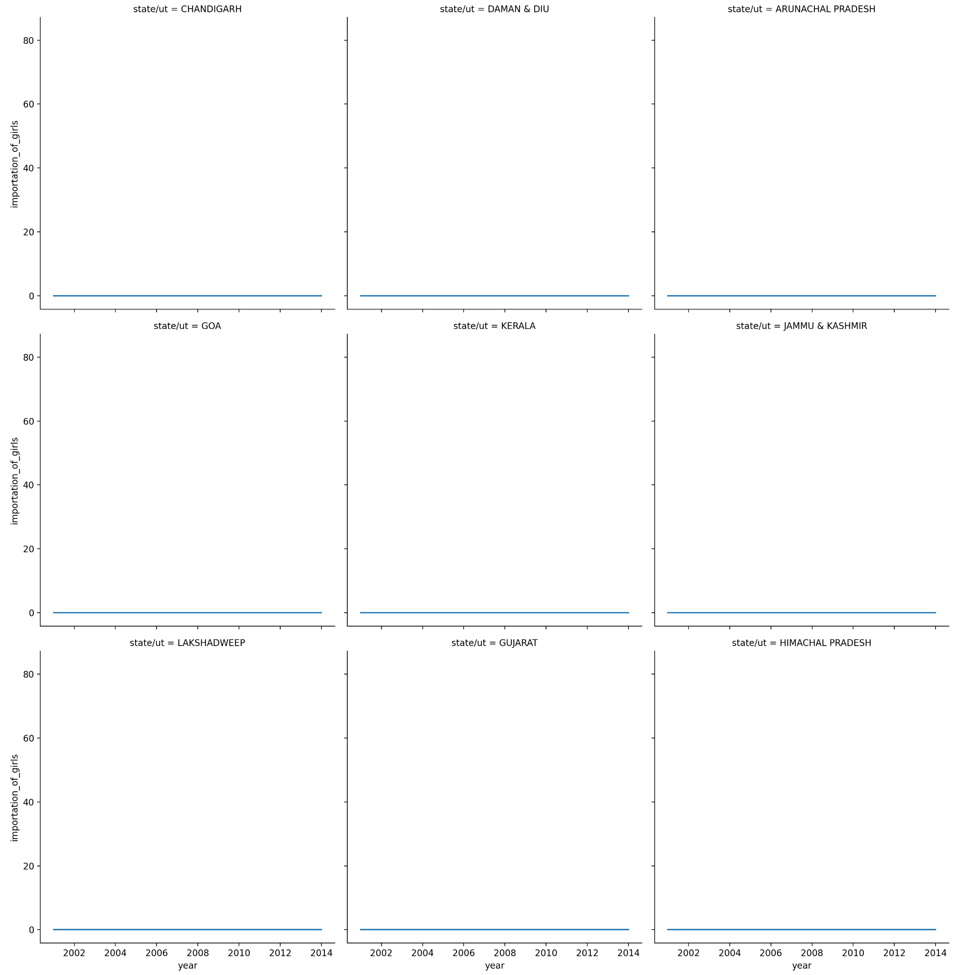

**We see that even across states mostly, we have more human trafficking cases around 2005.**

## 

## CONCLUSIONS

There is still limited knowledge about what interventions are most effective for the prevention of gender based violence, however documentation and evaluation are key elements in building this knowledge and clear definitions are an important element in this.

Violence against women is a serious violation of women’s human rights and of direct concern to the public health sector because of the significant contributions that public health workers could do if properly trained, as they are placed close to the victims, and possibly well acquainted with the community and its inhabitants. Thus, local health services and communities could play a central part in raising awareness among the public to prevent this violence. To openly debate this subject is a way to reduce society’s tolerance towards violence against women.

In India, reducing domestic violence is imperative not only from an ethical and human rights perspective but also because of obvious instrumental and immediate health benefits that would be gained from such reduction.