**Photos32 Storyboard Overview**

**go ba**

Login

User album list

Admin

Search photos

User album photos

Rename album

Add album

Search results

Create/edit caption

Copy photo

Move photo

Add tag

**We can go back skipping a screen e.g. Move photo to User album list.**

**Storyboard**

1

Clicking Login button takes to either 2 or 3 based on Username

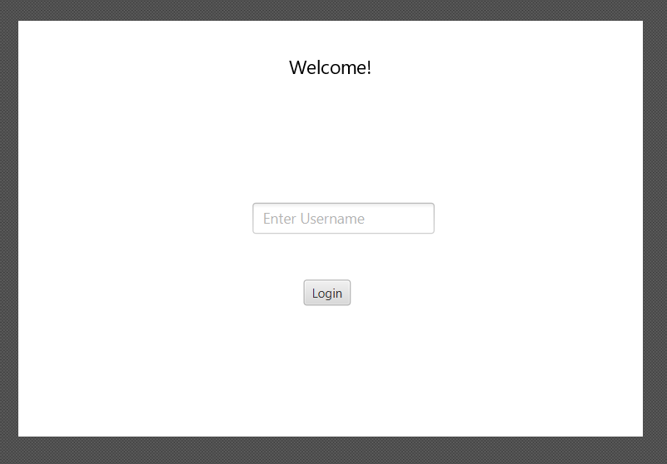

2

3

**Storyboard**

2

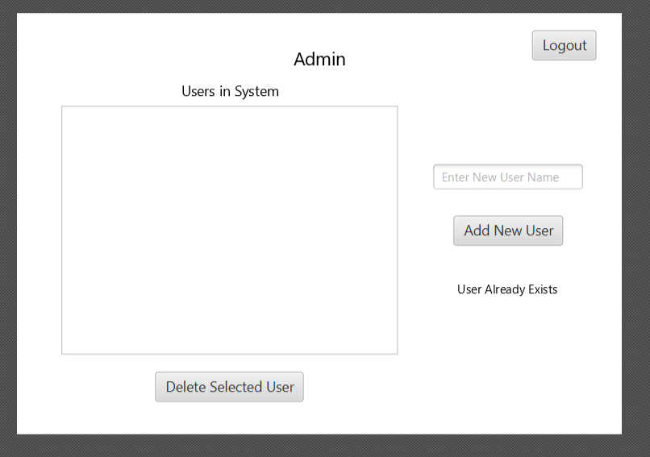

1

**Storyboard**

3

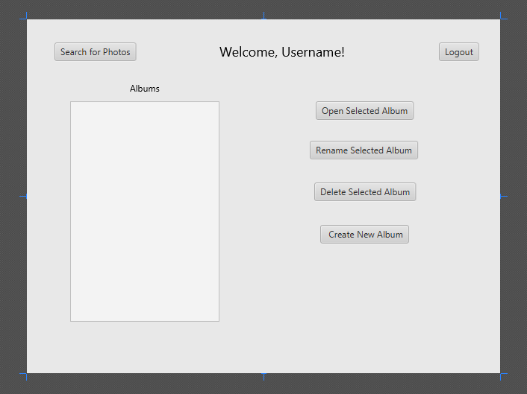

5

4

9

**Storyboard**

4

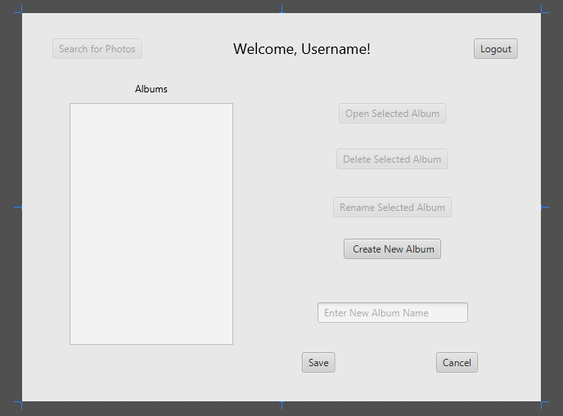

3

1

3

**Storyboard**

5

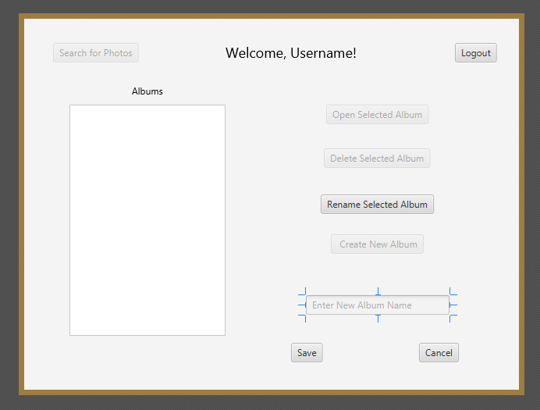

3

3

1

**Storyboard**

6

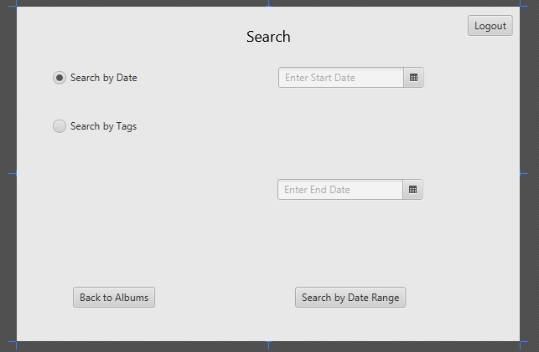

3

7

8

**Storyboard**

7

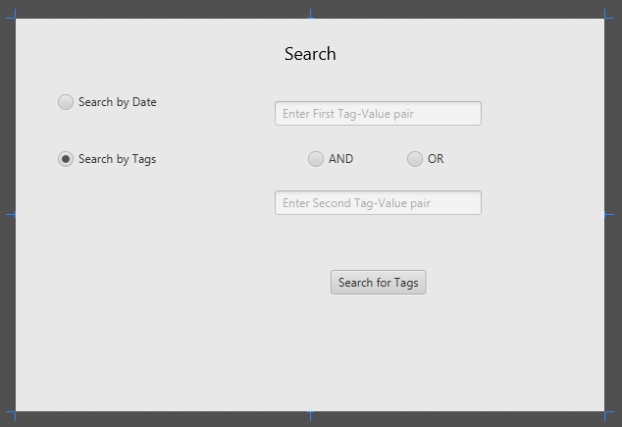

Back to albums

6

3

8

**Storyboard**

8

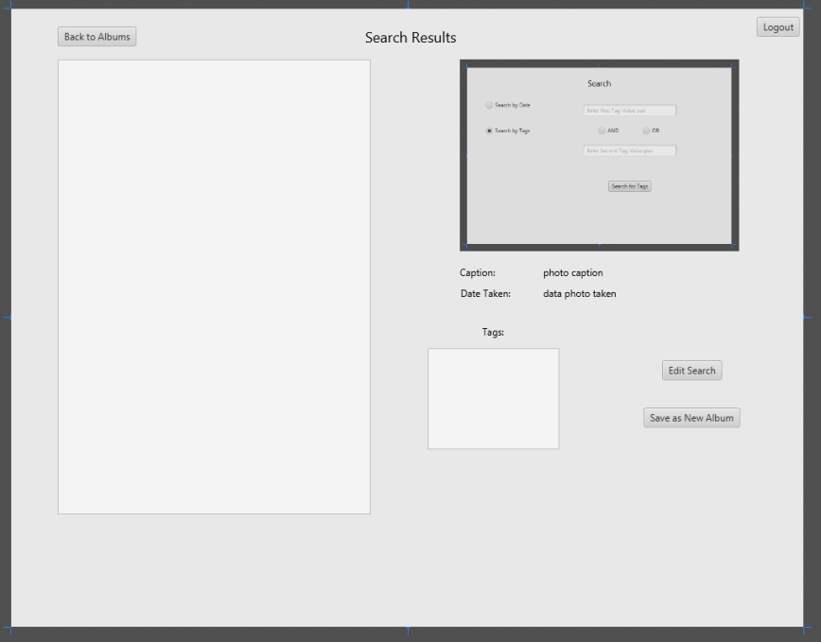

1

14

3

6/7

**Storyboard**

9

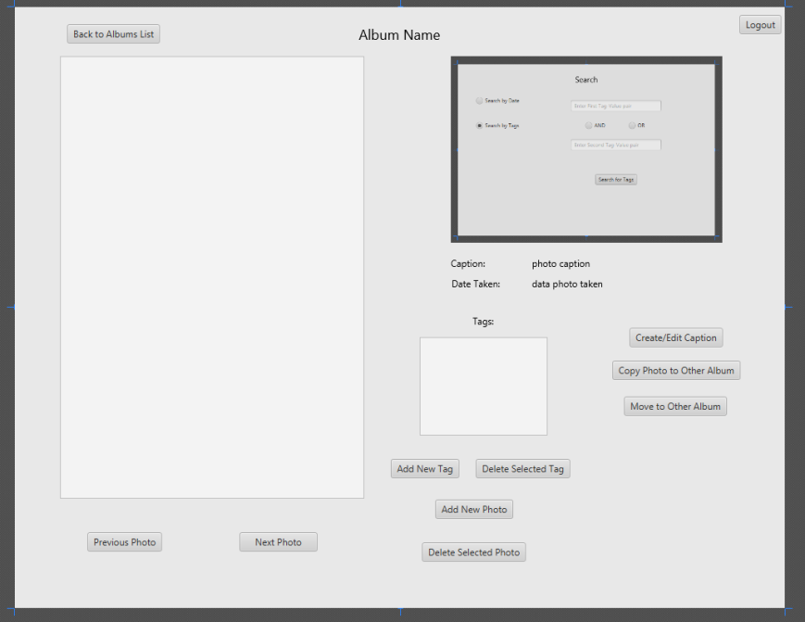

10

3

1

12

11

13

File explorer

**Storyboard**

10

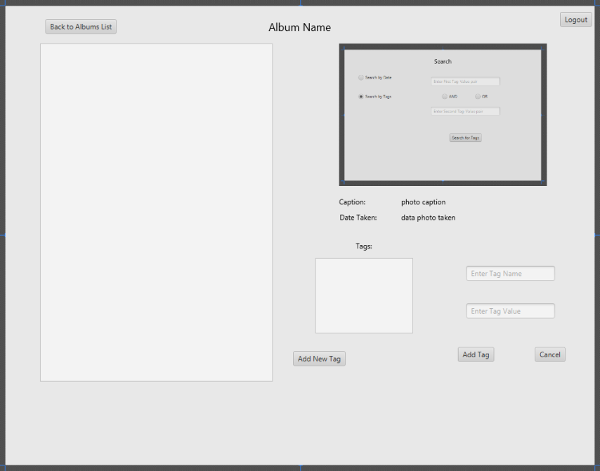

1

13

3

**Storyboard**

11

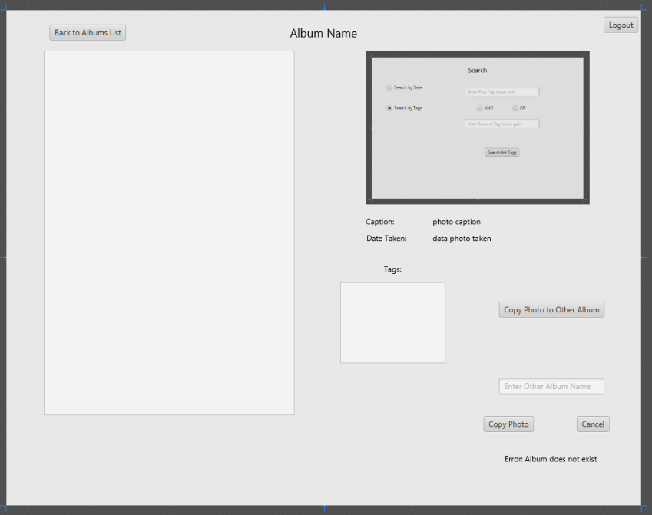

1

9

3

**Storyboard**

12

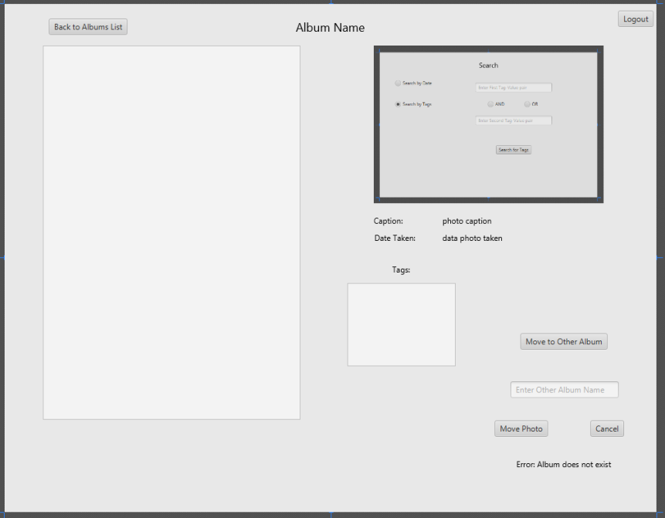

3

9

1

**Storyboard**

13

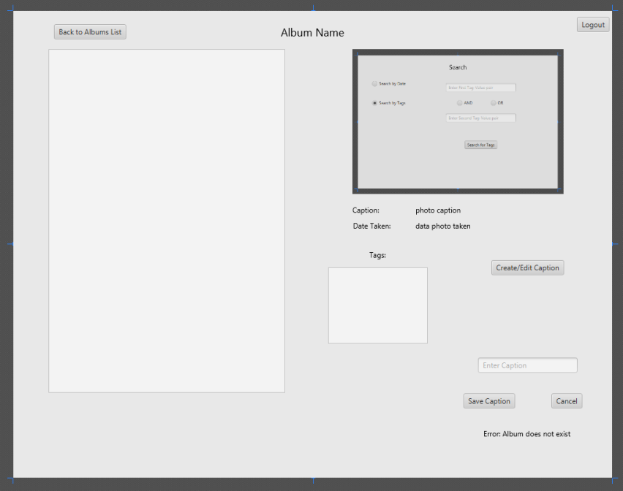

3

1

9

**Storyboard**

14

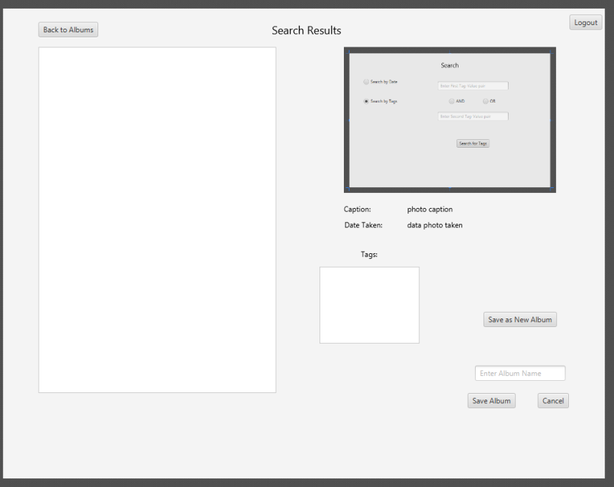

1

8

3

3