**University of Manchester UK Biobank papers 2024**

I’ve used research explorer to search for UK Biobank research by UoM researchers in 2024. Apologies if I’ve missed anything. If I have feel free to let me know and I’ll add them on.

**35 papers** (including 6 preprints) from **50 UoM researchers** (across 2 faculties, 4 schools and 16 divisions/departments), published in **29 journals** (including medRxiv and psyArXiv).

I’ve thrown the titles and abstracts into R and made some pretty word clouds to try to get an overview of types of research. Surprise surprise “biobank” came up as a frequently used word!

***Titles***

***Abstracts***

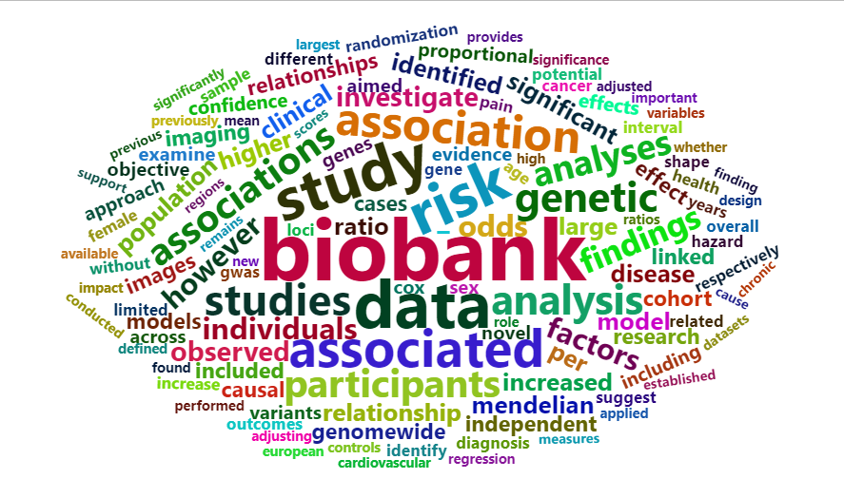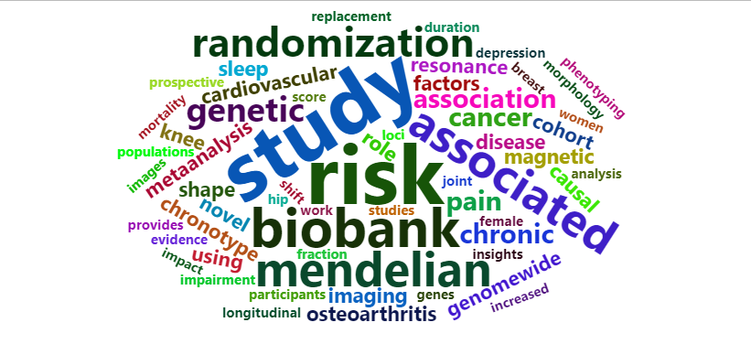

A full list of papers, in alphabetical order, is below (with links). Names in **bold** are UoM linked researchers (to the best of my knowledge).

[**A Generative Shape Compositional Framework to Synthesize Populations of Virtual Chimeras**](https://research.manchester.ac.uk/en/publications/a-generative-shape-compositional-framework-to-synthesize-populati)

Haoran Dou, Seppo Virtanen, Nishant Ravikumar, **Alejandro F Frangi**

IEEE Transactions on Neural Networks and Learning Systems

<https://doi.org/10.1109/TNNLS.2024.3374121>

[**Analysis of more than 400,000 women provides case-control evidence for BRCA1 and BRCA2 variant classification**](https://research.manchester.ac.uk/en/publications/analysis-of-more-than-400000-women-provides-case-control-evidence)

Maria Zanti, Denise G. O’Mahony, ….,**D.** **Gareth Evans, Sacha J Howell, Artitaya Lophatananon, Kenneth Muir**,… Kyriaki Michailidou.

medRxiv.

<https://doi.org/10.1101/2024.09.04.24313051>

### [A novel classifier of radiographic knee osteoarthritis for use on knee DXA images is predictive of joint replacement in UK Biobank](https://research.manchester.ac.uk/en/publications/a-novel-classifier-of-radiographic-knee-osteoarthritis-for-use-on)

Rhona A Beynon, Fiona R Saunders, **Raja Ebsim**, Benjamin G Faber, Mijin Jung, Jennifer S Gregory, **Claudia Lindner**, Richard M Aspden, Nicholas C Harvey**, Timothy Cootes**, Jonathan H Tobias

medRxiv

<https://doi.org/10.1101/2024.08.08.24311666>

**Association of Rest Activity Rhythm and Risk of Developing Dementia or Mild Cognitive Impairment in the middle-aged and older population**

Shahab Haghayegh, Chenlu Gao, Elizabeth Sugg, Xi Zheng, Hui-Wen Yang, Richa Saxena, **Martin K. Rutter**, Michael Weedon, Agustin Ibanez, David A Bennett, Peng Li, Lei Gao, Kun Hu

JMIR Public Health and Surveillance

<https://doi.org/10.2196/55211>

**Autoencoder-based phenotyping of ophthalmic images highlights genetic loci influencing retinal morphology and provides informative biomarkers**

**Panos Sergouniotis**, Adam Diakite, Kumar Gaurav, Ewan Birney, Tomas Fitzgerald

medRxiv

<https://doi.org/10.1101/2023.06.15.23291410>

**Automated cardiac coverage assessment in cardiovascular magnetic resonance imaging using an explainable recurrent 3D dual-domain convolutional network**

Shahabedin Nabavi, Mohammad Hashemi, Mohsen Ebrahimi Moghaddam*, Ahmad Ali Abin, **Alejandro F. Frangi**

Medical Physics

<https://doi.org/10.1002/mp.17411>

**Causal associations of central and peripheral risk factors with knee osteoarthritis: a longitudinal and Mendelian Randomisation study using UK Biobank data**

William David Thompson, Subhashisa Swain, **Sizheng Zhao**, Carol Coupland, Changfu Kuo, Michael Doherty, Weiya Zhang

PAIN

<https://doi.org/10.1097/j.pain.0000000000003183>

**Chronotype, but not night shift work, is associated with psoriasis: a cross-sectional study among UK biobank participants**

**Robert Maidstone, Mudassar Iqbal, Martin K. Rutter,** **David W. Ray,** **Helen Young**

Journal of Investigative Dermatology

<https://doi.org/10.1016/j.jid.2023.07.019>

**Depression, Brain Structure and Socioeconomic Status: A UK Biobank Study**

**Sasha Johns, Caroline Lea-Carnall, Nick Shryane, Asri Maharani**

Journal of Affective Disorders

<https://doi.org/10.1016/j.jad.2024.09.102>

**Differences in polygenic score distributions in European ancestry populations: implications for breast cancer risk prediction**

Kristia Yiangou, …, **D. Gareth Evans, Sacha Howell, Anthony Howell, Eleanor Roberts**, …, Kyriaki Michailidou

medRxiv

<https://doi.org/10.1101/2024.02.12.24302043>

**Dual-energy X-ray absorptiometry derived knee shape may provide a useful imaging biomarker for predicting total knee replacement: findings from a study of 37,843 people in UK Biobank.**

Rhona A. Beynon, Fiona R. Saunders, **Raja Ebsim**, Monika Frysz, Benjamin G. Faber, Jennifer S. Gregory, **Claudia Lindner**, Aliya Sarmanova, Richard M. Aspden, Nicholas C. Harvey, **Timothy Cootes**, Jonathan H. Tobias

Oesteoarthritis and Cartilage Open

<https://doi.org/10.1016/j.ocarto.2024.100468>

**Executive functioning and its role in high impact chronic pain. Building a causal model using Directed Acyclic Graphs.**

Annick De Paepe, Anna Gibby, Laura Oporto Lisboa, Beate Ehrhardt, Matthew Nunes, Emma Fisher, Edmund Keogh, Christopher Eccleston, **Charlotte Sarah Catherine Woolley, John McBeth,** Geert Crombez

PsyArXiv

<https://doi.org/10.31234/osf.io/e8afg>

**Femoral neck width genetic risk score is a novel independent risk factor for hip fractures**

Jon Tobias, Maria Nethander, Benjamin Faber, Sophie Heppenstall, **Raja Ebsim, Tim F Cootes, Claudia Lindner,** Fiona Saunders, Jennifer Gregory, Richard Aspden, Nicholas Harvey, John Kemp, Monika Frysz, Claes Ohlsson

Journal of Bone and Mineral Research

<https://doi.org/10.1093/jbmr/zjae002>

**Genetically proxied IL-13 inhibition is associated with risk of psoriatic disease: Mendelian randomization study**

**Sizheng Steven Zhao, Kimme Hyrich, Zenas Yiu, Anne Barton, John Bowes**

Arthritis and Rheumatology

<https://doi.org/10.1002/art.42942>

**Genome-wide association study meta-analysis of dizygotic twinning illuminates genetic regulation of female fecundity**

Hamdi Mbarek, ..., **Cynthia C Morton**, …, Dorret I Boomsma, Nicholas G Martin

Human Reproduction

<https://doi.org/10.1093/humrep/dead247>

**Hippocampal and limbic microstructure changes associated with stress across the lifespan: a UK biobank study**

**Elizabeth McManus, Hamied Haroon,** Niall W. Duncan, **Rebecca Elliott, Nils Muhlert**

Scientific Reports

<https://doi.org/10.1038/s41598-024-71965-4>

**How Well Can We Measure Chronic Pain Impact in Existing Longitudinal Cohort Studies? Lessons Learned**

Diego Vitali, **Charlotte S C Woolley**, Amanda Ly, Matthew Nunes, Laura Oporto Lisboa, Edmund Keogh, **John McBeth,** Beate Ehrhardt, Amanda C de C Williams, Christopher Eccleston

Journal of Pain

<https://doi.org/10.1016/j.jpain.2024.104679>

**Increased risk of asthma in female night shift workers**

**Robert Maidstone, David Ray**, Junxi Liu, Jack Bowden**, Martin K. Rutter, Hannah Durrington**

medRxiv

<https://doi.org/10.1101/2024.12.05.24318539>

**Insomnia and short sleep duration, but not chronotype, is associated with chronic widespread pain: Mendelian randomization study**

**Jacob Corum Williams, Ryan Malcolm Hum**, Uazman Alam, **Sizheng Zhao**

Rheumatology International

<https://doi.org/10.1007/s00296-024-05636-y>

**Joint shape/texture representation learning for cardiovascular disease diagnosis from magnetic resonance imaging**

Xiang Chen, Yan Xia, Erica Dall'Armellina, Nishant Ravikumar, **Alejandro F Frangi**

European Heart Journal - Imaging Methods and Practice

<https://doi.org/10.1093/ehjimp/qyae042>

**Large-scale genome-wide association study of 398,238 women unveils seven novel loci associated with high-grade serous epithelial ovarian cancer risk**

Daniel R. Barnes, …, **D. Gareth Evans**, …, Paul D.P. Pharoah

medRxiv

<https://doi.org/10.1101/2024.02.29.24303243>

**Modifiable risk factors and inflammation-related proteins in polymyalgia rheumatica: genome-wide meta-analysis and Mendelian randomisation**

**Sizheng Zhao**, Sarah L Mackie, Susanna C. Larsson, Stephen Burgess, Shuai Yuan

Rheumatology

<https://doi.org/10.1093/rheumatology/keae308>

**Overall mortality for community-dwelling adults over 50 years at risk of malnutrition**

**Matthew Gittins, Nada AlMohaisen, Chris Todd,** Simon Lal, **Sorrel Burden**

Journal of Cachexia, Sarcopenia and Muscle

<https://doi.org/10.1002/jcsm.13585>

**Population-based germline breast cancer gene association studies and meta-analysis to inform wider mainstream testing**

C.F. Rowlands, S. Allen, J. Balmaña, S. M. Domchek, **D. G. Evans**, H. Hanson, N. Hoogerbrugge, P.A. James, K. L. Nathanson, M. Robson, M. Tischkowitz, W. D. Foulkes, C. Turnbull

Annals of Oncology

<https://doi.org/10.1016/j.annonc.2024.07.244>

**Rationale and design of the United Kingdom Heart Failure with Preserved Ejection Fraction Registry**

UK HFpEF Collaborative Group. **Exec committee chaired by Christopher Miller**

Heart failure and cardiomyopathies

<https://doi.org/10.1136/heartjnl-2023-323049>

**Risk factors for raised left ventricular filling pressure by cardiovascular magnetic resonance: Prognostic insights**

Ross J Thomson, Ciaran Grafton-Clarke, Gareth Matthews, Peter P Swoboda, Andrew J Swift, **Alejandro Frangi,** Steffen E Petersen, Nay Aung, Pankaj Garg

ESC Heart Failure

<https://doi.org/10.1002/ehf2.15011>

**Shift work and evening chronotype are associated with hepatic fat fraction and non-alcoholic fatty liver disease in 282,303 UK biobank participants**

**Robert Maidstone, Martin K. Rutter,** Thomas Marjot, **David W. Ray**, Matthew Baxter

Endocrine Connections

<https://doi.org/10.1530/EC-23-0472>

**Sleep regularity is a stronger predictor of mortality risk than sleep duration**

Daniel P. Windred, Angus C. Burns, Jacqueline M. Lane, Richa Saxena, **Martin K. Rutter,** Sean W. Cain, Andrew J. K. Phillips

Sleep

<https://doi.org/10.1093/sleep/zsad253>

**Speech-in-noise hearing impairment is associated with increased risk of Parkinson’s: A UK Biobank Analysis.**

**Megan Rose Readman**, Yang Wang, Fang Wan, Ian Fairman, Sally A. Linkenauger, Trevor J. Crawford, **Christopher J. Plack**

Parkinsonism and Related Disorders

<https://doi.org/10.1016/j.parkreldis.2024.107219>

**Strengthening the Evidence for a Causal Link between Type 2 Diabetes Mellitus and Pancreatic Cancer: Insights from Two-Sample and Multivariable Mendelian Randomization**

**Te-Min Ke, Artitaya Lophatananon, Kenneth R. Muir**

International Journal of Molecular Sciences

<https://doi.org/10.3390/ijms25094615>

**The co-occurrence of genetic variants in the TYR and OCA2 genes confers susceptibility to albinism**

**David Green**, Vincent Michaud, Eulalie Lasseaux, Claudio Plaisant, Tomas W. Fitzgerald, Ewan Birney, **Graeme Black**, Benoit Arveiler, **Panos Sergouniotis**

Nature Communications

<https://doi.org/10.1038/s41467-024-52763-y>

**The genetic architecture of hip shape and its role in the development of hip osteoarthritis and fracture**

Benjamin G Faber, Monika Frysz, Jaiyi Zheng, Huandong Lin, Kaitlyn A Flynn, **Raja Ebsim**, Fiona R Saunders, Rhona Beynon, Jennifer S Gregory, Richard M Aspden, Nicholas C Harvey, **Claudia Lindner, Timothy Cootes,** David M Evans, George Davey Smith, Xin Gao, Sijia Wang, John P Kemp, Jonathan H Tobias

Human Molecular Genetics

<https://doi.org/10.1093/hmg/ddae169>

**The role of accelerometer-derived sleep traits on glycated haemoglobin and glucose levels: a Mendelian randomization study**

Junxi Liu, Rebecca C. Richmond, Emma L. Anderson, Jack Bowden, Ciarrah Jane S. Barry, Hassan S. Dashti, Iyas S. Daghlas, Jacqueline M. Lane, Simon D. Kyle, Céline Vetter, Claire L. Morrison, Samuel E. Jones, Andrew R. Wood, Timothy M. Frayling, **Alison K. Wright**, **Matthew J. Carr**, **Simon G. Anderson**, Richard A. Emsley, **David W. Ray,** Michael N. Weedon, Richa Saxena, **Martin K. Rutter,** Deborah A. Lawlor

Scientific Reports

<https://doi.org/10.1038/s41598-024-58007-9>

**Unsupervised ensemble-based phenotyping enhances discoverability of genes related to left-ventricular morphology**

Rodrigo Bonazzola, Enzo Ferrante, Nishant Ravikumar, Yan Xia, **Bernard Keavney**, Sven Plein, Tanveer Syeda-Mahmood, **Alejandro F Frangi**

Nature Machine Intelligence

<https://doi.org/10.1038/s42256-024-00801-1>

**Vitamin D, chronic pain, and depression: linear and non-linear Mendelian randomization analyses**

Emily Bassett, Eva Gjekmarkaj, Amy M. Mason, **Sizheng Zhao,** Stephen Burgess

Translational Psychiatry

<https://doi.org/10.1038/s41398-024-02997-7>