OFH cross-sectional analysis plan

Overview

- Brief analysis outline
- Asthma definition
- Shift work definition
- Variables (grouped by models used previously, with some potential extras also listed)
- Preliminary analysis using an age adjusted model

Brief analysis outline

- Sex stratified shift work/asthma analysis
  - Verifying results from ERJ Open paper in OFH

- Age and sex stratified shift work/asthma analysis
  - Do male/female differences vary of age groups
  - Can also consider age as a continuous variable although may be non-linear

- Contraception/asthma
  - Contraception type effect on asthma (this is ever used these types of contraception)
    - Might be linked mostly to health reasons as to why on particular medication
  - Length of time on pill. Have data on first started and last used pill

- Pill stratified shift work/asthma
  - Compare combined pill users (should be current users I think or maybe above a certain threshold of time spent on pill) against women on no contraceptive medication

- Menopause & HRT stratified shift work/asthma
  - Verify results found in UKB
  - Can look at both use of HRT as well as amount of time on it

Asthma definition

Currently used DIAG_RESP_1_M includes “Asthma” and MEDICAT_1_M. includes “Lung or breathing problems”. Can maybe split asthma from mod-severe asthma by also including medicat_resp_1_m.

DIAG_RESP_1_M: Have you ever been diagnosed with any of the following lung or respiratory conditions by a doctor or other health professional? Do not know, prefer not to answer, none of the above, COPD, lung fibrosis, bronchiectasis, asthma, hay fever, other

MEDICAT_1_M. Do you regularly take medications for any of the following reasons? Do not know, prefer not to answer, none of the above, autoimmune disorder, neurological disorders, pain relief, reproductive or sexual health, supplements/nutritional health, bone health, cancer, diabetic health, digestive problems, endocrine disorder, heart or circulatory health, lung or breathing problems, mental health conditions or insomnia

MEDICAT_RESP_1_M. Do you regularly take any of the following medication for lung or breathing problems? (numbers in current workers only ~944,511)
- Do not know, 637
- prefer not to answer, 51
- none of the above, 2705
- asthma reliever inhaler (usually blue), 71419
- asthma preventer inhaler (containing steroid medicine), 71836
- asthma combination inhaler, 20759
- anticholinergic inhaler (for COPD or asthma, e.g. Tiotropium or Spiriva), 9368
- leukotriene receptor antagonist (LTRAs) tablets (e.g. Montelukast), 7357
- tablet bronchodilator (e.g. theophylline), 923
- corticosteroids (e.g. prednisolone), 4610
- other not listed 7872

Shift work definition

WORK_SHIFTS_1_1: Does your work involve shift work? Do not know, prefer not to answer, never/rarely, sometimes, usually, always

WORK_NIGHTS_1_1: Does your work involve night shifts? Do not know, prefer not to answer, never/rarely, sometimes, usually, always

Currently defining groups in same way as in UKB. “no shift work” if answered “never/rarely” to work_shifts_1_1, else take values from work_nights_1_1 combining “usually” and “sometimes”.

Models:

Model 1:
- Age
  - SUBMISSION_YEAR – BIRTH_YEAR
    - Submission_year taken from submission_date
- Ethnicity
  - DEMOG_ETHNICITY_1_1: What is your ethnic group?
    - Prefer not to answer, white (sub cats for british, irish, gypsy or irish traveller, polish, other), Asian or Asian british (sub cats for indian, Pakistani, banglasdeshi,other), Chinese, black or black british (sub cats for African, Carribean, other), arab, mixed (sub cats for white/black carribean, white/black African, white/asian, other), other

Model 2:
- TDI
  - No fields in OFH
  - Or geographic location data I think ??
- Alcohol
  - UKB: status & daily intake
  - ALCOHOL_CURR_1_1: About how often do you drink alcohol?
    - Prefer not to answer, daily or almost daily, 3 or 4 times a week, once or twice a week, 1-3 times a month, special occasions only, never
  - ALCOHOL_PREV_1_1: Did you previously drink alcohol?
    - Prefer not to answer, no, yes
  - Also data on frequency of drinking specific types of alcohol (beer/cider, spirits, fort wine, white wine, red wine, other). Change from 10 years ago. Reason for stopping. Reason for reducing
- Days exercised
  - UKB: walked, moderate, vigorous
  - ACTIVITY_WALK_DAYS_2_1: Thinking about the last 4 weeks, in a typical week, how many days did you walk for a least 10 mins at a time?
  - ACTIVITY_WALK_MINS_2_1: Thinking about the last 4 weeks, how many minutes did you usually spend walking on a typical DAY?
  - Similar for VIG and MOD
  - Also data on climbing stairs
  - And type of activity (walking for pleasure, other (swimming, cycling, keep fit, bowling), strenuous sports, light DIY, Heavy DIY)
- Length of working week
  - WORK_WK_HRS_1_1: Ina typical week, how many hours do you spend at work?
- Chronotype
  - SLEEP_CHRONOTYPE_1_1: Do you consider yourself to be?
    - Do not know, prefer not to answer, definitely a “morning” person, more a “morning” than “evening” person, more an “evening” than a “morning” person, definitely an “evening” person.
- Job asthma risk
- Job medical required
  - No job SOC codes in OFH or anything detailed about job type. Only has data on distance to work, manual labour, shift wrok, transport to/from work, walking or standing most of time, work hours, times a week travelled to work, years in current job

Model 3:
- sleep duration
  - SLEEP_HRS_1_1: How many hours sleep do you get in every 24hours?
- sleep medication
  - MEDICAT_PSYCH_1_M: Do you regularly take any of the following medication for mental health conditions or insomnia
- smoking status
  - Ever used tobacco products (cigs, cigars, e cigs, etc.)
  - Followed by smoking status (how often smoked cigarettes)
- smoking pack years
  - can calculate, have number smoked per day, age started, age finished, maybe some data about breaks of >6months
- BMI
  - Have height and weight (from clinic measurements) so can calculate
  - Can also use BRI as have Waist circumference

Potential other variables to consider
- Vapes
  - Have data on use of e-cigs. Age started, how often, type of liquid/cartridge and whether smoker when started
- Exposure to other people’s smoke
  - SMOKE_EXPOSURE_1_1
  - SMOKE_EXPOSURE_HRS_1_1
  - Also separate fields for hours exposed at home and outside home (per week)
- Manual labour in job
  - WORK_MANUAL_LABOUR_1_1: Does your work involve heavy manual or physical work?
- Work from home
  - WORK_WK_TRAVEL_1_1: How many times a week do you travel from home to your main work?
- Qualifications
  - EDU_QUAL_1_M: Which of the following qualifications do you have?
- Other sleep
  - Data on involuntary daytime sleeping, daytime napping, snoring, trouble falling asleep/waking in middle of night, how easy do you find waking up in morning?
- Number of pregnancies
  - Number of children but not number of pregnancies
  - Have experienced pregnancy complications is there (stillbirth, miscarriage, ectopic etc)
  - Might be in medical records
- Hours spent outside
  - LIFESTYLE_OUTDOOR_SUM_HRS_1_1
  - LIFESTYLE_OUTDOOR_WIN_HRS_1_1
- Screen use
  - LIFESTYLE_SCREEN_PC_HRS_2_1
  - LIFESTYLE_SCREEN_TV_HRS_2_1
  - No phone data

Analyses:

Sex stratified shift work/asthma analysis
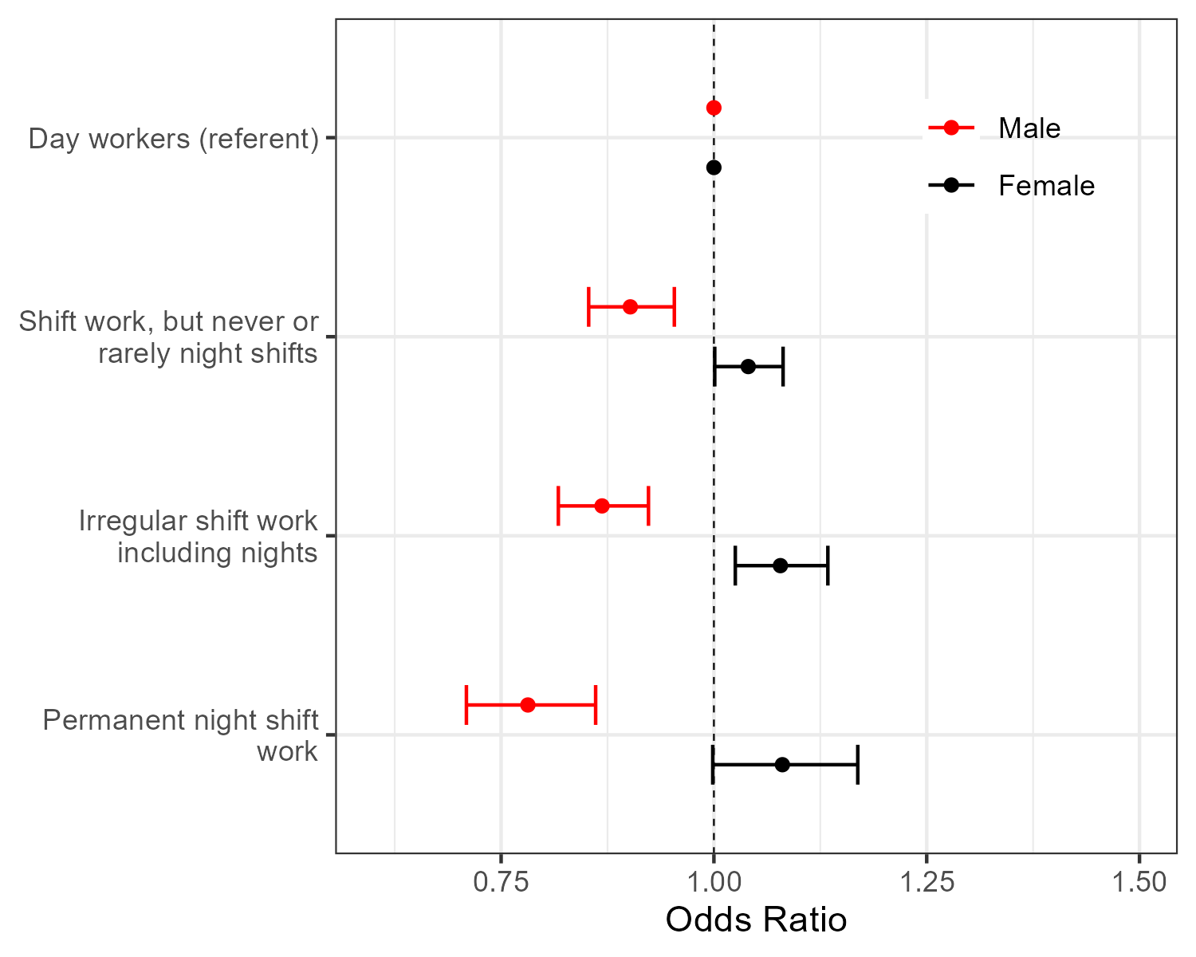
Age and sex stratified shift work/asthma analysis
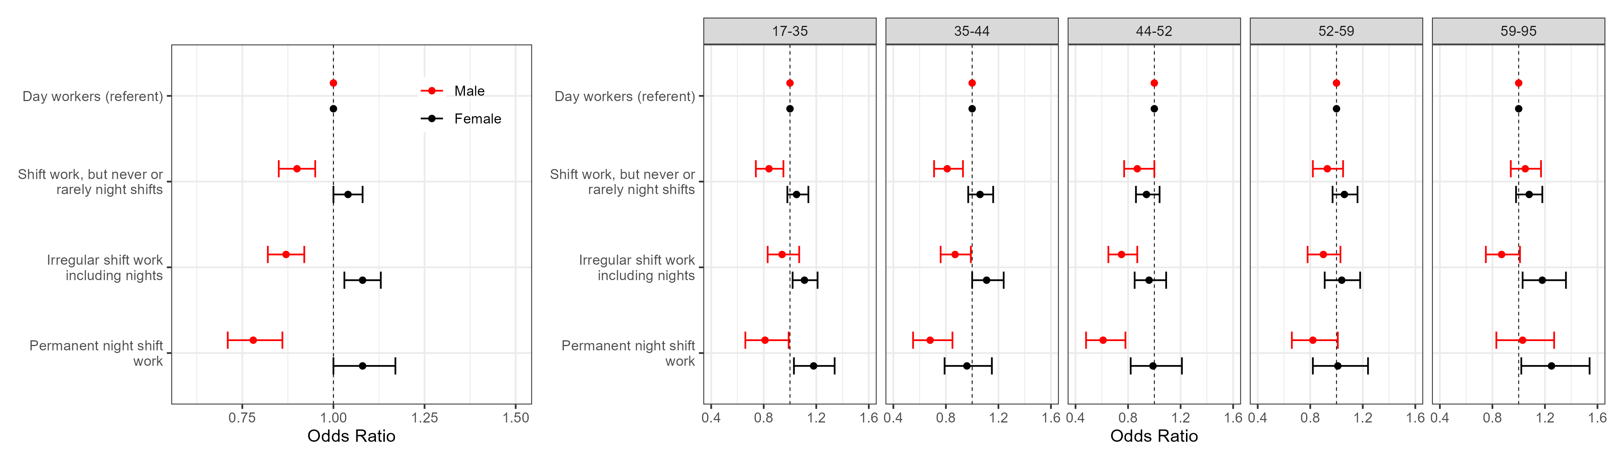

Contraception/asthma
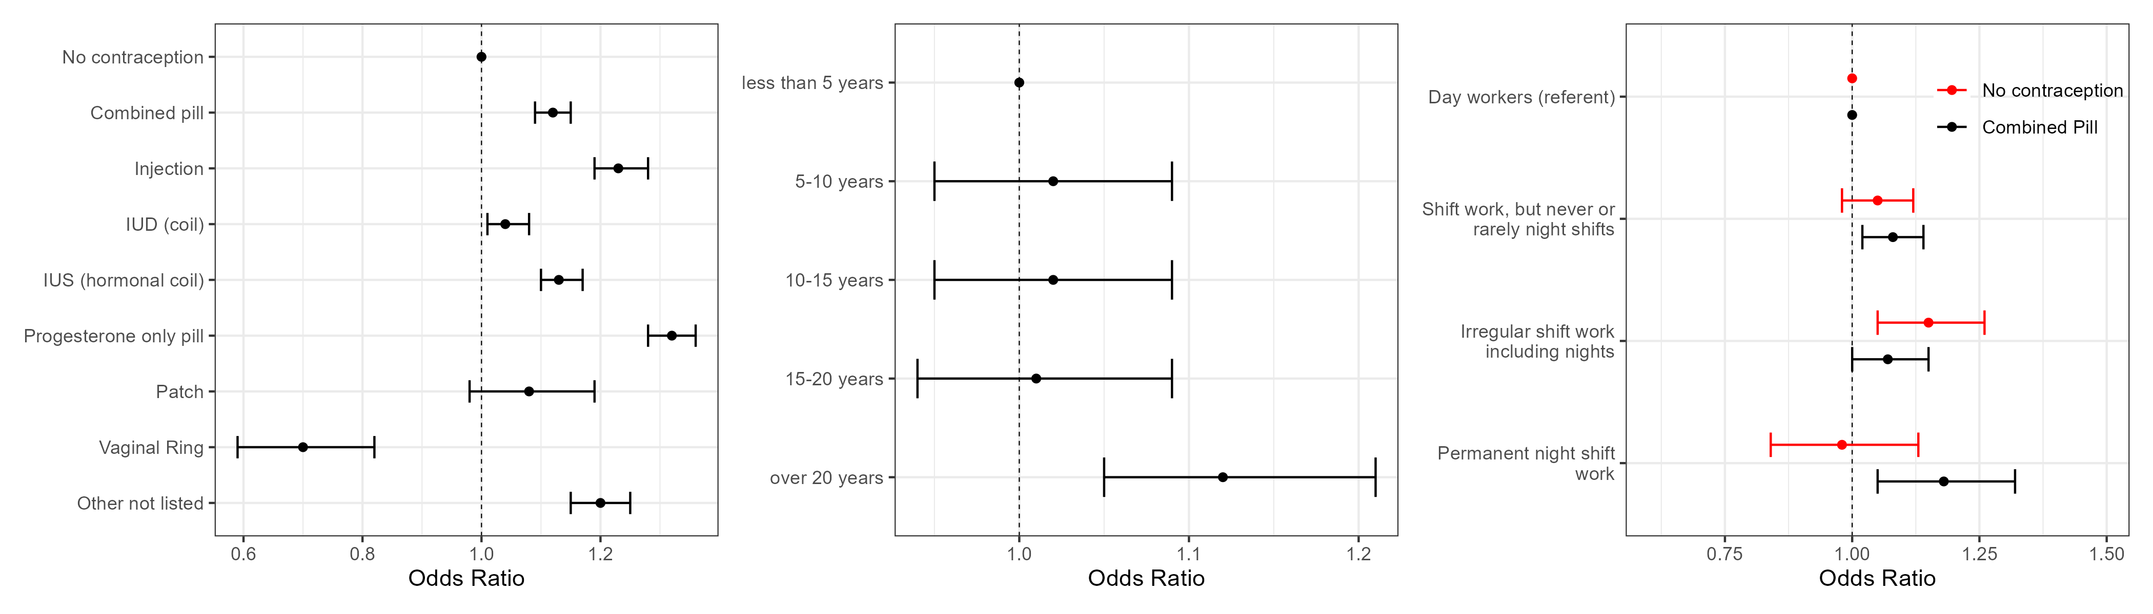
GYN_CONTRACEPT_METHODS_1_M: What have you used for contraception?
GYN_CONTRACEPT_PILL_FIRST_AGE_1_1: about how old were you when you first went on the contraceptive pill? (similarly for last age)
Data on hrt, first and last age take. Hyst and age/ menopause and age of last period. Age started periods, average days for menstrual cycle, days since last period. Oopherectomy and age.

Pill stratified shift work/asthma


HRT stratified shift work/asthma

