The server side of this project as of now is very similar to the client. The main difference is it takes in the text being sent from the client, capitalizes it and then sends it back. The components are:

* Stream Socket: this is the client socket that will be used to send and receive the data to the server router. It points towards the IP address and socket of the server router
* PrintWriter for writing into the stream
* BufferedReader for reading from the stream
* Method to capitalize the text

This was the easiest piece of the project to implement. The server would simply read in from the input stream, take the text passed to it via the server router from the client, capitalize it, and then send it back through the output stream of the socket.

In the design side of this started with a basic client set up. Created a stream socket with default properties and set the IP and Socket to use. Tested it first with simple text messages and made sure it could send and receive. Next we added in the capitalizing feature of the server which took the text and capitalized it then the program would send it back across the output stream. I then wrapped it in a GUI like the rest of the program which made it easier for a user to set up before launching. The server runs the same as the client; it starts by taking values given to it from the GUI and sets up its connection to the server router. Once user clicks connect the program sets the values for the socket (routerIP and Port Number). Then it sets the printwriter to the output stream for writing and the bufferedReader to the inputstream to read incoming messages. The program tells the user what’s going on in the message area of the GUI. Then the server sends out its initial send to the server router letting it now the destination IP it wants to send too. Now the program waits for the response before moving on. Once the initial receive comes from the router verifying it has a connection it waits for the client to send it some text to capitalize. As long as the client is sending text the server will continue to loop in a while loop executing the capitalizing method and outputting it back into the stream to the router then to the client. The text returning to the client will be in all caps.

Server run:

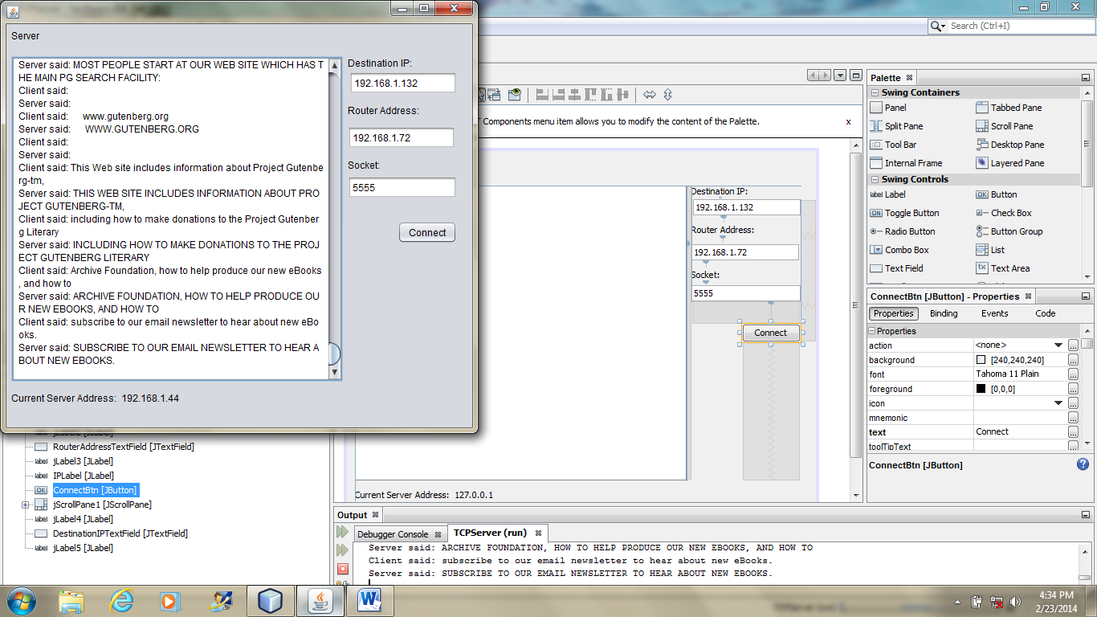

Trying to connect. Router: 192.168.1.72 Socket: 5555

Connection completed.

ServerRouter: Connected to the router.

Client said: null

Server said: NULL

Client said: The Project Gutenberg EBook of The Pioneer Trail, by Alfred Lambourne

Server said: THE PROJECT GUTENBERG EBOOK OF THE PIONEER TRAIL, BY ALFRED LAMBOURNE