The Server Router for this project is the actual server. It’s the most complex part out of this project thus far. It contains Distributed Computing technology along with threading. Some key components are:

- ServerSocket: This is one of the biggest differences in the server router compared to the client/server technology. The ServerSocket is what makes this a server. It waits for requests to come in over the network. Then performs actions based on the requests sent to it.
- Client Socket: The server router will use a regular client socket just like the client/server. Once the server socket accepts a new connection we set our client socket equal to it. We then pass this socket information into the new communication thread that is created. It is then used for the forwarding of messages to the designated client/server.
- BufferedReader / PrintWriter: These two are used to read incoming messages from the socket and then write output messages through the socket.
- Communication Thread: This is the magic of the server router. The communication thread handles the actual forwarding of messages in its own independent thread.
- 2D array RouteTable: This array is used to store the routing information. It stores forwarding IP and Socket.
The server router started out as a simple then became a date time server, then turned into chat server, then evolved into what it is now. When it was a date time server user would send a message “DateTime”. The server would take the message, read it, look to see if it had a method to handle it, which it did, then send back the date and time to client. When it was a chat server it would just post the messages passed to from the client to a text box area.
For this phase of the project the server router needed to act as a middle man between the client/servers connecting to the server. We created a server socket that will listen on specified port. The user has the ability to set the port number before launching the server router. Also you can see the address of the server router at the bottom of the screen. This is helpful for when setting up the client/server. Once you click start the server router goes into action. We take in the socket being passed in from the GUI and instantiate the server socket with the socket number. Then placed inside a while loop we tell the server socket to listen for incoming connections. Once a connection is received we set out client socket equal to the socket information, and then create a new communication thread to handle the communication. We pass in the route table, client socket, and table index to the communication thread. After thread is created move real quickly to post a message saying who connected, then add them to the client/server list on the GUI. Then the program goes back to the top of the while loop, and if running is still true the server goes back into listening mode.
We’ve just created and started a new communication thread. This is a very important part of a multi client to server distributed system. It allows the channel of communication between two clients to run independently and not be interrupted or blocked. The communication thread has its own private set of tools it uses. Similar to the client and server set up it has your main components:
- 2 PrintWriters, one for each client speaking with each other. One that send to destination specified and one that responds to the requestor.
- BufferedReader to read incoming messages.
- Another Socket that is used to send to the designated receiver (destination IP and Socket).
- 2D object Array that is passed in when creating the communication thread. This is what keeps track of senders and receivers and where messages are coming from and going too.
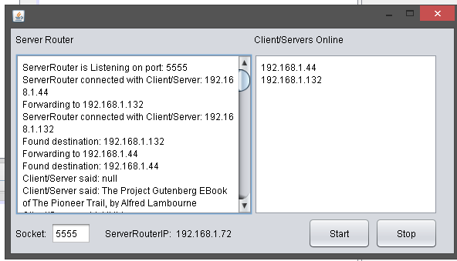
Everything else supports these components. In the constructor of this class we set one of the print writers equal to the pass in sockets output stream. Then set our buffered reader equal to the client sockets input stream. The after we set up our router table we enter in the client address and socket into the table. Now that we are set up, it’s time to Run. In the Run, the program first waits to receive the destination IP from the client/server for forwarding address. Then it sends back a response saying that the client/server has connected successfully. Then a delay was added to insure enough time was given for both client/server to connect and set up. If the receiver didn’t have enough time to get his information into the table the program would not be able to find the forwarding address. After the time is up, we iterate through the route table searching for the destination IP. Once found, we set our outgoing socket equal to the information from the table (IP and Socket). Then we set the outgoing print writer equal to the outgoing socket output stream. Now that the link is created and we have out communication portal the server router can pass messages back and forth. This all happens inside the communication loop. While data is coming into the server router from the client/server it will forward it to the destination that is specified.

ServerRouter:

ServerRouter is Listening on port: 5555
ServerRouter connected with Client/Server: 192.168.1.44
Forwarding to 192.168.1.132
ServerRouter connected with Client/Server: 192.168.1.132
Found destination: 192.168.1.132
Forwarding to 192.168.1.44
Found destination: 192.168.1.44
Client/Server said: null
Client/Server said: The Project Gutenberg EBook of The Pioneer Trail, by Alfred Lambourne
Client/Server said: NULL
Client/Server said:
Client/Server said: THE PROJECT GUTENBERG EBOOK OF THE PIONEER TRAIL, BY ALFRED LAMBOURNE
Client/Server said: This eBook is for the use of anyone anywhere at no cost and with
Client/Server said:
Client/Server said: almost no restrictions whatsoever. You may copy it, give it away or
Client/Server said: THIS EBOOK IS FOR THE USE OF ANYONE ANYWHERE AT NO COST AND WITH

