Outlook Security Files Download
README
Office 2007 Beta 2

Overview
In previous versions of Outlook, security settings could be customized by using the Exchange Server security form, then publishing the settings in a form in an Exchange Public Folder. In Microsoft Office Outlook 2007, you can configure the same security options by using new Group Policy settings. The new security settings are available in a separate Group Policy settings (ADM) file, included in this download.

If you want to establish trusted add-ins for Outlook by using Group Policy as part of the Office Outlook 2007 security options feature, you need to first run a small program to generate the hash key required when setting the policy. The new hash generator program is necessary because the hash value previously created by the Exchange Server security form now must be created manually and then included in the Group Policy setting. The files required for the hash generator program are also in this download.

Configuring Outlook to use the new security settings

To use Group Policy to manage Office Outlook 2007 security, you must configure a new Group Policy setting: Outlook Security Mode. The option you choose for this setting determines which security settings are enforced in Outlook: default security settings in the product, security settings in the Exchange Server security form, or Group Policy security settings.
To configure Outlook to use Group Policy for security settings
- In Group Policy, load the Office Outlook 2007 template (Outlk12.adm) and go to User Configuration\Administrative Templates\ Microsoft Office Outlook 2007\Security Form settings\Microsoft Office Outlook 12.0 Security.
- Double-click Outlook Security Mode, and then click Enabled.
- In the Outlook Security Policy drop-down list, select Use Outlook Security Group Policy.
- Click OK.
If you previously used the Exchange Server security form to manage security settings, you must manually migrate the settings that you configured earlier to the corresponding Group Policy settings for Outlook.
Learn more about using the new settings to configure Outlook security in the 2007 Office Resource Kit. For information about how the new Outlook Group Policy security settings work, see the topics included in Customizing virus prevention features in Outlook 2007 in Messaging guide section. For information specific to configuring trusted add-ins, see Managing trusted add-ins for Outlook 2007.

Files included in this download package
The following files are included in this download package:

File | Description
Addinhash.vbs | Hash generator Visual Basic file
CreateHash.bat | Batch file to run the hash generator program
Hashctl.dll | Hash generator program
Readme.doc | This document

Installing and using the Hash Generator Tool
To install and use the hash generator program with the Group Policy setting for establishing an add-in program as “trusted” by Outlook, follow these steps.

First, install the files.

- Double-click the download to extract the files to a folder.
- Open a command prompt and change directory (CD) to the folder with the extracted files.
- Type: CreateHash.bat /register

To establish a program as a trusted add-in, first run the program to generate the hash value, and then copy the value into the Group Policy setting.

- Open a command prompt and change directory (CD) to the folder with the extracted files.
- Type:

CreateHash.bat filename.dll

Where filename.dll is the path and filename of an add-in program file (DLL) that should be trusted by Outlook.

The program returns an output value name and value as shown here:

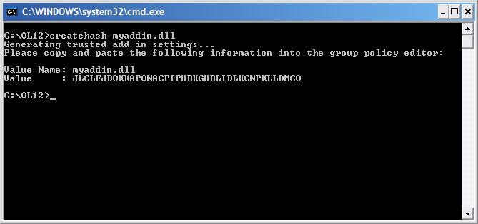

Copy the value name and value into the Trusted Add-ins Group Policy setting.

- In Group Policy, load the Office Outlook 2007 template (Outlk12.adm) and go to User Configuration\Administrative Templates\ Microsoft Office Outlook 2007\Security Form settings\Microsoft Office Outlook 12.0 Security\Programmatic Security\Trusted Add-ins.
- Double-click Configure trusted add-ins, and then click Enabled.
- Click Show.
- In the Show contents dialog box, click Add.
- In the Add item dialog box, in the Enter the name of the item to be added field, type the file name of the add-in.
- In the Enter the value of the item to be added field, paste the hash value of the add-in that you copied when you ran the hash value calculation program.
- Click OK three times.

If you want to uninstall the hash generator program, follow these steps.

- Open a command prompt and change directory (CD) to the folder with the extracted files.
- Type: CreateHash.bat /unregister
- Delete the extracted files from the folder.

