Carbon Dioxide Effects on Colorado Snowfall

Robert Munch

November 12, 2018

# Introduction

Colorado, home to some of the best and well known ski resorts in the United States, prides itself on a culture of winter sports and activities. Yet, increasing atmospheric carbon dioxide concentrations are threatening this culture and is currently decreasing snowfall, which in turn limits the amount of tourism and the economic benefits that come with it.  
The data collected shows a correlation of increasing carbon dioxide concentration in the atmosphere and decreasing snowfall across Colorado. This is turn will affect the amount of ski visitors going to Colorado ski areas, and therefore decreases revenue generated from tourism in Colorado.

# Snow Water Equivalency Data

Using data gathered from the National Resource Conservation Service (NRCS) Snow Telemetry (SNOTEL) stations, the average snow water equivalent (SWE) in millimeters for the year was gathered. Data was gathered from every available station, 113 stations in total, from around the state. The data was recorded giving a sum of the snowfall at the end of each month, and did not include the amount of SWE that was already on the ground.

Because of the seasonality of snowfall, summer months almost always gave zero SWE values, making the data incoherent, therefore annual average of SWE was used because it provided cleaner data points, and still was able to show enough differentiation over time.

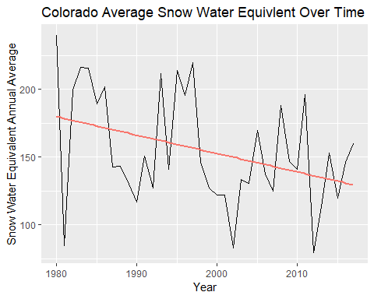

Figure 1

##   
## Call:  
## lm(formula = SWE.mm.Avg ~ Year, data = SWE.year.agg)  
##   
## Residuals:  
## Min 1Q Median 3Q Max   
## -93.810 -26.661 -8.144 30.094 62.831   
##   
## Coefficients:  
## Estimate Std. Error t value Pr(>|t|)   
## (Intercept) 2867.2886 1152.7831 2.487 0.0176 *  
## Year -1.3573 0.5768 -2.353 0.0242 *  
## ---  
## Signif. codes: 0 '***' 0.001 '**' 0.01 '*' 0.05 '.' 0.1 ' ' 1  
##   
## Residual standard error: 38.99 on 36 degrees of freedom  
## Multiple R-squared: 0.1333, Adjusted R-squared: 0.1092   
## F-statistic: 5.537 on 1 and 36 DF, p-value: 0.0242

Figure 2

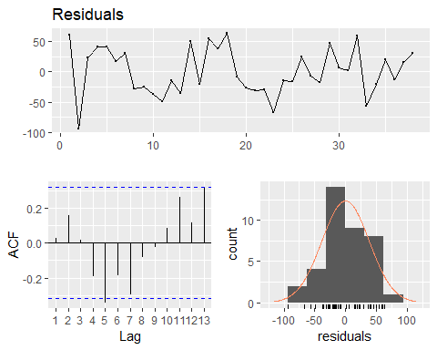

##   
## Breusch-Godfrey test for serial correlation of order up to 7  
##   
## data: Residuals  
## LM test = 10.276, df = 7, p-value = 0.1734

Figure 3

This shows residual data for the linear model of SWE annual mean over time

As seen in Figure 1, the cyclical nature follows patterns generated by El Nino and La Nina cycles. These cycles are significant, giving a fairly consistent change in snowfall over the course of the 27 years, but even with these effects, there is still a downward trend to the annual average data.

As seen in the analysis of the frequency data generated from the linear model, the cyclical nature shows up most strongly on the ACF plot, and the histogram is fairly normally distributed.

Because the year 1981 seems to be especially low, and the available data is less complete earlier in the dataset, I wanted to make sure the variation was not due to certain monitoring stations only used in earlier data collection that had a higher chance of collecting low data.

Using only sites available in 1981, I averaged annual SWE data and compared it to the original values. The data is below with the annual average SWE data for all stations displayed in blue and the data for only the stations available in 1981 displayed in red.

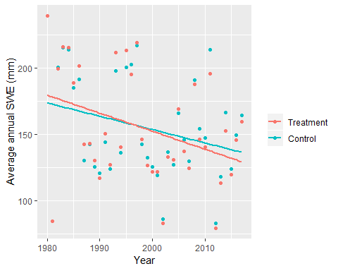

Figure 4

##   
## Pearson's Chi-squared test  
##   
## data: PrecipData.outlier$SWE.mm.Avg.outlier and PrecipData.outlier$SWE.mm.Avg  
## X-squared = 1406, df = 1369, p-value = 0.2378

Based on the chart, it is obvious the plot with only sites available in 1981 is very similar to data using all available sites. Also, based on the p value from the chi-squared test, using standard alpha value of 0.05, I cannot confirm the null hypothesis. Therefore the data do show that the low SWE value in 1981 is highly unlikely to be due to selecting stations that have a lower average SWE.

# Atmospheric Carbon Dioxide concentration.

Using data gathered from NOAA Earth System Research Laboratory, average monthly $CO_{2}$ concentration in ppm is displayed over time.

Data was used from the Interpolated column, as this column replaces missing values with an expected value.There was one missing value point in March of 1984, using the interpolated column gave the ability to have a more complete data set.

Because of the line, no linear model was necessary.

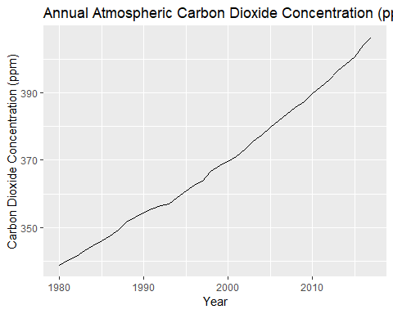

##   
## Call:  
## lm(formula = co2.ppm.Avg ~ Year, data = co2.year.agg)  
##   
## Residuals:  
## Min 1Q Median 3Q Max   
## -2.7439 -1.5450 -0.0066 1.3493 4.2646   
##   
## Coefficients:  
## Estimate Std. Error t value Pr(>|t|)   
## (Intercept) -3.210e+03 5.462e+01 -58.76 <2e-16 ***  
## Year 1.791e+00 2.733e-02 65.52 <2e-16 ***  
## ---  
## Signif. codes: 0 '***' 0.001 '**' 0.01 '*' 0.05 '.' 0.1 ' ' 1  
##   
## Residual standard error: 1.847 on 36 degrees of freedom  
## Multiple R-squared: 0.9917, Adjusted R-squared: 0.9915   
## F-statistic: 4293 on 1 and 36 DF, p-value: < 2.2e-16

Figure 5

Based on these linear models, I expect that $CO_{2}$ concentration to follow a linear equation of $y=1.791x-3210$.

Next we will look at what this means in context of snowfall.

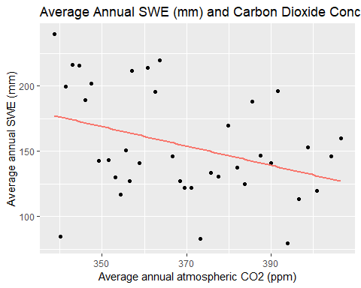

Figure 6

##   
## Call:  
## lm(formula = SWE.mm.Avg ~ co2.ppm.Avg, data = SWE.co2.year.agg)  
##   
## Residuals:  
## Min 1Q Median 3Q Max   
## -91.591 -26.043 -9.087 32.261 62.468   
##   
## Coefficients:  
## Estimate Std. Error t value Pr(>|t|)   
## (Intercept) 428.2543 118.9057 3.602 0.000947 ***  
## co2.ppm.Avg -0.7412 0.3216 -2.304 0.027077 *   
## ---  
## Signif. codes: 0 '***' 0.001 '**' 0.01 '*' 0.05 '.' 0.1 ' ' 1  
##   
## Residual standard error: 39.1 on 36 degrees of freedom  
## Multiple R-squared: 0.1285, Adjusted R-squared: 0.1043   
## F-statistic: 5.31 on 1 and 36 DF, p-value: 0.02708

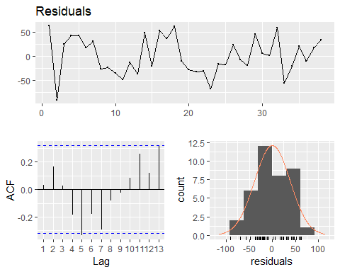

##   
## Breusch-Godfrey test for serial correlation of order up to 7  
##   
## data: Residuals  
## LM test = 9.7898, df = 7, p-value = 0.2008

Figure 7

This figure compares the average annual SWE data for all sites across CO, and the average annual $CO_{2}$ concentration in parts per million. This has been fitted with a linear line of best fit. Based on this plot, it shows there is a negative linear correlation between $CO_{2}$ concentration and average annual SWE in Colorado. This means that as $CO_{2}$ concentration increases, SWE decreases.

Similarly to the previous plot showing only SWE data over time, the histogram generated from the residuals is fairly normally distributed.

Based on the linear model of past average annual snowfall and $CO_{2}$ concentration, I expect the SWE to follow a linear model of $y=-0.7412x+428.2543$.

# Visitor Data

Because there was no publicly available data available for only the state of Colorado or to specific ski resorts, data made available by the National Ski Area Association which has released visitor numbers by region over time. Because Colorado is in the Rocky Mountain region and visitor data should correlate to Colorado quite fairly, data was manually scraped from a report released by the National Ski Area Association. Visitor data is used to see if there is a correlation with visitors to SWE data. Thus showing if lower snowfall causes a decrease in visitors to ski areas.

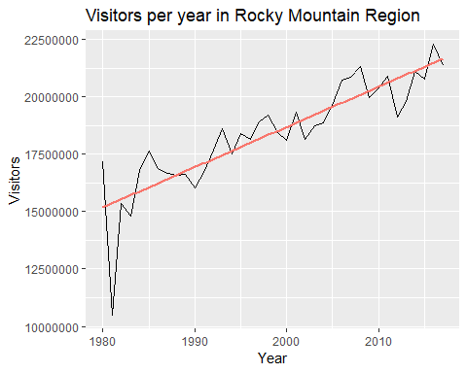

Figure 8

This plot showing the number of visitors each year in the Rocky Mountain region, shows that there is an overall increase in the number of visitors to ski areas, however there is shifts in the change for year over year.

# Tourism

Tourism data was manually scraped from the Colorado department of tourism, and the tourism numbers represent total tourism dollars spent in the mountain resort area of Colorado. Unlike the rest of the data, which started in 1980, this data was only available since 1996, therefore this is a smaller data set and does not contain as many years worth of data.

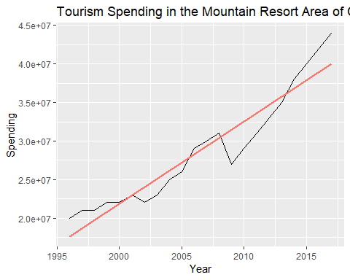

Figure 9

As shown in the plot, like visitor data, spending in the ski resort areas of Colorado also increased over time. However there does seem to be annual shifts from the average.

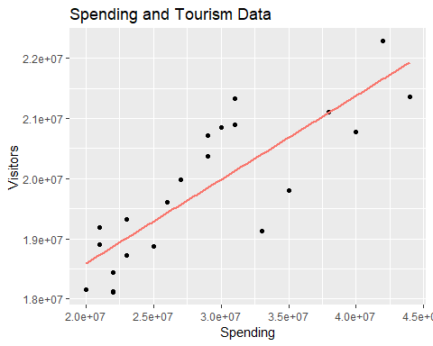

Figure 10

This is to show higher visitors generate higher tourism spending.

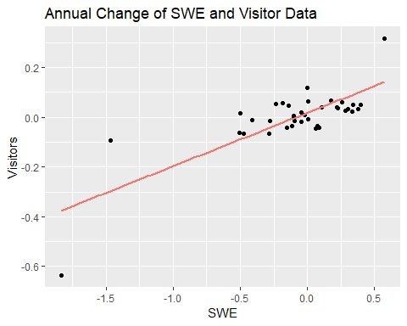

Figure 11

This plot shows the correlation of change year over year for change in SWE and change in visitors to show a correlation in change in snowfall and a change in visitors to ski areas.

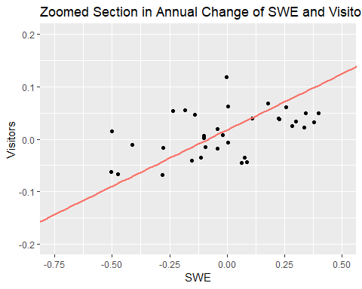

Figure 12

Because of the outliers in the previous plot are outliers, yet still viable data, this plot shows a zoomed in section of the main group.

##   
## Call:  
## lm(formula = Visitors ~ SWE, data = delta.all)  
##   
## Residuals:  
## Min 1Q Median 3Q Max   
## -0.26077 -0.04111 -0.01100 0.02791 0.20483   
##   
## Coefficients:  
## Estimate Std. Error t value Pr(>|t|)   
## (Intercept) 0.01737 0.01348 1.289 0.206   
## SWE 0.21440 0.02896 7.404 1.16e-08 ***  
## ---  
## Signif. codes: 0 '***' 0.001 '**' 0.01 '*' 0.05 '.' 0.1 ' ' 1  
##   
## Residual standard error: 0.08061 on 35 degrees of freedom  
## Multiple R-squared: 0.6103, Adjusted R-squared: 0.5992   
## F-statistic: 54.82 on 1 and 35 DF, p-value: 1.159e-08

Figure 13

These charts show the average annual change of SWE and Visitor data. This shows that there is a positive correlation between the change in snowfall from the previous year and the amount of people who visit ski areas.

# Solutions

According to the U.S. Energy Information Administration, between 2005 and 2015, Colorado was the state that had the worst reduction of carbon dioxide, increasing its total carbon dioxide emissions by 6.64%.

Figure 14

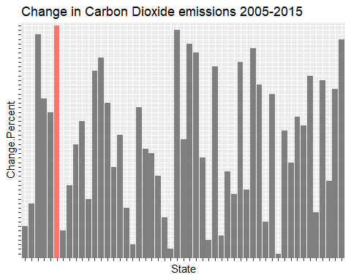

Figure 15

This figure shows that over the entire 50 states and the District of Columbia, Colorado had the 4th lowest carbon dioxide reduction, increasing by 6.64% between 2005 and 2015.

This is not the whole story however, because Colorado had a large population influx throughout this ten year period, it had a large amount of carbon emitted through population increase. When looking at increase by population, Colorado in fact had the 9th largest decrease in carbon dioxide emissions, decreasing emissions per capita by 0.15%.

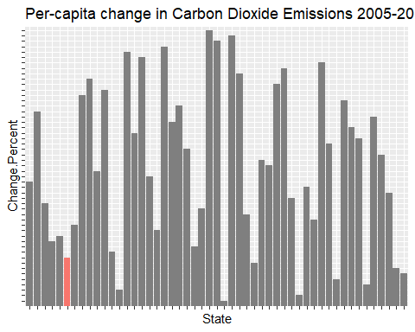

Figure 16

This chart shows Colorados carbon dioxide emissions change between 2005 and 2015 per capita. As this Chart shows, when taking population into account, Colorado was 9th in reduced carbon dioxide emissions per capita.

Maine is a state however that appears very high on both overall and per capita carbon dioxide reduction. 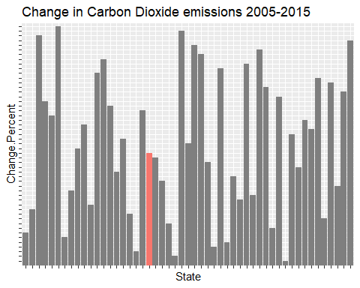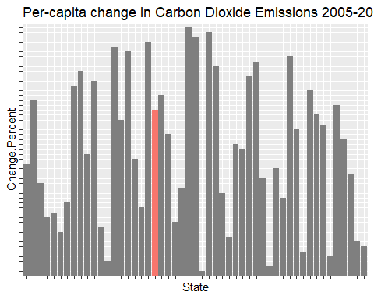

Figure 17

This reduction is done in part due to strict law placed in 2003, which set aggressive carbon emission goals.

# Conclusion

Based on the data presented the data do show that increasing $CO_{2}$ concentration in the atmosphere does have a negative effect on annual snowfall, and thus a negative effect on visitors to ski areas which in turn affects the amount of money spent on tourism in Colorado. Lawmakers in Colorado as well as individuals who enjoy winter sports and gain economic benefit from winter sports should me more mindful of the implications of increasing $CO_{2}$ concentration on Colorado’s ability to provide world class ski terrain for the future.