Table of Contents

Task 1: Directory Structure Creation 1

Task 2: File Permissions 2

Task 3: File Editing with nano or vi 3

4

Task4 File compression 4

5

Task 5 Searching for file 5

Step 1: Search for .txt Files 5

Understanding Key Linux Directories 6

# **Task 1: Directory Structure Creation**

1. **Create the Home Directory**:

* mkdir -p ~/student

1. **Create the Week2 and Week3 Directories**:

* mkdir ~/student/Week2 ~/student/Week3

1. **Create the Text Files in Week2**:

* touch ~/student/Week2/file1.txt ~/student/Week2/file2.txt ~/student/Week2/file3.txt

1. **Create the TextFiles Subdirectory in Week3**:

* mkdir ~/student/Week3/TextFiles

1. **Move the Text Files from Week2 to TextFiles**:

* mv ~/student/Week2/*.txt ~/student/Week3/TextFiles/

1. **Verify the Directory Structure**: You can list the directory structure using:

* tree ~/student
* If you don’t have tree installed, you can also use:
* ls -R ~/student

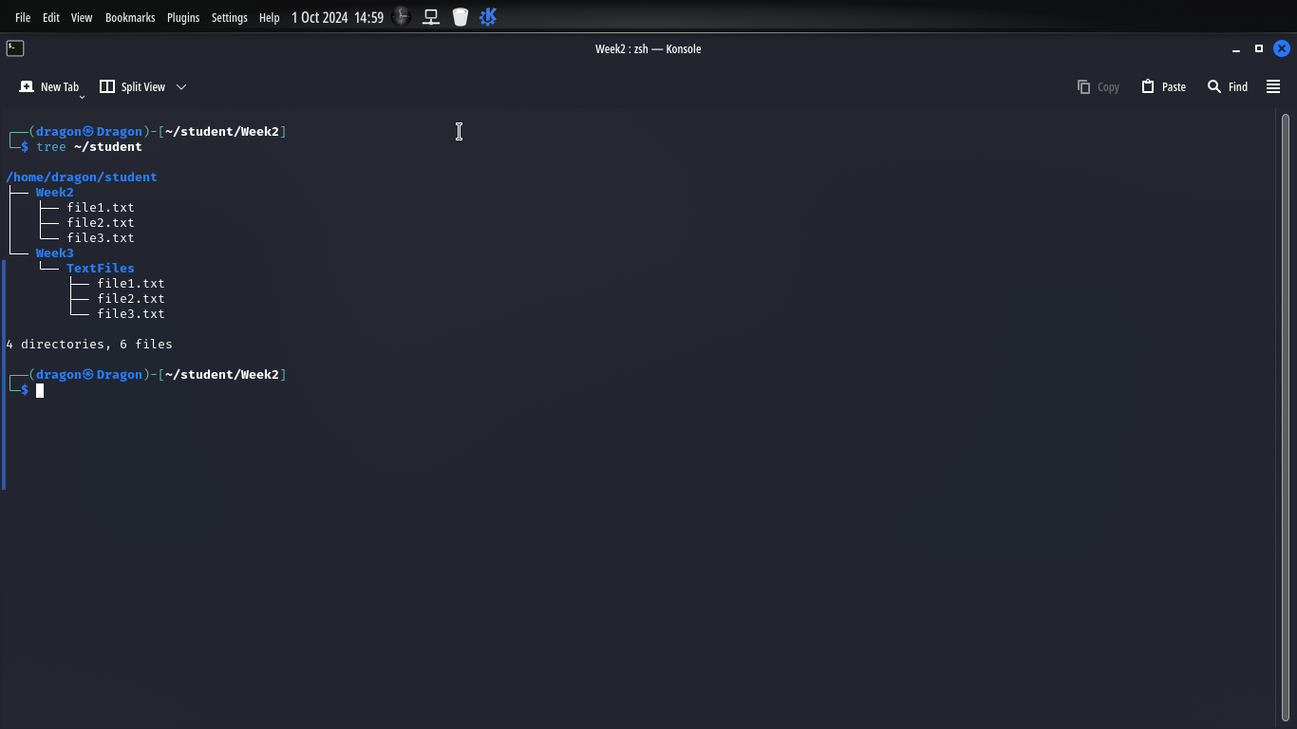

# **Task 2: File Permissions**

1. cd ~/student/Week3/TextFiles
2. chmod 755 *.txt
3. ls -l

* 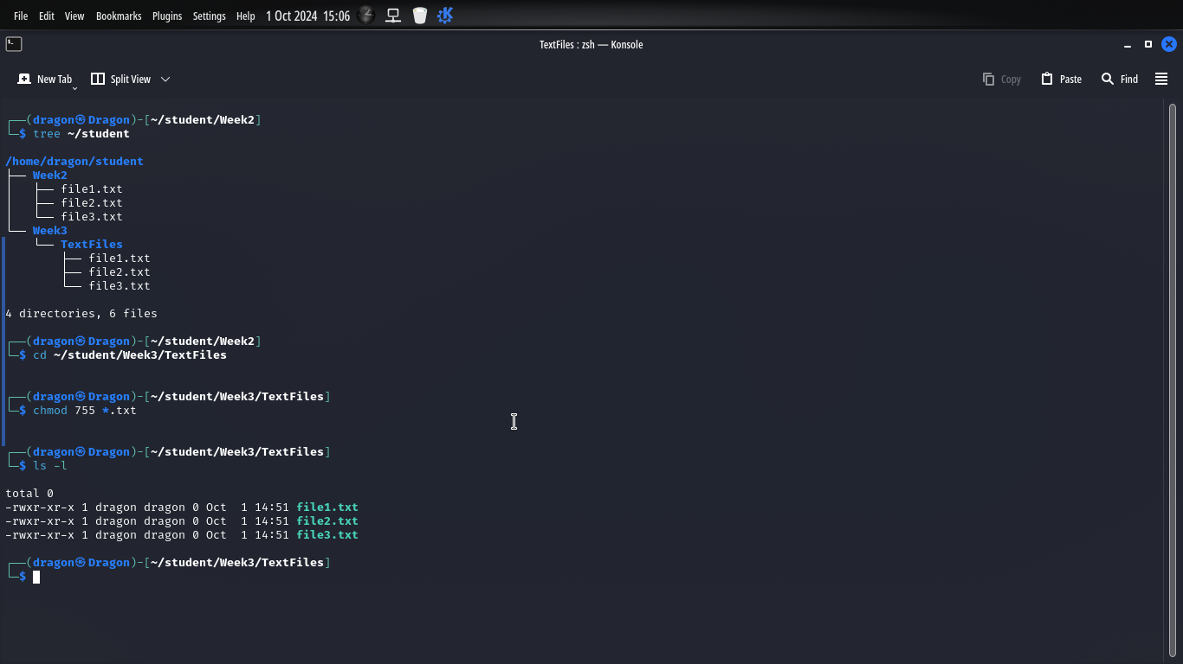

# T**ask 3: File Editing with nano or vi**

1. vi ~/student/Week3/TextFiles/file1.txt
2. This is the first line.  
   This is the second line.  
   This is the third line.

* cat ~/student/Week3/TextFiles/file1.txt

### 

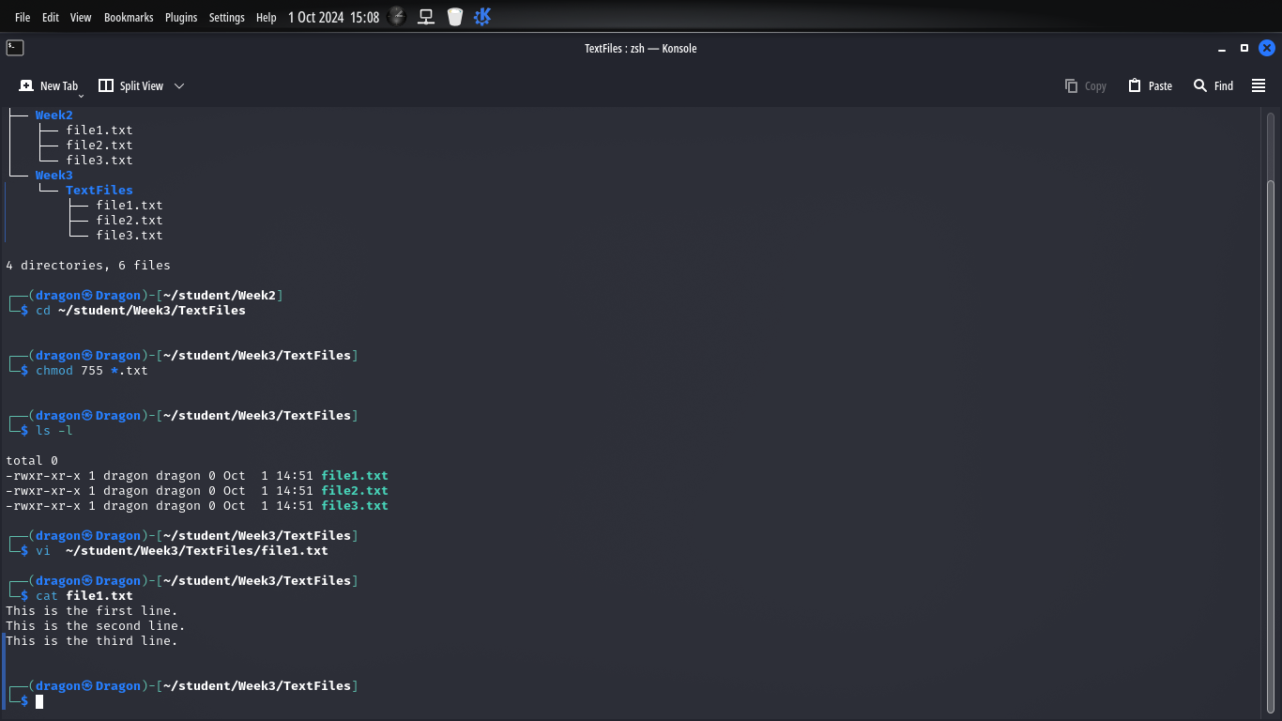

# 

# Task4 File compression

# 

cd ~/student/Week3

tar -czvf TextFiles.tar.gz TextFiles

ls -l

# 

# Task 5 Searching for file

### Step 1: Search for .txt Files

1. find ~/student -type f -name "*.txt"

* grep "Linux" ~/student/Week3/TextFiles/file1.txt

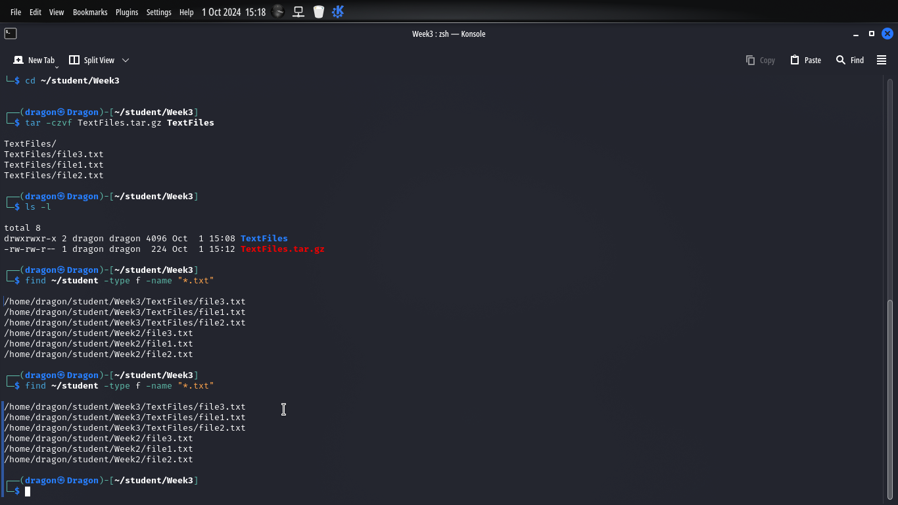

### Understanding Key Linux Directories

1. **/bin**: This directory incorporates the essential binary executors required for machine booting and basic device operations. The functions in /bin are to be had to all customers and are required for single user mode. Examples include commonplace instructions which include ls, cp, and mv. This directory complies with the File System Hierarchy Standard (FHS) by means of ensuring that the desired instructions are without difficulty handy.
2. **/etc**: The /etc directory is where device configuration files are saved. This includes configuring device services, user bills, and alertness configuration.
3. **/home**: FHS mandates that consumer domestic directories are living under /rest to hold consumer records become independent from configuration files.
4. **/var**: The /var directory is used for variable information files, along with logs, databases, and mail spools. It is crucial for the operation of the device as it stores regularly converting statistics at some stage in everyday operation.
5. **/usr**: The /usr directory includes programs and information associated with programs.