## **Business opportunity**

## Markets and Competition: What will be the first specific market targeted and what would the perceived advantages of your product over existing ones (List at least three products, projects or concept papers that represent the prior art and discuss how your proposal compares to these)?

## The specific market for my game are strategy game players on mobile looking for an experience similar to what they would get on pc.

## The advantages of my game over other mobile strategy games will be involving more complex planning before battles. Also a better user interface during the actual battle, making use of grouping for commands, and an ability to pause while issuing orders. These along with the removal of micro transactions.

## Whereas the typical mobile strategy gameplay will rely on immense time investment building a base which can be sped up through the payment of a virtual currency paid for with actual currency, and battles that are a tower defense game (units charge in while towers shoot them down). Current products like this being Clash of Clans, Dawn of Gods, Alien Creeps TD.

## Clients: What are the profiles of the targeted clients.

## Male or female players, somewhere in their 20s and 30s with an average income.

## Enjoy strategy games that are similar to what is offered on PC. Users who enjoy analyzing situations and choosing an appropriate response.

## Revenues and Profits: What is your revenue model and business model.

## My profit plan is to generate revenue through two different copies of the game. One is a free download with ads between games, and the other costs a dollar, but is ad free. Games like this usually have a micro transaction system in place, but with ads or a one time fee they will save and have a better user experience.

## Risks: What would be the key business success factors that need to be controlled to achieve the expected benefits?

## Key business success factors would be that people have fun playing the game, as well as share it with their friends. Would be an idea to give away free copies to players who share the game on social media, but this is a bit out of scope right now.

## Capabilities: Briefly describe your team’s capabilities in accomplishing the results of the proposed project.

## I have experience making games in adobe flash, as well as completing two projects in android.

## **Project Description**

## **Project duration**

september 2016 – december 2016

## **Project title**

## Deltacore

## **Project Summary**

My project is an android sci-fi strategy game. Gameplay involves creating an army from owned ships and using it in space battles which will unlock random packs of new ships.

## **Project objectives**

To create a fun and interesting android app and release it to the play store.

## **Market/Technology Environment**

## Describe the current technological problems for this industry.

## A lack of keyboard and mouse on mobile, preventing more complex controls and because of that must have less complex gameplay.

## What are the key players in this field proposing to address or circumvent the above problem?

## Simplifying gameplay, separating base building and battles. Base building amounts to large time or monetary investment for linear improvements. Battles amount to a tower defence game.

## How did you select the technology to be developed and the primary applications?

## We were required by our assignment to develop in android. We were also required to use Espresso for testing which I have some experience in and would use regardless.

## What do you see as the main innovative aspects and/or advantages of your product over others?

## A friendlier interface, and fun for a single fee, rather than withholding fun for recurring fees.

## **Anticipated challenges and uncertainties:** Describe anticipated challenges and uncertainties in meeting the project’s objectives and related tasks. What work-around have you considered to address these uncertainties?

## Developing the game engine is a big challenge and uncertainty. A work around which I have considered is to go with an already created engine for android.

## **Description of activities**

I have begun with conceptualizing the ideas behind the game and planning. This will be followed by implementation and testing of each milestone. The project will be finalized with deployment to the Play Store.

## Identify project phases and/or milestones

## Finish main menu UI, Finish in game UI, Create pre game loadout menu, Develop base game,

## Methodology to be used (Rationalize why other process models would not be suitable for the product development you are intend to undertake)

I will be using waterfall. This is usually bad because of its inflexibility, but since there will be no client I think that the requirements will not be changing during the development.

## Major activities to be undertaken.

## Creating/learning game engine, fleshing out gameplay

**User Stories**

1. As a player I want to be able to start a new game so that I may start again.

2. As a player I want to be able to save my game so that I can come back to it later.

3. As a player I want to be able to load my saved game so that I can pick up where I left off.

4. As a player I must have interface buttons that are large enough to click so that I can play without frustration.

5. As an advertiser I want my ads to be used in a way that generates maximum clicks.

6. As a player I want to be able to resize and move the game view so that I can easily see what is going on.

7. As a player I want to be able to select my desired ships from a list of owned ships so that I can change my load out.

8. As a player I want my ships to move to the position that I drag them to so that I can re-position them.

9. As a player I want the AI to attack me so that I can play a game.

10. As a player I want to be able to remove ships I don’t want from my load out so that I can change my strategy.

**Software Requirements Specification**

# 1. Introduction

## 1.1.1 Purpose

This is meant to layout the development of an android game.

## 1.1.2 Scope

This is a sci-fi strategy game set in space. The intended audience is anyone who is interested in space combat, strategy, and planning.

## 1.1.3 Definitions

API: Application Program Interface

## 1.1.4 References

IEEE Software Engineering Standards Committee

## 1.1.5 Overview

Section 1: introduction to the project. This goes into overview information about the project.

Section 2: overall description. It contains information about the overall structure of the project and contains some graphics.

Section 3: the specific requirements of the applications

Section 4: System model

Section 5: Test cases

**2. Overall description**

* **2.1 Product perspective** 
  + **2.1.1 System Interfaces**

|  |
| --- |
| -Saving game pushes all game information to the database.  -Load game requests information from the database and loads it into the current game |

* + **2.1.2 User Interfaces**

|  |
| --- |
| **Main Menu** |
| **Load Out Menu** |
| **Game HUD** |
| **In Game Menu** |

* + **2.1.4 Hardware interfaces**

none

* + **2.1.5 Software interfaces**

Android SQLite db

* + **2.1.6 Communication Interfaces**

none

* **2.2 Product functions**

Start new game

Load previous game

Play current game

Save current game

* **2.3 User characteristics**

Mobile gamers who enjoy strategy games.

* **2.4 Constraints, assumptions and dependencies**

**2.4.1 Constraints:**

Mobile graphics limitations.

Touch controls.

Small screen.

**2.4.2 Assumptions:**

Database will be enough to hold save game data.

Will be able to create game in required time.

**2.5 Dependencies:**

**3. Specific requirements**

* **3.1 External interface requirements**
* **3.2 Functional requirements**

**3.2.1 Game:**

Must be able to collect ships

Must be able to select current ships

AI must work

Must be able to give orders to ships

**3.2.2 UI:**

Buttons must be large enough to be easily selected

Must be able to move between menus (Main, load out, battle, game menu)

Must be easily readable

* **3.3 Software System attributes** 
  + **3.3.1 Reliability**

The game shall save progress reliably

The game shall load progress reliably

The AI shall control units correctly

* + **3.3.2 Availability**

Game must be uploaded to Google Play Store

* + **3.3.3 Security**

No networking as of yet planned

* + **3.3.4 Maintainability**

The game will be created in a well organized way following object oriented paradigms, allowing for easy maintainability

* + **3.3.5 Portability**

The game will be coded in a way that creates abstraction between game logic and system interfaces

**4. System Model**

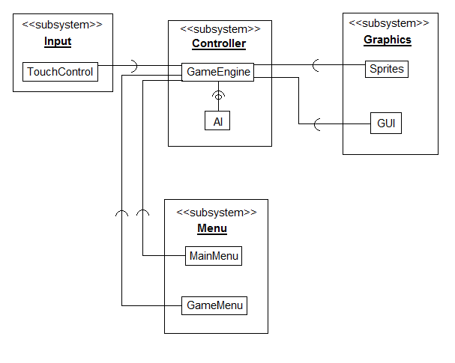

**5. Test cases**

|  |  |  |  |  |
| --- | --- | --- | --- | --- |
| **Test Objective** | **Precondition** | **Steps** | **Test Data** | **Expected Result** |
| Successfully starting a new game. | None | Press New Game button in main menu | None | Check that interface has moved to the load out screen, and created a new set of starting units. |
| Successfully saving current game | A game is in progress | Bring up in game menu. Press save game in UI | A valid set of currently owned units, and completed levels | Data of current units owned and levels completed will be saved to the database |
| Successfully loading a previous game | A previously played game has been saved to the database | Press Load Game button in main menu | A valid saved game in the database | The previously saved game data will be successfully loaded from the database and user can pick up where they left off |
| Unit moves to position dragged by user | Game has started. Units are on screen | Press and drag from unit to desired position. Wait | None | Units move to the position dragged to through touch interface |
| Use unit ability in game | Game has started. Unit has an ability to test | Press ability menu. Select ability to test. Select target on game view | None | Ability function will be successfully called on target unit |
| Add unit to load out | Game is on load out screen and player has available points to add unit | Press add unit button on units owned list | None | Unit will move from units owned list to units ready list |
| Remove unit from load out | Game is on load out screen and player has a unit in their ready list | Press remove unit button on ready list | None | Unit will move from ready list to units owned list |
| Zoom out game view | Game is in battle screen | Pinch screen (two finger touch moving toward each other) | None | Battle view will zoom out (all sprites in battle will shrink and decrease distance) |
| Move game view in a direction | Game is in battle screen | Drag finger on view in opposite direction to which you wish to move. Finger must not begin on a selectable object | None | Battle view will pan in the desired direction |
| AI will attack player units | Game is in battle screen. Player has unit alive and in attack range. AI has unit alive and in attack range | Set units to position where they can attack | None | Enemy units will attack player units |

**Technical Issues in Software Development**

**COMP 7081**

**Deliverables for October 10th**

**Robert Moffat**