IPEDS

Version 10

Positions have an IPEDS tab with 4 columns.

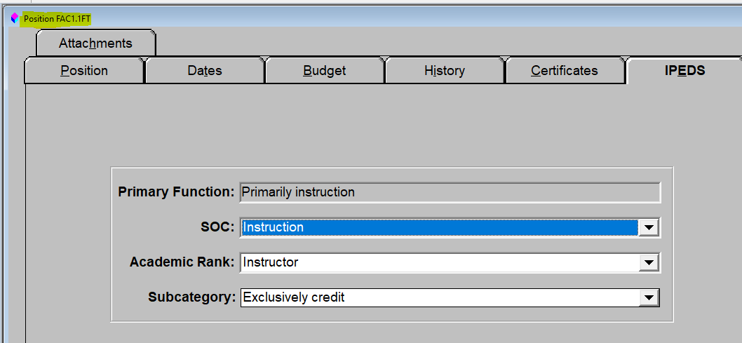
Primary Function, SOC, and Academic Rank come from tables that we populate.
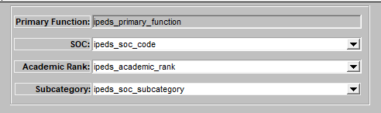
ipeds_primary_functions (obsolete)
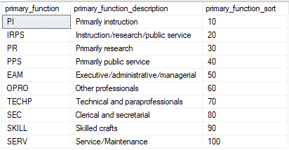
For the 2012-2013 reporting, primary functions were replaced by standard occupational classification codes.
ipeds_soc_codes
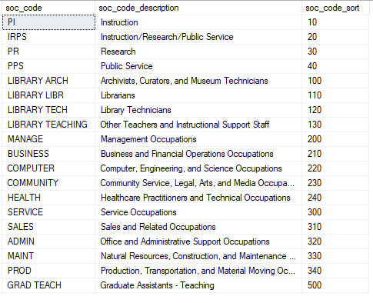
ipeds_academic_ranks - Academic Rank is enabled only if ipeds_soc_code is PI or IRPS
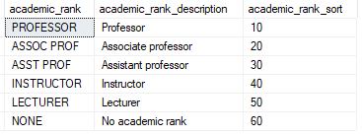

Subcategory is a dropdown listbox and is visible only if SOC is PI for Instruction.
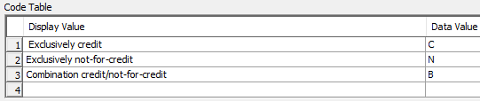
Employee Profile IPEDS
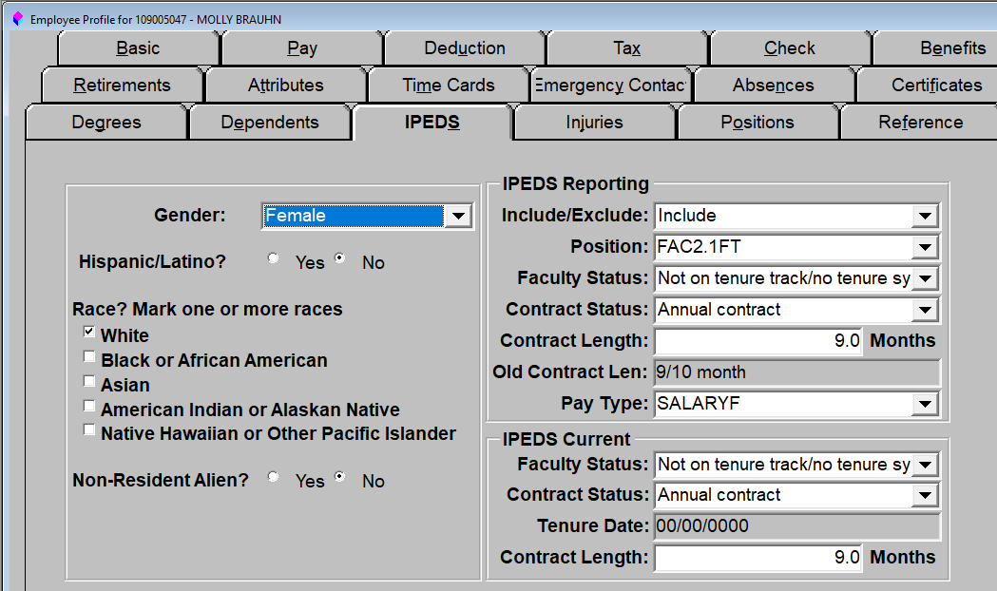
Faculty Status
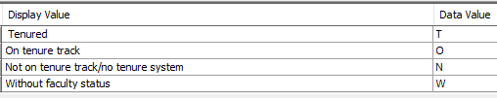
Contract Status
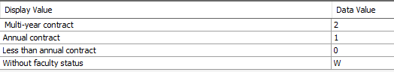
The IPEDS Employee Update takes the following current values and puts them into the IPEDS Reporting values:
Faculty Status
Contract Status
Contract Length
Position (
Pay Type (base pay type)

EmpowerWin
Faculty Status and Contract Length have been combined into Tenure Status. Months Worked was introduced in 2016.
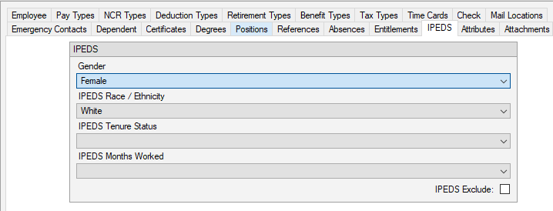

Positions have an IPEDS tab with only two columns. Both are editable. The v10 SOC and Subcategory are combined in the IPEDS Occupational Category.
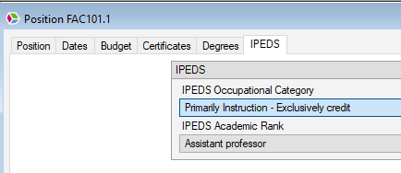
The IPEDS Calculation saves data into a table called ipeds_calculation_employees. Reports run off this table.
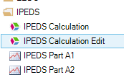
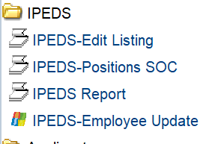

Version 10 – Correct
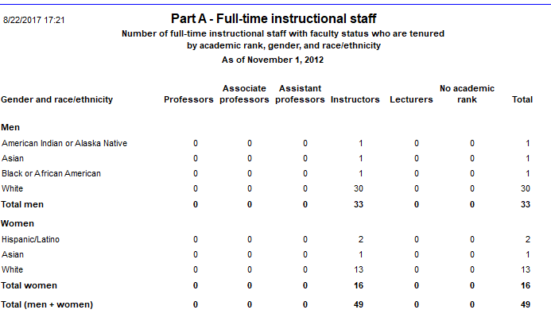
EmpowerWin
Each report is its own menu option. The reports can be saved as CSV files to see the employees behind the counts.
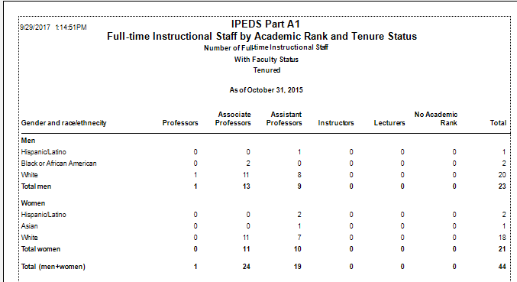

Documentation is at
https://survey.necs.ed.gov/ipeds/
Report Your Data – in the left-hand column
Survey Schedule and Materials

