Hey guys!

Here is the document of the INEMO board that I made in 2014 for my masters research and undergrad students. The purpose of this board was to test my code and peripherals before I build v2 of my sensor which is much smaller.

If you have to solder the board (some of you will get ones that have already been soldered) then please ask questions if you are unsure of something before you solder it!

Here is an Altium image of the board that shows all the names of the connectors and which is pin 1!!!. When soldering in the molex connectors, please match pin 1 of the molex to pin1 of the PCB. The square block represents pin 1.

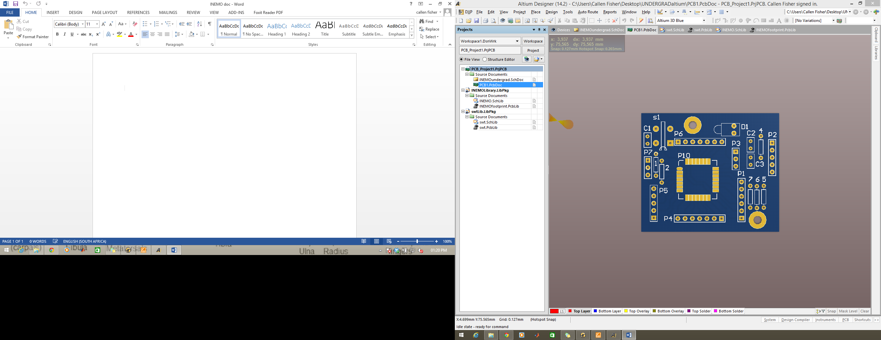

For ease of use (you can refer to the INEMO datasheet to determine what each do) I have labelled what each connector pin is connected to on the INEMO. These are described below:

P1: SWD connector to programme the device **(USE PIN HEADERS AND NOT A MOLEX CONNECTOR)**

1: Reset

2: VDD (3v)

3: GND

4: SWCLK

5: SWO

6: SWDIO

P2: **(MOLEX CONNECTOR)**

1: supply in

2: ground (in/out)

3: 5v (in/out)

4: PA9

5: PA10

P3: 5V voltage regulator

1: supply in

2: ground

3: 5V out

P4: **(MOLEX CONNECTOR)**

1: GND

2: PB8

3: PB9

4: PB7

5: PB6

6: PA12

7: PA11

P5: **(MOLEX CONNECTOR)**

1: PA0

2: GND

3: PA2

4: PA3

5: VDD (3v out)

P6: **(MOLEX CONNECTOR)**

1: GND

2: VDD (3v out)

3: PA1

4: PA7

5: PA6

6: PA5

7: PA4

P7: Boot selection mode **(USE PIN HEADERS)**

1: GND

2: BOOT0

3: VDD (3v)

P10: INEMO chip- pin 1 is the circle pad

__________________________________________________________________________________

A list of components is given below:

D1: power LED (lower pin is the supply, top pin is the ground

C1: 100pF

C2: 100pF

C3: 100pF

S1: switch **(refer to side note before soldering the switch)**

R1=10K

R2=10K

R4= LED resistor 100 ohms

R5= 10K

R6= 10K

R7= 10K

__________________________________________________________________________________

The image below is from Altium, use it to see where the pins are connected if you are confused. Pin 1 of the INEMO is the circle pad. From the INEMO datasheet and this image you should be able to figure out what each pin of the molex connectors are connected to.

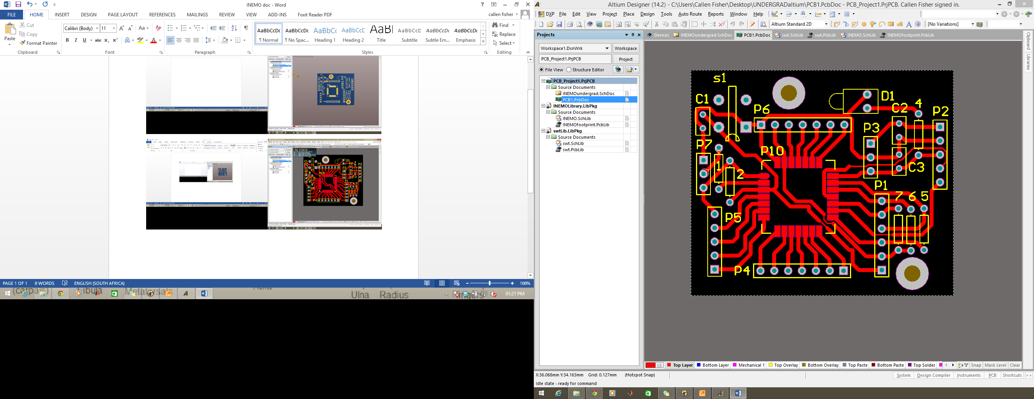

**Soldering the switch:**

If you refer to the above image, the switch must be connected to S1. In this layout the switch must connect the two pins on the left to the two pins on the right when it is pressed. Therefore you should be able to figure out which way the switch must go. If you are unsure ask before you solder it!!!

**Programming the device:**

To programme the device you need to connect it to the STM32 via the SWD connector (the top left connector in the figure below). Before you connect it to the STM32 you need to remove both jumpers shown in the top right of the figure below.

Create a molex connector ***(THIS IS NOT A ONE TO ONE CABLE!!!!)*** to connect the SWD to the INEMO board (CONNECTOR P1). The INEMO board needs to be powered on first. To power on the board it is sometimes easiest to connect the 5v pin from the stm32f4 to pin3 of P2 of the INEMO board (it gets ground through the SWD connector).

The SWD pin out on the STM32 is as follows: (match this to the SWD connector on the INEMO)

1: VDD (3v)

2: SWCLK

3: GND

4: SWDIO

5: RESET

6: SWO

(the dot by the top pin represents pin1)

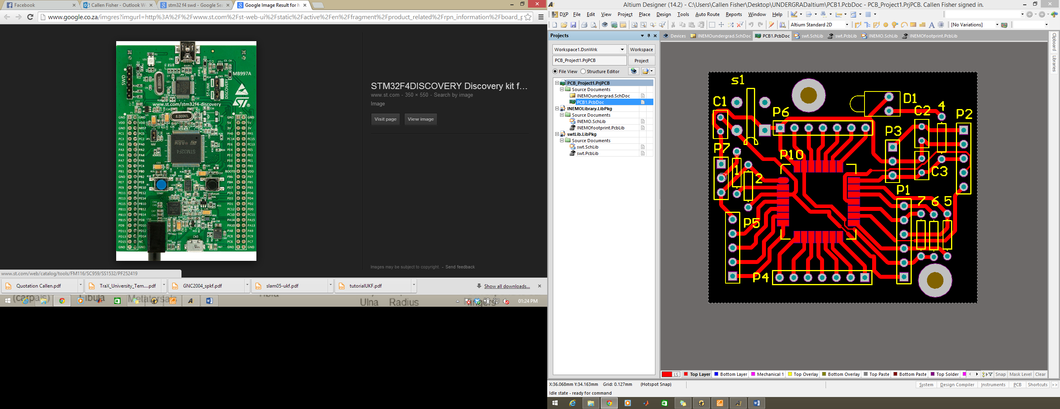

**Using Atollic:**

Download the free Lite version of attolic true studio from their website and install it on your PC.

(<http://atollic.com/index.php/download>)

Once it is installed download and unzip my sample code.

To import the code into atollic: File-import-General-existing projects into workspace

Then click next and keep going until it is imported.

How to use atollic: you first need to build the project. To do this click the hammer at the top. Once the project has been built you need to debug it. To do this you click the green bug. This will take you to the Debug perspective and there you will need to click the resume button to get the code running on your INEMO.

If you are unsure of where a variable is defined or what a piece of code does, click F3 on it and it will take you to where it was defined.

**Sample Code:**

I have written very basic sample code to get you started. The code is capable of getting the gyroscope, accelerometer and magnetometer data from the INEMO. I have also set up some GPIO pins, PWM and USART.

If there are any queries please set up a meeting with me. My email address is:

[Fshcal001@myuct.ac.za](mailto:Fshcal001@myuct.ac.za)