**Paestum**

ancient city, Italy

[Print](https://www.britannica.com/print/article/438129) Cite Share Feedback

Also known as: Poseidonia

Written and fact-checked by

The Editors of Encyclopaedia Britannica

Last Updated: [Article History](https://www.britannica.com/place/Paestum/additional-info#history)

[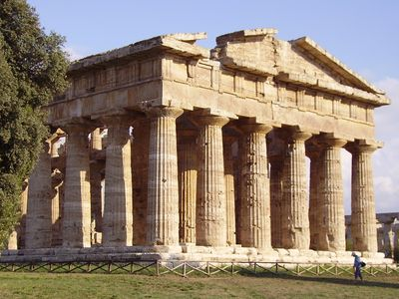](https://cdn.britannica.com/75/125575-050-7EC5DB09/Temple-of-Apollo-Paestum-Italy.jpg)

Paestum: Temple of Apollo

[See all media](https://www.britannica.com/place/Paestum/images-videos)

Category: [Geography & Travel](https://www.britannica.com/Geography-Travel)

**Greek:**Poseidonia

Related Places:

[Italy](https://www.britannica.com/place/Italy) [ancient Greece](https://www.britannica.com/place/ancient-Greece) [Basilicata](https://www.britannica.com/place/Basilicata)

[See all related content →](https://www.britannica.com/facts/Paestum)

**Paestum**, Greek **Poseidonia**, ancient city in southern [Italy](https://www.britannica.com/place/Italy) near the west coast, 22 miles (35 km) southeast of modern [Salerno](https://www.britannica.com/place/Salerno-Italy) and 5 miles (8 km) south of the Sele (ancient Silarus) River. Paestum is noted for its splendidly preserved Greek temples.

[[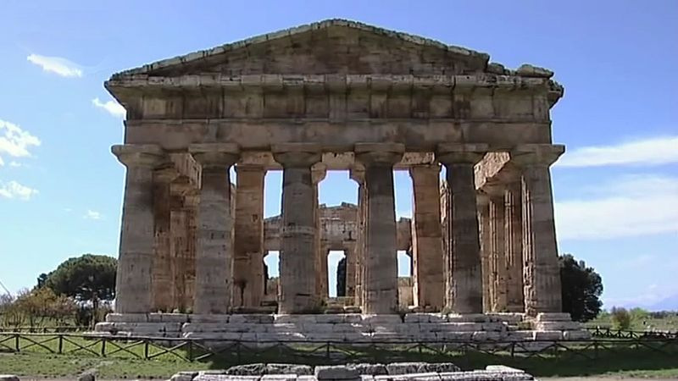](https://www.britannica.com/video/187683/video-tour-ruins-colony-Greek-Italy-Paestum)](https://www.britannica.com/video/187683/video-tour-ruins-colony-Greek-Italy-Paestum)

Visit the ruins of the ancient Greek colony of Paestum and discover its history, culture, and society

[See all videos for this article](https://www.britannica.com/place/Paestum/images-videos)

Poseidonia was probably founded about 600 BC by Greek colonists from [Sybaris](https://www.britannica.com/place/Sybaris), along the [Gulf of Taranto](https://www.britannica.com/place/Gulf-of-Taranto), and it had become a flourishing town by 540, judging from its temples. After many years’ resistance the city came under the domination of the [Lucanians](https://www.britannica.com/topic/Lucanian) (an [indigenous](https://www.merriam-webster.com/dictionary/indigenous) Italic people) sometime before 400 BC, after which its name was changed to Paestum. Alexander, the king of Epirus, defeated the Lucanians at Paestum about 332 BC, but the city remained Lucanian until 273, when it came under Roman rule and a Latin colony was founded there. The city supported [Rome](https://www.britannica.com/place/Rome) during the [Second Punic War](https://www.britannica.com/event/Second-Punic-War). The locality was still prosperous during the early years of the Roman Empire, but the gradual silting up of the mouth of the Silarus River eventually created a malarial swamp, and Paestum was finally deserted after being sacked by Muslim raiders in AD 871. The abandoned site’s remains were rediscovered in the 18th century.

[[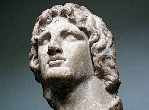](https://www.britannica.com/quiz/ancient-greece)](https://www.britannica.com/quiz/ancient-greece)

**[Britannica Quiz](https://www.britannica.com/quiz/ancient-greece)**

[Ancient Greece](https://www.britannica.com/quiz/ancient-greece)

[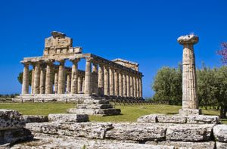](https://cdn.britannica.com/98/140998-050-FCED0B79/Temple-of-Athena-Paestum-Italy.jpg)

[Paestum, Italy: Temple of Athena](https://cdn.britannica.com/98/140998-050-FCED0B79/Temple-of-Athena-Paestum-Italy.jpg)

The ancient Greek part of Paestum consists of two sacred areas containing three Doric temples in a remarkable state of preservation. During the ensuing Roman period a typical [forum](https://www.britannica.com/topic/forum-ancient-Rome) and town [layout](https://www.britannica.com/dictionary/layout) grew up between the two ancient Greek sanctuaries. Of the three temples, the [Temple of Athena](https://www.britannica.com/place/Temple-of-Athena) (the so-called Temple of Ceres) and the Temple of [Hera](https://www.britannica.com/topic/Hera) I (the so-called Basilica) date from the 6th century BC, while the Temple of Hera II (the so-called Temple of Neptune) was probably built about 460 BC and is the best preserved of the three. The Temple of Peace in the forum is a Corinthian-Doric building begun perhaps in the 2nd century BC. Traces of a Roman amphitheatre and other buildings, as well as intersecting main streets, have also been found. The circuit of the town walls, which are built of travertine blocks and are 15–20 feet (5–6 m) thick, is about 3 miles (5 km) in circumference. In July 1969 a farmer uncovered an ancient Lucanian tomb that contained Greek frescoes painted in the early [classical style](https://www.britannica.com/art/Classicism). Paestum’s archaeological museum contains these and other [treasures](https://www.britannica.com/dictionary/treasures) from the site.