**Library Management System**

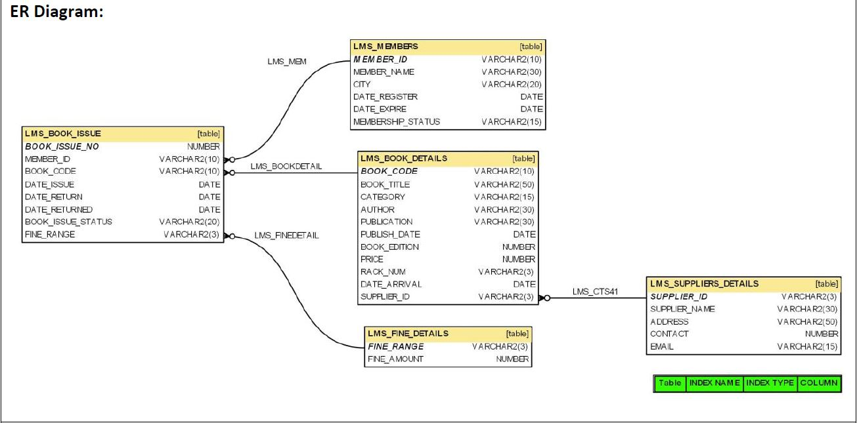

**Entity Relationship Diagram**

**1.** Write a query to display the book code, book title and supplier name of the supplier who has supplied maximum number of books. For example, if “ABC Store” supplied 3 books, “LM Store” has supplied 2 books and “XYZ Store” has supplied 1 book. So “ABC Store” has supplied maximum number of books.

with m as (select supplier_id, max(n_book) from (select count(book_code) n_book, supplier_id from lms_book_details

group by supplier_id) as counted)

select bd.book_code, bd.book_title, sd.supplier_name

from lms_book_details bd join lms_suppliers_details sd

on bd.supplier_id = sd.supplier_id join m

on m.supplier_id = sd.supplier_id

where bd.supplier_id = m.supplier_id

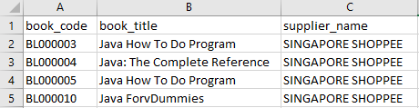

**2.** Write a query to display the member id, member name and number of remaining books he/she can take with “REMAININGBOOKS” as alias name. Hint: Assuming a member can take maximum 3 books.

SELECT ms.member_id, ms.member_name, 3-count(date_issue) REMAININGBOOKS

FROM lms_members ms JOIN lms_book_issue bi

ON ms.member_id = bi.member_id

GROUP BY ms.member_id

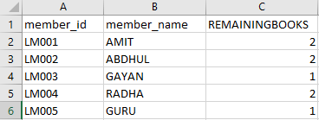

**3.** Write a query to display the supplier id and supplier name of the supplier who has supplied minimum number of books. For example, if “ABC Store” supplied 3 books, “LM Store” has supplied 2 books and “XYZ Store” has supplied 1 book. So “XYZ Store” has supplied minimum number of books.

with counting as (

    select count(bd.book_code) counted, sd.supplier_id, sd.supplier_name

    from lms_book_details bd join lms_suppliers_details sd

    on bd.supplier_id = sd.supplier_id

    group by bd.supplier_id

)

select supplier_id, supplier_name from counting

where counted = (select min(counted) from counting)

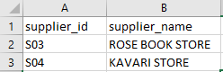

**4.** Write a query to display the member id, member name of the members, book code and book title of the books taken by them.

select ms.member_id, ms.member_name, bi.book_code, bd.book_title from lms_members ms

join lms_book_issue bi on ms.member_id =  bi.member_id

join lms_book_details bd on bi.book_code = bd.book_code;

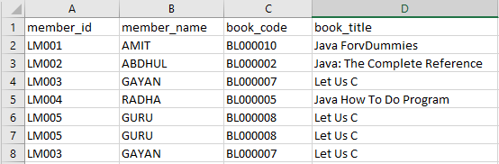

**5.** Write a query to display the total number of books available in the library with alias name “NO_OF_BOOKS_AVAILABLE” (Which is not issued). Hint: The issued books details are available in the LMS_BOOK_ISSUE table.

select count(book_code) as NO_OF_BOOKS_AVAILABLE from lms_book_details

where book_code NOT IN (select book_code from lms_book_issue);

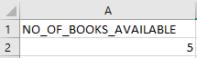

**6.** Write a query to display the member id, member name, fine range and fine amount of the members whose fine amount is less than 100.

select ms.member_id, ms.member_name, fd.fine_range, fd.fine_amount

from lms_members ms join lms_book_issue bi on ms.member_id = bi.member_id

join lms_fine_details fd on fd.fine_range = bi.fine_range

where fd.fine_amount < 100;

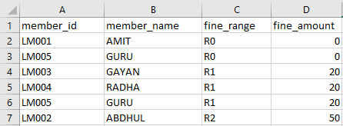

**7.** Write a query to display the book code, book title and rack number of the books which are placed in rack 'A1' and sort by book title in ascending order.

select book_code, book_title, rack_num from lms_book_details

where rack_num = 'A1'

ORDER BY book_title ASC;

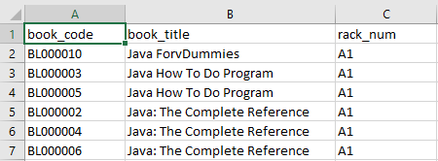

**8.** Write a query to display the member id, member name, due date and date returned of the members who has returned the books after the due date. Hint: Date_return is due date and Date_returned is actual book return date.

SELECT ms.member_id, ms.member_name, bi.date_return, bi.date_returned

FROM lms_members ms

JOIN lms_book_issue bi ON ms.member_id = bi.member_id

WHERE bi.date_returned > bi.date_return;

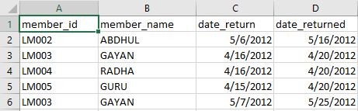

**9.** Write a query to display the member id, member name and date of registration who have not taken any book.

SELECT ms.member_id, ms.member_name, ms.date_register

FROM lms_members ms

WHERE ms.member_id NOT IN (

    SELECT member_id from lms_book_issue

);



**10.** Write a Query to display the member id and member name of the members who has not paid any fine in the year 2012.

SELECT member_id, member_name FROM lms_members

WHERE member_id NOT IN (SELECT member_id FROM lms_book_issue bi

    JOIN lms_fine_details fd on bi.fine_range = fd.fine_range

    WHERE year(bi.date_returned) = 2012

    GROUP BY bi.member_id HAVING SUM(fd.fine_amount)>0);

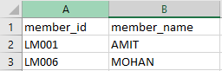

**11.** Write a query to display the date on which the maximum numbers of books were issued and the number of books issued with alias name “NOOFBOOKS”.

SELECT COUNT(book_code) as NOOFBOOKS, date_issue

FROM lms_book_issue

GROUP BY date_issue;

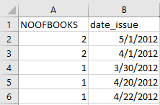

**12.** Write a query to list the book title and supplier id for the books authored by “Herbert Schildt" and the book edition is 5 and supplied by supplier ‘S01’.

SELECT bd.book_title, sd.supplier_id FROM lms_book_details bd

JOIN lms_suppliers_details sd ON bd.supplier_id = sd.supplier_id

WHERE bd.author = 'Herbert Schildt' AND book_edition = 5

AND sd.supplier_id = 'S01';



**13.** Write a query to display the rack number and the number of books in each rack with alias name “NOOFBOOKS” and sort by rack number in ascending order.

select rack_num, count(book_code) as NOOFBOOKS

from lms_book_details

group by rack_num

order by rack_num asc;

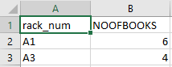

**14.** Write a query to display book issue number, member name, date or registration, date of expiry, book title, category author, price, date of issue, date of return, actual returned date, issue status, fine amount.

SELECT bi.book_issue_no, ms.member_name, ms.date_register, ms.date_expire,

bd.book_title, bd.category, bd.author, bd.price, bi.date_issue, bi.date_return,

bi.date_returned, fd.fine_amount

FROM lms_members ms

JOIN lms_book_issue bi

ON ms.member_id = bi.member_id

JOIN lms_book_details bd

ON bi.book_code = bd.book_code

JOIN lms_fine_details fd

ON bi.fine_range = fd.fine_range

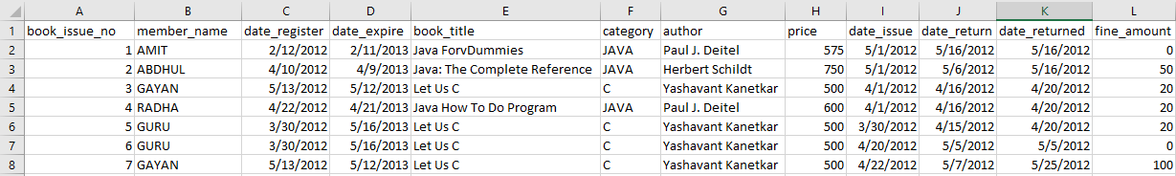

**15.** Write a query to display the book code, title, publish date of the books which is been published in the month of December.

SELECT book_code, book_title, publish_date FROM lms_book_details

WHERE month(publish_date) = 12

