Plugin structure
Plugin sources are contained in the directory org.sotileza.plugin.v3 and show the following package structure:
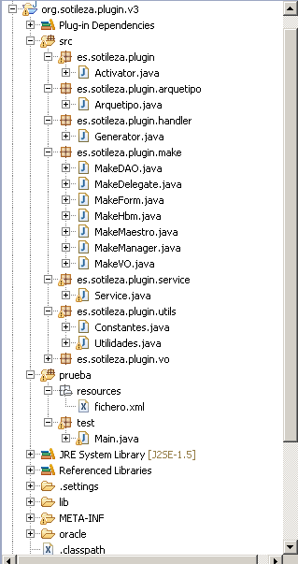
Package contents
- es.sotileza.plugin.arquetipo
  - In this package you can find a class that contains the methods we need to generate all the folder and files structure that will compose the final application.
- es.sotileza.plugin.handler
  - This package contains the class that can be run when we execute Sotilizator from Eclpise.
- es.sotileza.plugin.make
  - In this package we see the classes in charge of generating all apliccation the bussiness logic. There is a class for each layer.
- es.sotileza.plugin.service
  - This package incorporates the class that parces the initial .xml folder and is in charge of obtaining from the data base all the fileds from it.
- es.sotileza.plugin.utils
  - Here we can find the different variables and support tools and that are used in the rest of the plugin.
- es.sotileza.plugin.vo
  - Here there are the objets that would contain the information to be used to generate tha apliccations. It is important to mention:
    - TablaVO: It brings together the necessary data from a DB.
    - CampoVO: Each of the fields that consists a tablaVO.
    - FkVO: It is used when the field from the table refers to another table. That is to say, a foreign key.
    - SetVO: It contains the data from a collection that belogns to another table and that is linked to tablaVO.
For example: An author has writen many books. Therefore on author’s tablaVO there should be a SetVO with the author’s books.
    - ArquetipoVO: It contains the data meant on the .xml folder.

Testing the changes
If you make a change on the plugin and want to test it, it is not necessary that you make all the plugin creation process. You just have to run prueba.test.Main.java.
In order to work you have to change line 106 and 68 from Arquetipo.java folder so that it can find the directory from arquetype org.sotileza.plugin.resources. As follows:
//raiz = new File("plugins/org.sotileza.plugin.resources/resources");
raiz = new File("C:/Documents and Settings/Administrador/Escritorio/eclipse/plugins/org.sotileza.plugin.resources/resourcesClases");
instead of:
raiz = new File("plugins/org.sotileza.plugin.resources/resources");
//raiz = new File("C:/Documents and Settings/Administrador/Escritorio/eclipse/plugins/org.sotileza.plugin.resources/resources");
Generating a new version
