Ontology Models

Roberto Viviani, University of Innsbruck

2024-04-18

We plot correlation on cosine distance of embeddings, to see if distance predicts correlation. We consider different NEO subscales separately.

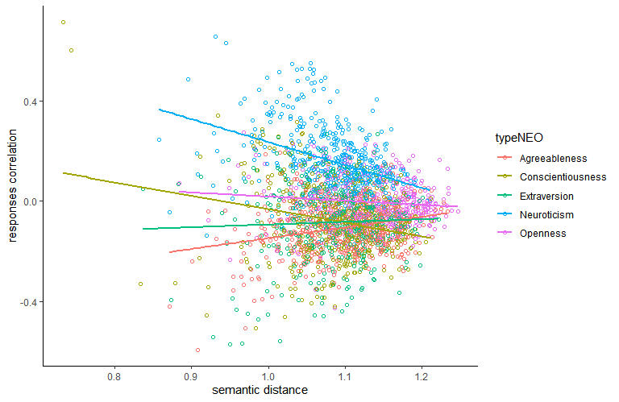

One question that naturally arises is the extent to which semantic similarity explains the correlation between scales. The average correlation between NEO and PID scales, computed from the correlation of the items, is

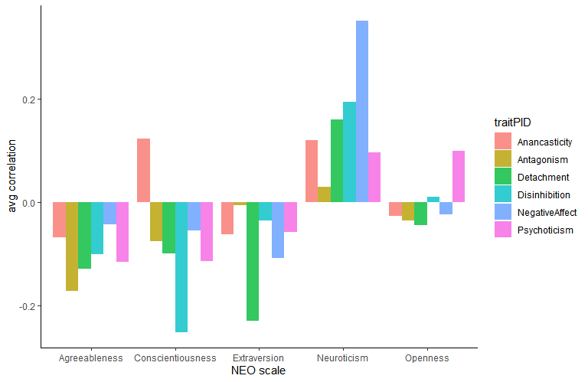

We see here the pattern of a positive association between neuroticism and PID scores, and a negative association of all other NEO scales, with the exception of openness to experience that had no association. Conscientiousness is another exception to this pattern because of the opposite associations with anancasticity and disinhibition.

To see how much these correlations are explained by semantic relatedness, we plot their absolute value on semantic relatedness.

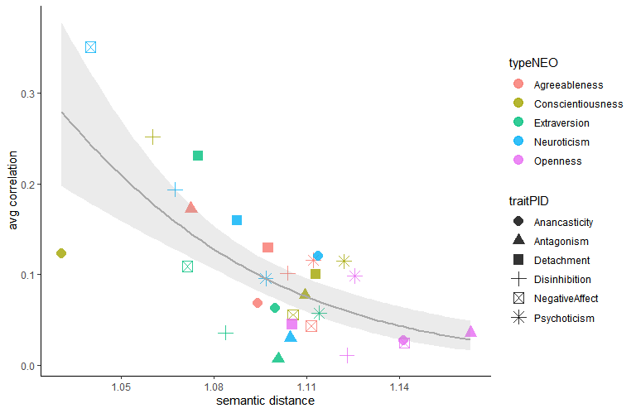

##   
## Call:  
## glm(formula = abs(corr) ~ dist, family = quasibinomial, data = summarize(group_by(cordata,   
## typeNEO, traitPID), corr = mean(corrs), dist = mean(cosdist)))  
##   
## Deviance Residuals:   
## Min 1Q Median 3Q Max   
## -0.37802 -0.11443 0.00168 0.13497 0.24476   
##   
## Coefficients:  
## Estimate Std. Error t value Pr(>|t|)   
## (Intercept) 19.366 3.928 4.931 3.35e-05 ***  
## dist -19.708 3.611 -5.458 7.95e-06 ***  
## ---  
## Signif. codes: 0 '***' 0.001 '**' 0.01 '*' 0.05 '.' 0.1 ' ' 1  
##   
## (Dispersion parameter for quasibinomial family taken to be 0.02977943)  
##   
## Null deviance: 1.81380 on 29 degrees of freedom  
## Residual deviance: 0.92642 on 28 degrees of freedom  
## AIC: NA  
##   
## Number of Fisher Scoring iterations: 5

In general, the closer the semantic relatedness of items of the respective subscales and traits, the stronger the correlations in the answers of participants. We also see that the strongest correlation, given by neuroticism and negative affect, was also accompanied by a short semantic distance between the items of the respective scales. However, the amount of correlation is higher than we would expect from a linear prediction from the amount of semantic relatedness. We can see also that conscientiousness departed from this pattern. However, the semantic construct implied by the conscientiousness items appears to be heterogeneous. As described in the literature, openness to experience was not related to PID dimensions. We see that in both its large semantic distance and low correlation with total PID scores.

## Association of individual NEO items

For conscientiusness, we can show that with lower semantic distance the associations diverge into two groups.

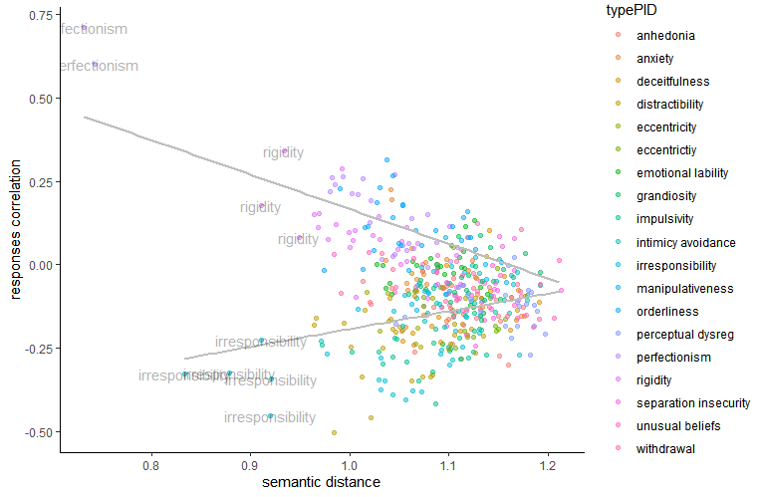

Furthermore, the items that associated positively with PID subscales concern rigidity and perfectionism. Distractability and irresponsibility are negatively associated with conscientiousness, meaning individuals who are more conscienscious are less distractable and irresponsible.

We now identify the items in the scale that are responsible for the negative association:

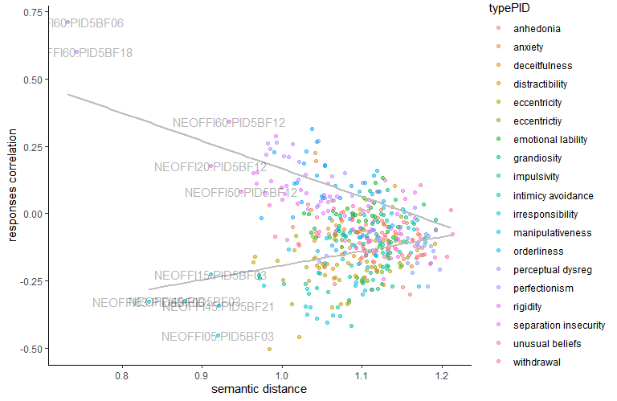

NEO item 60 is “I strive for excellence in everything I do” (Bei allem, was ich tue, strebe ich nach Perfektion”). This ends up correlated with responses on “I keep approaching things the same way, even when it isn’t working” (“Auch wenn es andere zum Wahnsinn treibt, bestehe ich darauf, alles perfekt zu machen”) and “I get stuck on one way of doing things, even when it’s clear it won’t work” (“Ich versuche Dinge weiter zu perfektionieren, auch wenn ich sie wahrscheinlich schon so gut wie möglich hinbekommen habe”). The differences in meaning between the German and English version are enough to produce different results in the semantic analysis: here, the notion of perfectionism drives a semantic association that is absent in the original English language (see Ontology.ipynb).

Extraversion, by contrast, appears to be so sparsely distributed because of the selective negative association of some items with anhedonia, anxiety, and withdrawal. Here, the language model detected semantic affinities between properties such as distractability and emotional lability that were not confirmed by higher response associations.

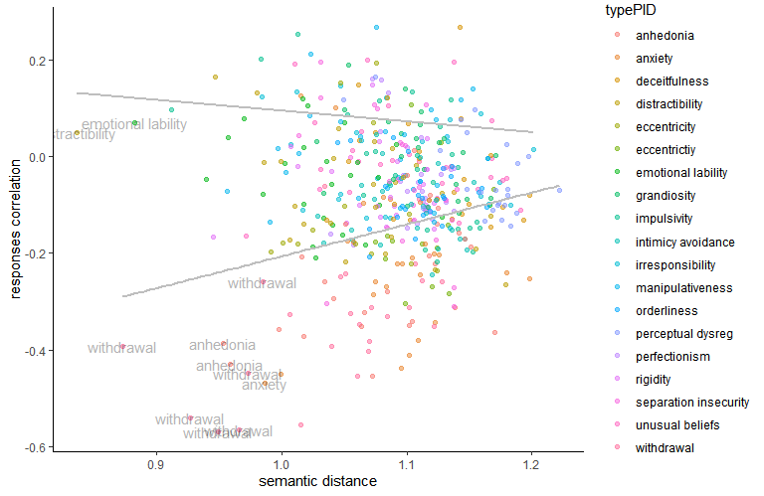

Agreableness, in contrast, presents a weak and less specific negative association with the PID traits, with some stronger associations with manipulativeness and deceitfulness.

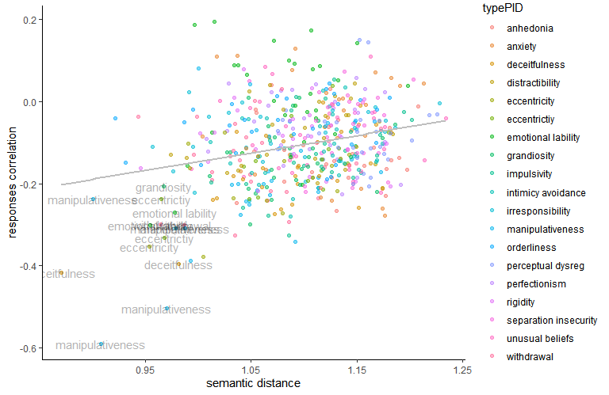

Finally, we show what appears to be a genuine association between low openness and anhedonia. “Genuine”, because the language model detects no semantic affinity between the items of openness and anhedonia, but in some cases a negative association is present among participants.

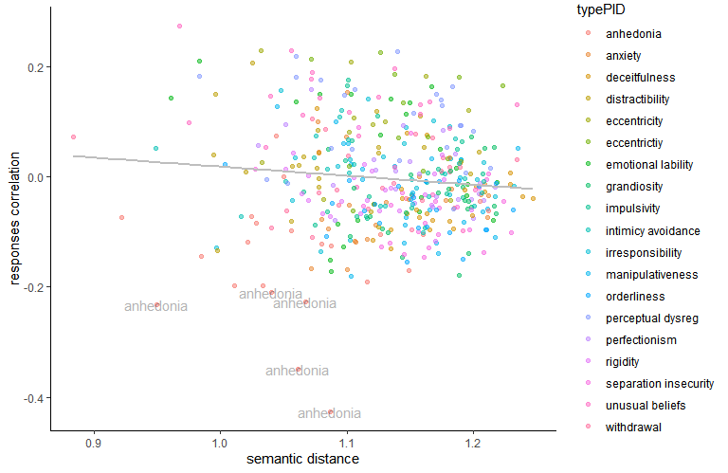

We can identify the NEO items that are responsible for these associations:

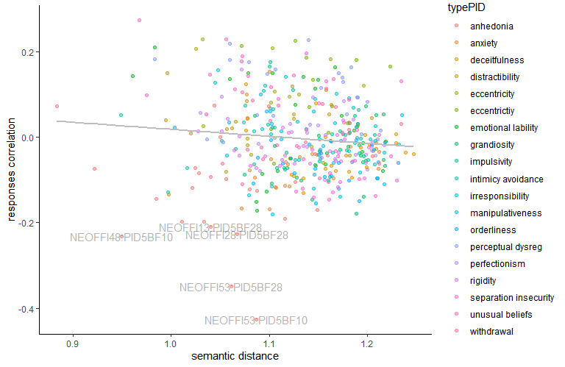

NEOFFI53, which shows the most negative correlations with PID28 and PID10, is the text I have a lot of intellectual curiosity” (“Ich bin sehr wissbegierig”). The correlated anhedonia PID items are “I rarely get enthusiastic about anything” (“Ich bin selten von irgendetwas begeistert”) and “Nothing seems to interest me very much” (“Nichts scheint mich wirklich zu interessieren”). Here, the notion of intellectual curiosity appears to have been coded as being distinct from general enthusiasm and interest by the language model, but ends up correlating with anhedonia in the responses of participants.