**MINESWEEPER v1.0**

Contents

Requirements 2

Code Compilation 2

# Requirements

1. Visual Studio Code IDE.
2. Angular 16

# Code Compilation and Using the FPTMinesweeper

1. Extract source code at <https://github.com/robertoalubay/FPTMinesweeper.git> and copy to a folder.
2. Open “Visual Studio Code” to point to the folder from #1.
   1. Open a “Terminal – New Terminal”.
   2. Type “npm install –force”:

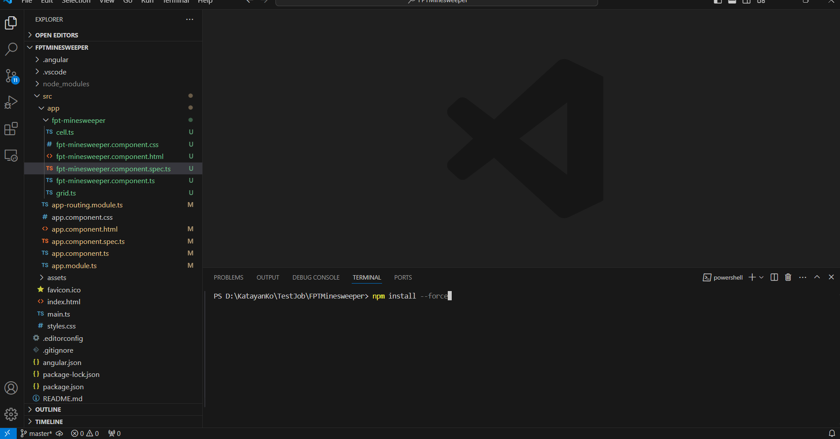

* 1. Type “ng serve”. Should expect a “Compiled successful

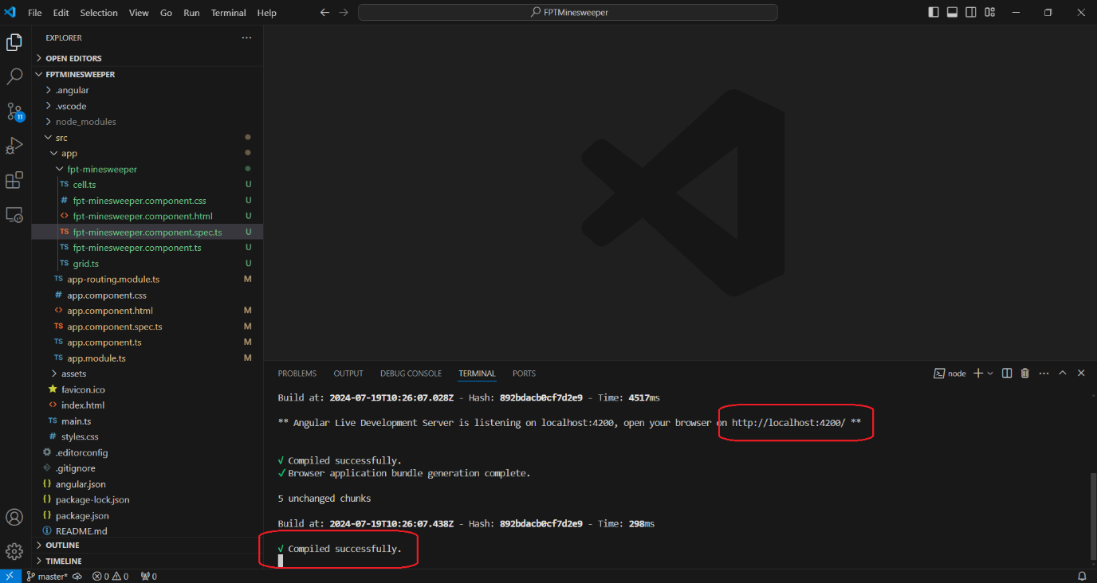

* 1. Open a Chrome Web Browser and go to <http://localhost:4200/home>. Ensure the port appeared at 2c is used, in this case, the port is “4200”.

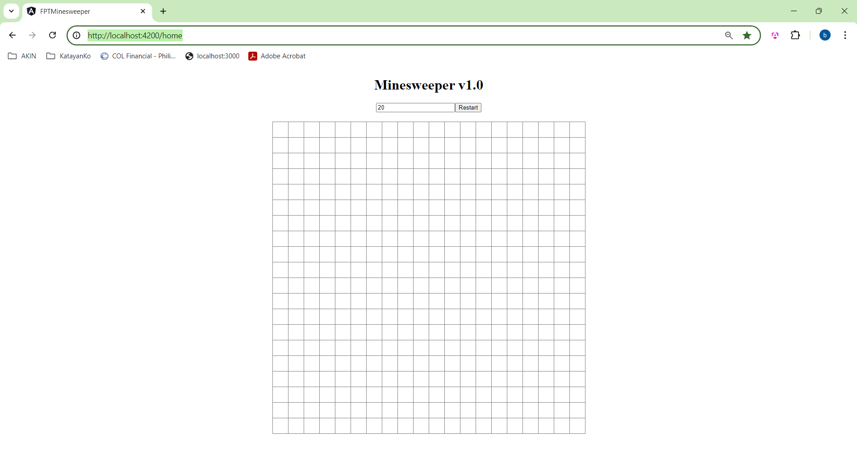

* 1. Mouse Left click is used to guess. Mouse Right click is used to put a flag in a cell:

