Backend

1. Import the Maven project at Eclipse and start Spring Boot application class “ChatApplication”:

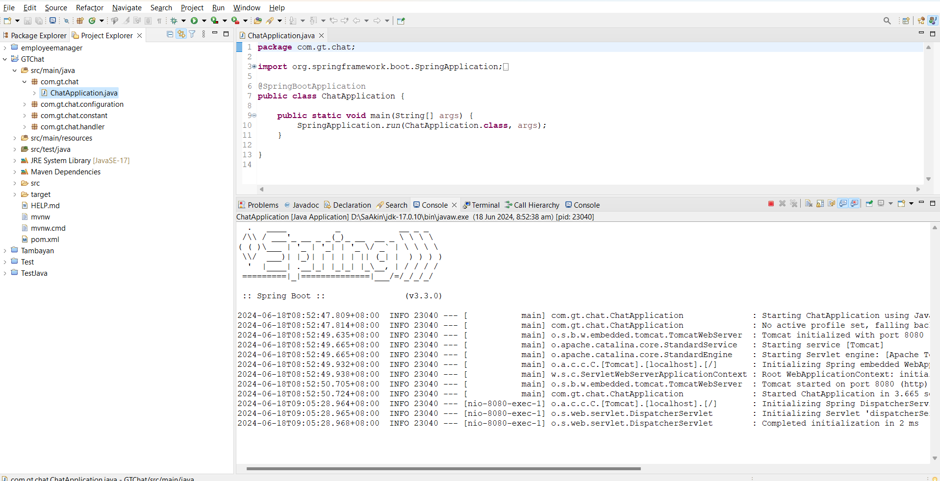

FrontEnd

1. Import the FE application to “Visual Studio”.
2. Open a console and type “ng server”:

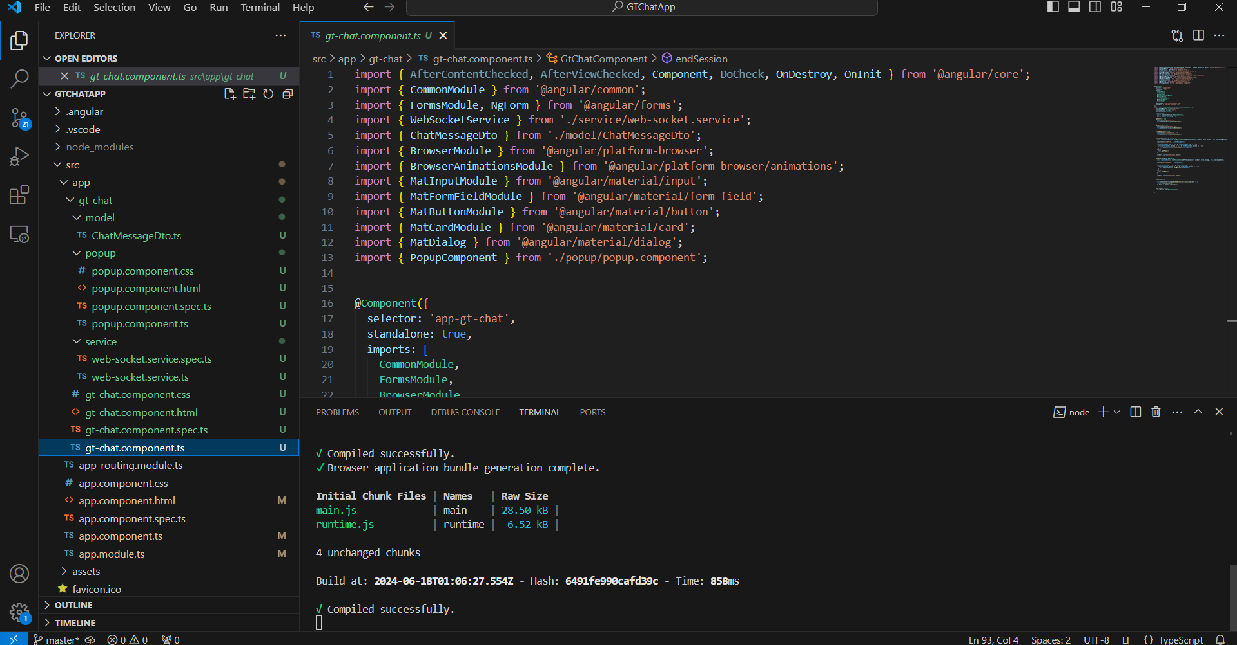

Testing the Application

1. Ensure both Backend and Frontend are up. Refer above to start.
2. Open Chrome browser and go to this URL: <http://localhost:4200/>. The home page appears

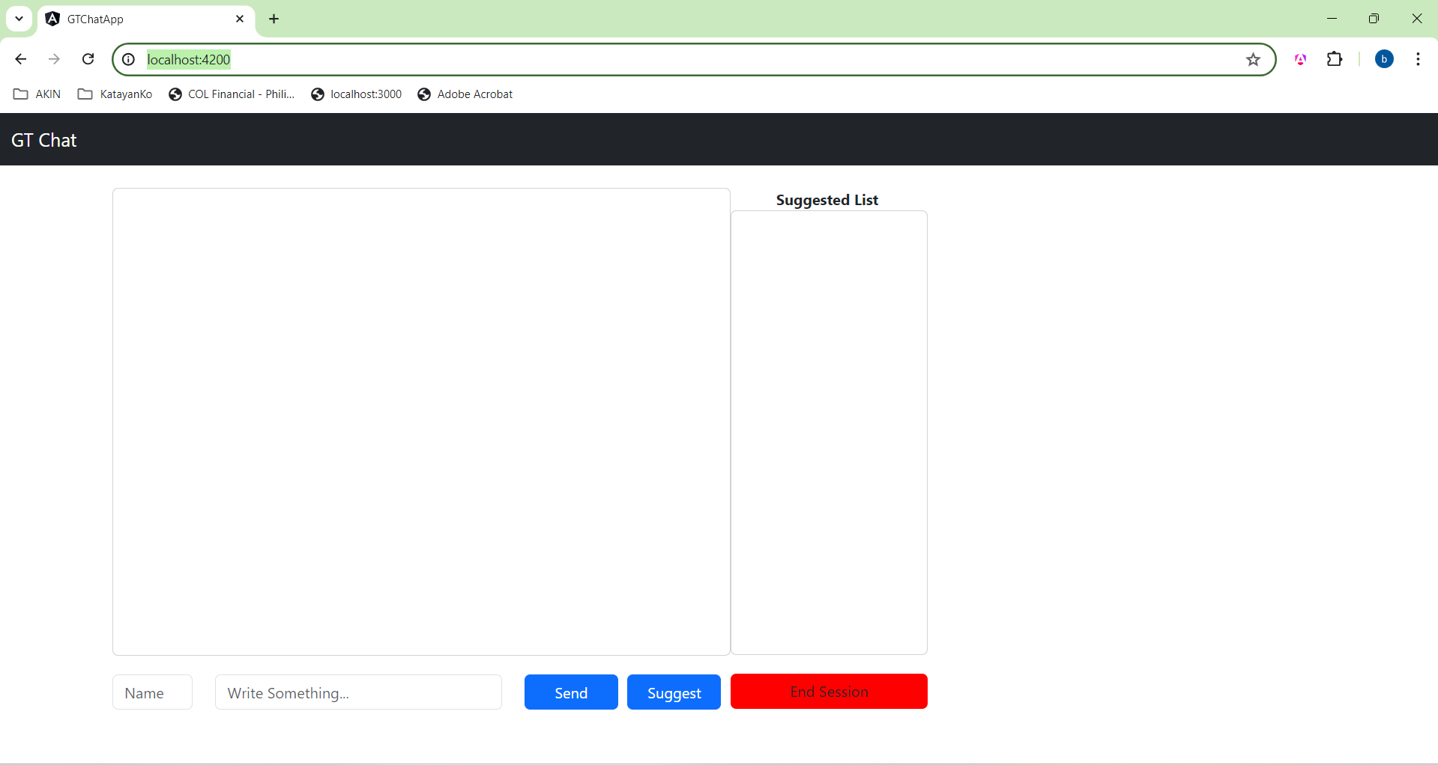

1. Enter your name, your “message” then press the “Send” button to broadcast a message:

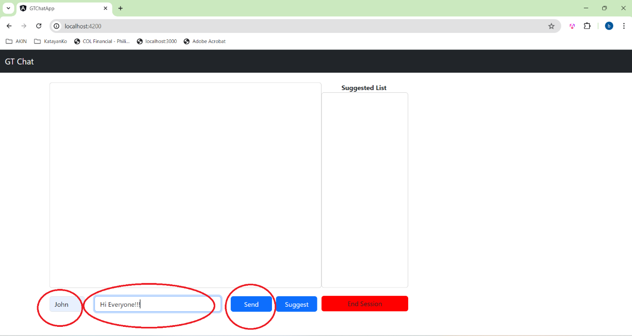

1. Suggest a location to eat by typing at the “message” box and hit the “Suggest” button :

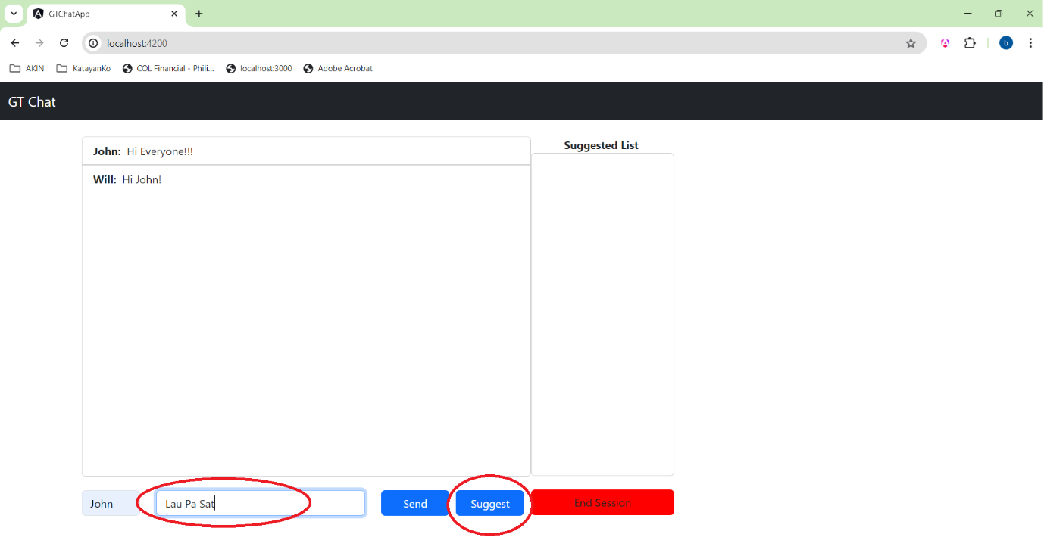

The “Suggest”ed location will be added at the “Suggested List”.

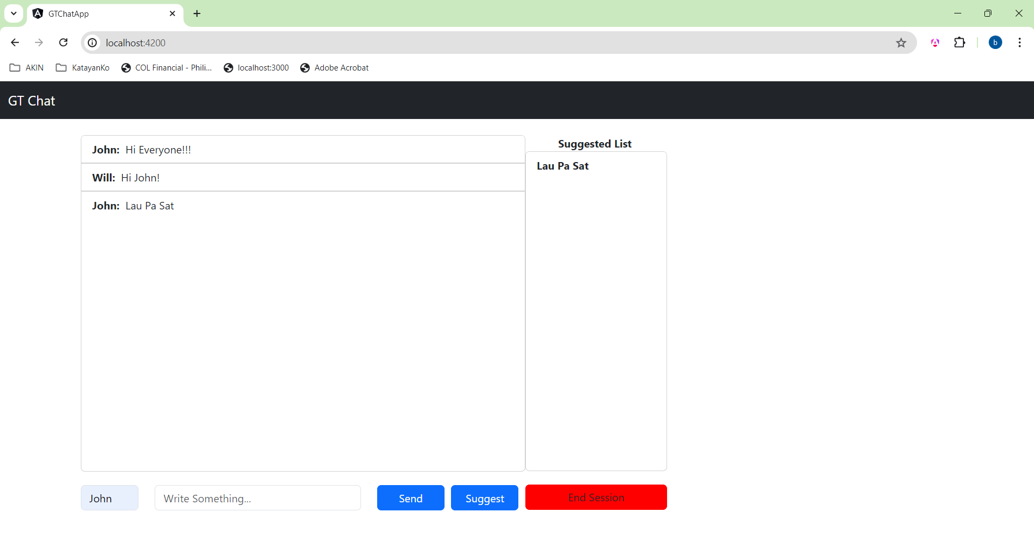

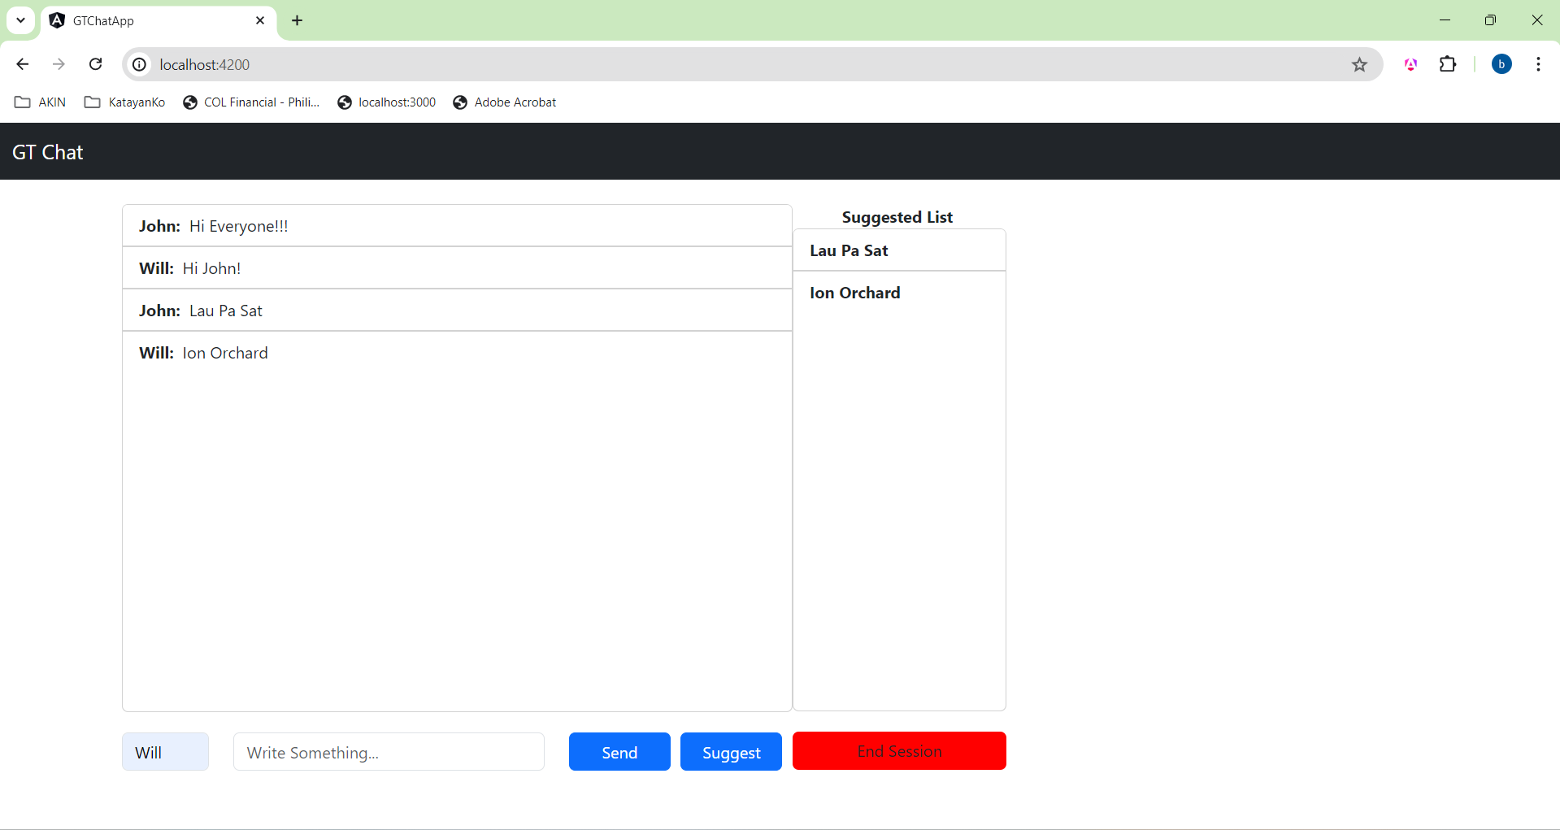

Selected Location

1. Press “End Session” to end the session and chooses the final location:

