Contents

Project Info 2

Cloning the Github repository: 2

Starting Backend Using Eclipse 2

Starting FrontEnd using Visual Studio 2

Application User Guide 3

# Project Info

1. Backend: Java 17, Spring Boot
2. Frontend: Angular 16

# Cloning the Github repository:

1. Clone URL: <https://github.com/robertoalubay/GTChat.git>
2. Backend folder: GTChat
3. Frontend folder: GTChatApp

# Starting Backend Using Eclipse

1. Import the Maven project “GTChat” at Eclipse and start Spring Boot application class “ChatApplication”:

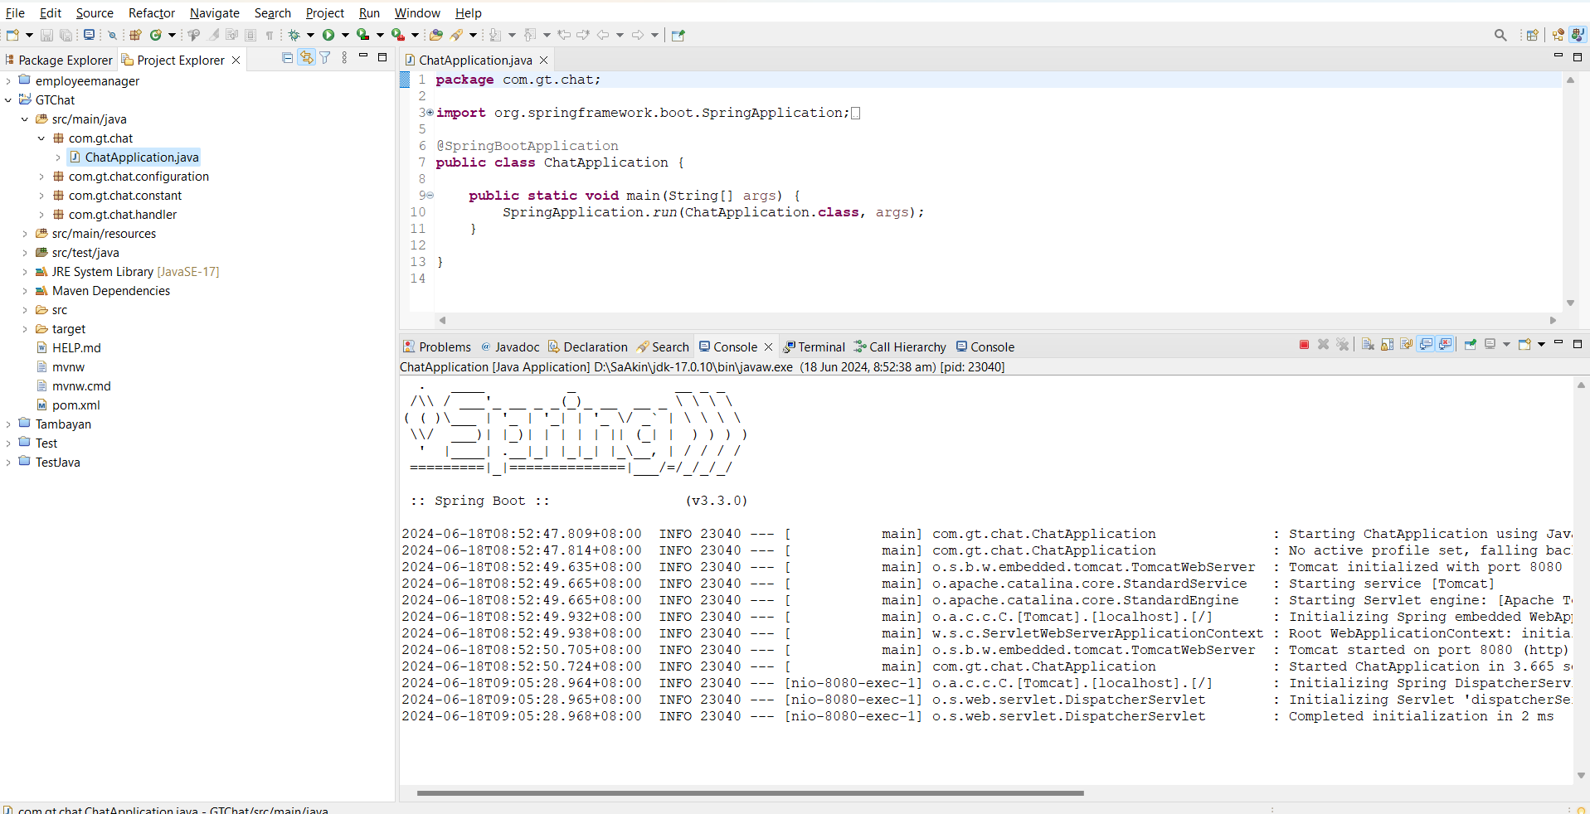

# Starting FrontEnd using Visual Studio

1. Import the FE application “GTChatApp” to “Visual Studio”.
2. Using “Visual Studio”, open a console and install the following:
   1. Bootstrap(ng add @ng-bootstrap/ng-bootstrap)
   2. Material(ng add @angular/material)
3. Open a console and type “ng serve”:

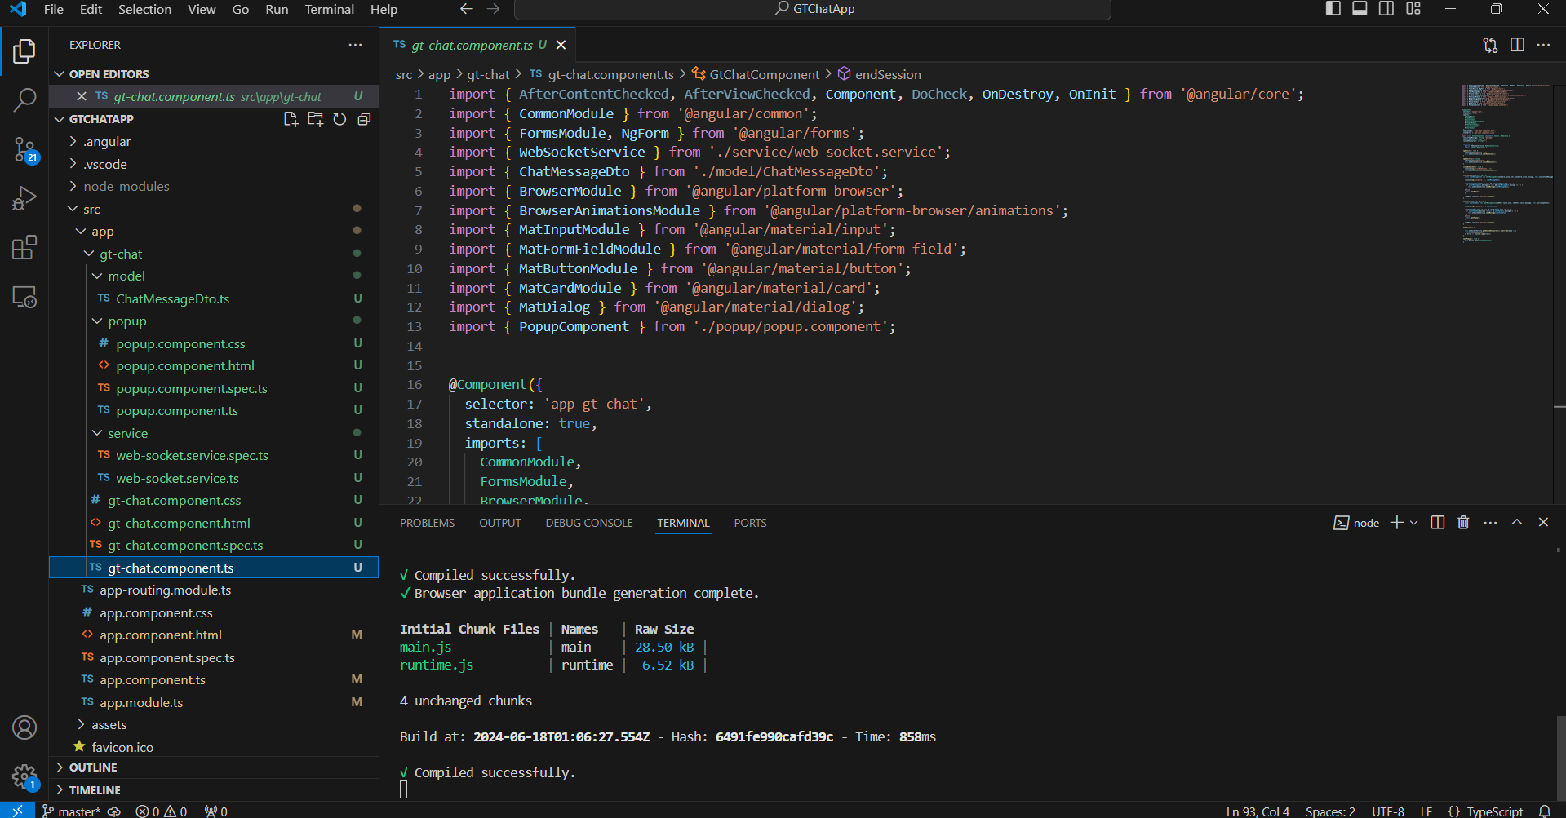

# Application User Guide

1. Ensure both Backend and Frontend are up. Refer above to start.
2. Open Chrome browser and go to this URL: <http://localhost:4200/>. The home page appears

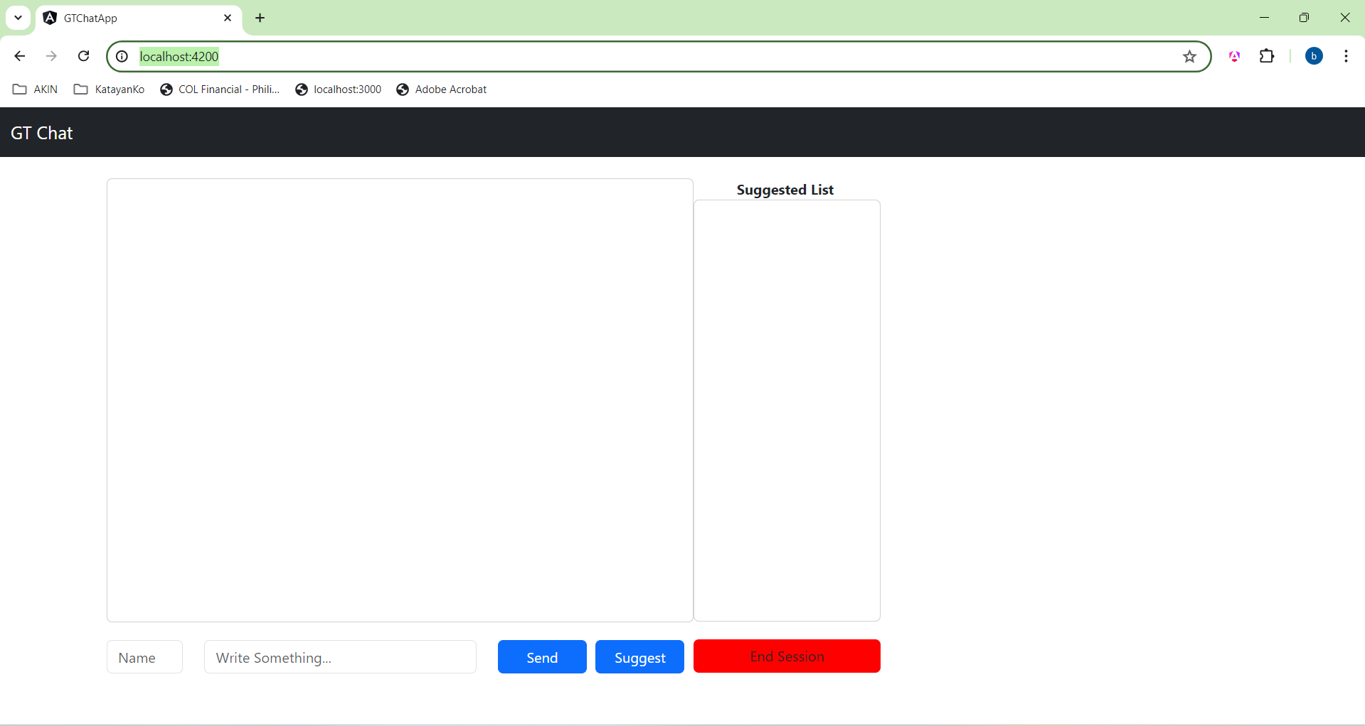

1. Enter your name, your “message” then press the “Send” button to broadcast a message:

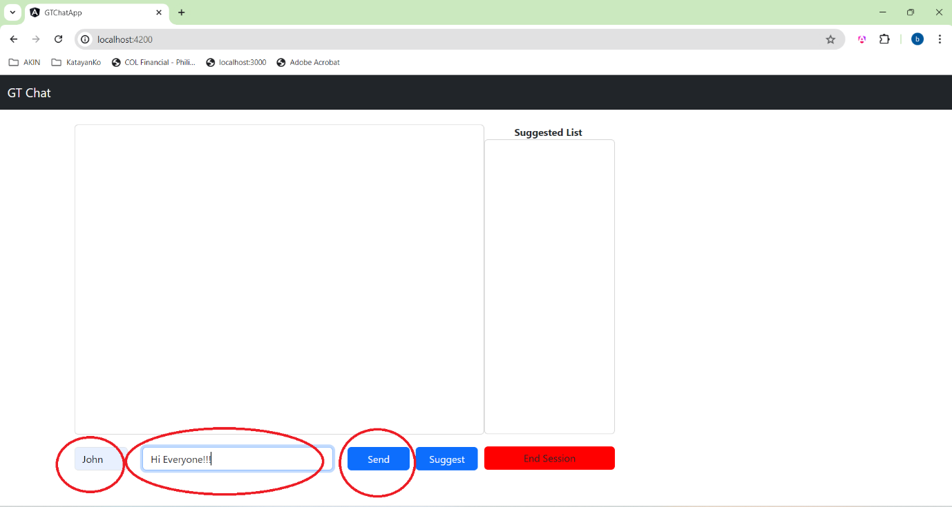

1. Suggest a location to eat by typing at the “message” box and hit the “Suggest” button :

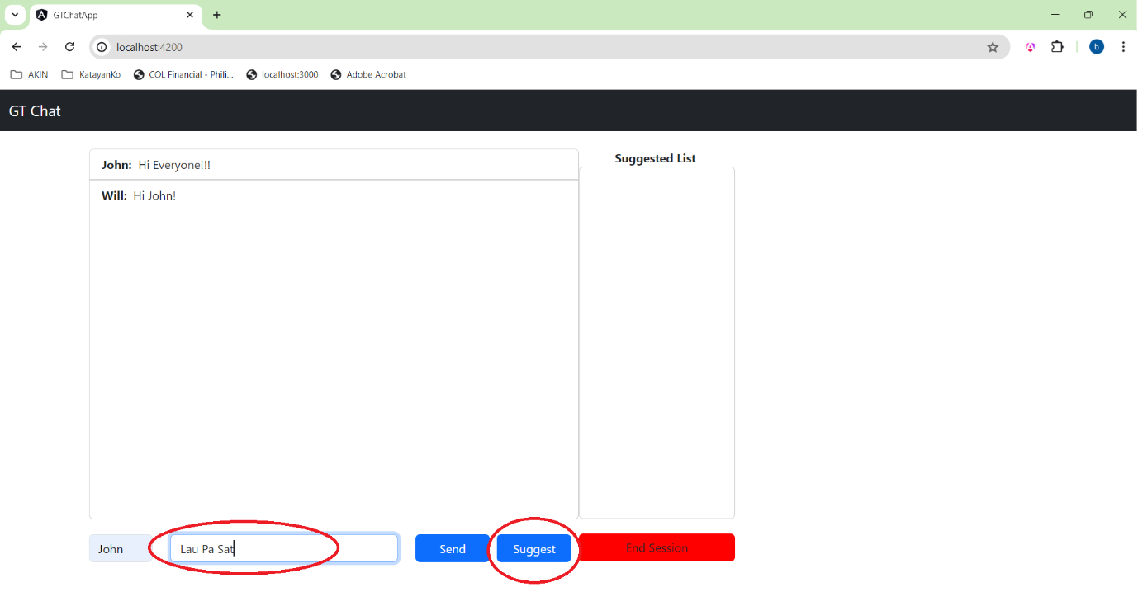

The “Suggest”ed location will be added at the “Suggested List”.

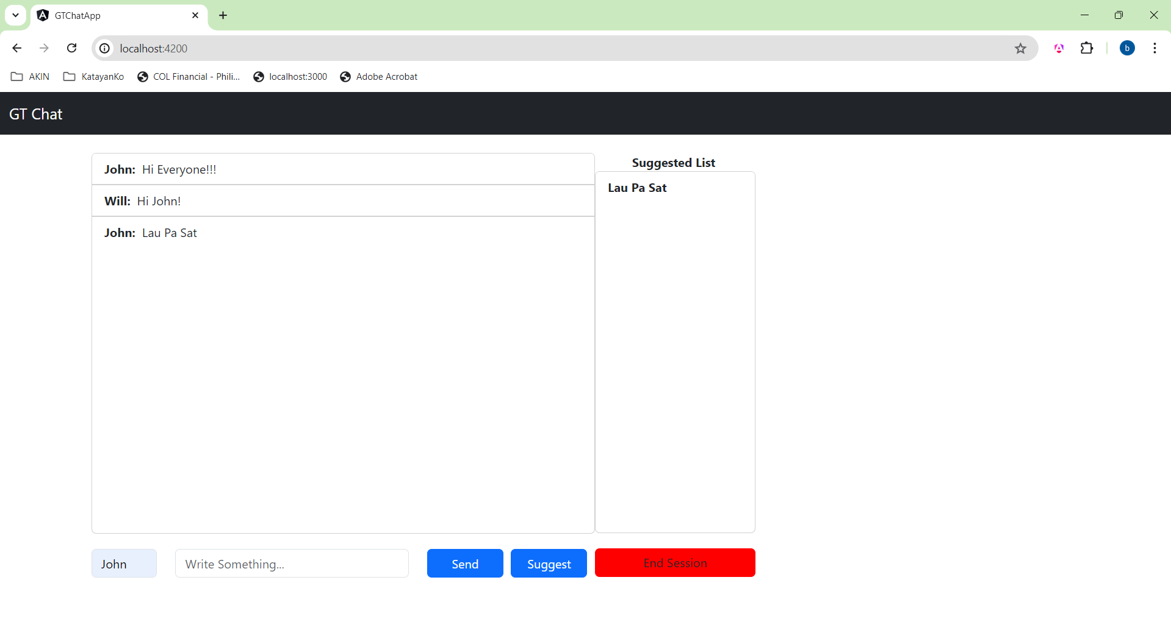

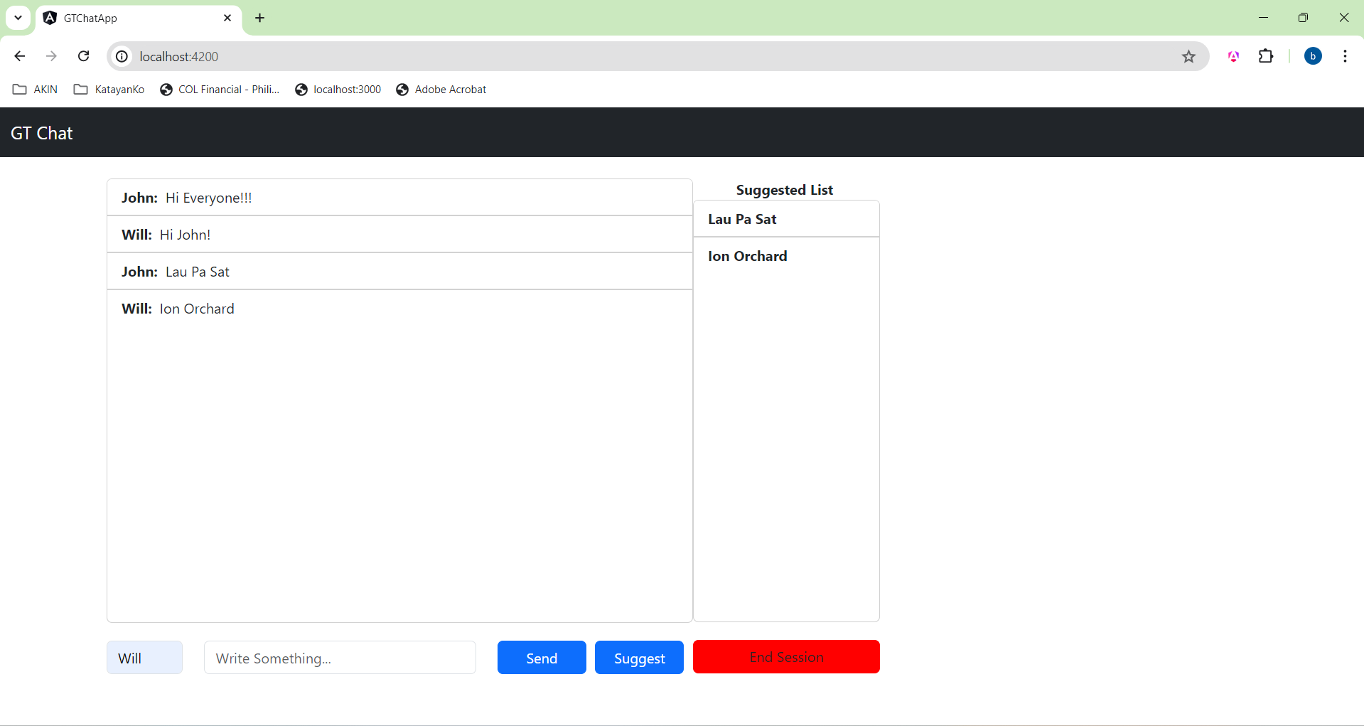

Selected Location

1. Press “End Session” to end the session and chooses the final location:

