Gameux Install Helper

<https://github.com/walbourn/directx-sdk-samples>

The **GameuxInstallHelper** is a DLL for use with install/setup programs to handle registration of Game Definition Files (GDF) with Windows Vista, Windows 7, and Windows 8 desktop games. For Windows 7 and Windows 8, the utility registers the GDFv2 schema data file using IGameExplorer2. For Windows Vista, the utility handles the additional manual steps required for registering a GDFv2 schema data file using the IGameExplorer interface.

The package also includes **GDFInstall** which is a command-line test tool and utility for using the GameuxInstallHelper DLL. It supports a number of command-line options and switches. Run it with /? to see this help dialog.

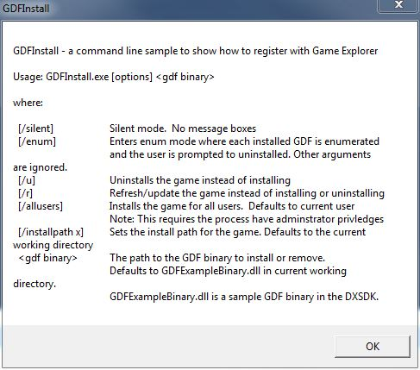

The technical article [Windows Games Explorer for Game Developers](http://msdn.microsoft.com/en-us/library/windows/desktop/ee419047.aspx) covers usage of this install helper.

This utility was originally published as part of the legacy DirectX SDK. This version does not require the DirectX SDK to build and can be built using Visual Studio 2010 or Visual Studio 2012.

**Note:** This utility is not required or used for Metro style applications. For details on how you use a GDF file to provide game ratings information for Metro style applications, see [Windows game publishing requirements](http://msdn.microsoft.com/en-us/library/windows/apps/hh452788.aspx).

# Localization

The **GameUxInstallHelper** DLL is intended to be called by a install/setup program which handles all UI requirements, so there is no localization support.

# More Information

[Windows Games Explorer](http://msdn.microsoft.com/en-us/library/windows/desktop/ee415240.aspx)

[Games Explorer](http://msdn.microsoft.com/en-us/library/windows/desktop/hh437965.aspx)

[Games for Windows Technical Requirements](https://docs.microsoft.com/en-us/windows/win32/dxtecharts/games-for-windows-technical-requirements-1-1-0006) (TR 1.1 and 1.2)

[Games for Windows Test Cases](https://docs.microsoft.com/en-us/windows/win32/dxtecharts/games-for-windows-test-requirements-1-0-0006) (TR 1.1 and 1.2)

[Where is the DirectX SDK (2021 Edition)?](https://aka.ms/dxsdk)

[Games for Windows and DirectX SDK blog](https://walbourn.github.io/)