Group: Kirstan Komajda, Roberto Briones, Amee Yang, Greg Spahlinger

Segregation in public schools

Project idea:

We are going to get data on the racial demographics and resources of different schools and school districts. We have already scraped data from the web on the racial demographics and locations of Michigan Schools. We are planning a dashboard with geoplotting to show racial composition of different schools and school districts. We will look for resources and plot resource metrics vs racial composition in a more targeted manner on a selection of the schools/districts. We will use javascript, leaflet and plotly for presentation. We plan to process our data in python and use a flask app hosted on Heroku to feed the data to the dashboard. We will either use sqlalchemy or pymongo in this process since that will enable us to feed the data out.

Data:

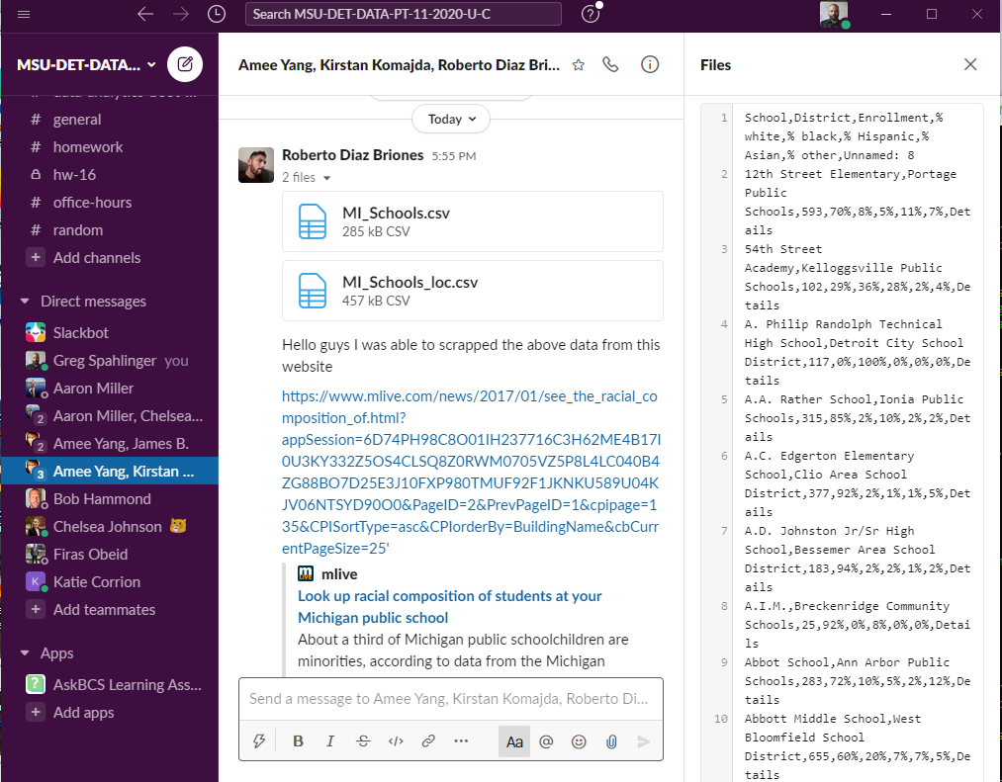

<https://www.mlive.com/news/2017/01/see_the_racial_composition_of.html?appSession=6D74PH98C8O01IH237716C3H62ME4B17I0U3KY332Z5OS4CLSQ8Z0RWM0705VZ5P8L4LC040B4ZG88BO7D25E3J10FXP980TMUF92F1JKNKU589U04KJV06NTSYD90O0&PageID=2&PrevPageID=1&cpipage=135&CPISortType=asc&CPIorderBy=BuildingName&cbCurrentPageSize=25>

Inspirational plots:

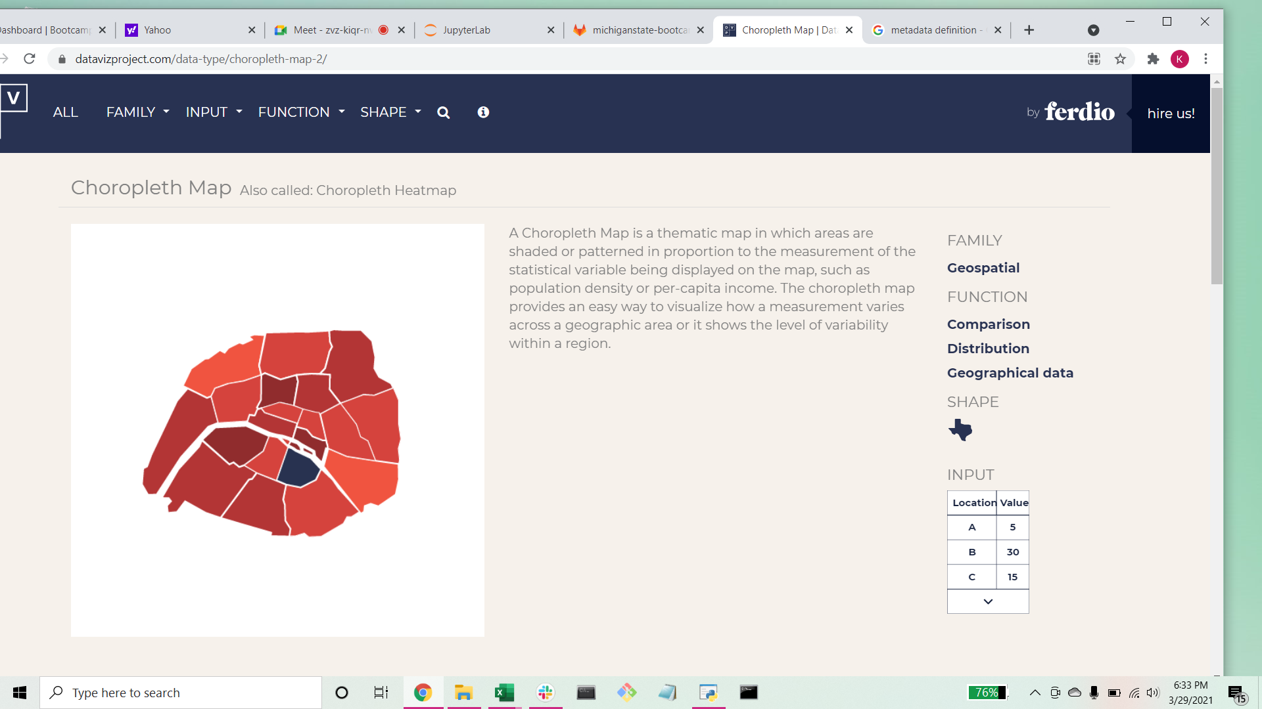

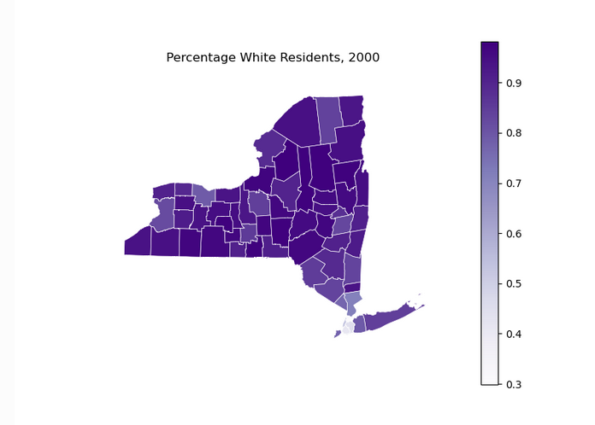

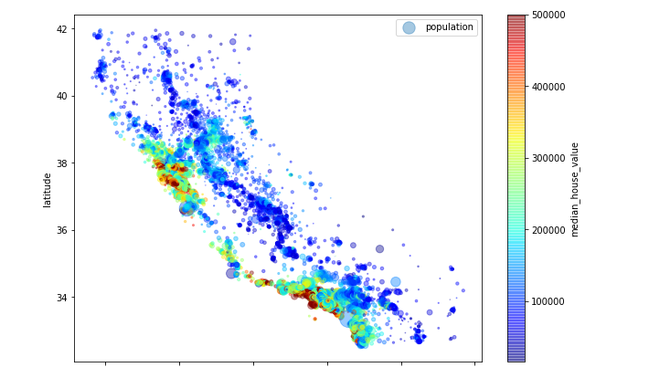

Github Link:

<https://github.com/robertodiazbriones/Project_2>

These are the parts of the project each person is leading, but we will help each other out if we get into trouble.

Roberto: Webscraping/data acquisition (step 1)

Greg: Flask app/databasing (step 3)

Kirstan: Dashboard (step 4)

Amee: Data Cleaning/exploration (step 2)