Three-Tier Architecture Pattern

Three-Tier Logical Diagram

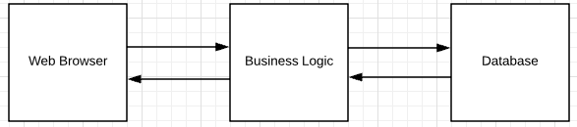

Three-Tier Physical Diagram

