DOCUMENTATION

ASSIGNMENT 3

STUDENT NAME: OLTEAN ROBERT-VIRGILIU
GROUP: 30422

CONTENTS
DOCUMENTATION 1
ASSIGNMENT 3 1
CONTENTS 2
1. Assignment Objective 3
2. Problem Analysis, Modeling, Scenarios, Use Cases 4
3. Design 7
4. Implementation 11
5. Conclusions 13
6. Bibliography 14

Assignment Objective

Main objective:

Develop an Order management application using MySQL database management system, Java for back-end and Java Swing for graphical user interface.

Sub objectives:

The following list outlines all the steps necessary to achieve developing the application, where each step is explained briefly. This provides a clear roadmap for understanding the goals for the assignment.

• Analyze the problem and identify requirements
• Design the orders management application
• Implement the orders management application
• Test the orders management application

Problem Analysis, Modeling, Scenarios, Use Cases
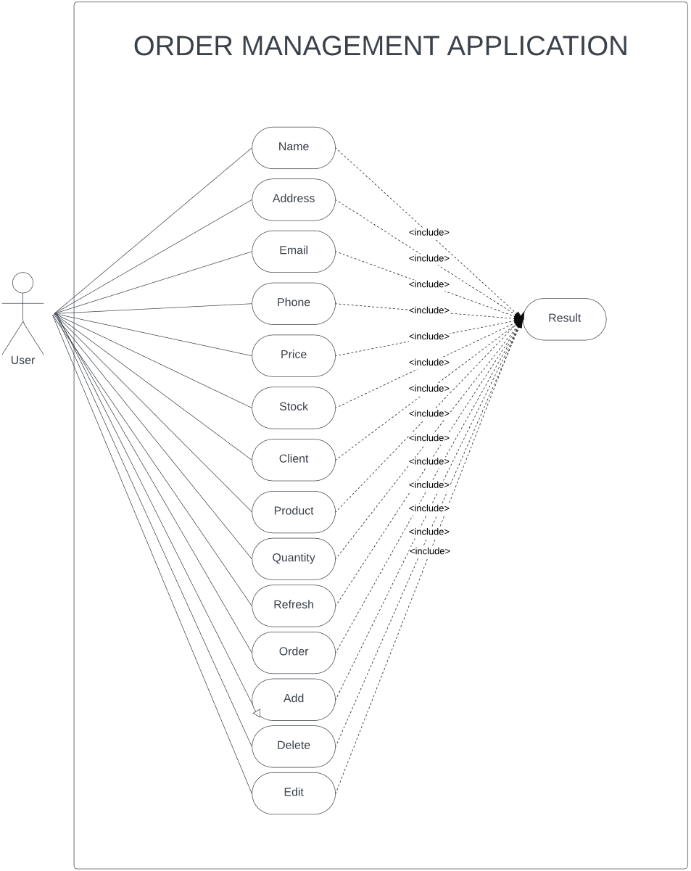
Use case diagram description:
- Manage Clients
  - Lets the user add/delete/refresh/edit client database
- Manage Products
  - Lets the user add/delete/refresh/edit product database
- Manage Orders
  - Lets the user make orders

Use Case: Manage Clients
- Description: This use case allows the user to manage client information in the system, including adding, updating, and deleting client records.
- Actors: Admin, User
- Preconditions: The user must be authenticated and have the necessary permissions to manage clients.
- Main Success Scenario:
  - The user navigates to the client management section.
  - The user can view a list of all clients.
  - The user can add a new client by entering the necessary details (name, address, email, phone).
  - The user can update an existing client's information.
  - The user can delete a client from the list.
- Alternative Sequences:
  - Invalid Input: If the user enters invalid data (e.g., incorrect email format), the system displays an error message and prompts the user to correct the input.
  - Client Not Found: If the user attempts to update or delete a client that does not exist, the system displays an error message.
- Functional Requirements:
  - The system shall allow the user to add new clients.
  - The system shall allow the user to update client information.
  - The system shall allow the user to delete clients.
  - The system shall validate client input data before saving.
- Non-Functional Requirements:
  - The system shall respond to client management actions within 2 seconds.
  - The system shall ensure data integrity and prevent duplicate client entries.

Use Case: Manage Products
- Description: This use case allows the user to manage product information in the system, including adding, updating, and deleting product records.
- Actors: Admin, User
- Preconditions: The user must be authenticated and have the necessary permissions to manage products.
- Main Success Scenario:
  - The user navigates to the product management section.
  - The user can view a list of all products.
  - The user can add a new product by entering the necessary details (name, price, quantity).
  - The user can update an existing product's information.
  - The user can delete a product from the list.
- Alternative Sequences:
  - Invalid Input: If the user enters invalid data (e.g., negative price), the system displays an error message and prompts the user to correct the input.
  - Product Not Found: If the user attempts to update or delete a product that does not exist, the system displays an error message.

- Functional Requirements:
  - The system shall allow the user to add new products.
  - The system shall allow the user to update product information.
  - The system shall allow the user to delete products.
  - The system shall validate product input data before saving.
- Non-Functional Requirements:
  - The system shall respond to product management actions within 2 seconds.
  - The system shall ensure data integrity and prevent duplicate product entries.

Use Case: Place Orders
- Description: This use case allows the user to place orders by selecting clients and products.
- Actors: Admin, User
- Preconditions: The user must be authenticated and have the necessary permissions to place orders.
- Main Success Scenario:
  - The user navigates to the order placement section.
  - The user selects a client for the order.
  - The user selects one or more products to include in the order.
  - The user specifies the quantity for each product.
  - The user confirms and places the order.
- Alternative Sequences:
  - Insufficient Stock: If there is not enough stock to fulfill the order, the system displays an error message and prompts the user to adjust the quantity or select a different product.
  - Invalid Client/Product: If the selected client or product does not exist, the system displays an error message.
- Functional Requirements:
  - The system shall allow the user to select a client for an order.
  - The system shall allow the user to select products and specify quantities for an order.
  - The system shall check product stock levels before confirming the order.
  - The system shall update product stock levels after an order is placed.
- Non-Functional Requirements:
  - The system shall respond to order placement actions within 3 seconds.
  - The system shall ensure data integrity and prevent duplicate orders.

Design
The project is designed following OOP principles with a layered architecture:

- Presentation Layer handles the user interface with Swing.
- Business Logic Layer encapsulates the core functionality and validation.
- Data Access Layer manages database operations.
- Model Layer defines the data structures. 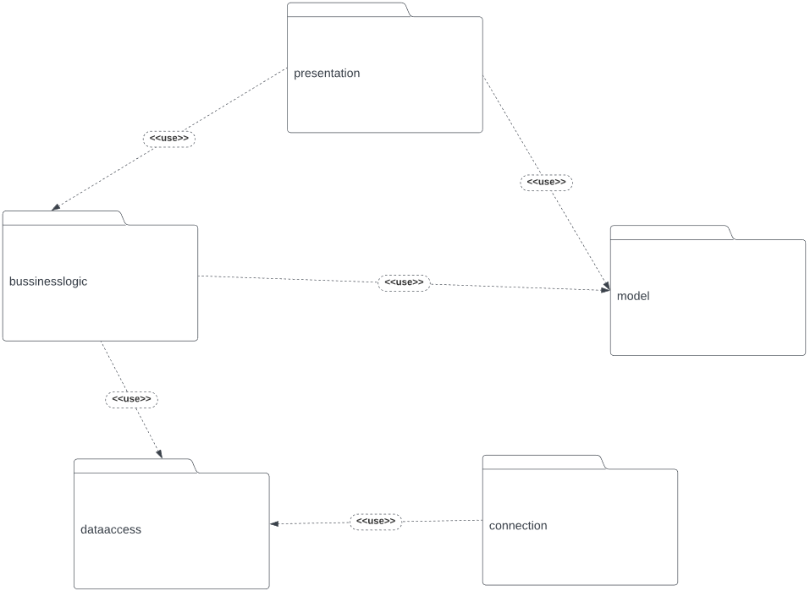

1. presentation: User interface components and controllers using Java Swing.
2. bussinesslogic: Core business logic and validations for the application.
3. dataaccess: Database interaction and CRUD operations for entities.
4. model: Data structures representing clients and products.
5. connection: Manages database connections and transactions.
UML Classes Diagram
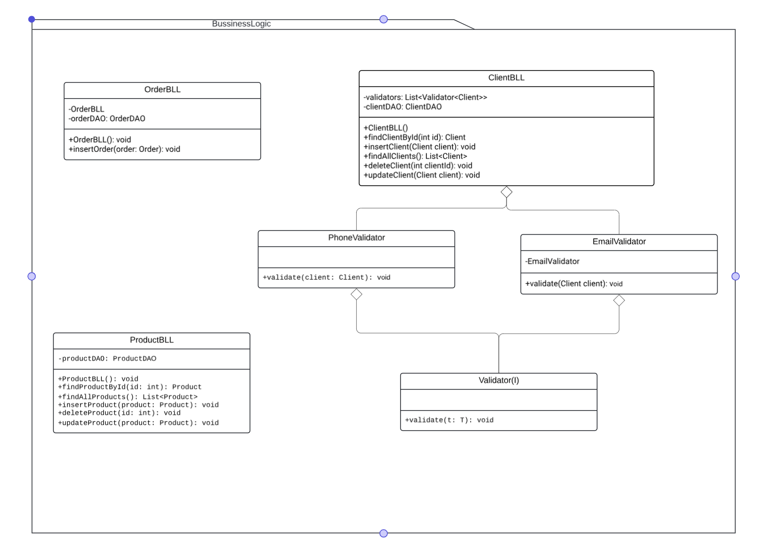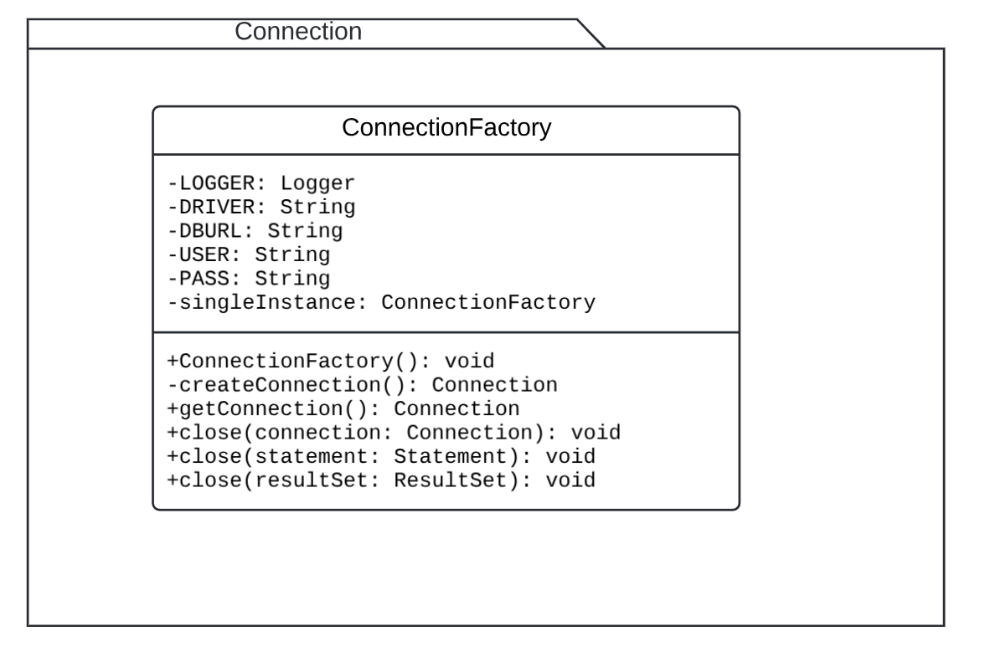
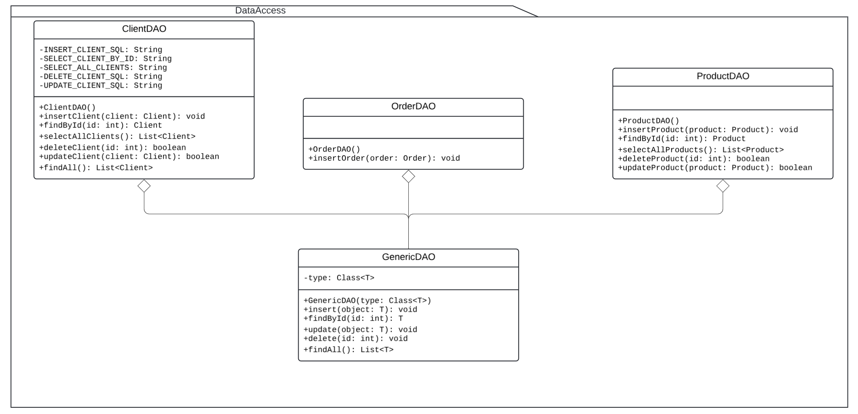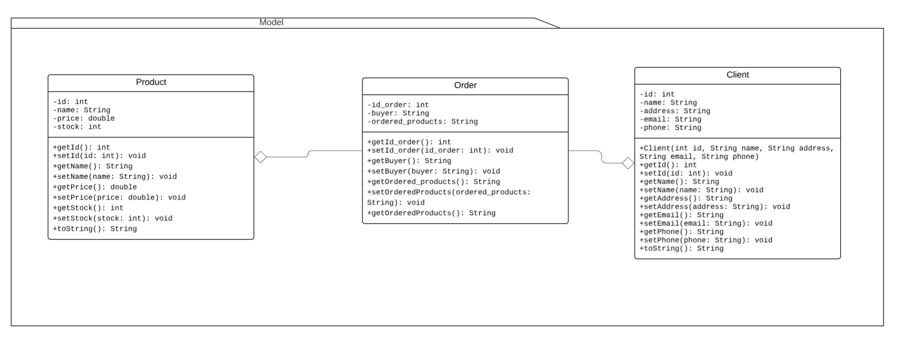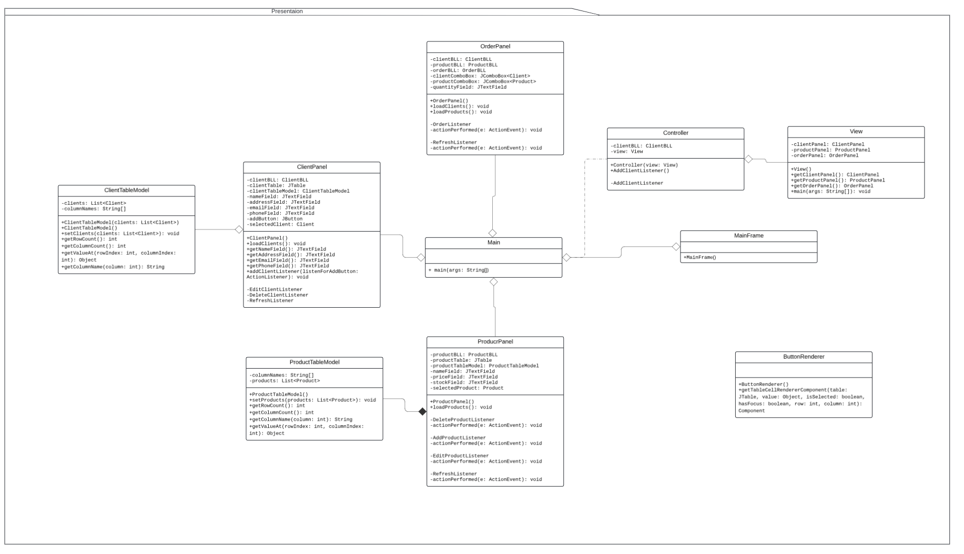
Data Structures used:
Lists: Lists are used to store collections of objects. They are utilized in various parts of the project to manage collections of clients, products, and orders. For example, in the ProductPanel class, a List<Product> is used to store products retrieved from the database before displaying them in a table.
Arrays: Arrays are used to store fixed-size sequential collections of elements of the same type. In the ProductTableModel class, arrays are used to store column names for the product table.
JTable: While not a traditional data structure, a JTable from Swing is effectively used to display tabular data in the user interface. It provides a structured way to present data in rows and columns.

Implementation
Class Description

ClientBLL:

- findClientById(int id): This method retrieves a client from the database using their ID.
- insertClient(Client client): This method validates and inserts a new client into the database.
- findAllClients(): This method retrieves all clients from the database.
- deleteClient(int clientId): This method deletes a client from the database using their ID.
- updateClient(Client client): This method updates a client's information in the database.

OrderBLL:
- OrderBLL(): This is the constructor of the OrderBLL class, which initializes the OrderDAO object.
- insertOrder(Order order): This method is used to insert an order into the database using the OrderDAO object.

ProductBLL:

- ProductBLL(): This is the constructor of the ProductBLL class, which initializes the ProductDAO object.
- findProductById(int id): This method retrieves a product from the database using their ID.
- findAllProducts(): This method retrieves all products from the database.
- insertProduct(Product product): This method inserts a new product into the database.
- deleteProduct(int id): This method deletes a product from the database using their ID.
- updateProduct(Product product): This method updates a product's information in the database.
- ConnectionFactory:
ConnectionFactory(): This is the private constructor of the ConnectionFactory class. It loads the JDBC driver.
- createConnection(): This private method is used to create a new database connection.
- getConnection(): This static method is used to get a database connection. It calls the createConnection method of the ConnectionFactory object.
- close(Connection connection): This static method is used to close a database connection.
- close(Statement statement): This static method is used to close a Statement.
- close(ResultSet resultSet): This static method is used to close a ResultSet.

ClientDAO:
- ClientDAO(): This is the constructor of the ClientDAO class.
- insertClient(Client client): This method inserts a client into the database.
- findById(int id): This method retrieves a client from the database using their ID.
- selectAllClients(): This method retrieves all clients from the database.
- deleteClient(int id): This method deletes a client from the database using their ID.
- updateClient(Client client): This method updates a client's information in the database.
- findAll(): This method is used to get all clients from the database. It is currently not implemented.

GenericDAO:

- GenericDAO(Class<T> type): This is the constructor of the GenericDAO class. It initializes the type of object on which the database operations are performed.
- insert(T object): This method inserts an object into the database.
- findById(int id): This method retrieves an object from the database using its ID.
- update(T object): This method updates an object's information in the database.
- delete(int id): This method deletes an object from the database using its ID.
- findAll(): This method is used to get all objects from the database.
- setPreparedStatementParameters(PreparedStatement statement, T object, Field[] fields): This private method is used to set the parameters of a PreparedStatement for an object.
- createObjectFromResultSet(ResultSet resultSet): This private method is used to create an object from a ResultSet.

OrderDAO:
- insertOrder(Order order): This method inserts an order into the database. It uses a PreparedStatement to execute the SQL query. The PreparedStatement sets the buyer and ordered products of the order.

ProductDAO:
- insertProduct(Product product): This method inserts a product into the database. It uses a PreparedStatement to execute the SQL query. The PreparedStatement sets the name, price, and stock of the product.
- findById(int id): This method finds a product by its ID. It uses a PreparedStatement to execute the SQL query. The PreparedStatement sets the ID of the product to be found.
- selectAllProducts(): This method gets all products from the database. It uses a PreparedStatement to execute the SQL query.
- deleteProduct(int id): This method deletes a product from the database by its ID. It uses a PreparedStatement to execute the SQL query. The PreparedStatement sets the ID of the product to be deleted.
- updateProduct(Product product): This method updates a product in the database. It uses a PreparedStatement to execute the SQL query. The PreparedStatement sets the name, price, stock, and ID of the product to be updated.

ClientPanel:

- loadClients(): This method retrieves all clients from the database and loads them into the client table.
- getNameField(), getAddressField(), getEmailField(), getPhoneField(): These getter methods return the respective text fields for client's name, address, email, and phone.
- addClientListener(ActionListener listenForAddButton): This method adds an action listener to the "Add Client" button.
- EditClientListener.actionPerformed(ActionEvent e): This method updates the selected client's information in the database when the "Edit Client" button is clicked.
- DeleteClientListener.actionPerformed(ActionEvent e): This method deletes the selected client from the database when the "Delete Client" button is clicked.
- RefreshListener.actionPerformed(ActionEvent e): This method refreshes the client table by reloading all clients from the database when the "Refresh" button is clicked.

ProductPanel:

- ProductPanel(): This is the constructor of the ProductPanel class. It initializes the ProductBLL object, sets the layout, creates the table and input panel, and loads the products.
- loadProducts(): This method is used to load all products into the product table. It fetches all products from the database using the ProductBLL object and sets them in the ProductTableModel.
- AddProductListener: This is an inner class that implements ActionListener. It is responsible for handling the action of adding a product. When the add product button is clicked, it gets the product data from the input fields, creates a new product, and inserts it into the database.
- DeleteProductListener: This is an inner class that implements ActionListener. It is responsible for handling the action of deleting a product. When the delete product button is clicked, it gets the selected product and deletes it from the database.

Conclusions

In conclusion, this project demonstrates the development of a simple order management application using Java Swing for the user interface and JDBC for database interaction. The application allows users to manage clients, products, and orders through a user-friendly graphical interface. Key features include the ability to add, edit, and delete clients and products, as well as place orders with specified quantities. The project employs a layered architecture, separating presentation, business logic, and data access concerns, promoting modularity and maintainability. While this implementation serves as a basic framework, it can be extended and customized to meet specific business requirements or integrated into larger systems for comprehensive order management solutions.

Bibliography
Oracle Documentation: Java Swing - https://docs.oracle.com/javase/tutorial/uiswing/index.html
Oracle Documentation: JDBC - https://docs.oracle.com/javase/tutorial/jdbc/index.html
Baeldung: Java Reflection API - https://www.baeldung.com/java-reflection

