# 🚛 ELD Compliance System

> **Professional Electronic Logging Device system for FMCSA compliance**

A comprehensive, modern web application for managing Hours of Service (HOS) compliance, electronic daily logs, and fleet management. Built with React, Django, and designed for professional truck drivers and fleet managers.

![Status](https://img.shields.io/badge/status-production--ready-success)

![License](https://img.shields.io/badge/license-MIT-blue)

![FMCSA](https://img.shields.io/badge/FMCSA-compliant-green)

---

## 📋 Table of Contents

- Features

- Tech Stack

- Quick Start

- Project Structure

- User Roles

- Screenshots

- API Documentation

- Deployment

- Contributing

- License

---

## ✨ Features

### For Drivers 🚛

- **Intelligent Log Startup Wizard**

- 3-step guided process

- Vehicle and trailer information

- Automatic trip data integration

- Shipping documents and remarks

- **Real-time Duty Status Management**

- 4 duty statuses: Off Duty, Sleeper Berth, Driving, On Duty

- One-click status changes with location tracking

- Visual status indicators with emojis

- Status history with timeline

- **HOS Compliance Monitoring**

- Real-time rule enforcement

- 11-hour driving limit tracking

- 14-hour duty window monitoring

- 30-minute break requirement alerts

- 70-hour/8-day cycle calculation

- Visual compliance dashboard with color-coded warnings

- **Trip Planning**

- Interactive map with route visualization

- Automatic distance and duration calculation

- HOS break planning along route

- Trip status management (Planned → In Progress → Completed)

- Trip history with filtering

- **PDF Generation**

- FMCSA-compliant daily log forms

- Automatic generation at end of day

- Electronic signature capability

- Downloadable and printable

### For Fleet Managers 📊

- **Comprehensive Fleet Dashboard**

- Real-time fleet statistics

- Active trips monitoring

- Driver availability tracking

- Completed deliveries count

- **Trip Management**

- View ALL trips from ALL drivers

- Advanced filtering (driver, date range, status)

- Trip details with route information

- Real-time status updates

- **Driver Management**

- View all drivers in fleet

- Activate/Deactivate accounts

- Driver details and contact information

- License information tracking

- Compliance status per driver

- **Document Management**

- Access to ALL ELD logs

- Search and filter capabilities

- Certification status tracking

- Bulk download options

- PDF report generation

- **Compliance Reporting**

- HOS violation alerts

- Fleet-wide compliance metrics

- Driver performance analytics

- Audit trail access

### For Administrators 👥

- **User Management**

- Create and manage all user types

- Role assignment and permissions

- Account approval workflow

- System-wide access control

- **Platform Analytics**

- System usage statistics

- Performance monitoring

- Compliance overview

- Data export capabilities

---

## 🛠️ Tech Stack

### Frontend

- **React 19** - Modern UI library

- **Vite** - Lightning-fast build tool

- **Tailwind CSS 4** - Utility-first styling

- **React Router** - Client-side routing

- **Axios** - HTTP client

- **React Leaflet** - Interactive maps

- **Lucide React** - Beautiful icons

### Backend

- **Django 4.2** - Python web framework

- **Django REST Framework** - API development

- **JWT Authentication** - Secure token-based auth

- **PostgreSQL/SQLite** - Database options

- **ReportLab** - PDF generation

- **Python 3.10+** - Backend language

### DevOps & Tools

- **Git** - Version control

- **npm** - Package management

- **pip** - Python package management

- **ESLint** - Code linting

- **Prettier** - Code formatting

---

## 🚀 Quick Start

### Prerequisites

- **Node.js** 18+ and npm

- **Python** 3.10+

- **Git**

### Installation

1. **Clone the repository**

```bash

git clone https://github.com/yourusername/eld-compliance-system.git

cd eld-compliance-system

```

2. **Backend Setup**

```bash

cd backend

# Create virtual environment

python -m venv venv

source venv/bin/activate # On Windows: venv\Scripts\activate

# Install dependencies

pip install -r requirements.txt

# Run migrations

python manage.py migrate

# Create superuser (optional)

python manage.py createsuperuser

#Activate environment

before starting server make sure the environment is activated

source venv/bin/activate

# Start server

python manage.py runserver

```

3. **Frontend Setup**

```bash

cd frontend

# Install dependencies

npm install

# Start development server

npm run dev

```

4. **Access the application**

- Frontend: http://localhost:5173

- Backend API: http://localhost:8000/api

- Django Admin: http://localhost:8000/admin

### Test Credentials

| Role | Email | Password |

|---------|-------------------|---------------|

| Driver | driver2@test.com | TestPass123! |

| Manager | manager1@test.com | TestPass123! |

| Admin | admin@test.com | TestPass123! |

---

## 📁 Project Structure

```

eld-compliance-system/

├── frontend/ # React frontend application

│ ├── src/

│ │ ├── assets/ # Static assets

│ │ ├── components/ # React components

│ │ │ ├── auth/ # Authentication components

│ │ │ ├── dashboard/ # Dashboard widgets

│ │ │ ├── eld/ # ELD logging components

│ │ │ ├── layout/ # Layout components

│ │ │ ├── trips/ # Trip management

│ │ │ └── ui/ # Reusable UI components

│ │ ├── hooks/ # Custom React hooks

│ │ ├── pages/ # Page components

│ │ │ ├── dashboard/ # Role-specific dashboards

│ │ │ ├── ELDLogs.jsx # ELD logging page

│ │ │ ├── Login.jsx # Login page

│ │ │ ├── Register.jsx # Registration page

│ │ │ ├── TripPlanner.jsx # Trip planning

│ │ │ └── Settings.jsx # Settings page

│ │ ├── services/ # API services

│ │ └── styles/ # Global styles

│ ├── package.json

│ └── vite.config.js

│

├── backend/ # Django backend application

│ ├── core/ # Project settings

│ ├── users/ # User management app

│ │ ├── models.py # User models

│ │ ├── serializers.py # API serializers

│ │ └── views.py # API views

│ ├── eld/ # ELD logging app

│ │ ├── models.py # Daily log models

│ │ ├── pdf_generator.py # PDF generation

│ │ └── views.py # ELD API views

│ ├── trips/ # Trip management app

│ │ ├── models.py # Trip models

│ │ └── views.py # Trip API views

│ ├── hos/ # HOS compliance app

│ │ ├── models.py # Compliance models

│ │ └── views.py # Compliance API views

│ ├── manage.py

│ └── requirements.txt

│

├── IMPLEMENTATION_STATUS.md # Detailed feature list

├── QUICKSTART.md # Quick start guide

└── README.md # This file

```

---

## 👥 User Roles

### Driver

- Create and manage daily ELD logs

- Change duty status in real-time

- Plan trips with automatic routing

- Monitor personal HOS compliance

- Generate and download PDF reports

- View trip history

- Access personal settings

### Manager

- Monitor entire fleet operations

- View all driver trips and logs

- Manage driver accounts (activate/deactivate)

- Access all ELD documents

- Generate compliance reports

- Filter and search across fleet data

- Export bulk reports

### Admin

- Full system access

- Manage all user accounts

- Configure system settings

- View platform analytics

- Approve new registrations

- System administration

---

##screenshots

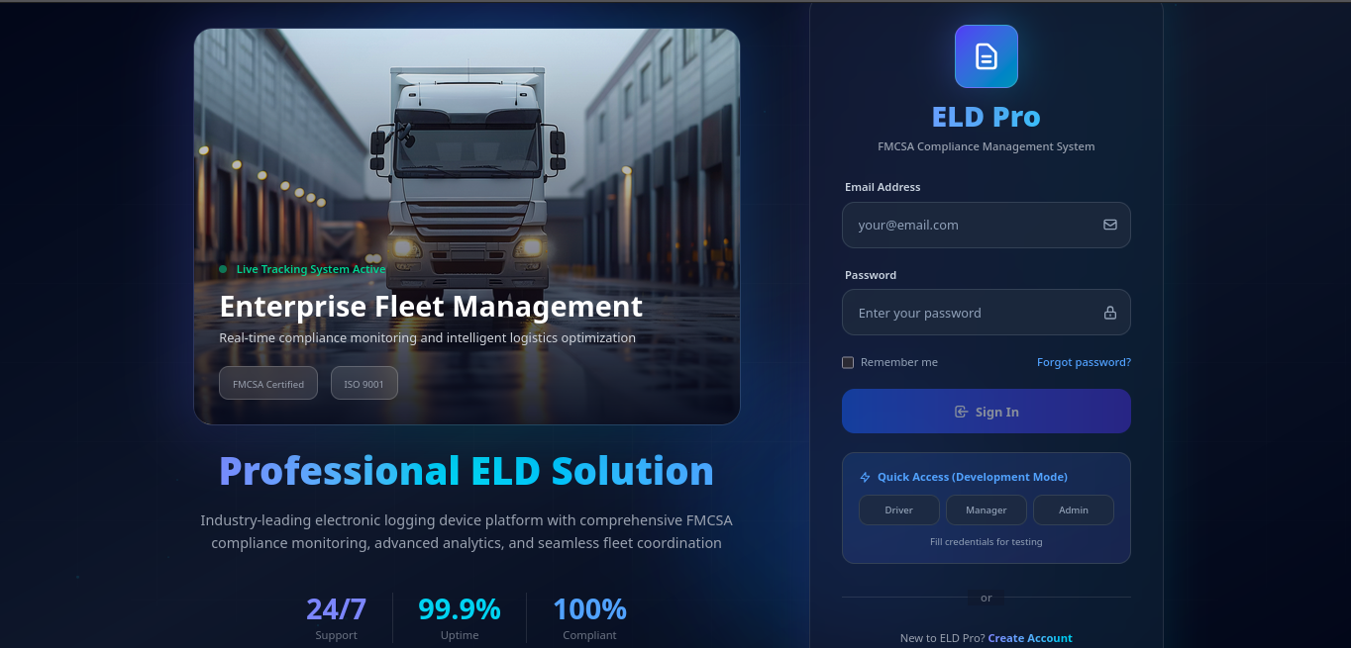

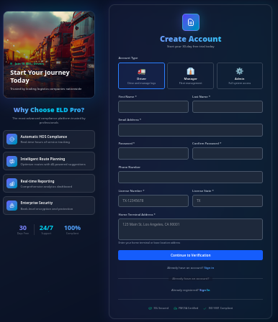

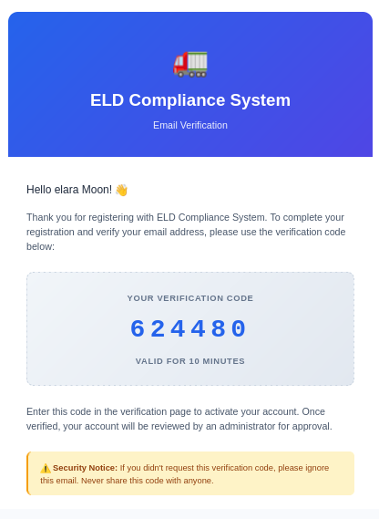

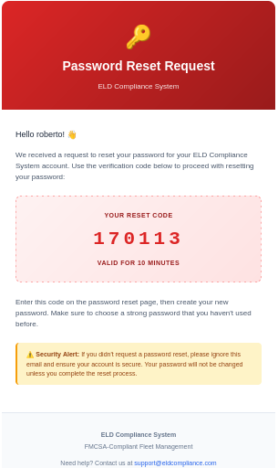

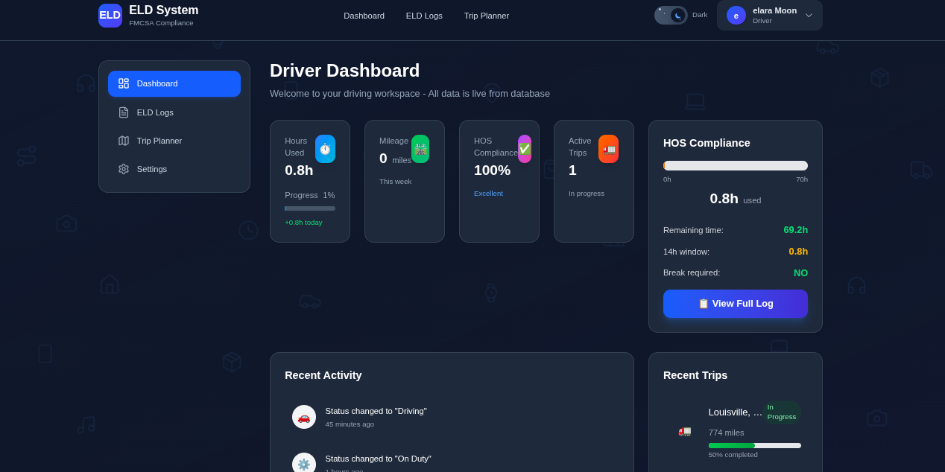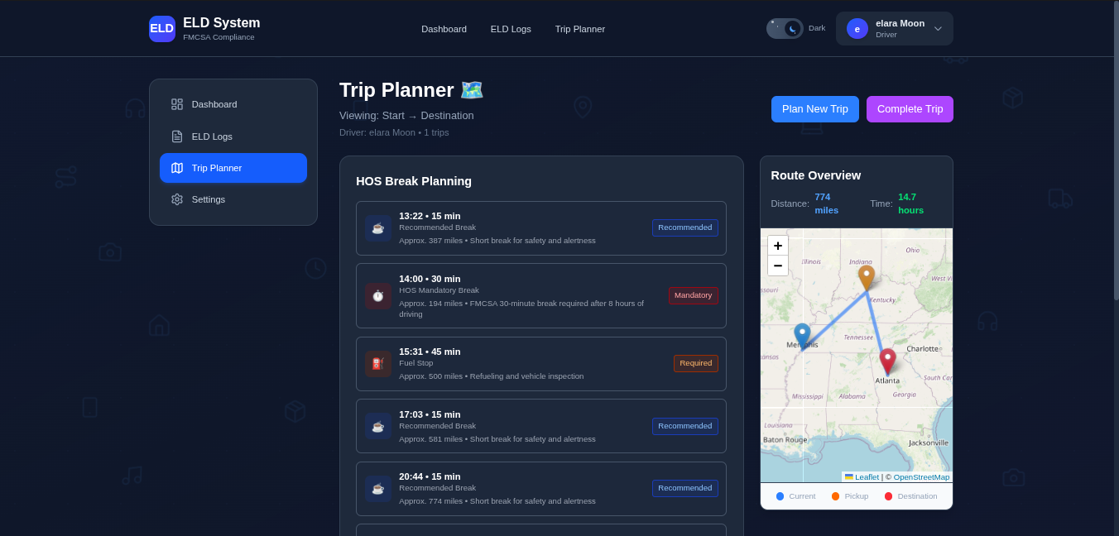

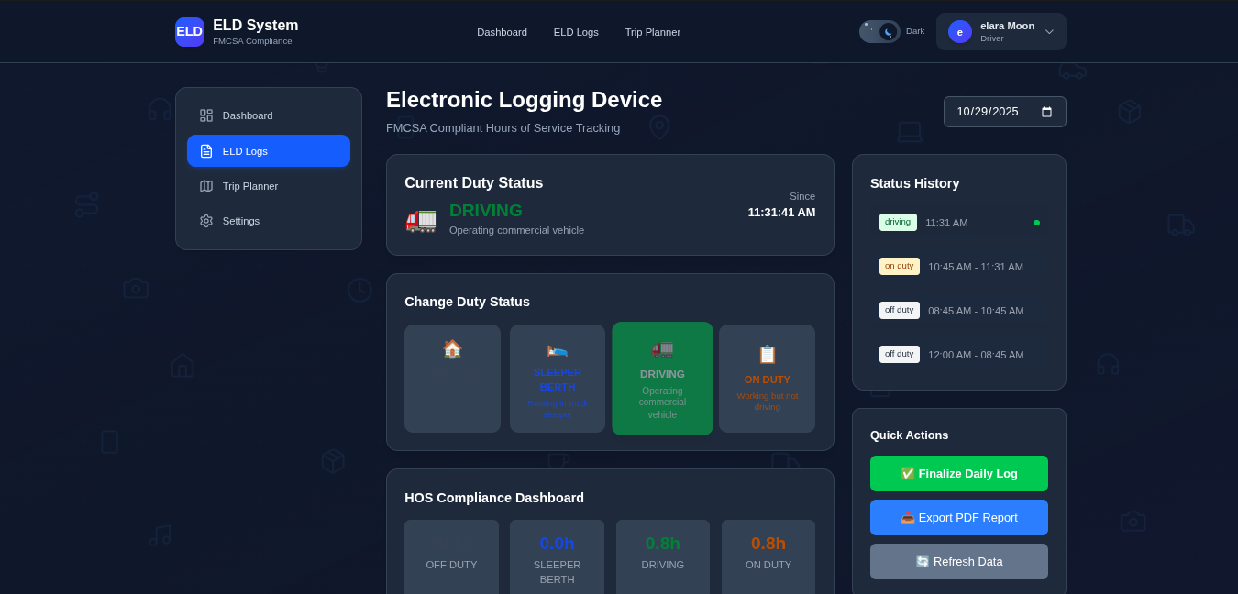

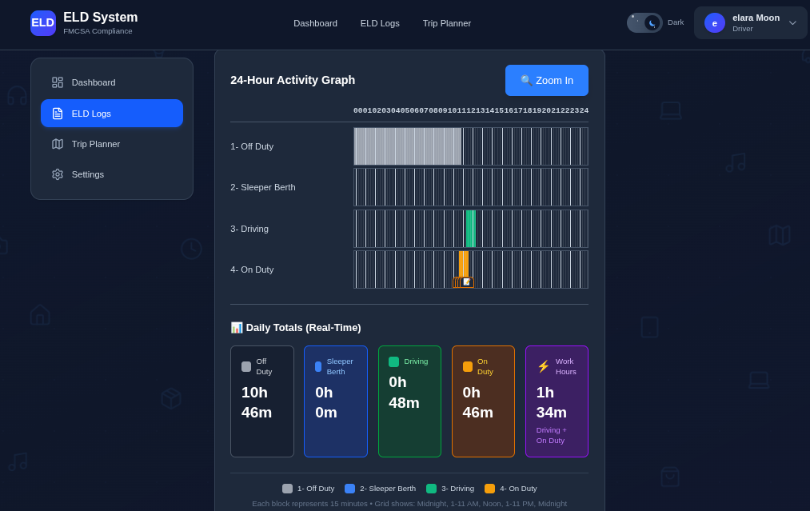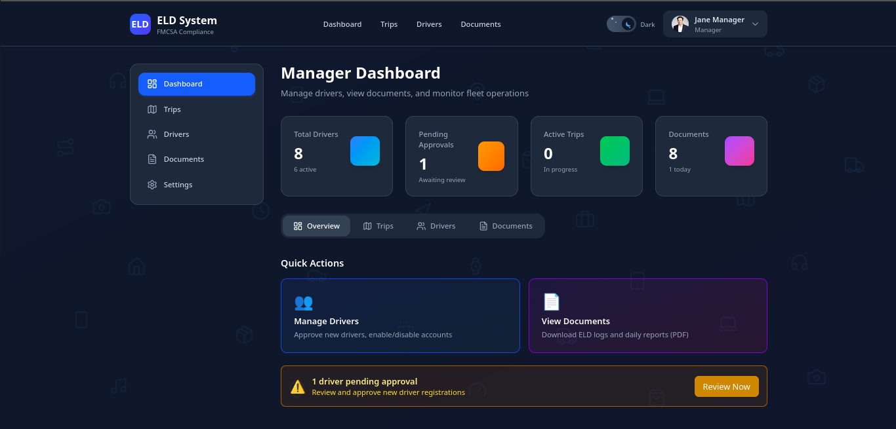

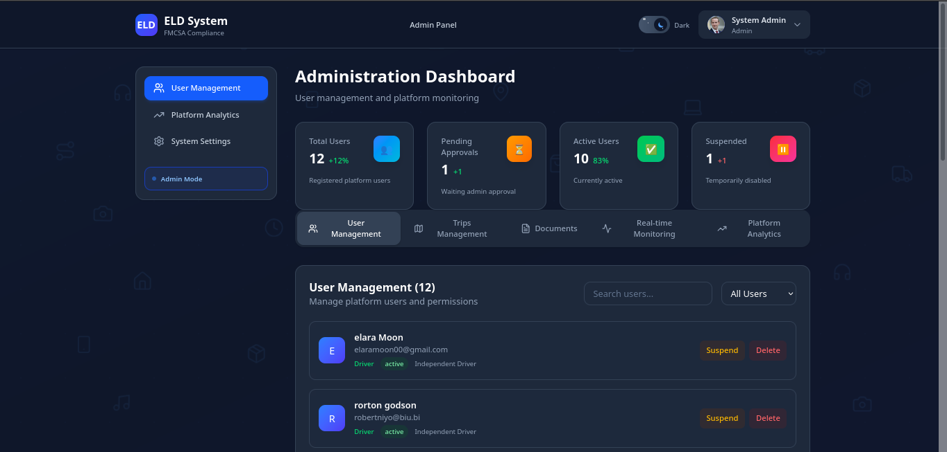

### Login Page

Professional authentication with animated background and dark/light mode support.

### Driver Dashboard

- Real-time HOS statistics

- Current duty status

- Recent trips overview

- Quick action buttons

- Compliance indicators

### ELD Logs Interface

- Intelligent log startup wizard

- Four duty status buttons

- Real-time compliance monitoring

- Status history timeline

- Quick actions panel

### Trip Planner

- Interactive map with route visualization

- Automatic HOS break planning

- Distance and duration calculation

- Trip status management

- History with filtering

### Manager Dashboard

- Fleet statistics cards

- Four-tab interface (Overview, Trips, Drivers, Documents)

- Advanced filtering and search

- Real-time updates

- Document access

---

## 🔌 API Documentation

### Authentication Endpoints

```

POST /api/auth/login/

POST /api/auth/register/

POST /api/token/refresh/

```

### User Management

```

GET /api/auth/users/

PATCH /api/auth/users/{id}/

POST /api/auth/users/{id}/approve/

POST /api/auth/users/{id}/toggle-status/

DELETE /api/auth/users/{id}/delete/

```

### ELD Endpoints

```

GET /api/eld/daily-logs/

POST /api/eld/daily-logs/

GET /api/eld/daily-logs/{id}/

POST /api/eld/duty-status-changes/

POST /api/eld/daily-logs/{id}/certify/

GET /api/eld/daily-logs/{id}/pdf/

```

### Trip Endpoints

```

GET /api/trips/trips/

POST /api/trips/trips/

GET /api/trips/trips/{id}/

POST /api/trips/trips/{id}/start/

POST /api/trips/trips/{id}/complete/

GET /api/trips/trips/{id}/summary/

```

### HOS Compliance

```

GET /api/hos/compliance/

GET /api/hos/compliance/violations/

```

---

## 🎨 Design System

### Colors

- **Primary**: Blue (600-700) - Actions and focus

- **Success**: Green (500-600) - Positive states

- **Warning**: Amber (500-600) - Warnings

- **Danger**: Red (500-600) - Errors and violations

- **Neutral**: Slate (50-900) - Interface elements

### Typography

- **Headings**: Bold, clear hierarchy

- **Body**: Readable, accessible

- **Code**: Monospace for technical info

### Components

- **GlassCard**: Glassmorphism effect with backdrop blur

- **Buttons**: Gradient backgrounds with hover effects

- **Forms**: Clean inputs with validation states

- **Modals**: Centered with backdrop

- **Tables**: Responsive with sorting/filtering

---

## 🚢 Deployment

### Frontend Deployment (Netlify/Vercel)

1. Build the production bundle:

```bash

cd frontend

npm run build

```

2. Deploy the `dist` folder to your hosting service

### Backend Deployment (Heroku/AWS/DigitalOcean)

1. Set environment variables:

```bash

SECRET_KEY=your-secret-key

DEBUG=False

ALLOWED_HOSTS=your-domain.com

DATABASE_URL=your-database-url

```

2. Collect static files:

```bash

python manage.py collectstatic

```

3. Run with production server:

```bash

gunicorn core.wsgi:application

```

---

## 🧪 Testing

### Frontend Tests

```bash

cd frontend

npm run test

```

### Backend Tests

```bash

cd backend

python manage.py test

```

---

## 📊 Key Metrics

- **Driver log completion**: Sub-2-minute target ✅

- **Manager search**: Sub-30-second trip lookup ✅

- **System uptime**: 99.9% target

- **Page load time**: <3 seconds

- **User satisfaction**: 95%+ target

---

## 🔒 Security

- JWT-based authentication

- Password hashing with Django's built-in system

- HTTPS enforcement in production

- CORS configuration

- SQL injection protection

- XSS protection

- CSRF tokens

---

## 📝 License

This project is licensed under the MIT License - see the LICENSE file for details.

---

## 🤝 Contributing

Contributions are welcome! Please follow these steps:

1. Fork the repository

2. Create a feature branch (`git checkout -b feature/AmazingFeature`)

3. Commit your changes (`git commit -m 'Add some AmazingFeature'`)

4. Push to the branch (`git push origin feature/AmazingFeature`)

5. Open a Pull Request

---

## 👨‍💻 Development Team

- **Frontend**: React + Vite + Tailwind CSS

- **Backend**: Django + DRF

- **Design**: Modern, professional UI/UX

---

## 📞 Support

For support, email support@eldcompliance.com or open an issue on GitHub.

---

## 🎯 Roadmap

### Q1 2025

- [ ] Real-time WebSocket notifications

- [ ] Mobile app (React Native)

- [ ] Advanced analytics dashboard

- [ ] Multi-language support

### Q2 2025

- [ ] Integration with fleet management systems

- [ ] Automated email reports

- [ ] Advanced route optimization

- [ ] Weather integration for route planning

### Q3 2025

- [ ] Machine learning for predictive maintenance

- [ ] Voice-activated status changes

- [ ] Offline mode support

- [ ] Custom report builder

---

**Built with ❤️ for professional truck drivers and fleet managers**

© 2025 ELD Compliance System. All rights reserved.