Title: | ACU AEP - PSS  Airbag Control Unit

History
Issue status  (Index) | Maturity/Date  (draft/invalid/valid)  (dd-mmm-yyyy) | Author  Department | Check/Release  Department | Description
1.0 | Draft  27-Aug-15 | Alexis Garcia | Alexis Garcia | Creation of the document, draft version.
1.1 | Draft  08-Sep-15 | Alexis Garcia | Alexis Garcia | Addition of the diagrams
1.2 | Draft  08-Sep-15 | Alexis Garcia | Alexis Garcia | Correction of diagrams
1.3 | Draft  08-Sep-15 | Alexis Garcia | Alexis Garcia | Addition of diagrams description

Table of Contents
1 Purpose 3
2 Definitions and abbreviations 3
3 Realization constraints and targets 3
4 SW Component internal breakdown 4
4.1 Functional Decomposition 4
4.2 Function <Type> <function name> (type par 1, .., type par n) 5
4.3 Function <Type> <function name> (type par 1, .., type par n) 5

Purpose
The purpose of the ACU unit is to control the airbags and the seatbelts reminders. The purpose of these reminders is to provide a safe travel to the driver and passenger of the vehicle. This also complies with the norms of security of seatbelts. When a person is occupying the seat and the seatbelt is unbuckled the chime and telltale will indicate is a certain type that the seatbelt must be buckled , this will work in three mode, American basic, American enhanced and European.

Definitions and abbreviations
Definitions
APP  HAL  MAL | Application layer, contains the applications used for the module  Hardware Abstraction Layer, contains the external peripheral drivers  Microcontroller Abstraction Layer, contains the microcontroller drivers

Abbreviations
References
N° | Document name | Reference
1  2 | PFinal-PSS_ACU Requirements  Traceability matrix driver and passenger | PFinal-PSS_ACU Requirements.doc

Realization constraints and targets

With the realization of this module the user will be advised in the instance that the driver or the passenger inside the vehicle don’t put on his seatbelts. This is compliant with the norms of security; also the mode of function will be compatible with the regions of America in the basic and enhanced mode and the European region. Depending on the mode the chime and telltale indicator will work in a similar way but with some variations, like the speed and distance traveled without the seatbelt buckled.

SW Component internal breakdown
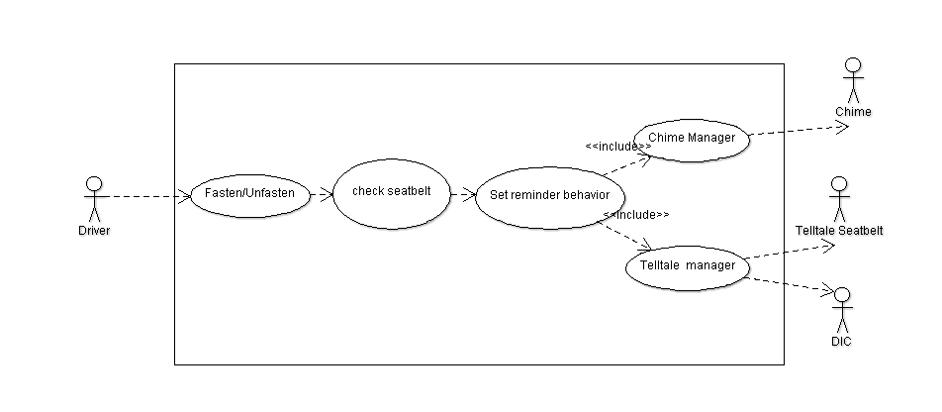
Figure 1.1 Driver Use case
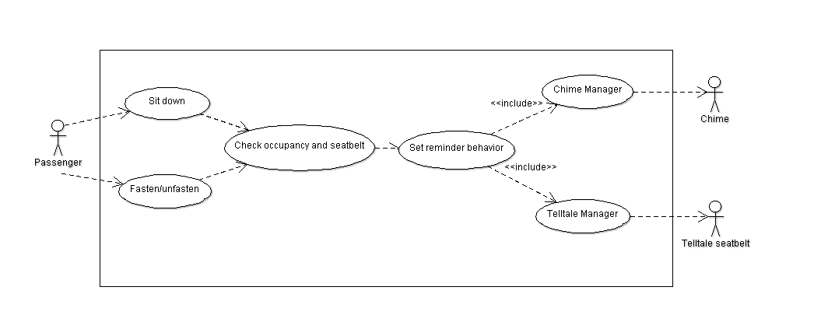
Figure 1.2 Passenger Use case

This diagrams checks for the both uses case of the Driver and Passenger who are the actors, in both cases they can sit down and fasten or unfasten the seatbelts, after this the system will check for the status depending on the case and set the correct behavior for the reminder depending on the mode of functionalty, this includes the chime behavior and the telltale indicator behavior.
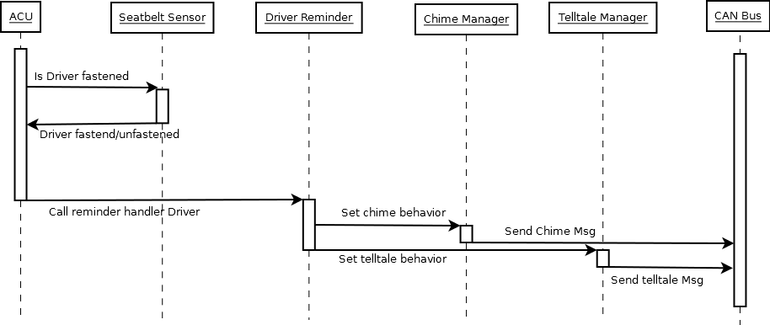
Figure 2.1 Driver Sequence Diagram

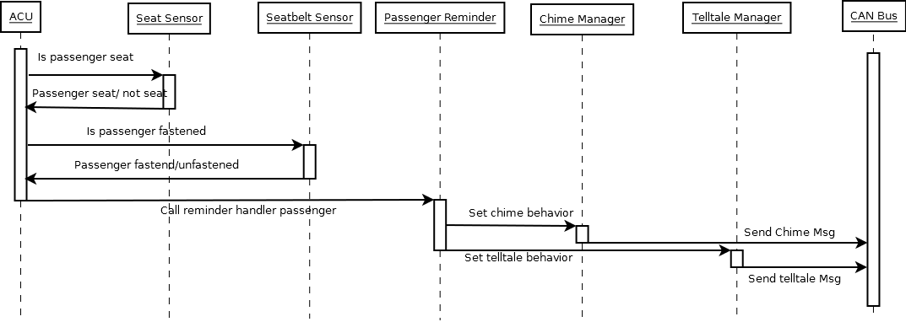
Figure 2.2 Passenger Sequence Diagram

This diagram represents the sequence of the calling modules that the code will follow on the modeling of the ACU system. In the case of the driver the module APP of ACU will check for the status of the seatbelt asking to the module of seatbelt sensor, after this , will call the Driver reminder in the specified mode of functionality, and set the behavior of the telltale and chimer, and finally the chime manager and telltale manger will send the corresponding CAN messages filling with the data required. In the case of the Passenger the sequence is similar but also adds the detection of seat sensor for occupancy.

Functional Decomposition
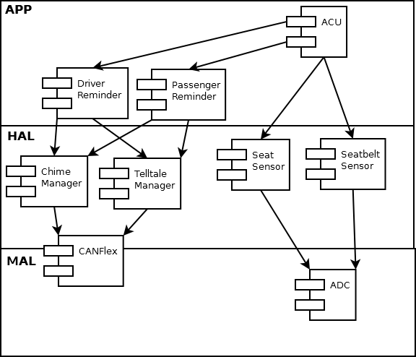
Figure 3 Component diagram of the system ACU
This system is layered oriented, we have the MAL layer where the ADC driver and the CAN driver is placed, it’s necessary to correct that the can its between the MAL and HAL layer due to the nature of the driver. In the HAL layer we have driver for the external HW control, this is the seat sensor and the seatbelt sensor, also this is where the chime manager and the telltale manager is placed to control the can messages of their respective hw. Finally on the APP layer we have the main application that runs the scheduler and the ACU app, this includes the modules of reminders of respective position, Driver and Passenger control.
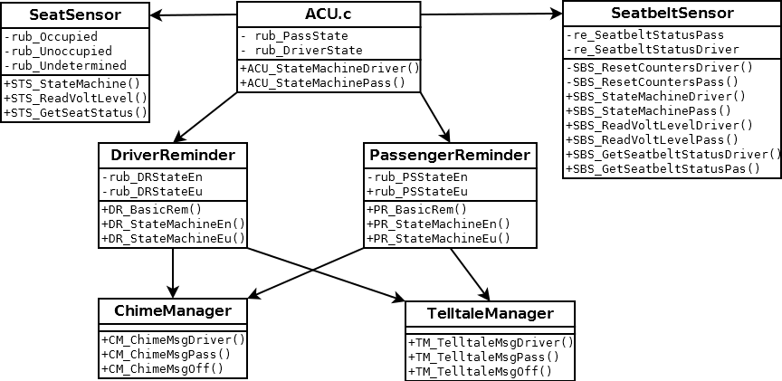
Figure 4 Class diagram system

This diagram specifies the relation between the different modules excepting the low layer of MAL. The modules are represented on classes, the attributes represents the global variables of the modules, and the methods represents the functions the module provides, also , the lines between them represents the interaction of modules, this is modeled after the sequence diagram and the component diagram seen above. So the ACU calls for the services of the seat and seatbelt sensor, after this information is gathered call for the driver and passenger reminder, this modules sets the behavior and control of the telltale and chime using the services of the chime manager and telltale manager.

Function Description and Dynamic Behavior

Function <Type> <function name> (type par 1, .., type par n)

Description | Brief description of the function behavior and useful remarks
Parameter 1  <input| output| inout> | Give an explanation if the parameter shall be checked by the user, or if a check is implemented in the function here
Parameter 2..n
Return Value
Precondition | e.g. Function can only be called in a certain state, SW component is initialized  Relation between input parameters where applicable (Input for Module Test)
Post condition | e.g. specific State change e.g. car is locked, EEPROM Values written,  Relation between output parameters where applicable
Error Conditions

Dynamic Behavior
State Chart¹, Flow Chart¹

Function <Type> <function name> (type par 1, .., type par n)
Description | Brief description of the function behavior and useful remarks
Parameter 1
<input| output| inout>
Parameter 2..n
Return Value
Precondition | e.g. Function can only be called in a certain state, SW component is initialized  Relation between input parameters where applicable (Input for Module Test)
Post condition | e.g. specific State change e.g. car is locked, EEPROM Values written,  Relation between output parameters where applicable
Error Conditions

Macros

SW module global variables

Name | Type | Memory section | Description | Shared

Design solutions for general features
It should describe detailed design solutions for general features of our products. i.e ”Layer Programming”

SW Component integration

Integration context / constraints
Tbd: help text

Include files
List here the necessary include files and their order,

Initialization
e.g. Sequence Chart for initialization
All function bellow shall be called on initialization
Call Order | Service | Call constraints linked to an other module
1 | BCM_Warning_Output_Init_Function | After EEPROM init

Interrupts
If described in the SW Architecture Document, just put the reference here.

Real time scheduler task
If described in the SW Architecture Document, just put the reference here.

Other entry points
Name | Service | Task level

