BIMLog

USER MANUAL
  - Complete illustrated operational guide
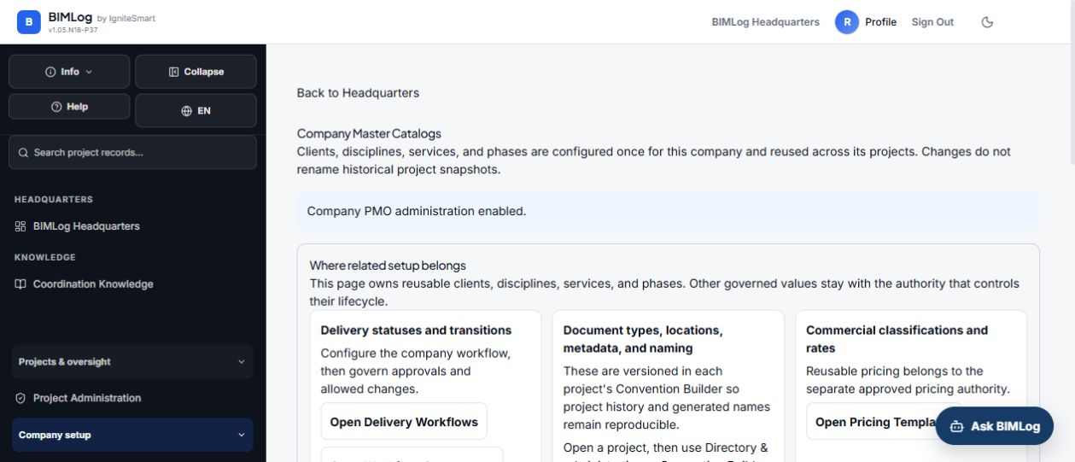
BIMLog company administration and capability navigation
Reference release v1.05.N18-P37. This guide supports project users, coordinators, project administrators, company administrators and finance users.

Start here
BIMLog connects project coordination, verified records, documents, accountability, reporting and handover. Always confirm the company, project, responsible party, status and evidence before saving or issuing a record.

Interactive access
Open the interactive Help Center
Open All Tools
Report a problem or suggestion

Role journeys
Role | Recommended journey
Project user | Projects, files, RFIs, submittals and meetings
Coordinator | Command center, coordination, Lens and reports
Project administrator | Team, permissions, workflows and project setup
Company administrator | Catalogs, governance and integrations
Finance user | Budgets, contracts, APU and evidence

Access navigation and roles
Use Headquarters for daily work and All Tools for the complete authorized capability directory. Help returns to the page where it was opened.
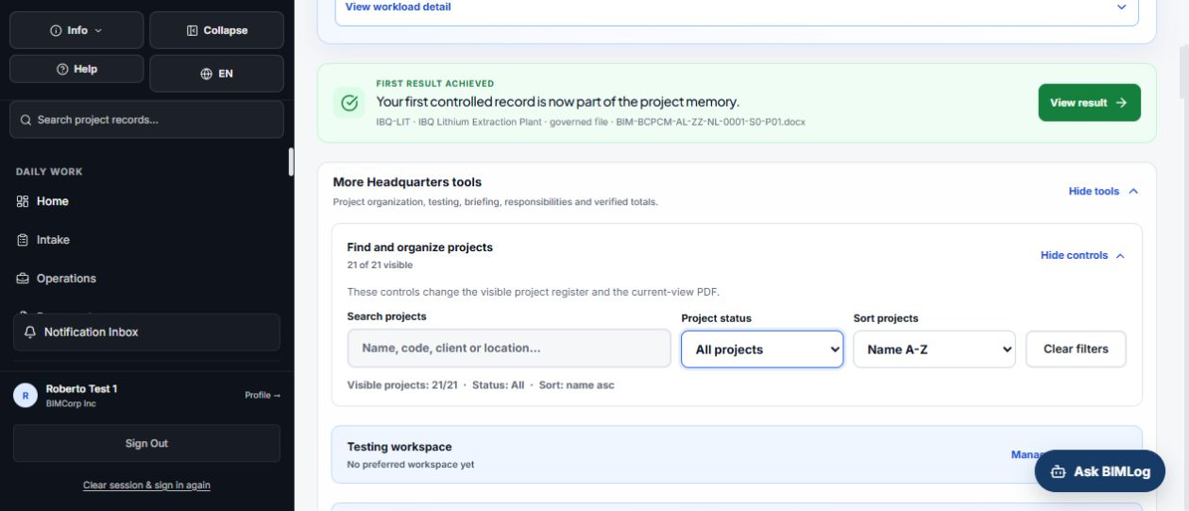
Access navigation and roles

Workflow
- Sign in with your authorized account.
- Confirm company and project.
- Choose daily navigation or All Tools.
- Open Help for a guided task.

Intake and operations
Intake prepares new work from controlled sources; Operations tracks active jobs, errors and deliverables.
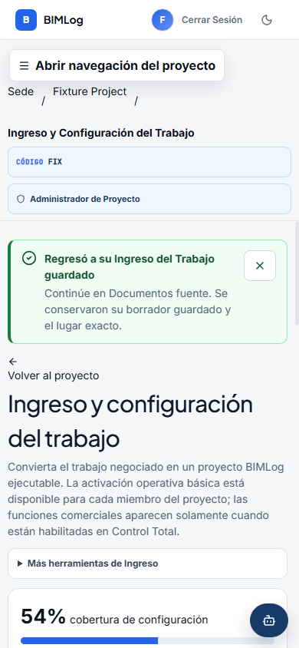
Intake and operations

Workflow
- Choose the source and authorized destination.
- Review the preview.
- Confirm required fields.
- Open Operations to monitor the result.

Coordination command center
Coordination records issues, responsibilities, priorities, status and evidence.
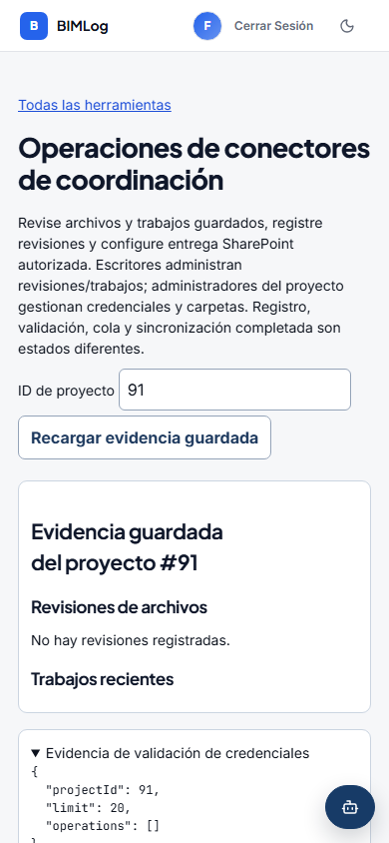
Coordination command center

Workflow
- Open the project and Coordination.
- Create or open the issue.
- Set trade, floor, responsible company, priority and status.
- Attach evidence and save.
- Refresh and reopen to confirm persistence.

Files and document control
Files preserves documents with custody, version and project context.
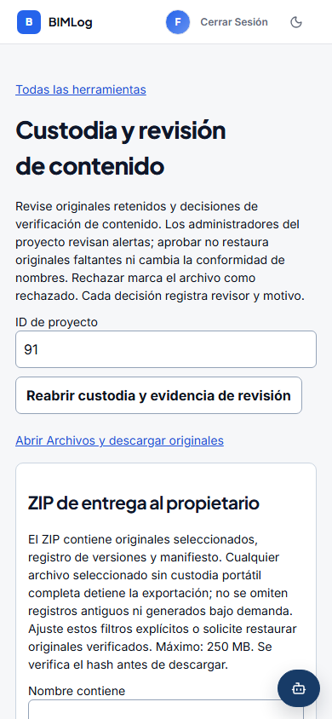
Files and document control

Workflow
- Choose the project folder.
- Upload and classify the file.
- Confirm version, status and responsible party.
- Search and reopen the saved record.

RFIs submittals and transmittals
These workflows preserve questions, reviews, formal deliveries and linked evidence.

Workflow
- Create a complete draft.
- Assign the responsible party and due date.
- Attach supporting records.
- Issue only after final review.
- Preserve the response and decision history.

Meetings changes and schedule
Meetings connect agenda, decisions and action items. Change orders preserve cause, impact, evidence and authorization.
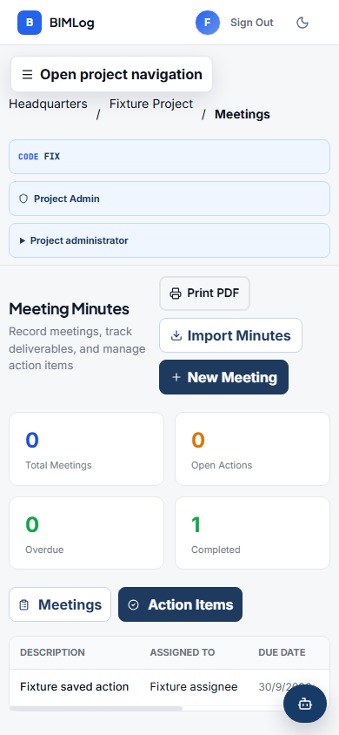
Meetings changes and schedule

Workflow
- Prepare participants and agenda.
- Record decisions and assign actions.
- Link related RFIs, issues or change records.
- Export the authorized minutes.

Reports and exports
Reports summarize working records and link back to the operational module.
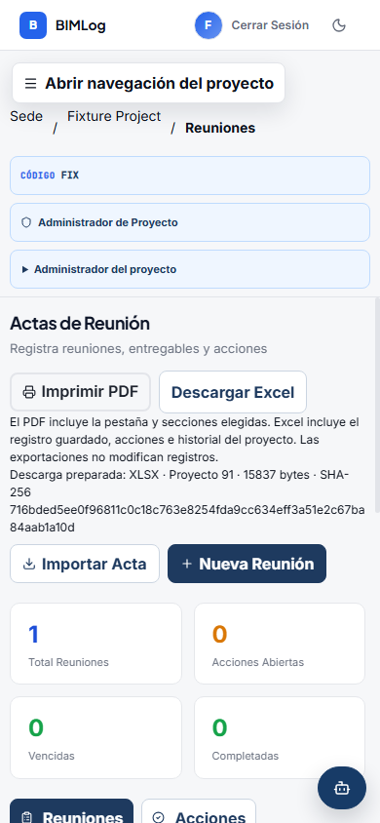
Reports and exports

Workflow
- Choose report, project, filters and period.
- Review included records.
- Generate and open the file.
- Compare totals, dates and attachments.

Lens and Navisworks
Lens binds the Navisworks model context to BIMLog issues and evidence.
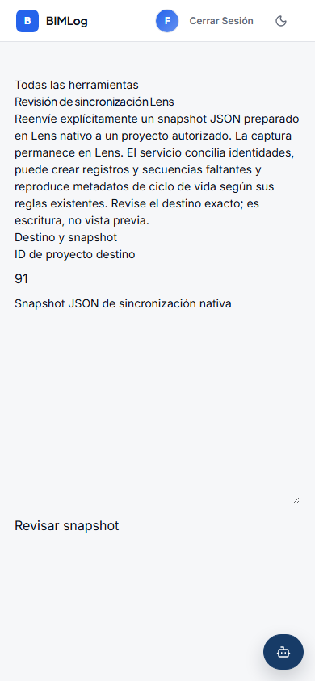
Lens and Navisworks

Workflow
- Confirm connection, BIMLog project and active model.
- Review issue fields and viewpoint.
- Review before creation.
- If an outcome is pending, inspect and retry the unchanged draft.
- Open the BIMLog record and verify persistence.

Procore and personal connections
Each user authorizes their own Procore account. BIMLog only exposes companies, projects and documents allowed by Procore.
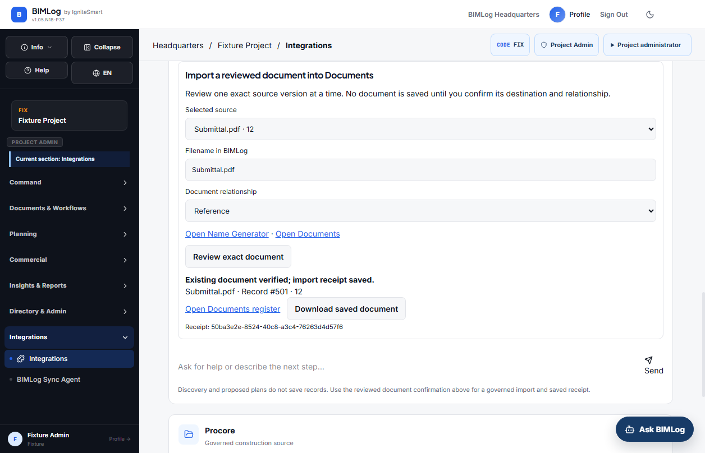
Procore and personal connections

Workflow
- Open My Connections and choose Procore.
- Sign in directly to Procore and authorize BIMLog.
- Return to Integrations and choose company and project.
- Tell the guided assistant what outcome or documents are needed.
- Review the preview and confirm the governed import.

Cost and financial control
Financial work connects cost structure, budgets, baselines, contracts, APU, payments and evidence.
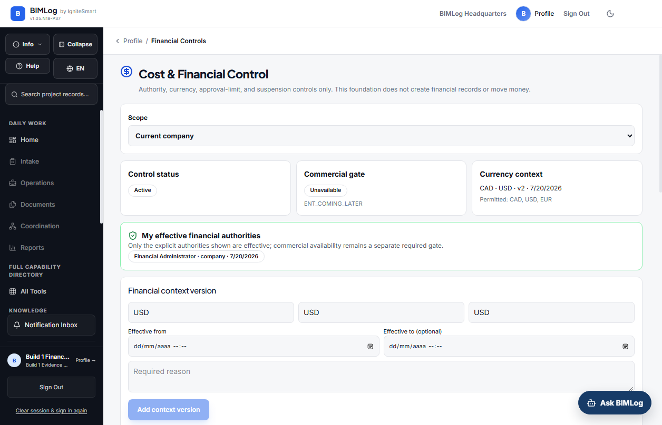
Cost and financial control

Workflow
- Confirm project and financial permission.
- Prepare the cost structure and budget.
- Preserve an approved baseline when authorized.
- Record contracts, items, amendments and payments.
- Export and compare with the approved record.

Company administration
Company administrators maintain catalogs, workflows, governance, pricing and directory data without removing legitimate capability.
Company administration

Workflow
- Choose the company configuration surface.
- Edit the correct catalog or workflow.
- Save with stable names and identifiers.
- Verify the value in the operational form.
- Deactivate rather than deleting historical values when supported.

Help support and acceptance
Use Help for guided workflows, troubleshooting, downloads and release information.

Workflow
- Save, refresh and reopen critical records.
- Confirm permissions and project isolation.
- Capture the full screen for any defect.
- Report module, role, steps, expected and actual result, time and impact.

Acceptance checklist
- Correct role and project
- Save refresh and reopen
- Permissions and isolation
- Expected success and error states
- Exports match the displayed records
- No unexplained console or network failure

