Puertos – Aplicaciones

Grupo N6:

* Ardusso, Matias.
* Fernandez, Marial Sol.
* Micozzi, Juan.
* Ocaña, Roxana.

Zoom:

* TPC: 80, 443, 8801, 8802.
* UDP: 3478, 3479, 8801, 8810.



Discord:

* TCP: 443
* UDP: 50000-65535

Google Meet:

* TPC: 443
* UDP: 19302, 19309.

WhatsApp Web:

* TCP: 5222, 5223, 5228 y 524.
* UDP: 3478.

MySQL:

* TCP:33096
* UDP: 3306

Git:

* TCP: 9418
* UDP:

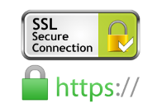 Secure Sockets Layer (SSL):

* TCP: 443
* UDP:

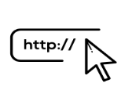HTTP:

* TCP: 80.
* UDP:

VirtualBox:

* TCP: 22, 23, 80, 2023, 2222.
* UDP:

Microsoft Outlook:

* TPC: 443
* UDP:

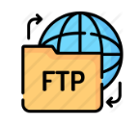File Transfer Protocol (FTP):

* **TCP: 20, 21.**
* **UDP:**

Microsoft Word:

* TCP: 80, 443.
* UDP:

Skype:

* TCP: **443.**
* UDP: **3478-3481 y 50000-60000.**

Epic Games:

* TCP: 433, 3478-3479, 5060, 5062, 5222, 6250, 12000-65000
* UDP: 3478-3479, 5060, 5062, 6250, 12000-65000

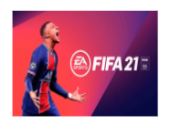FIFA 21:

* TCP: 3569, 8080, 9946, 9988, 10000-20000, 42124
* UDP: 3659, 9000-9999

Spotify:

* TCP: 4070
* UDP: 4070

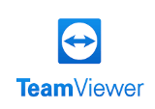TeamViewer:

* TCP: 5900
* UDP:

Netflix:

* TPC: 80, 443
* UDP: -



Garena:

* UDP: 1513

Warframe:

* TPC: 6695-6699
* UDP: 4950, 4955

### NVIDIA GameStream:

### TCP: 35043, 47984, 47989, 47991, 47995-47996

### UDP: 7, 9, 47989, 47992, 47998-47999, 48000, 48010