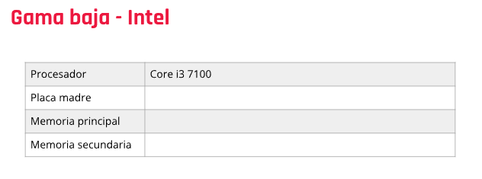

Motherboard Gigabyte H410M-H v3

8GB

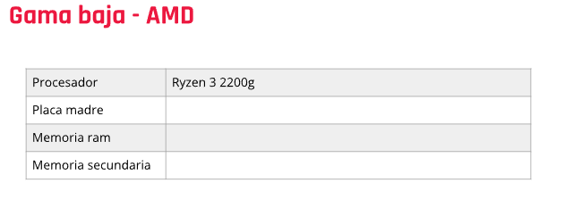1tb wd blue

A320 asus

8gb ram

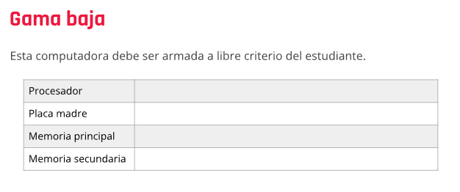 1tb wd blue

AMD 6010

E6010n

8gb ddr3

1tb dw blue

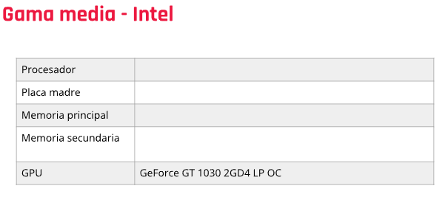

I5 10600KF

SUS PRIME B460M-A

ddr4 8gb 2666mhz

ssd 240g

1tb wd blue

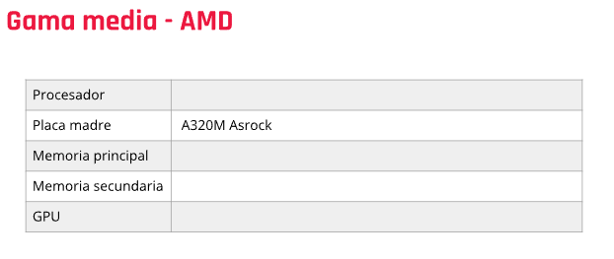

Rayzen 5 3500x

Ddr4 8gb 3200mhz

M2 512gb

Gt 730 4gb ddr3

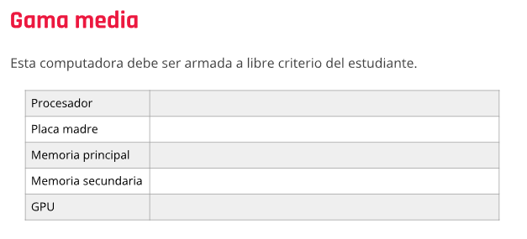

Rayzen 5 3600

Asrock b450m

8gb ddr4 3200mhz

Ssd 240

1650 4gb gddr5

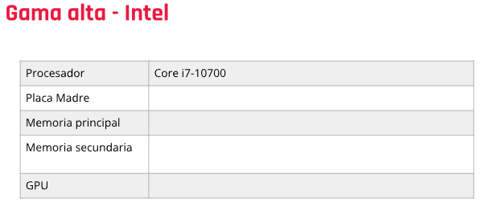

H410 10ma gen

16 gb ddr4 3200mzh

M2 512gb sdd 240 x2

2060 gb ddr6

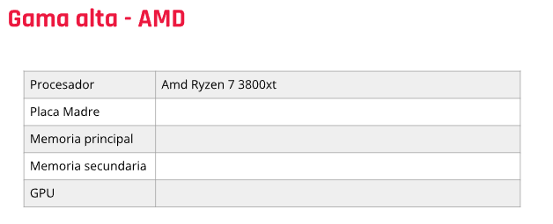

Sus rog b550-e

16gb ddr4 4800mhz

M2 2TB M2 512GB sdd 240

RTX 3090 24GB

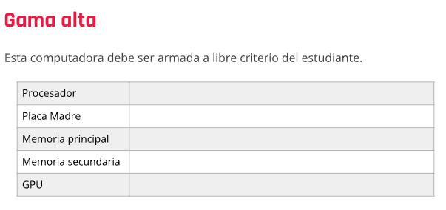

Intel core I9 12900k

1700 Gigabyte Z690 Gaming

Drr4 16gb x 2 5000mhz

M2 4tb

Rtx 3090 24gb